EA FC 27 PRO CLUBS · AL HARAMIS FC

Pro Clubs performance tracker
The thinking behind it, what the research found, where it goes next, and how it ties into my sports-analytics research
Mamoon Khan · October 2026 · github.com/M4moon/clubs-performance-tracker-fc27

In one page
I play EA FC 27 Pro Clubs most nights with a group of friends, as Al Haramis FC. Every game we play is recorded by EA, but EA only keeps the last few, and nobody looks at them. I built a system that saves every game within an hour or so of the final whistle. It then analyses how we play, who is improving and what each of us should work on, and it forecasts results.
Three weeks in, it holds 92 games, 371 player appearances and about 12,800 in-game event counts, all public data. It has produced three findings I didn't expect:
- Who we play matters far more than who plays for us. Every 100 points of opponent skill rating costs us almost a goal a game (0.87, ± 0.19). Once that is allowed for, having more players online helps only a little, and no single player can yet be shown to change results.
- Our problem is decisions, not effort. We take as many shots as our opponents but score fewer of them. EA's own in-game feedback shows our players take a good passing option 48% of the time, against 63% for typical players in the same positions. They are in position when prompted 69% of the time, against 88%.
- Honest testing changed the model. My first model looked accurate, but it was leaking the result through the opponent's post-game rating. Fixing that removed its edge, and a simpler goals model now beats guessing from our average on every measure (log loss 0.850 vs 0.925 over 82 forecast games).
The project is a small, complete version of the questions I want to work on at PhD level. How much credit does an individual deserve for a team result? Can a model honestly beat a simple baseline? How do players make decisions under pressure and fatigue? Section 5 sets out how each one connects.

1. Why I built it
The starting point was simple curiosity. We lose a lot of close games, and every evening ends with the same argument about why. I wanted to replace the argument with evidence: how we actually play, how we are trending, which of us is most effective, and where each of us can improve.
The deeper reason is that Pro Clubs is an unusually good small laboratory for team sports analytics:
- It is a real team sport with complete data. Up to 11 players per side, positions, roles, results and a ranking system, with every game logged by the publisher.
- It has the same hard problems as professional football. Messy data, missing games, small samples, individuals inside a team result, opponents of varying strength, and decisions made under pressure and fatigue.
- It records decisions directly. EA logs in-game feedback, such as whether a pass was the best option or whether the player was out of position. Real football needs tracking data and expert coding to measure that. Here it is a counter.
- It matches my day job. As a game producer I already use player analytics (engagement, retention, progression) to make product decisions. This project points the same skills at performance.
I set myself a professional standard from the start: data collected automatically and checked, every analysis reproducible from one command, every model tested only on games it had not seen, and results written up in plain English, including the ones that didn't work.

2. How it works
Stage | What happens
Collect | A scheduled task polls EA's public Pro Clubs API around when we play: hourly every night, hourly on weekend days, and catch-up runs on weekday mornings. It saves each new game with every player's line, EA's event counters, the opponent's players and the opponent club's rating.
Check | Player lines must add up to EA's team totals, or the game is fetched again and flagged. A cross-check catches stale cached data from EA. A daily snapshot of EA's own season record reveals any game that slipped through (3 out of 90 so far).
Analyse | Team and player tables, trends, a comparison with 51,395 player-matches from other clubs, and a regression of what goes with winning.
Model | A hierarchical Poisson / negative binomial goals model, retrained after every new game and tested walk-forward.
Share | A live dashboard my teammates use, a GitHub repository with all code and data, and plain-English write-ups.

Technical detail: EA's API is unofficial and only keeps a club's latest games. Its cache ignores a cache-busting parameter named "_" but respects one named "cb". That once hid a whole night of playoff games until the collector was fixed. Finding and fixing issues like this is most of real-world sports data engineering.

3. What the research found

Results track the opponent
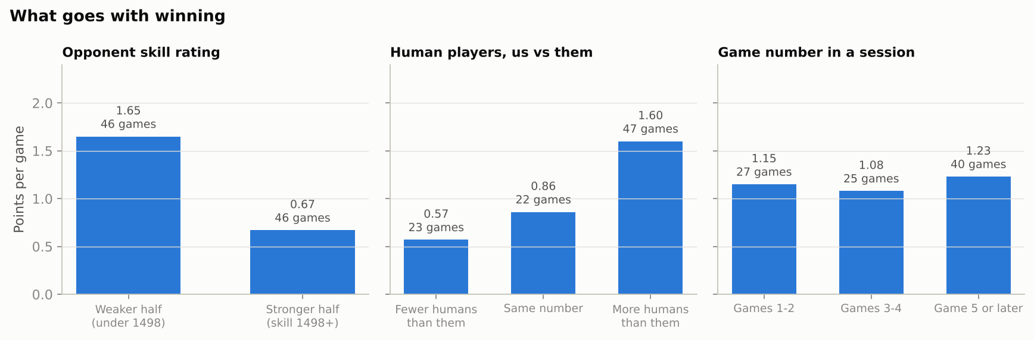
Points per game split three ways. Opponent strength is the clear driver. The numbers advantage mostly reflects who we played.
Against the weaker half of opponents we average 1.65 points a game, and against the stronger half 0.67. Having more humans than the opponent looks powerful on its own (1.60 vs 0.57 points a game), but those games were often against weaker clubs. Once opponent strength is in the model, an extra player is worth about a quarter of a goal (0.24 ± 0.16), which is not clearly different from zero.

We lose games on decisions and finishing
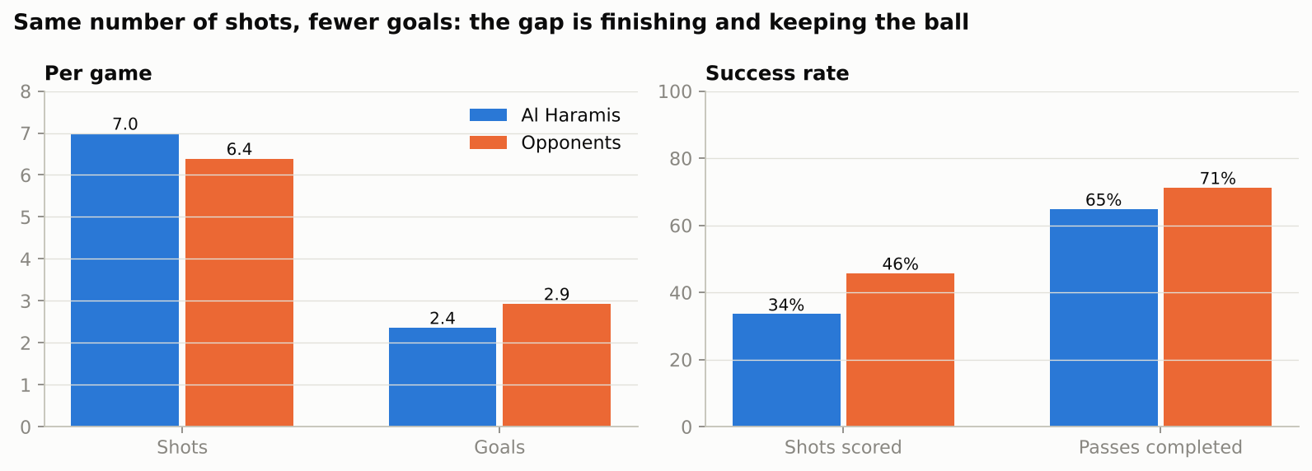
We shoot as often as opponents, but they score 46% of their shots to our 34%, and complete more passes.
EA in-game feedback (295 appearances) | Al Haramis | Typical, same positions
Good or best passing option taken | 48% | 63%
In position when prompted | 69% | 88%
Possession lost per player per game | 4.0 | 3.1

Decisions under pressure. Decision quality did not change with the stakes: 48% in league games, 49% in playoffs, and 50% vs 47% against weaker and stronger opponents. Positioning did change. It fell from 74% in the first two games of a night to 65% from the fifth game on. That pattern, stable choices but slipping off-ball discipline late in a session, is exactly the kind of fatigue effect I want to study properly.

Individual players
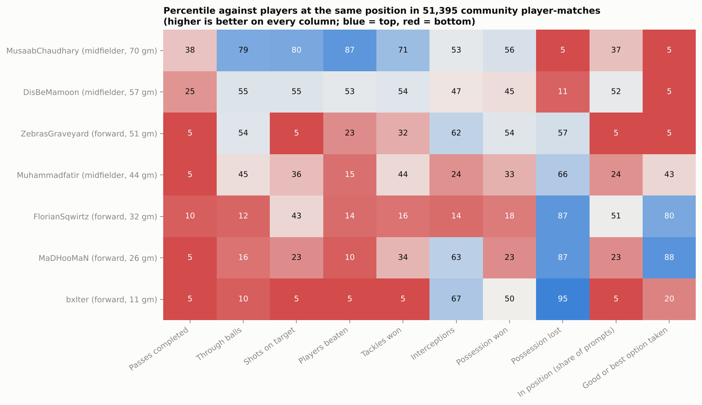
Each player against players in the same position elsewhere. Higher is better in every column, and 50 is typical.
Each player gets concrete strengths and things to work on. The creative midfielder is near the top fifth for beating players and playing through balls, but loses the ball too often. Two forwards make excellent decisions but are not involved enough. My own clearest improvement is a rise in match rating from 7.45 to 7.81 against opponents of similar strength. My biggest weakness is decision-making: a good option only 38% of the time.
Crediting individuals for results is much harder. After allowing for opponents, most players' with-versus-without differences sit within about one standard error of zero. One forward's +1.16 goals (± 0.52) is the only result past two standard errors, and with seven players tested that could still be chance.

Forecasting
Walk-forward test, 82 forecast games | Model | Club's average so far
Win / draw / loss log loss (lower is better) | 0.850 | 0.925
Brier score (lower is better) | 0.501 | 0.568
Average miss on goal difference | 2.15 goals | 2.46 goals
Results called right | 50 of 82 (61%) | 43 of 82 (52%)

4. What I learned about doing this properly
- Leakage hides in plain sight. My first model used each opponent's rating saved after the game. Ratings move with results, so the feature quietly encoded the outcome. Rebuilding pre-game ratings (the saved rating minus the 17-point swing per result, estimated from our own snapshots) removed XGBoost's apparent edge entirely. The lesson I take into research is to audit every feature for when it was known.
- Always beat a baseline, honestly. Every forecast is made only from earlier sessions, and even the model's tuning uses only earlier sessions. The model's edge over our own average is modest, and the write-up says so.
- Uncertainty is the result. With 92 games, the most important output is often the standard error. Saying that no player can yet be shown to change results is a finding, not a failure.
- Data quality is research. Validating every game against EA's totals, catching stale caches and reconciling against EA's own season record turned an unreliable feed into a dataset I can stand behind.
- Write for the people who use it. My teammates read the dashboard. The coaching notes only work if they are specific, fair and in plain language.

5. How it ties into my sports-analytics research goals
My long-term aim is a PhD in sports analytics or applied statistics, working on how data can help teams make better decisions about players, development and performance. This project is deliberately a miniature of that agenda.
Research interest | What this project does | Where it leads
Crediting individuals for team outcomes | Estimates each player's effect on goal difference after allowing for opposition, with standard errors and partial pooling in the model. | The same question as my Premier League transfer-impact project (points above replacement), now on a team I can observe every night.
Forecasting with honest baselines | Walk-forward testing, nested tuning, log loss and Brier score, and a documented leakage fix. | The discipline from my college-to-NFL rookie model, where the honest answer was that the model did not beat draft position.
Decision-making under pressure | Measures decision quality and positioning from EA's feedback counters, split by stakes (playoffs), opponent strength and fatigue (game number in a session). | A direct pilot for my planned cricket study of decision-making under pressure. Same logic: score the context, measure the decision, test what shifts it.
Load, fatigue and performance | Tracks positioning and output across long sessions. Positioning drops from 74% to 65% late in a night. | A low-cost analogue of the workload and wearable time-series work I want to do with athlete data.
Player development | Per-player trends adjusted for opponent strength, plus coaching notes benchmarked by position. | A template for development tracking in youth and amateur football, where data is scarce.

It also shows the end-to-end skills a research group needs: building a data pipeline from an undocumented source, validating it, modelling with appropriate uncertainty and communicating results to non-specialists.

6. Future goals

Next few weeks
- Keep collecting through season 2 and season 3. Doubling the sample roughly shrinks the player-effect standard errors by 30%, enough to test whether the forward's +1.16 is real.
- Close a known gap. Twenty games still rely on a fallback opponent rating, and the collector should save every opponent's post-game rating so the pre-game estimate is exact.
- Turn the coaching notes into a short weekly report for the squad.

Research extensions
- A feedback experiment. Share each player's decision and positioning notes, then test whether their decision rate changes in the following games compared with their earlier games. That is a small, real intervention study.
- A multi-club dataset. Collect the same data for many clubs at different levels. That would let me test whether decision quality predicts winning across teams, and build hierarchical models of player development.
- A pressure index per game. Combine stakes (league or playoff, season situation), opponent strength and fatigue into one context score, mirroring the ball-level pressure model in my cricket research plan.
- An open methods note. Publish the collection, validation and leakage lessons as a short write-up, so EA Pro Clubs data can be used as an open dataset for sports and esports analytics.

Career
This repository sits alongside my transfer-impact and NFL rookie projects as evidence for PhD applications and analyst roles in sports and gaming. Together they show three things: I can find and clean data that doesn't come ready-made, I test models honestly, and I can explain the results to coaches and players.

Limitations
92 games and six or seven regular players make for wide uncertainty. Pre-game opponent ratings are estimates. EA's event-code meanings are decoded by the community, not published by EA, and the benchmark players come from a September 2026 sample of other clubs. Three games were missed, and games before 7 October can't be recovered. The descriptive splits show what went with winning, not what caused it. Full details are in the repository README.

Links and credits
- Repository: github.com/M4moon/clubs-performance-tracker-fc27 (README, plain-English RESULTS.md, all code and data).
- Related projects: Premier League transfer impact and college-to-NFL rookie model.
- Data: EA SPORTS FC Pro Clubs public web API. This is an unofficial use, and the project is not affiliated with EA. Event-code meanings and benchmarks come from the community research at Interactive-63/eafc-pro-clubs-api-research.
- Tools: Python (pandas, NumPy, SciPy, scikit-learn, matplotlib). Built with AI assistance from Claude (Anthropic), which also runs the scheduled collector.

