# Syntax-Highlighter-Transaction-

Open notepad++ -> Language -> Define your language -> Import -> select file from the Folder

Go to setting🡪 preferences, select autocompletion. Set as below

## Shortcuts

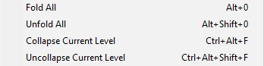



**Default shortcut keys:**  
Toggle Bookmark: Ctrl+F2  
Next Bookmark: F2  
Prev Bookmark: Shift+F2

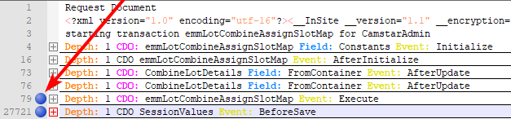

## Deleting the time Charts from the Text

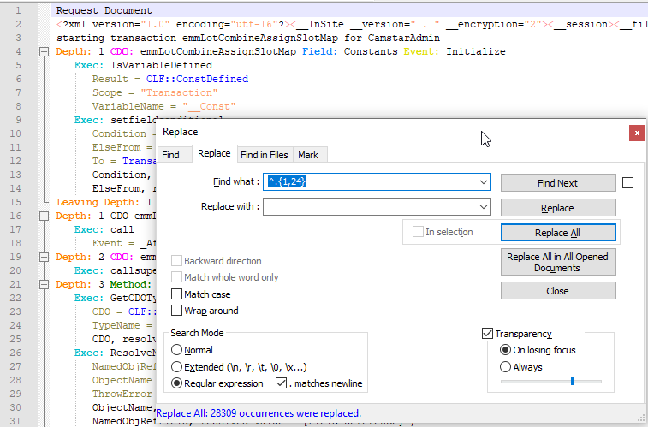

Find what: ^.{1,24}

Replace with:

Needs to be space