Principles of Computing Tutorial 1

- What are the 5 ‘processes’ necessary in creating a Database Definition?

  - Identify the data requirements
  - Produce the Conceptual Data Model
  - Use B to produce the logical Data Model
  - Use C to produce the Physical Data Model
  - Use B & C to produce the Actual Database Definition

2) What does the Database Definition actually represent?

- The DbD represents the steps involved to turn data to an organisable database, which goes through the 5 processes. This must meet the data requirements, if not this would mean the database isn’t correctly defined.

Consider the following case study:

A University holds details of students, tutors and the modules available to students that are taught by tutors.

When students enrol on a module, they are given an enrolment number (to uniquely identify them). Details recorded re:students would include name, address, year enrolled on module, etc.

Each tutor has a name, office number and personnel number. Tutors can teach one or more students on a module but may also be a personal tutor to one or more students. Not all tutors will be personal tutors. Each student will have a personal tutor.

Each module has a code, title and credit point value and will have one or more students enrolled on it.

3) What entities can you find in the above case study?

- Personal Tutor
- Student
- Module
- Tutor

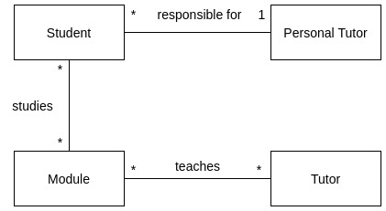

4) Produce some attributes for each entity (Use the case study but add more if appropriate)
- Personal Tutor
  - TutorNo (PK)
  - Name
  - OfficeNp
- Student
  - StudentNo (PK)
  - Name
  - Address
  - DOB
- Module
  - ModuleCode (PK)
  - Title
  - Level
  - NoOfCredits
- Tutor
  - TutorNo (PK)
  - Name
  - OfficeNo

5) For each of your entities: which attribute is the primary key?
- TutorNo
- StudentNo
- ModuleCode
- TutorNo

6) What relationships can you find between these entities?
- Personal Tutor-1 - *Students
- Student-* - *Module
- Module* - *Tutor

