MS4S21 CW-1
Mark Baber – 17076749
Table of Contents
1 – Experiment 1 3
1.1 - Hadoop-Main 4
1.1.1 – Set Hostname 4
1.1.2 – Set Hosts 4
1.1.3 – Download and Install Java 4
1.1.4 – Download and Install Hadoop 4
1.1.5 – Cloning the VM 5
1.1.6 – Set Static IP 5
1.1.7 – Generate SSH Keys 6
1.1.8 – Modifying Hadoop Files 6
1.1.9 – Copy files to worker nodes 8
1.1.10 – Adding HADOOP to bashrc 8
1.1 – Hadoop-Worker 9
1.1.1 – Modify files 9
1.2 – Map Reduce 9
2 – Experiment 2 13
2.1 - Twitter Streamer 13
2.2 – Data Pre-Processing 17
2.3 – DynamoDB 20
3 – Experiment 3 23
3.1 - The country which has authored the most tweets 23
3.2 - The most frequent hashtag/word mentioned in experiment 2 found in tweets from each country 23
3.3 - The most frequent hashtag/word mentioned in experiment found in all tweets 23
3.4 - Total number of user mentions in tweets from each country 23
3.5 - Total number of user mentions in all tweets 24
4 - Conclusion 24
5 – References 25
6 - Software 26
6.1 - VirtualBox – Version 6.1.22 r144080 (Qt5.6.2) 26
6.2 - Windows Terminal - Version: 1.7.1033.0 26
6.3 – Microsoft Excel – Version: 16.0.13929.20360 27
6.4 – Microsoft Visual Studio Code – Version 1.56.2 27
6.5 – Notepad++ - Version 7.9.5 28
6.6 – Loop through tweets for X 28
6.7 – Created and Describe EMR cluster via CLI 30

1 – Experiment 1
This section will detail what was carried out for experiment 1, which was to create a Hadoop cluster using Ubuntu Virtual Machines (VMs) on our local machines. This will be done with Oracles VirtualBox software. The main task was to replace the existing worker node with a new worker node with the following specifications:
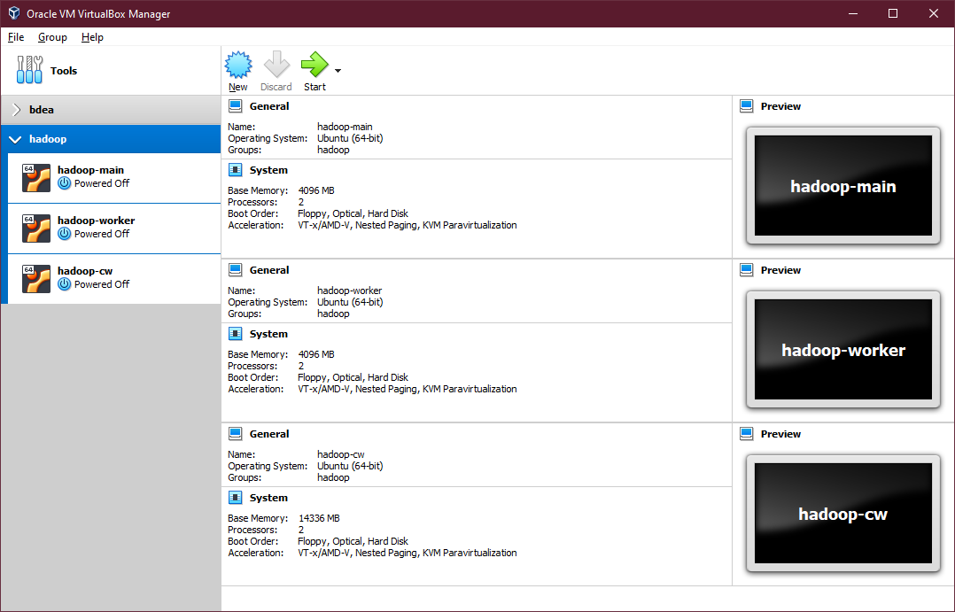
(Figure 1 – Screenshot of the 3 node hadoop cluster)
Seeing as I ran into some issues with my existing cluster from the tutorials, I took a day to re-create the whole cluster again following the notes from the tutorials which I manipulated for myself. The next few steps will be the sequence of events which happened from start to finish, with a working 3 node cluster.

- Hadoop-Main
After installing Ubuntu Desktop 20.04 Long Term Support (Instruction Here), I installed the updates and openssh-server so I could ssh into the main node from my computer using Windows Terminal. This would allow me to copy and paste some of the commands I initially edited during the tutorials, to speed up my process of setting up the VMs.

1.1.1 – Set Hostname
I checked the hostname on the main node to make sure it was correctly assigned as: hadoop-main. This was done by editing the file with sudo nano /etc/hostname and deleting the hostname and changing it to hadoop-main.

1.1.2 – Set Hosts
Next was to assign the hosts correctly for the main node and the two worker nodes – I already knew I was going to set a static IP as it is good practice, so these were hard coded in a range which I knew was free on my local network. Setting the hosts file was done by typing into a terminal, sudo nano /etc/hosts and adding the following:
- 127.0.0.1 localhost
- #127.0.1.1 hadoop-xyz (this would be Virtual Machine hostname)
- 192.168.1.173 hadoop-main
- 192.168.1.174 hadoop-worker
- 192.168.1.175 hadoop-cw

1.1.3 – Download and Install Java
To install java on Linux, this can be done with the follow code: sudo apt install openjdk-8-jdk which is an open-source version of java freely distributed. Now that java is installed, the path needs to be assigned to the ~/.bashrc file. This can be done with the following code: sudo nano ~/.bashrc and add the following code at the very bottom of the file:
- # JAVA
- export JAVA_HOME=/usr/lib/jvm/java-8-openjdk-amd64/jre
and apply these changes with this: source ~/.bashrc – this is all that is currently needed for setting up java on Linux.

1.1.4 – Download and Install Hadoop
This next section will cover how to download and install Hadoop, which is required for our clusters, this code can be run from everywhere, but I usually change directory to downloads when downloading files. This can be done with:
- cd Downloads/
- wget https://archive.apache.org/dist/hadoop/common/hadoop-3.2.2/hadoop-3.2.2.tar.gz
Next will be to extract the archive which can be done with tar -xvf hadoop-3.2.2.tar.gz and should be moved to /usr/local/hadoop, this can be done with the following code: sudo mv hadoop-3.2.2 /usr/local/hadoop – now that we have moved the hadoop files to our local user files, we would need to add the path to ~/.bashrc again. This can be done with: sudo nano ~/.bashrc and adding the 3 lines to the bottom of the file (under the Java entry)
- # HADOOP
- export PATH=$PATH:/usr/local/hadoop/bin:/usr/local/hadoop/sbin
- export CONF=/usr/local/hadoop/etc/hadoop
and applying the changes again with source ~/.bashrc – this will conclude this section.

1.1.5 – Cloning the VM
After getting this far and setting up a few basic things, the next step is to clone the VM. This can be done by right clicking the VM and clicking clone with these settings:
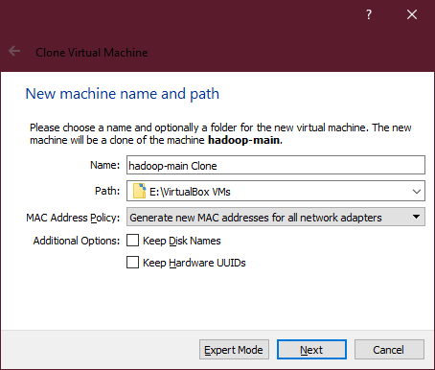
(Figure 2 – Screenshot of Cloning a VM)
And using the Full Clone option for the next setting – this will create (as the name suggests) a full clone of the VM but will generate a new mac address for the network adapter.

1.1.6 – Set Static IP
Now that the VM has been cloned, this is where I set a static IP for my VMs which I know are free on my local network. This can be done with the following code: sudo nano /etc/netplan/01-network-manager-all.yaml and pasting the following code:
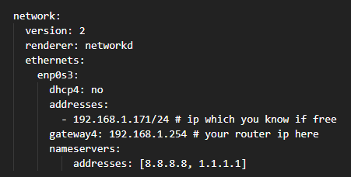
(Figure 3 – Screenshot of how to set static IP)

1.1.7 – Generate SSH Keys
The next step will be to generate SSH keys from the main node to the two worker nodes, this is an easy task to do, but will need to be done after completing a few dependencies:
- Changing the hostname of the 2 worker nodes
- Setting static IPs for the 2 worker nodes
To generate your ssh keys from the main node, this can be done with: ssh-keygen -t rsa and accepting the default (which is not best practice, but this is only local). These keys would then need to be copied to the two worker nodes. This can be done with:
- ssh-copy-id hadoop-cw@hadoop-main # copy the key to main
- ssh-copy-id hadoop-cw@hadoop-worker # copy the key to worker 1
- ssh-copy-id hadoop-cw@worker-cw # copy the key to worker 2
These can be tested with all the machine running and typing from the main node: ssh hadoop-cw@hadoop-worker – you should be asked about accepting the connection and asked for the password. If successful you should see the terminal for hadoop-cw@hadoop-worker.

1.1.8 – Modifying Hadoop Files
This step requires a few hadoop files to be modified, seeing as this will require going back and forth the path, we will create a command which will make changing directories much easier. This can be done by adding this code to the ~/.bashrc file again, with: sudo nano ~/.bashrc and at the bottom of the file adding: export CONF=usr/local/hadoop/etc/hadoop, saving the changes and typing source ~/.bashrc. This will allow us to easily navigator to the hadoop folder with cd $CONF/.

1.1.8.1 – hadoop-env.sh
Now this has been added, we need to change 4 files for the main node, these files are:
- hadoop-env.sh
- core-site.xml
- hdfs-site.xml
- workers
The first file will be changed with sudo nano $CONF/hadoop-env.sh, for this file we need to add the Java path which we created earlier. Within this file look for the java which is commented out and add our customised one like so:
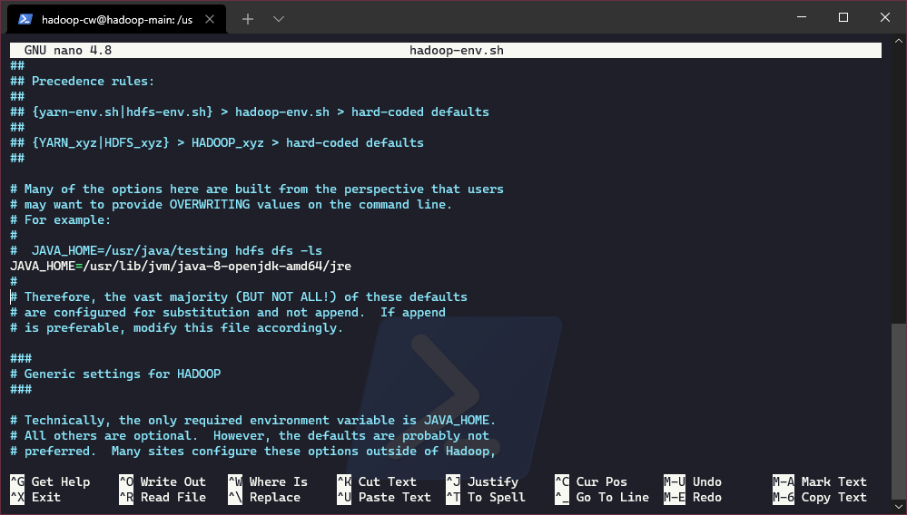
(Figure 4 – hadoop-env.sh modified)

1.1.8.2 – core-site.xml
Next we will need to change core-site.xml, this can be done with sudo nano $CONF/core-site.xml, within this file we want to add:
<configuration>
<property>
<name>fs.defaultFS</name>
<value>hdfs://hadoop-main:9000</value>
</property>
</configuration>
This is all for this file.

1.1.8.3 – hdfs-site.xml
Next we will change hdfs-site.xml, this can be done with sudo nano $CONF/hdfs-site.xml, within this file we want to add:
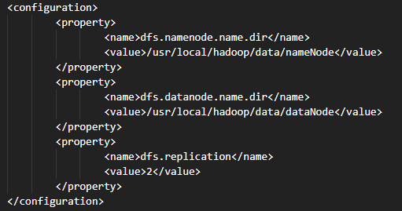
(Figure 5 – hdfs-site.xml)
This is all we need for this file.

1.1.8.4 – workers
The workers file is just there to list our worker nodes, for this we can access it with: sudo nano workers, within this file we want to add the two worker node hostnames, mine is as follows:
- hadoop-worker
- hadoop-cw

1.1.9 – Copy files to worker nodes
Now all these files have been modified, this is where we want to securely copy these files to our workers. This can be done with 2 lines of code:
- scp $CONF/* hadoop-cw@bdea-worker:/usr/local/hadoop/etc/hadoop/
- scp $CONF/* hadoop-cw@worker-cw:/usr/local/hadoop/etc/hadoop/
You should be presented with a success notification, and this concludes this section.

1.1.10 – Adding HADOOP to bashrc
To make sure we can call hadoop from everywhere on the machine, we want to add a few paths to bashrc. This can be done with sudo nano ~/.bashrc and within this file, again at the bottom add:
- export HADOOP_HOME=/usr/local/hadoop
- export HADOOP_COMMON_HOME=$HADOOP_HOME
- export HADOOP_CONF_DIR=$HADOOP_HOME/etc/hadoop
- export HADOOP_HDFS_HOME=$HADOOP_HOME
- export HADOOP_MAPPED_HOME=$HADOOP_HOME
saving the changes and applying the changes with source ~/.bashrc. Now before moving on to running a map reduce task, there are a few more changes to add to the worker nodes.

– Hadoop-Worker
To begin with our first worker, lets assigned a new hostname as it will be the same as the main node when we cloned the VM. Seeing as these instructions have already been described, I will just link to that section from here.
The next step is to make sure we have a static IP which we can use when connecting via ssh – again these steps have been mentioned so will be linked here.
Repeat these steps for the other worker and all should be good.

– Modify files
This section will show the files which need to be modified to get the workers up and running, the only file which needs to be modified is yarn-site.xml. Just make sure this file has this in the file:
- <configuration>
  - <property>
    - <name>yarn.resourcemanager.hostname</name>
    - <value>hadoop-main</value>
  - </property>
- </configuration>
Now this file has been modified, we want to copy this file to the other worker node, both are all set up. This can be done with:
- scp yarn-site.xml hadoop-cw@worker-cw:/usr/local/hadoop/etc/hadoop/

After this, we are finished for the two workers and can begin to format and run a hdfs map reduce job.

– Map Reduce
To begin with getting our cluster ready to carry out a map reduce job, there is still a few things left to do. The first is so format the main node which sets up the node and looks to see if the worker nodes are ready. This can be done with the following code, which can be executed from anywhere on the main node:
- hadoop namenode -format
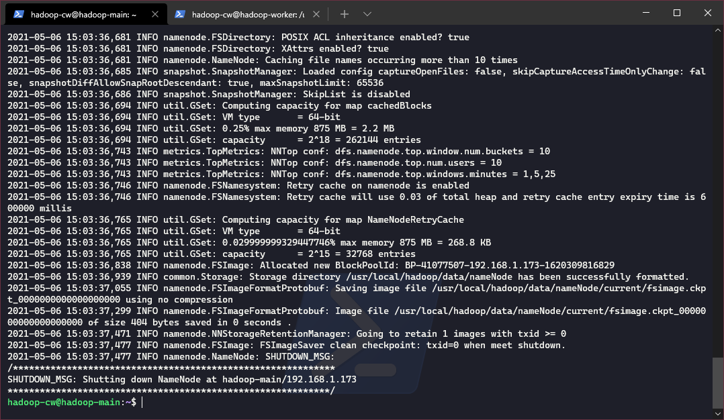
(Figure 6 – Hadoop Main Format Response)
After running this command, we can start the distributed file system (dfs), this can be done with start-dfs.sh or start-all.sh. This will have an output as seen below:
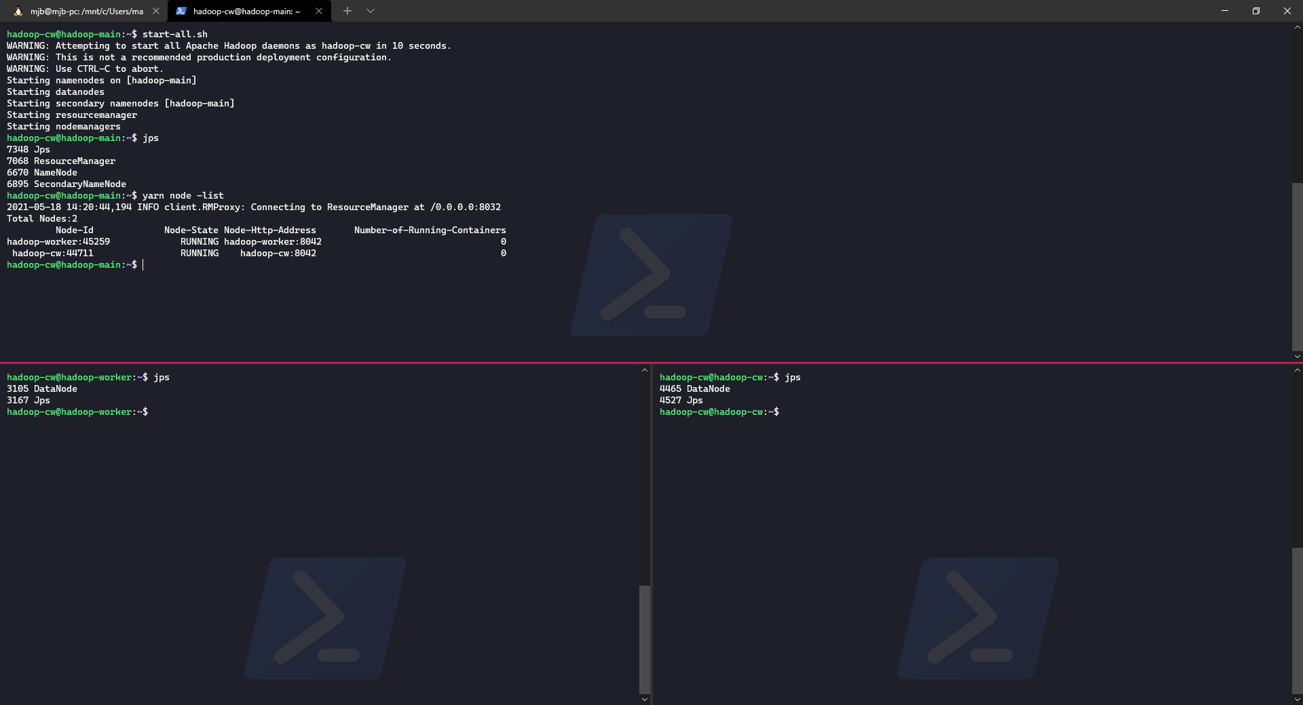
(Figure 7 – start-all.sh)
Now the cluster has been formatted and checked with yarn node -list (as seen above), this means our cluster is ready to run a map reduce job.
To run a map-reduce job, for this example lets run one of the built-in examples which is to estimate the value of pi. This can be done with the following code:
- yarn jar /usr/local/hadoop/share/hadoop/mapreduce/hadoop-mapreduce-examples-3.2.2.jar pi 16 50000
Where we are running a yarn jar file to estimate pi, with 16 map tasks and 50000 examples. Hopefully, you get no errors, and the output will look like the figure below.

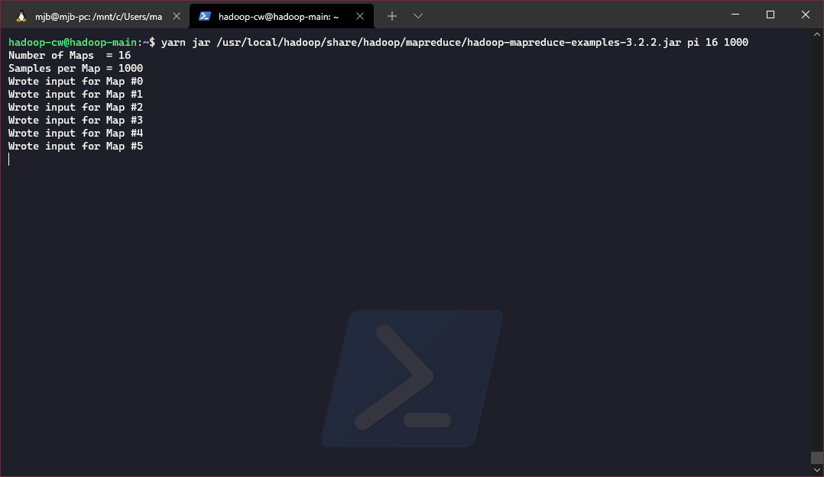
(Figure 8 – Map Reduce Job Running)
With the end looking like this:

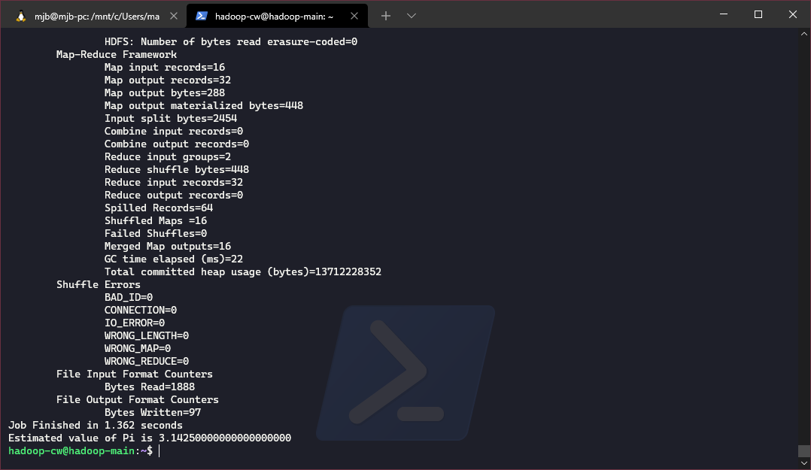
(Figure 9 – Map Reduce Job Finished)
This concludes this section of the report which looks to set up a 3-node cluster and run a map reduce task. With the 3 nodes and their system resources found below:

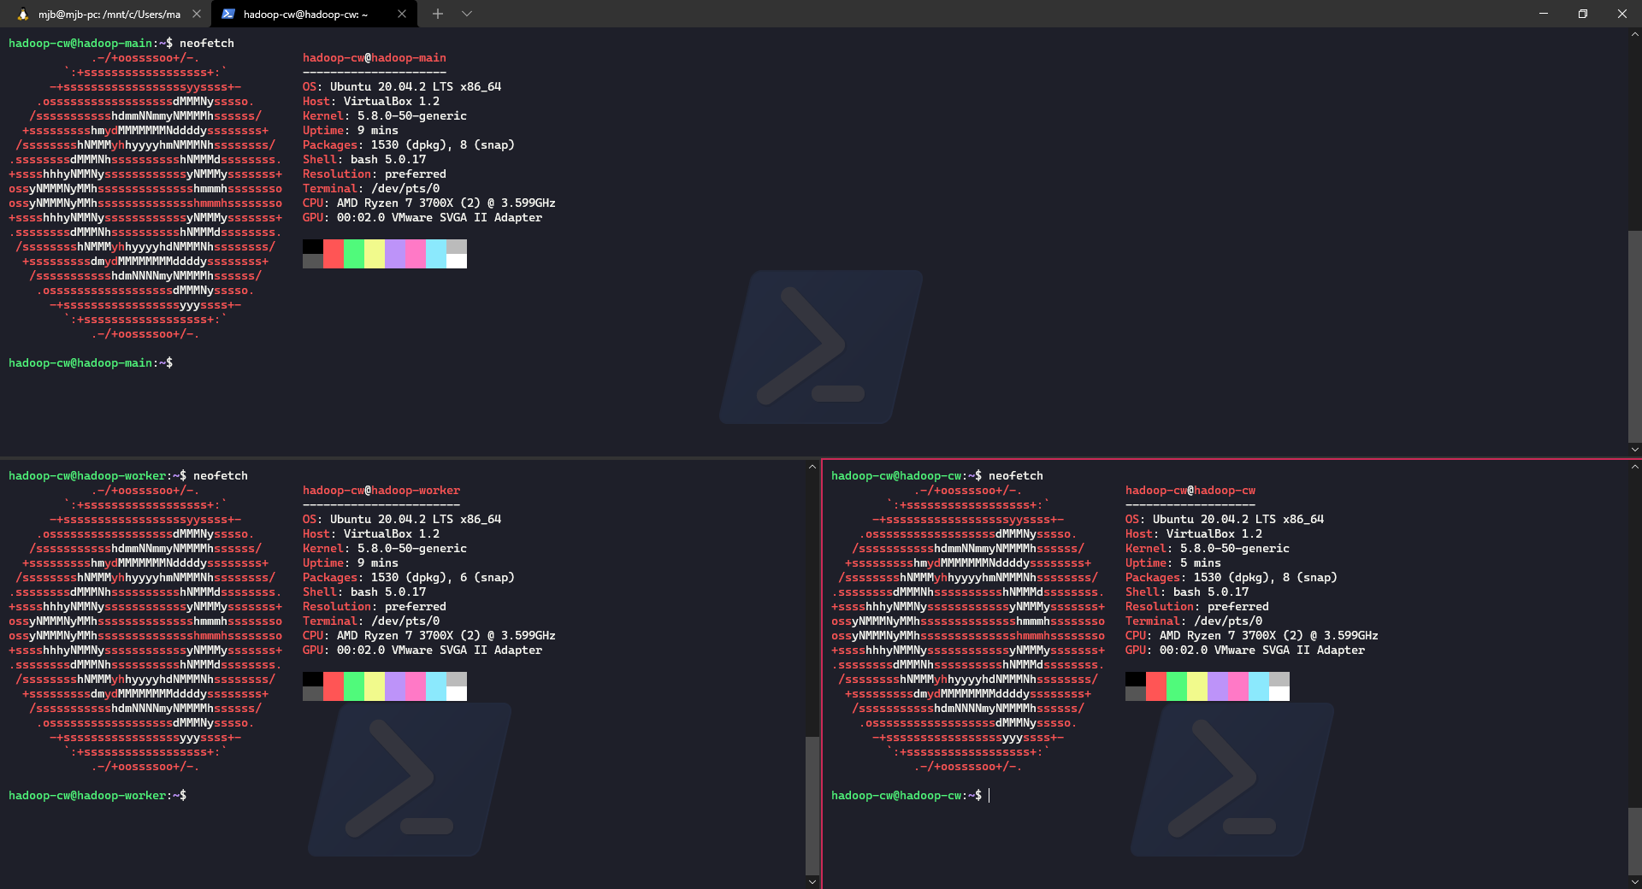
(Figure 10 – 3 Node Cluster System Resources)

– Experiment 2
This section of the report will go over how to stream tweets from the website Twitter using their API with a third-party API called Tweepy. This will be done using a Jupyter-Notebook and python, which is being run from the package Anaconda.

2.1 - Twitter Streamer
To start with this experiment, the first thing to do was to import two modules which are required for this task. This can be done with this:
# install modules
import tweepy, json
Next is to set up the security keys from the twitter developer account:
consumer_key = 'y1Hz3CADNPj7fWOtkPfReA5Vbyzz'
consumer_secret = 'sz3SszPNyJFA0URxqq8R76poS2q37pUbVwbj7Z0ARm68B5hQSRSzz'
Bearer_Token = 'AAzAAAAAAAAAAAAAAAAAAANkfKQEAAAAApqxe6v7ejWpxazCs0S2YSJuiIJE%3DoDJ41CBVFbZQ0cZ4KftvIAMFLCWYn0Ih3SRzvF8reI74UdqNDxzz'
access_token = '7z55358007-sDkidtK10EmFad6XaOFre7scKITWvoBMLkxkQ6KUzz'
access_token_secret = 'SzsYgAuAAFOl8m1zWWFSYJRdpL1L0u8KTZRDB2ZhbSsZZXzz'

(This code has been modified so it will not work.)
After setting these variables, we would need to set the authentication:
# set authentication
auth = tweepy.OAuthHandler(consumer_key, consumer_secret)
auth.set_access_token(access_token, access_token_secret)
api = tweepy.API(auth)
This is using tweepy to handle the authentication.
The next step is to create an instance of a file, which we will use to store the streamed tweets to.
# open a file to append the streaming data
streamedTweets = open("streamed-tweets.csv", "w")
unfilteredTweets = open("unfiltered.csv", "w")
For this, I have set up two files which are as follows.
- streamed-tweets – this will only save certain properties from the twitter streamer.
- unfiltered – this will save everything that comes from the twitter streamer.

This next function is a big function which is used to connected to the streamer, check for errors and picks what data to keep from the streamer.
class myStreamListener(tweepy.StreamListener):
def on_connect(self):
# Called initially to connect to the Streaming API
print("You are now connected to the streaming API.")

def __init__(self, api=None):
super(myStreamListener, self).__init__()

def on_error(self, status_code):
if status == 420:
# Returning False on_data method in case rate limit occurs.
return False
print(status)
# On error - if an error occurs, display the error / status code
print('An Error has occured: ' + repr(status_code))
return False

def on_data(self, data):
# Get all data from twitter as datajson
datajson = json.loads(data)
# dump all the data to see what we can use
json.dump(datajson, unfilteredTweets, indent = 6)

# select what we want to keep
createdAt = datajson['created_at']
userName = datajson['user']['name']
tweetText = datajson['text']
userLoc = datajson['user']['location']
hashTags = datajson['entities']['hashtags']
userMentions = datajson['entities']['user_mentions']

# get the data as a dictionary -
Dictionary = {1:createdAt, 2:userName, 3:tweetText,
4:userLoc, 5:hashTags, 6:userMentions}
# convert dict to json string
json_string = json.dumps(Dictionary)
# write this converted string to csv & JSON
json.dump(json_string, streamedTweets)
The on_data function is the part where we specify the data and what to save, for this I tried to take all the data as unfilteredTweets along with some filtered tweets. This was to check if working with one over the other would have been easier.
The next section is a big function which takes a few parameters which can be used against the rest of the streamer to filter down the stream. This can be done with things like locations, languages, hashtags and more. This can be done with the following code:
def goGetTweets():
try:
# locations # uk
loCal = [-3.576205, 51.466683, -3.143618, 51.825436]
# languages
lanG = ['en']
# hashtags
hashT = ['#COVID19', '#CoronaVirus', '#UnitedKingdom', '#UK', '#India']
# set wait on rate limit
listener = myStreamListener(api = tweepy.API(wait_on_rate_limit = True))
# init the streamer
streamer = tweepy.Stream(auth=auth, listener = listener)
# print tracking
print("Tracking location " + str('United Kingdom'))
# DOES THIS START OR STOP THE LOOP
streamer.filter(locations=loCal, languages = lanG, track = hashT)
except KeyboardInterrupt:
print("manually stopped at:", datetime.now())
finally:
print('Done.')
finalTime = datetime.now()
print(finalTime)
print("time ran out.")
The main parts of this code which is important is the locations which was set with BBoxFinder, the languages which was easy enough to set and the hashtags which are the topics we are interested in tracking.
Next is setting the listening with the Tweepy API with wait on rate limit as this will make sure we do not go over our limit, setting the streamer with the authorisation and printing a string to let us know the app is tracking when it runs.
Next is the filter being applied to streamer before setting 2 excepts which will wait for a keyboard interrupt printing the time it stopped, and finally printing out done if the code runs to completion.
Before calling the function to start the stream, I tried to set up a condition which would run for x amount of time before finishing. I could not get this to work, but left the code in, here is the following code:

####################################
## ALL OF THIS LOGIC DOESN'T WORK :(
####################################

# add some logic to see if it loops
from datetime import datetime, timedelta
# set start
startTimer = datetime.now()
# set end
endTimer = startTimer + timedelta(seconds=5)

print('START @',startTimer)
print('Should end at', endTimer)

# start loop
while datetime.now() < endTimer:
goGetTweets()
else:
finalTime = datetime.now()
print(finalTime)
print("time ran out.")
# close both csv files
streamedTweets.close()
unfilteredTweets.close()
# disconnect from streamer
#streamer.disconnect() # this kept throwing an error
print("Disconnecting from Streamer")
When running this code, I expected it to run for 5 seconds from when the command was run. However, this was not the case so instead I left it run for several hours before being hit with a connection issue. Although this code did run long enough to get two different types of csv’s saved – one which is unfiltered and in a JSON format, and the other which was a dictionary which contained only the entries which I wanted.
However, the second dataset which was a dictionary, seemed to all be within a single cell within Excel which I thought would have taken way too long to clean on submission day. Because of this I looked to the full JSON formatted file, which will be used in the next step.

2.2 – Data Pre-Processing
To begin with the data pre-processing, I started by creating a new notebook so I could keep things simple and clean. I then started by importing json, csv, pandas and importing the full unfiltered dataset which was dumped out from the last section.
import json, csv
import pandas as pd
myFile = open('unfiltered.csv','r') # read the data
data = json.load(myFile)
print(data[1]) # print all the data for the first entry
print(data[1]['created_at']) # print the create at for the first entry

There were some issues before getting the data to import correctly, when I was dumping out the data from section 2.1 the csv file which saved as a json format (indented) did not have commas between the curly brackets (This = }{ ) which needed to be converted to (This = },{). This was difficult as the data was too big to replace all with Microsoft Excel (Obviously), it was also too big to clean with Microsoft Visual Studio Code (this was a surprise), but I was able to replace all with Notepad++ which really impressed me.
After sorting out the comma between the curly brackets, the next step was to try and find what data I wanted to keep from the dataset. As this data used a JSON format, a few things were nested and proved difficult to find.
print('Created at:', data[1]['created_at'])
print('Username:', data[1]['user']['name'])
print('Text:', data[1]['text'])
print('Location:', data[1]['user']['location'])
print('Hashtags:', data[1]['entities']['hashtags'])
print('User mentions:', data[1]['entities']['user_mentions'])
This code snippet would find all the fields that I wanted to keep by looking at the first entry, which made it a lot easier when trying to get the actual fields.
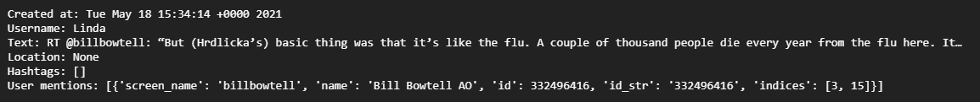
(Figure 11 – Output of fields from Tweets Streamed)
Next was to get this data into a pandas dataframe (df), this was done with the following code:
# create an empty dataframe
df = pd.DataFrame(data)
# check type
print('df type:', type(df))
# print the info
df.info()
After getting the data into the df, and checking the type and info for clarity, the next step was to build out the dfs structure. This included specifying the columns and then importing the data into the correct columns.
myDF = pd.DataFrame(columns = ['created_at',
'user_name',
'screen_name',
'text',
'location',
'hashtags',
'mentions'])
# put created_at into the df
myDF['created_at'] = df['created_at']
myDF['text'] = df['text']
print(myDF)
Seeing as the created_at and text was easily put into the df, these two were done together. The other columns proved to be more difficult as it was nested, the first thought was to s/lapply it by I could not figure that out in Python. So instead, I just created a loop and appended each entry into a list, before merging the list into the dfs columns.
# now we want to find screen names and user names
print(df['user'][0]['screen_name'])
print(df['user'][0]['name'])
# create a list of screenNames
screenNames = []
# loop through the screen_names and append to list ScreenNames
i = 0
for screen_names in df['user']:
screenNames.append(df['user'][i]['screen_name'])
i+=1
# add to myDF
myDF['screen_name'] = screenNames
After finding out how to select a user screen name and a username, this is where I implemented the loop into a list and merged the list and df. Now this section was done, the next step was to do the same thing for the other columns (the code for this will be in the appendix to save some space).
This next section will cover the pre-processing as a few of the entities within the df were nested and difficult to deal with. This step involved tokenization and removing stop words, whilst there is a good package in R, trying to convert what we have used from R to Python was quite difficult with the different package.
The package used for Python was NLTK and this was easily imported but also required the user to download additional data for the package to work. This was done with:
# Removing Stop Words with NLTK
import nltk
nltk.download()
# for this you can download corpus
# or all
print(stopwords.words('english'))
Now that I have successfully downloaded stopwords and tested this by printing the english stopwords, the next step was to create a custom stopwords dictionary and add it to the local dictionary used. After this the next step was to create a tokenized version of the words, this was done with the following:
# create a list
removedSW = []

# set english stopwords
en_stops = nltk.corpus.stopwords.words('english')
# add custom stop words
new_stopwords = ['“','’','https','.', ';', ':', ')', '(', '@', '...', '//t.co/', ',', '.']
# add stopwords to en_stops
en_stops.extend(new_stopwords)
print(len(en_stops)) # 179 stopwords

# first to tokenize the words from the tweets
twToken = nltk.word_tokenize(str(myDF['text']))

# only keep words not in the stopwords set above
for word in twToken:
if word not in en_stops:
removedSW.append(word)

# check the first 10 words
print(len(removedSW))
print(removedSW[1:10])
After removing the stopwords, I then printed the first 10 entries within the removedSW list. The next 2 steps were to sort the list and have a look at the top 10 entries again before saving the df to a csv again.
# here we have removed all the stop words
# now let us look the top 10
removedSW.sort(reverse=True)
print(removedSW[1:10])
# now save to csv
myDF.to_csv('marks-tweets.csv', index=False)
This will finally conclude this section, next will be creating a database on DynamoDB and running some HiveQL queries against the data.

2.3 – DynamoDB
For this section we will create a database on DynamoDB which will have the layout for the data we want to keep and query. This was done using a Jupyter Notebook again and using the package boto3. This will allow us to write out our code in a notebook and have it sync up to our AWS account.
I started by importing 2 modules and then creating an instance of my AWS account, this was done with the code below:
# import modules
import boto3
import csv
# create client instance
client = boto3.client('dynamodb', region_name='us-east-1')
Next was to create the skeleton of our database, seeing as this would be a NoSQL database not every single ‘column’ has to be designed at this point. Although it is still important to have a unique primary key, which is made up of a key value pair in DynamoDB. To create a table this code was run:
def createTable():
try:
resp = client.create_table(
TableName="myTweets",
# Declare your Primary Key in the KeySchema argument
KeySchema=[
{
"AttributeName": "created_at",
"KeyType": "HASH"
},
{
"AttributeName": "user_name",
"KeyType": "RANGE"
}
],
# Any attributes used in KeySchema or Indexes must be declared in AttributeDefinitions
AttributeDefinitions=[
{
"AttributeName": "created_at",
"AttributeType": "S"
},
{
"AttributeName": "user_name",
"AttributeType": "S"
}
],
# ProvisionedThroughput controls the amount of data you can read or write to DynamoDB per second.
# You can control read and write capacity independently.
ProvisionedThroughput={
"ReadCapacityUnits": 1,
"WriteCapacityUnits": 1
}
)
print("Table created successfully!")
except Exception as e:
print("Error creating table:")
print(e)
# now function is created run it with:
createTable()
This creates a function, which in turn created the table on our DynamoDB account, if there are any errors this is printed out. This piece of code was adapted from AWS documentation. Next is setting up our connection and selecting the DynamoDB we just created, before importing the data.
# Now that the table has been created, here we want to import our data.
# create an instance of dynamodb via boto3
dynamodb = boto3.resource('dynamodb', region_name='us-east-1')
# select our new db table
myTable = dynamodb.Table('myTweets')
Now to write a script which would take our csv and import it into this newly created table:
# create a function to read each row
def batch_write(table_name, rows):
table = dynamodb.Table(table_name)

with table.batch_writer() as batch:
for row in rows:
batch.put_item(Item=row)
return True

def read_csv(csv_file, list):
# get all rows
rows = csv.DictReader(open(csv_file, errors="ignore"))

for row in rows:
list.append(row)

if __name__ == '__main__':
table_name = 'myTweets'
file_name = 'marks-tweets.csv'
items = []

read_csv(file_name, items)

status = batch_write(table_name, items)

if(status):
print('csv inserted')
else:
print('Error inserting csv')
# source : https://www.youtube.com/watch?v=MOaXGYgqipQ
To check this data was uploaded correctly, I selected someone from the table.
# get item
resp = table.get_item(Key={"created_at": "Tue May 18 15:35:01 +0000 2021",
"user_name": "Stefan Hawley"})

print(resp['Item'])
Whilst I thought it was a good idea to have the created_at and user_name as the key value pair, another 2 columns could have been used for an easy time to use.
This concludes this section of the report, with the next step being HiveQL.

– Experiment 3
Before being able to run some HiveQL queries against our data, the first thing to do is to create a EMR Cluster on AWS. This can be done with the following code:
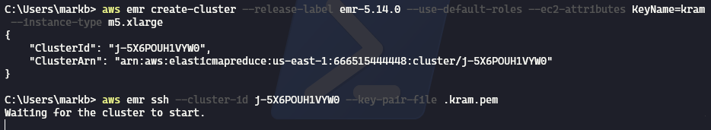
(Figure 12 – Creating a EMR cluster via CLI)
The figure above shows the command I used to create a cluster, there is also an updated version within the appendix.
This section will go over the HiveQL queries specified in the brief – whilst I was not able to get this far I have included the SQL which I think would have worked if I was able to upload my data to EMR.

3.1 - The country which has authored the most tweets
select * from mytweets
order by sum(tweets)
group by location;

3.2 - The most frequent hashtag/word mentioned in experiment 2 found in tweets from each country
select * from mytweets
where sum(hashtags)
order by hashtags
group by location

3.3 - The most frequent hashtag/word mentioned in experiment found in all tweets
select * from mytweets
where sum(hashtags)
order by hashtags

3.4 - Total number of user mentions in tweets from each country
select * from mytweets
where sum(mentions)
order by mentions
group by location

3.5 - Total number of user mentions in all tweets
select * from mytweets
where sum(mentions)
order by mentions
group by location

4 - Conclusion
This will conclude this report, which was been a very good learning curve into the technology AWS. Whilst I had a lot of issues during this coursework (Issues with VM’s, streaming tweets, logging into aws, creating clusters), I do think I have learnt a lot and have made notes of how to replicate this.
If there was not such a short time limit, I think I would have been able to finish this fully but didn’t want to get an extension – my favourite part was probably the virtual machines but that is only because I really enjoy working on servers from past experience and have been a great fan of Linux for several years.
Since doing this coursework, I have also had an interview for a data science grad role, who was very interested in the things I have learnt on AWS and asked about if I was able to do the same thing on Google Cloud.

5 – References
Anaconda (2021) Data science technology for human sensemaking. Available at: https://www.anaconda.com/ (Accessed 23/04/2021)
Bboxfinder (2021) Available at: http://bboxfinder.com/ (Accessed 27/04/2021)
Boto3 (2021) Boto3 documentation Available at: https://boto3.amazonaws.com/v1/documentation/api/latest/index.html (Accessed 27/04/2021)
Jupyter (2021) Jupyter. Available at: https://jupyter.org/ (Accessed 23/04/2021)
Microsoft Excel (2021) Available at: https://www.microsoft.com/en-gb/microsoft-365/excel (Accessed 23/04/2021)
NLTK (2021) Natural Language Toolkit Available at: https://www.nltk.org/ (Accessed 21/05/2021)
Notepad++ (2021) What is Notepad++ Available at: https://notepad-plus-plus.org/ (Accessed 23/04/2021)
Tweepy (2021) Tweepy Documentation. Available at: https://docs.tweepy.org/en/latest/index.html (Accessed 23/04/2021)
Twitter (2021) Happening now – Join Twitter today. Available at: https://twitter.com/ (Accessed 23/04/2021)
Twitter Developer (2021) Developer Portal. Available at: https://developer.twitter.com/en/portal/dashboard (Accessed 23/04/2021)
Visual Studio Code (2021) Redefined. Available at: https://code.visualstudio.com/ (Accessed 23/04/2021)

6 - Software

6.1 - VirtualBox – Version 6.1.22 r144080 (Qt5.6.2)
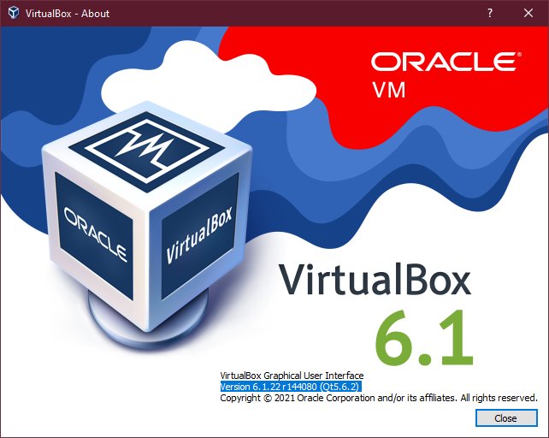

6.2 - Windows Terminal - Version: 1.7.1033.0
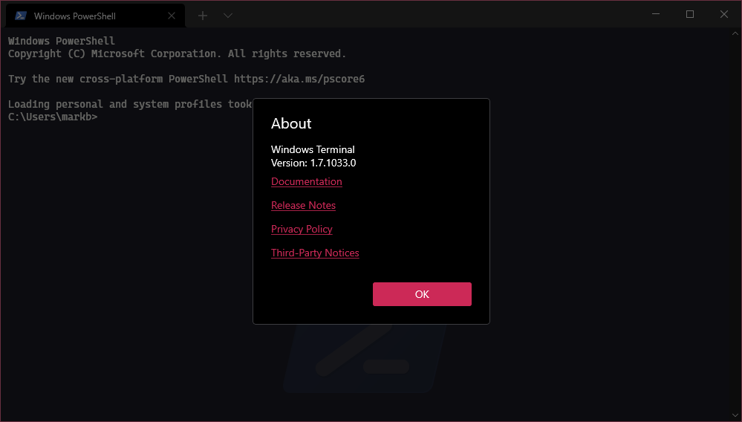

6.3 – Microsoft Excel – Version: 16.0.13929.20360
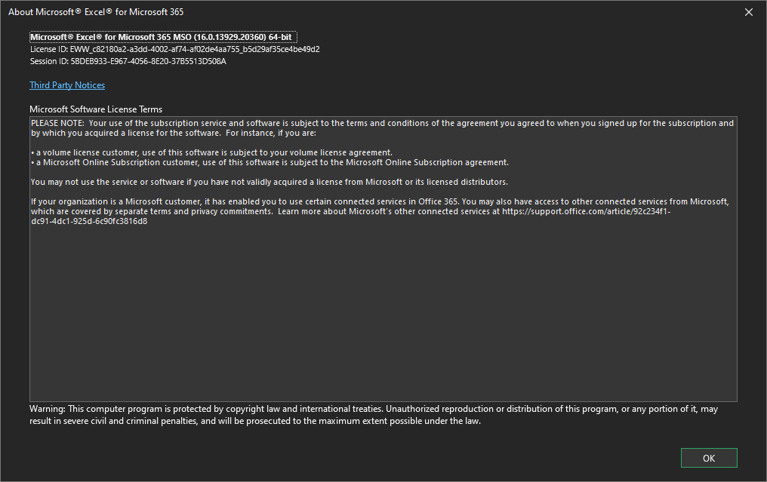

6.4 – Microsoft Visual Studio Code – Version 1.56.2
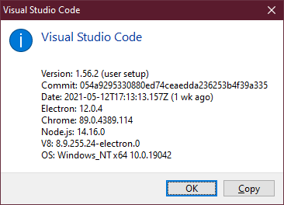

6.5 – Notepad++ - Version 7.9.5
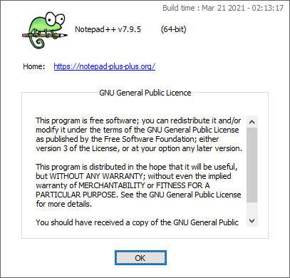

6.6 – Loop through tweets for X
# Now that we have created a way to get the listed entities, lets do that for the rest.
userNames = []
# get userName
i = 0
for user_names in df['user']:
userNames.append(df['user'][i]['name'])
i+=1
# add userNames to myDF
myDF['user_name'] = userNames

# create list
userLoc = []
# loop through
i = 0
for user_locations in df['user']:
userLoc.append(df['user'][i]['location'])
i+=1
# add userLoc to myDF
myDF['location'] = userLoc

# create list
hashTags = []
# loop through
i = 0
for user_names in df['user']:
hashTags.append(df['entities'][i]['hashtags'])
i+=1
# add userLoc to myDF
myDF['hashtags'] = hashTags

# create list
userMentions = []
# loop through
i = 0
for user_names in df['user']:
userMentions.append(df['entities'][i]['user_mentions'])
i+=1
# add userLoc to myDF
myDF['mentions'] = userMentions

6.7 – Created and Describe EMR cluster via CLI
