PYTHON Programming Exercises 2

Exercise 1 (Last 3 characters is a number):
Part 1
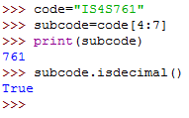
Part 2 (Module code starts with “IS”)

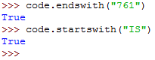

Some other String Operators: …

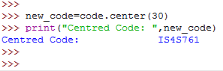

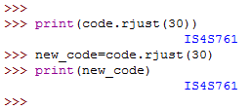

PYTHON Programming Exercises 3

Exercise 1
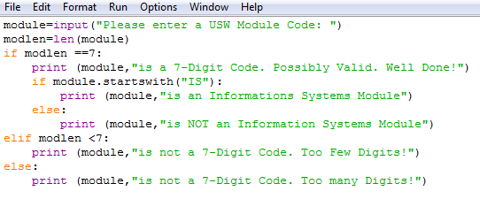
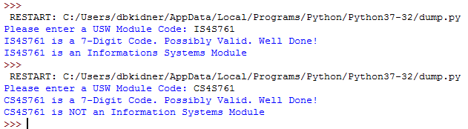

Exercise 2:
Ignore the 2nd print statement:

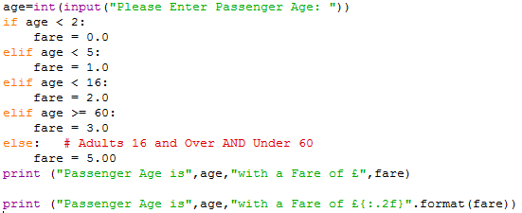

Edit the first print statement to the second and re-run. Notice the difference?

Exercise 3
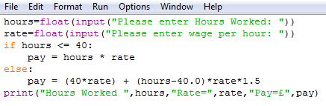

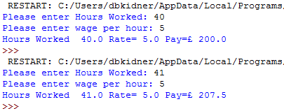

Exercise 4: This needs some thinking about, as there are a number of possible solutions.

A flowchart of the problem:

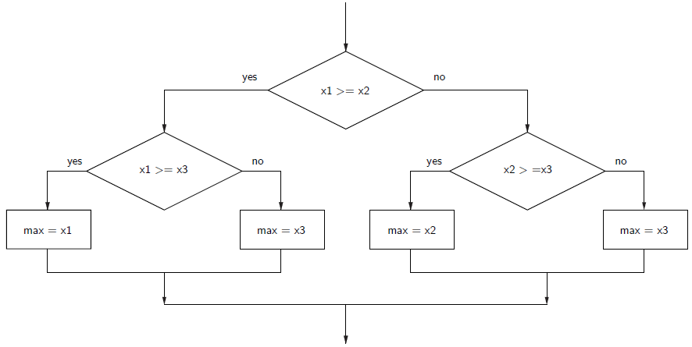

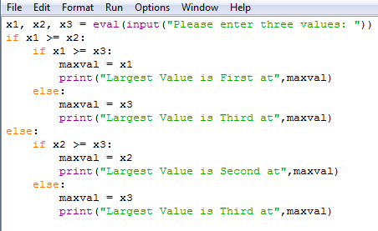
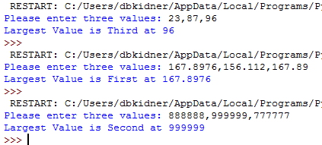

OR COMPARE EACH TO ALL

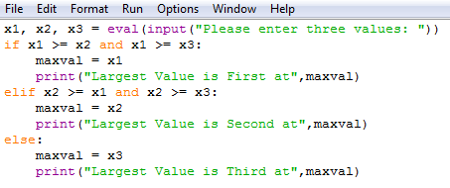

OR Sequentially Look through a list, trying to find the biggest:

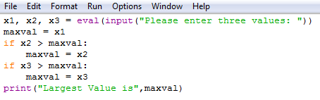

Think about how we could adapt the code FOR ANY NUMBER OF NUMBERS?

Exercise 5:

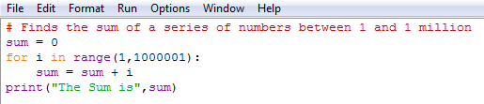

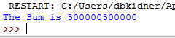

Exercise 6:

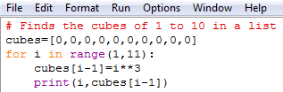

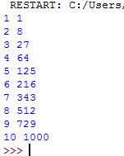

Exercise 7:

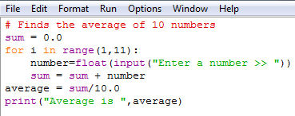

Exercise 8:

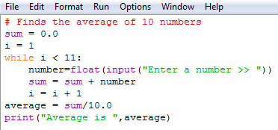

Exercise 9:

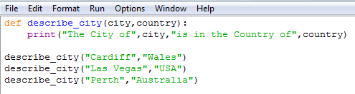

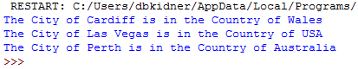

Exercise 10:

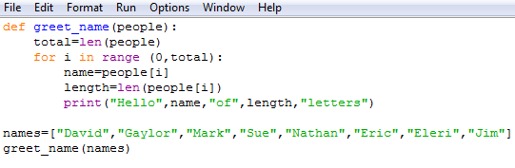

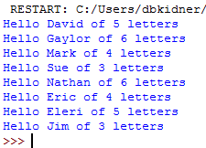

PYTHON Programming Exercises 4 Solutions
EXERCISE 1 (Possible Solution):
Perhaps the easiest way to consider this problem is to look at the 3 given solutions and determine which would be the simplest to adapt for many different numbers, i.e. “Sequentially Look through a list, trying to find the biggest:”



This can be adapted FOR ANY NUMBER OF NUMBERS:

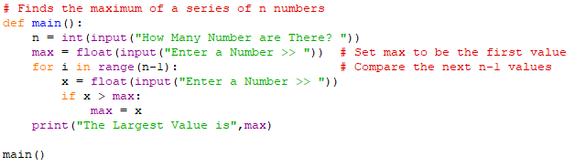
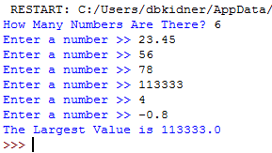

As an alternative, without using an IF statement, why not read the values into a LIST and then sort the list (which will give you the minimum and maximum at the ends of the list)?
DON’T JUST USE THE max function!!!

EXERCISE 2 (Possible Solution):
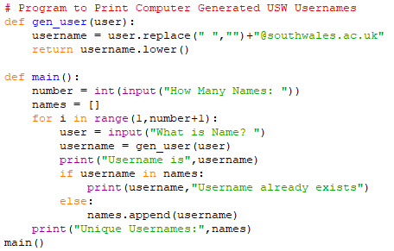

EXERCISE 3 Solution:
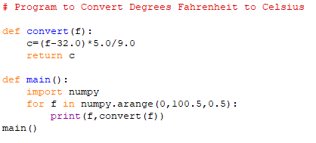
EXERCISE 4 Solution:
