Principles of Computing Tutorial 2

1) Revisiting the University case study (Amended):

A University holds details of students, tutors, modules taught by tutors and the grades of the students on these modules.

When students enrol on a module, they are given an enrolment number (to uniquely identify them). Details recorded re:students would include name, address, year enrolled on module, etc.

Each tutor has a name, office number and personnel number. Tutors can teach one or more modules but may also be a personal tutor to one or more students. Not all tutors will be personal tutors. Each student will have a personal tutor.

Each module has a code, title and credit point value and will have one or more students enrolled on it.

More difficult addition:
Modules have one or more assessments and the grades achieved by each student for each assessment need to be recorded.

Produce an ERD for the above case study.

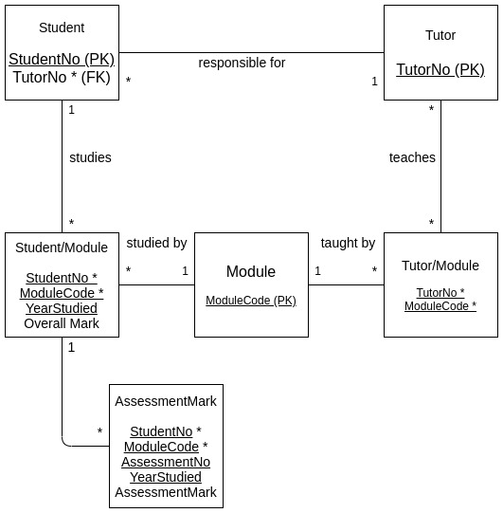

MSc ICT Tutorial 2 (Cont)

2a) A Doctors’ Surgery has a number of doctors. The practice (Surgery) has a number of patients who can make an appointment to see any of the doctors (when available). Produce an ERD that models the above. Use meaningful entity and relationship names.

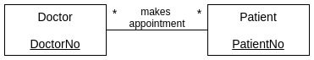

2b) However, a patient is registered as the responsibility of one particular Doctor. Not all Doctors are responsible for patients. Amend your ERD to include this new information.

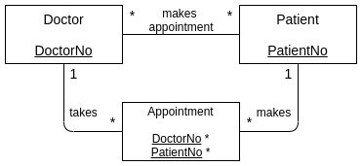

2c) The Surgery holds a number of clinics (Diabetic, Well Woman, Well Man etc.). Each Clinic will have a number of clinic sessions (Well Woman Clinic on the 15/11/2010, Well Woman Clinic on the 22/11/2010 etc)

A Doctor and a Practice Nurse is assigned to each clinic session. Assume each Clinic will run on a weekly basis and that we need to retain information (which Doctor/Nurse has been allocated) a number of weeks in advance. Amend your ERD to include this new information.

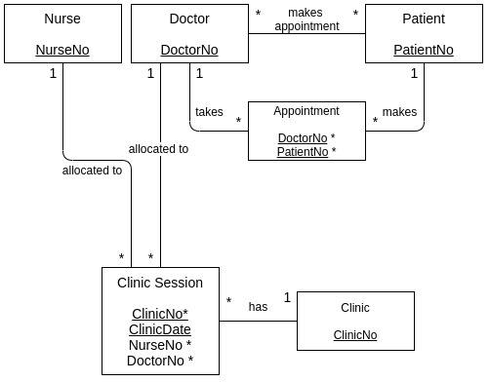
2d) Patients make appointments for each of these Clinic sessions. Amend your ERD to include this new information.

2e) Produce sensible attributes for each of your Entities.

2f) Select Primary Keys for each of your Entities.

2g) Select Foreign Keys for each of your Entities, where appropriate.

