Project Management and Research Methodology
ES, EF, LS and LF tutorial
Q1. Calculate ES, EF, LS and LF values for activities A, B, C, D and E
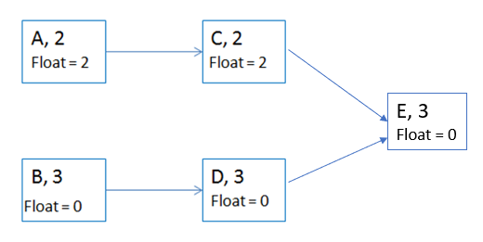
Q2. Calculate ES, EF, LS and LF values for all activities in the network diagram below:
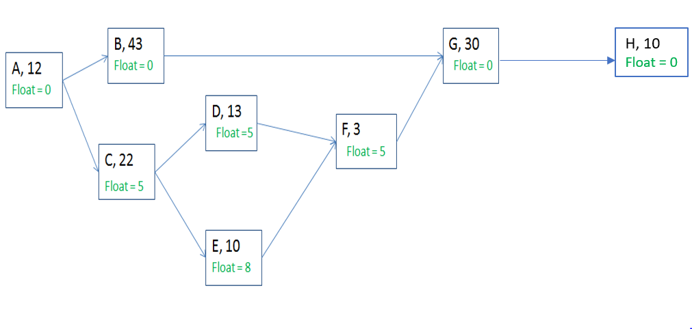
Q3. Calculate ES, EF, LS and LF values for all activities in the network diagram below:
