**PYTHON Programming Exercises 2**

**Exercise 1 (Last 3 characters is a number):**

**Part 1**

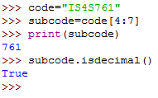

**Part 2 (Module code starts with “IS”)**

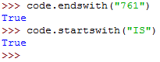

**Some other String Operators: …**

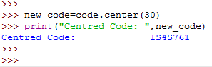

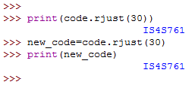

**PYTHON Programming Exercises 3**

**Exercise 1**

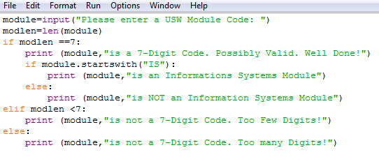

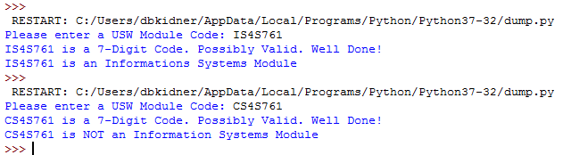

**Exercise 2:**

**Ignore the 2nd print statement:**

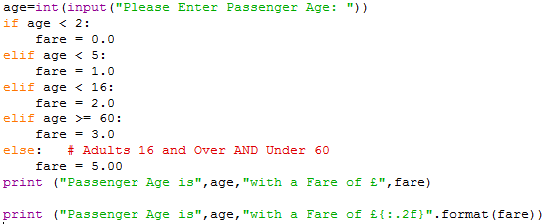

**Edit the first print statement to the second and re-run. Notice the difference?**

**Exercise 3**

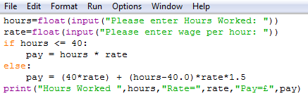

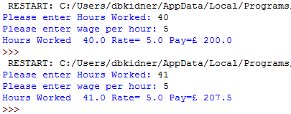

**Exercise 4: This needs some thinking about, as there are a number of possible solutions.**

**A flowchart of the problem:**

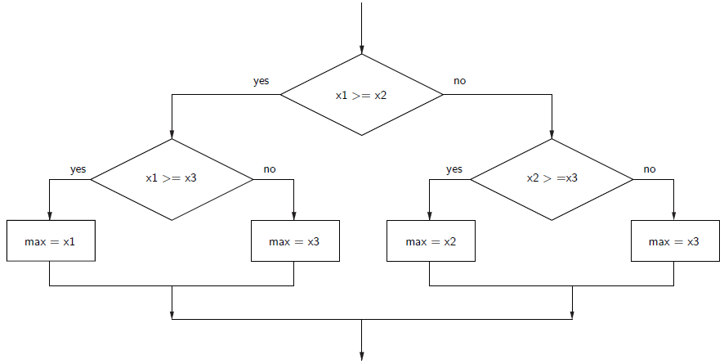

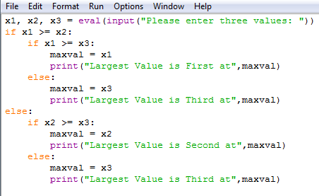

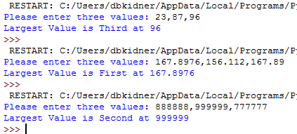

**OR COMPARE EACH TO ALL**

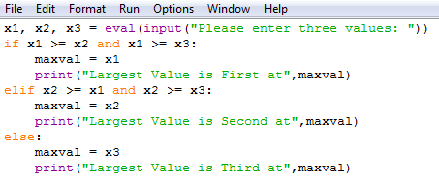

**OR Sequentially Look through a list, trying to find the biggest:**

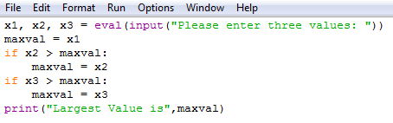

**Think about how we could adapt the code FOR ANY NUMBER OF NUMBERS?**

**Exercise 5:**

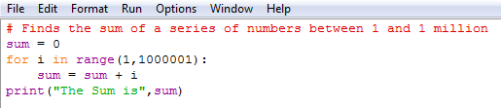



**Exercise 6:**

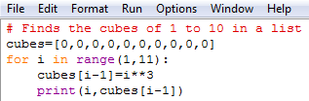

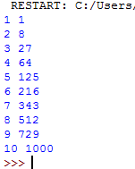

**Exercise 7:**

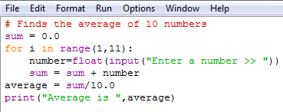

**Exercise 8:**

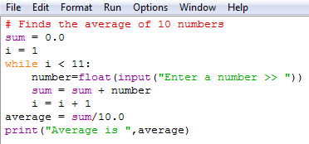

**Exercise 9:**

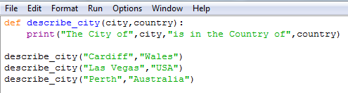

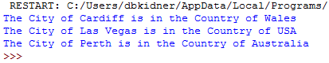

**Exercise 10:**

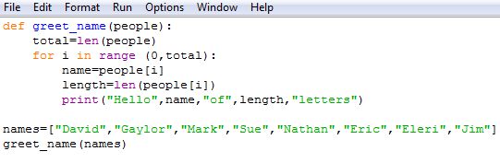

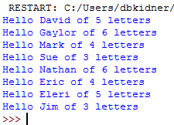

**PYTHON Programming Exercises 4 Solutions**

**EXERCISE 1 (Possible Solution):**

**Perhaps the easiest way to consider this problem is to look at the 3 given solutions and determine which would be the simplest to adapt for many different numbers, i.e. “Sequentially Look through a list, trying to find the biggest:”**



**This can be adapted FOR ANY NUMBER OF NUMBERS:**

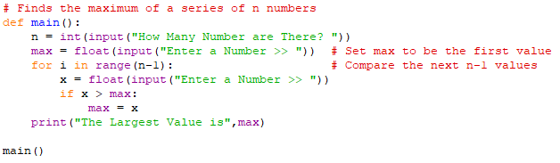

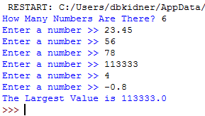

As an alternative, without using an IF statement, why not read the values into a LIST and then sort the list (which will give you the minimum and maximum at the ends of the list)?

DON’T JUST USE THE ***max*** function!!!

**EXERCISE 2 (Possible Solution):**

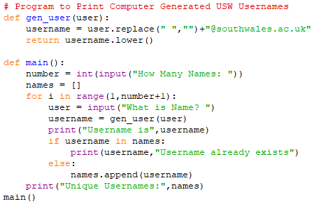

**EXERCISE 3 Solution:**

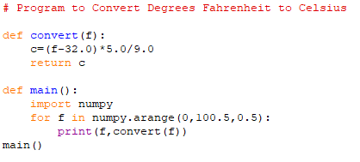

**EXERCISE 4 Solution:**

