# 1 - Entity Relationship Model

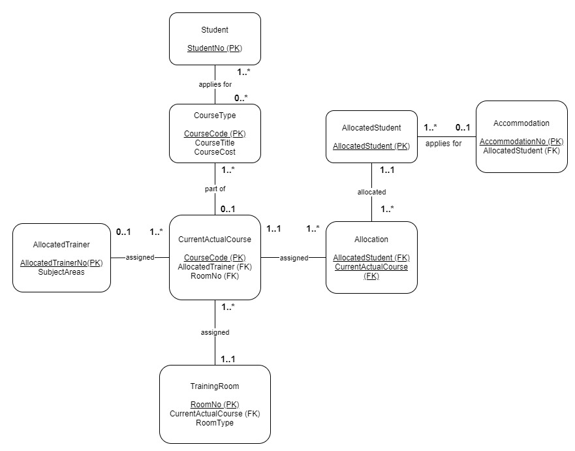

# 2 - Assumptions

***Student to CourseType.***

Here we have a many to many relationship which says many students can apply for many types of courses. This could be students who are wanting to apply for I.T and Writing courses. This would also imply that many types of courses will have many students.

The student in this relationship is mandatory for applying for the course type, whilst the course is optional as it might not be ready to run yet.

***CourseType to CurrentActualCourse.***

Here we have a many to 1 relationship where many course types will have actual courses. This is so depending on the staff; multiple versions of an IT course can run (beginner / advanced). This relationship is mandatory to optional, there needs to be a course type set before setting the current actual course.

***CurrentActualCourse to AllocatedTrainer***

This relationship is many to 1, where the assumption is many courses can be taught by 1 trainer. This could be a trainer teaching IT (Microsoft Word course or Beginner Programming). This is mandatory to optional, which assumes that the trainer does not have to be assigned straight away, but the course needs to be planned before it can run.

***TrainingRoom to CurrentActualCourse***

This relationship is a 1 to many, where the assumption here is that 1 training room can be used for multiple current actual courses. These would be booked in stacks of hours (1 – 2 ICT, 2 – 3 MS Word Training). The training room is mandatory as we need a room to assign to the current actual course, and the current actual course must be running to be able to assign it to a room.

***CurrentActualCourse to Allocation***

This relationship is 1 to many, where there must be one current course running, before allocating the many students to it. Both are mandatory as the assumption is that the course must be running before a student can be allocated to the course.

***Allocation to AllocatedStudent***

Here we have a many to 1 relationship, where when a student is allocated to allocation, they can be allocated to multiple courses. Both are mandatory with the assumption that an allocated student needs to exist before being assigned to the allocation table.

***AllocatedStudent to Accommodation***

This relationship is a many to 1, where many students can apply for 1 accommodation. With the allocation student being mandatory (they must be on a course to get a chance to apply for accommodation) and with the accommodation being optional as some students may not need to apply for accommodation.