**Project Management and Research Methodology**

**ES, EF, LS and LF tutorial**

Q1. Calculate ES, EF, LS and LF values for activities A, B, C, D and E

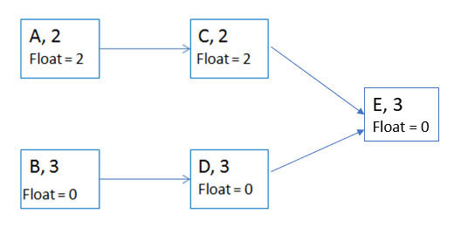

Q2. Calculate ES, EF, LS and LF values for all activities in the network diagram below:

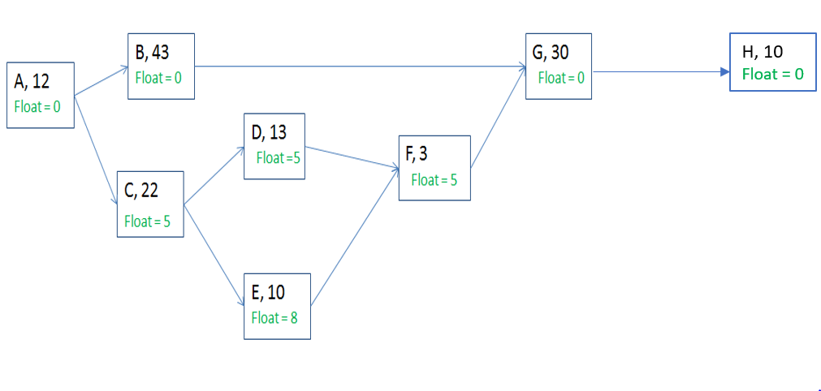

Q3. Calculate ES, EF, LS and LF values for all activities in the network diagram below:

