**Project Management and Research Methodology**

**Critical Path Analysis tutorial**

Q1.

1. Identify all paths through the network diagram below.
2. Calculate duration of each path.
3. Identify the critical path.
4. Calculate the FLOAT value for all activities.

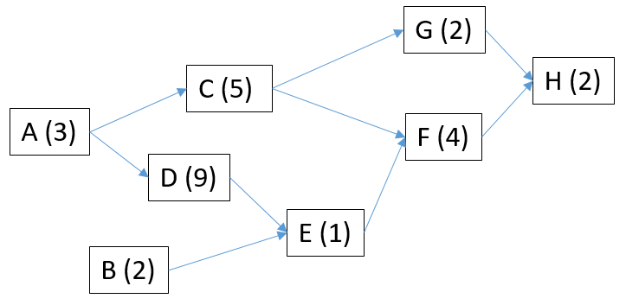

Q2.

1. Identify all paths through the network diagram below.
2. Calculate duration of each path.
3. Identify the critical path.
4. Calculate the FLOAT value for all activities.

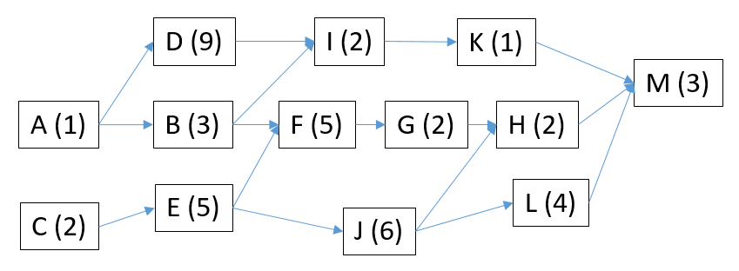

Q3.

Software Project scenario: At the start of the project, we can design the software. As soon as this is complete, the team can start writing the code. User acceptance test planning can also start immediately after software design is finished. When software is ready, integration testing can begin. The user manual can be prepared as soon as the software is ready. When the manual is ready, and provided integration testing is finished, users can be trained. Once trained, user acceptance testing can be performed.

1. Identify ACTIVITIES in the given scenario (there are 8 of them).
2. Construct a dependency table for these activities.
3. Draw a network diagram.
4. Estimate durations for each of the activities (each should take between 1 and 5 days)
5. Identify all paths through the network diagram.
6. Calculate duration of each path.
7. Identify the critical path.
8. Calculate the FLOAT value for all activities.