

*Final mark awarded*  ______

**FACULTY OF COMPUTING, ENGINEERING and SCIENCE**

**Assessment Cover Sheet and Feedback Form**

**2019/20**

|  |  |  |  |  |
| --- | --- | --- | --- | --- |
| **Module Code:**  IS3S662 | **Module Title:**  **Advanced Databases and Modelling** | | **Lecturer:**  **Alex Lohfink** | |
| **Milestone 2** | **No. of pages in total including this page: 5** | | **Maximum Word Count:**  **n/a** | |
| **Assignment Title: PLSQL / Data Analytics**  **Tasks:** see below | | | | |
| **Date Set: 3/2/2020** | | **Submission Date: 13/3/20** | | **Feedback Date: 27th April 2020** |

|  |
| --- |
| **Section A: Record of Submission** |
| **Record of Submission and Plagiarism Declaration**  I declare that this assignment is my own work and that the sources of information and material I have used (including the internet) have been fully identified and properly acknowledged as required in the referencing guidelines provided.  **Fit to Sit Policy**  The University operates a Fit to Sit policy whereby all students, in submitting or presenting themselves for any assessment, are declaring that they are fit to sit the assessment. Students cannot subsequently claim that their performance in that assessment was affected by extenuating circumstances.   |  | | --- | | **Student Number:** |   You are required to acknowledge that you have read the above statements by writing your student number(s) above.  (If this is a group assignment, please provide the student numbers of **ALL** group members)  **Details of Submission**   * IT IS YOUR RESPONSIBILITY TO KEEP A RECORD OF ALL WORK SUBMITTED. * Work should be submitted as detailed in your student handbook. You are responsible for checking the method of submission. * **Late Submission** – Work must be submitted by the submission date. If you fail to do this, you will be allowed a further five working days to submit the work but the work will be awarded a maximum mark of 40%. If you fail to submit work within five working days of the submission date, you will be deemed to have failed this assessment which will be given a mark of 0%. However see extenuating circumstances below.   **Extenuating Circumstances:** if there are any exceptional circumstances that may have affected your ability to undertake or submit this assignment, make sure you contact your Advice Shop and also see either <http://cesstudents.southwales.ac.uk/Ext_circs/> (Trefforest) or <http://glyntaffcampus.southwales.ac.uk/advice_shop/Extenuating_Circumstances/> (Glyntaff) |

# Section B. Assessment Criteria

|  |  |  |
| --- | --- | --- |
| **Marking Scheme** | **Marks Available** | **Marks Awarded** |
| **TASK 1** | **30** |  |
| **TASK 2a – PL/SQL implementation** | **70** |  |
| 1 | 10 |  |
| 2 | 10 |  |
| 3 | 10 |  |
| 4 | 15 |  |
| 5 | 10 |  |
| 6 | 15 |  |
| **TASK 2b – Data Analytics** | **70** |  |
| 1 | 10 |  |
| 2 | 15 |  |
| 3 | 15 |  |
| 4 | 15 |  |
| 5 | 15 |  |
| **TOTAL** | 100 |  |

# Section C- DETAILED REQUIREMENTS

# Complete tasks 1 and *EITHER* task 2a or 2b

# Task 1

Complete the Class Test in your allocated lab session.

# Task 2a – PL/SQL implementation:

Before you begin please refer to the appendix for initial setup of the database.

1. Populate the tables by writing a procedure that inserts a new record into the database. (The records shown in the appendix can be used). The procedure should:
   * Check for reasonable inputs
   * Put a new record in the "books" table
   * Put a corresponding new record in the "book_copies" table
2. Write a procedure that retrieves a book count.
3. Write a procedure getBookDetails which accepts a isbn number and returns the books title, author, date_published, and the number of copies. The main block should call the procedure with a isbn number and output the book’s details
4. Write a PL/SQL block which utilises the getBookdetails procedure and prints the data for each record.
5. Write a procedure that deletes a book and all copies from the database.
6. Write a trigger that that reports how many book copies are present after any insert/update/delete operation.

NB. For each of the above exercises include code that invokes the procedure.

# Task 2b – data analytics:

An important skill for a data scientist is the ability to communicate findings from data analysis. For this task, you are going to import some data sets into R in order to conduct some exploratory data analysis (EDA), and report on your findings.

You may use a dataset imported from a website or one from [here](https://vincentarelbundock.github.io/Rdatasets/datasets.html).

Using techniques you have learned, explore the data set and prepare a report on your findings.

You should:

1. Present and structure the report appropriately
2. Describe the data in a quantitative and qualitative way; i.e., summary statistics on the shape of the data, along with a translation of these statistics for a business audience
3. Report on the number of observations, the number of variables, the qualitative (categorical) variables, and the quantitative (numeric) variables
4. Further report on your analysis of any single variable, including measures of central tendency (mean, median, mode) and dispersion (range, variance, standard deviation)
5. Produce appropriate visualisations of your results.

*You may carry out this analysis for any number of single variables.*

The report should be 1500 words in length.

*The Report*

The report should contain the following sections:

* **Introduction:** A short section that sets out the aim, content (including the data sets chosen) and conclusions of the report.
* **Methods:** A section describing the methods used and/or recommended.
* **Results/Recommendations:** A section that presents results or recommendations from your analysis.
* **Summary and Conclusions**

# Deliverables

* Completed online test
* A word document containing commented code for the specified tasks if you attempted task 2a), or a word document containing your report (if you attempted task 2b).
* In both cases the document must be uploaded on Blackboard.

# Appendix

**Database design and setup (for task 2a)**

Relationship between books and their physical copies



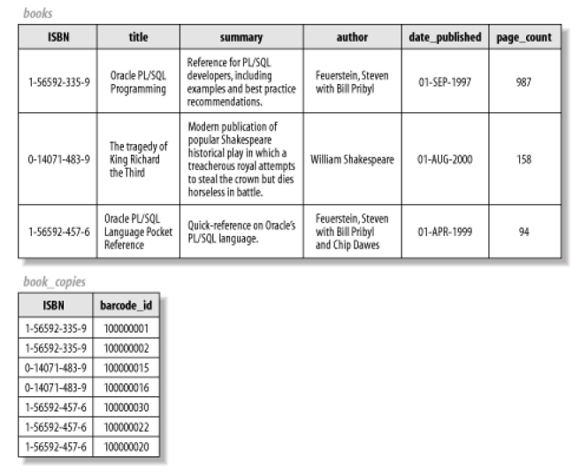

The SQL to create these tables:

CREATE TABLE books (

isbn VARCHAR2(13) NOT NULL PRIMARY KEY,

title VARCHAR2(200),

summary VARCHAR2(2000),

author VARCHAR2(200),

date_published DATE,

page_count NUMBER

);

CREATE TABLE book_copies(

barcode_id VARCHAR2(100) NOT NULL PRIMARY KEY,

isbn VARCHAR2(13) REFERENCES books (isbn)

);