Database – PL/SQL

Table of Contents

1 – Create the Tables 2

1.1 - Books 2

1.2 – Book Copies 2

2 – Procedures to Add Books & Copies 3

2.1 - Procedure to addBooks 3

2.2 – Insert Into addBooks 3

2.3 – Procedure to addBookCopies 4

2.4 – Insert Into addBooksCopies 4

3 – Count Books & Copies 5

3.1 – Count Books 5

3.2 – Test bookCount 5

3.3 – Count Book Copies 6

3.4 – Test bookCopiesC 6

4 – Procedure to Get Book Details from input. 7

4.1 – Procedure to Get Book Details 7

4.2 – Test Get Book Details procedure 7

5 – Loop through Get Book Details for each entry 8

5.1 – Loop through Get Book Details 8

6 – Procedure that deletes a book and all copies 9

6.1 – Delete Procedure 9

6.2 – Delete a book to test it 9

7 – Trigger whenever a record is inserted/updated/deleted 9

7.1 – Create the Book Trigger 9

7.2 – Test with a Delete 9

7.3 – Test with an insert 10

7.4 – Test with an update 10

8 – Appendix 11

# 1 – Create the Tables

## 1.1 - Books

CREATE TABLE books (

isbn VARCHAR2(13) NOT NULL PRIMARY KEY,

title VARCHAR2(200),

summary VARCHAR2(2000),

author VARCHAR2(200),

date_published DATE,

page_count NUMBER

);

/

## 1.2 – Book Copies

CREATE TABLE book_copies(

barcode_id VARCHAR2(100) NOT NULL PRIMARY KEY,

isbn VARCHAR2(13) REFERENCES books (isbn)

ON DELETE CASCADE

);

# 2 – Procedures to Add Books & Copies

## 2.1 - Procedure to addBooks

CREATE OR REPLACE PROCEDURE addBooks(

v_isbn books.isbn%TYPE,

v_title books.title%TYPE,

v_summary books.summary%TYPE,

v_author books.author%TYPE,

v_date_published books.date_published%TYPE,

v_page_count books.page_count%TYPE

)

AS BEGIN

INSERT INTO books (isbn, title, summary, author, date_published, page_count)

VALUES (v_isbn, v_title, v_summary, v_author, v_date_published, v_page_count);

END addBooks;

## 2.2 – Insert Into addBooks

BEGIN

addBooks (1,'Oracle PL/SQL Programming.','Considered the best Oracle PL/SQL programming guide by the Oracle','Steven Feuerstein',TO_DATE('16-02-14', 'dd/mm/yy'), 1392);

addBooks (2,'GDPR For Dummies.','Dont be afraid of the GDPR wolf','Learning Made Easy', TO_DATE('23-01-20', 'dd/mm/yy'), 464);

addBooks (3,'Designing Data-Intensive Applications.','Data is at the center of many challenges in system design today','Martin Kleppmann',TO_DATE('25-01-16', 'dd/mm/yy'), 400);

addBooks (4,'Oracle PL/SQL for Dummies.','Find tips for creating efficient PL/SQL code If you know a bit about SQL, this book will make PL/SQL programming painless','Michael Rosenblum',TO_DATE('26-05-06', 'dd/mm/yy'), 464);

END;

## 2.3 – Procedure to addBookCopies

CREATE OR REPLACE PROCEDURE addBookCopies(

v_barcode book_copies.barcode_id%TYPE,

v_isbn book_copies.isbn%TYPE

)

AS BEGIN

INSERT INTO book_copies (barcode_id, isbn)

VALUES (v_barcode, v_isbn);

END addBookCopies;

## 2.4 – Insert Into addBooksCopies

BEGIN

--addBookCopies (barcode_id, isbn);

addBookCopies (129167337463, 1);

addBookCopies (849421534208, 2);

addBookCopies (868023917703, 3);

addBookCopies (828324957607, 1);

addBookCopies (162033145736, 2);

addBookCopies (966025947302, 3);

addBookCopies (162033145775, 4);

addBookCopies (162123145775, 4);

addBookCopies (966025947321, 4);

END;

# 3 – Count Books & Copies

## 3.1 – Count Books

CREATE OR REPLACE FUNCTION bookCount

RETURN number IS

total number(2) := 0;

BEGIN

SELECT DISTINCT count(*) into total

FROM books;

-- WHERE isbn = &x;

-- This part doesn’t work.

RETURN total;

END;

## 3.2 – Test bookCount

-- Test the count

DECLARE

-- c = count

c number(2);

BEGIN

c := bookCount();

dbms_output.put_line('Total no. of distinct Books: ' || c);

END;

## 3.3 – Count Book Copies

CREATE OR REPLACE FUNCTION bookCopiesC

RETURN number IS

total number(2) := 0;

BEGIN

SELECT count(*) into total

FROM books

INNER JOIN book_copies

ON books.isbn = book_copies.isbn

ORDER BY books.isbn asc;

RETURN total;

END;

## 3.4 – Test bookCopiesC

DECLARE

-- c = count

c number(2);

BEGIN

c := bookCopiesC();

dbms_output.put_line('Total no. of book-copies available: ' || c);

END;

# 4 – Procedure to Get Book Details from input.

## 4.1 – Procedure to Get Book Details

CREATE OR REPLACE PROCEDURE getBookDetails(

v_isbn IN books.isbn%TYPE,

v_title OUT books.title%TYPE,

v_author OUT books.author%TYPE,

v_date_published OUT books.date_published%TYPE,

-- NumberOfCopies should be my count function, but can't figure it out.

v_numberOfCopies OUT INT)

IS BEGIN

SELECT title, author, date_published

INTO v_title, v_author, v_date_published

FROM books WHERE isbn = v_isbn;

SELECT COUNT(*) INTO v_numberOfCopies

FROM book_copies

WHERE isbn = v_isbn;

END;

## 4.2 – Test Get Book Details procedure

DECLARE

v_isbn books.isbn%TYPE;

v_title books.title%TYPE;

v_author books.author%TYPE;

v_date_published books.date_published%TYPE;

v_numberOfCopies NUMBER;

BEGIN

v_isbn := &x; -- := &x will ask for user input

-- Call the getBookDetails procedure

getBookDetails1 (v_isbn, v_title, v_author, v_date_published, v_numberOfCopies);

-- Print to Dbms Output

dbms_output.put_line( 'Book ' || v_isbn || '. Titled ' || v_title || ' Written by ' || v_author || '. Published: ' || v_date_published || '. With ' || v_numberofcopies || ' Copies Available.');

END;

# 5 – Loop through Get Book Details for each entry

## 5.1 – Loop through Get Book Details

DECLARE

v_isbn books.isbn%TYPE;

v_title books.title%TYPE;

v_author books.author%TYPE;

v_date_published books.date_published%TYPE;

v_numberOfCopies INT;

v_i NUMBER := 0;

v_myIndex NUMBER := 0;

BEGIN

-- Get the number of books, Save into v_myIndex

SELECT COUNT(*) INTO v_myIndex FROM books;

-- Loop when v_i is less than the number of books

WHILE v_i < v_myIndex

LOOP

-- Increment

v_i := v_i + 1;

-- ID = dynamic variable

v_isbn := v_i;

-- Use the getBookDetails to get the info we want

getBookDetails (v_isbn, v_title, v_author, v_date_published, v_numberOfCopies);

-- Print to Dbms Output

dbms_output.put_line('Book ' || v_isbn || '. Titled ' || v_title || ' Written by ' || v_author || '. Published: ' || v_date_published || '. With ' || v_numberofcopies || ' Copies Available.');

END LOOP;

END;

# 6 – Procedure that deletes a book and all copies

## 6.1 – Delete Procedure

CREATE OR REPLACE PROCEDURE bookDelete(

v_isbn IN books.isbn%TYPE

)

IS BEGIN

DELETE FROM books

WHERE isbn = v_isbn;

COMMIT;

END;

## 6.2 – Delete a book to test it

BEGIN

-- Select between 1 - 4 for which book&copies to delete.

bookDelete(&x);

END;

# 7 – Trigger whenever a record is inserted/updated/deleted

## 7.1 – Create the Book Trigger

CREATE OR REPLACE TRIGGER bookTrigger

AFTER DELETE OR INSERT OR UPDATE ON book_copies

DECLARE

total number;

BEGIN

SELECT COUNT(*) INTO TOTAL -- Should be my Count function

FROM book_copies;

dbms_output.put_line('There are now ' || total || ' copies available.');

-- print

END;

## 7.2 – Test with a Delete

-- Delete && trigger should run

BEGIN

delete from book_copies where barcode_id = 966025947321;

END;

## 7.3 – Test with an insert

BEGIN

INSERT INTO book_copies (barcode_id, isbn)

VALUES (123432123454, 4);

END;

## 7.4 – Test with an update

BEGIN

UPDATE book_copies

SET isbn = 3'

WHERE barcode_id = 123432123454;

END;

# 8 – Appendix

## 8.1 – Create Books Table

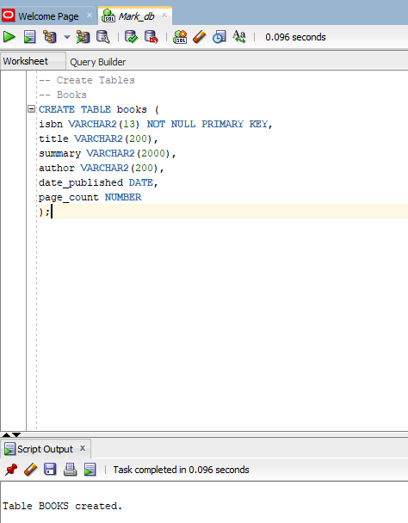

## 8.2 – Create Book Copies

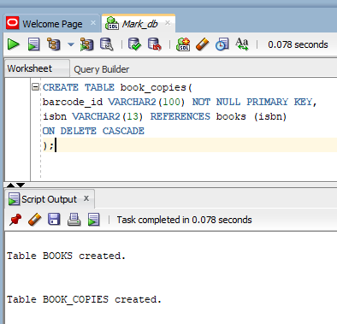

## 8.3 – Add Books Procedure

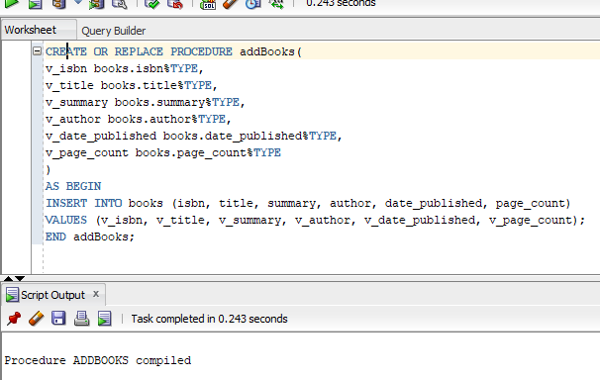

## 8.4 – Insert Books

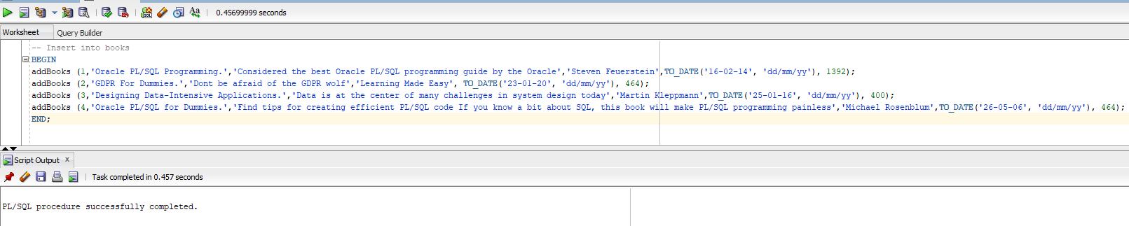

## 8.5 – Add Book Copies Procedure

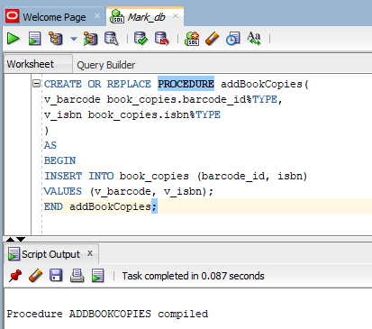

## 8.6 – Insert Book Copies

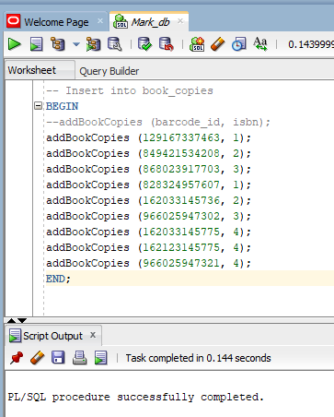

## 8.7 – Book Count

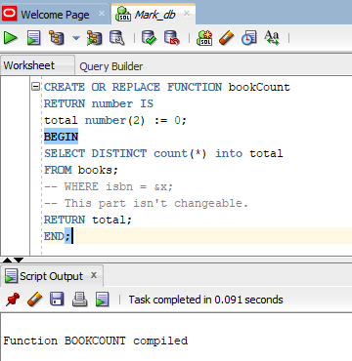

## 8.8 – Test Book Count

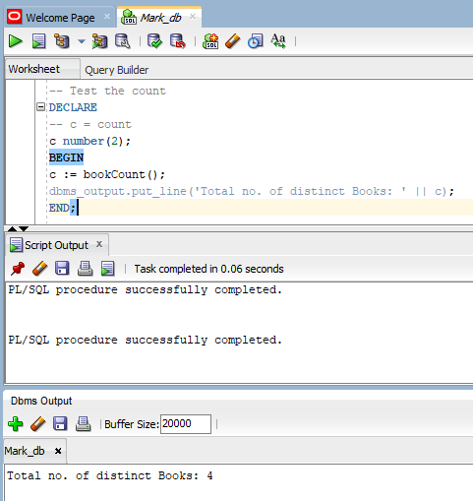

## 8.9 – Book Copies Count

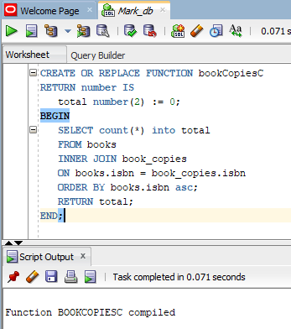

## 8.10 – Test Book Copies Count

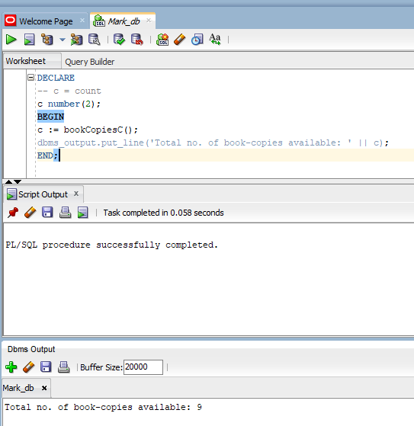

## 8.11 – Get Book Details Procedure

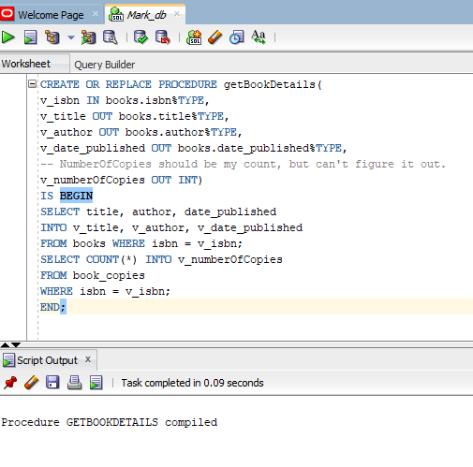

## 8.12 – Test Get Book Details with input 1

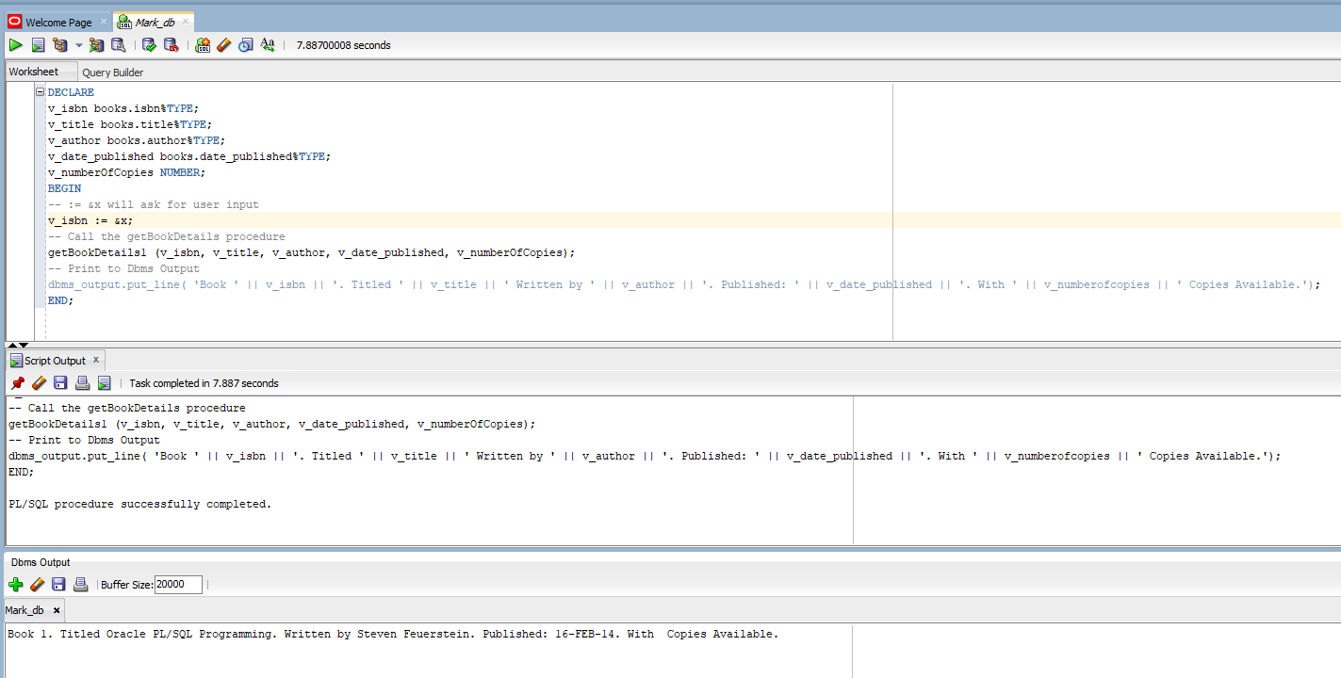

## 8.13 – Loop through Get Book Details

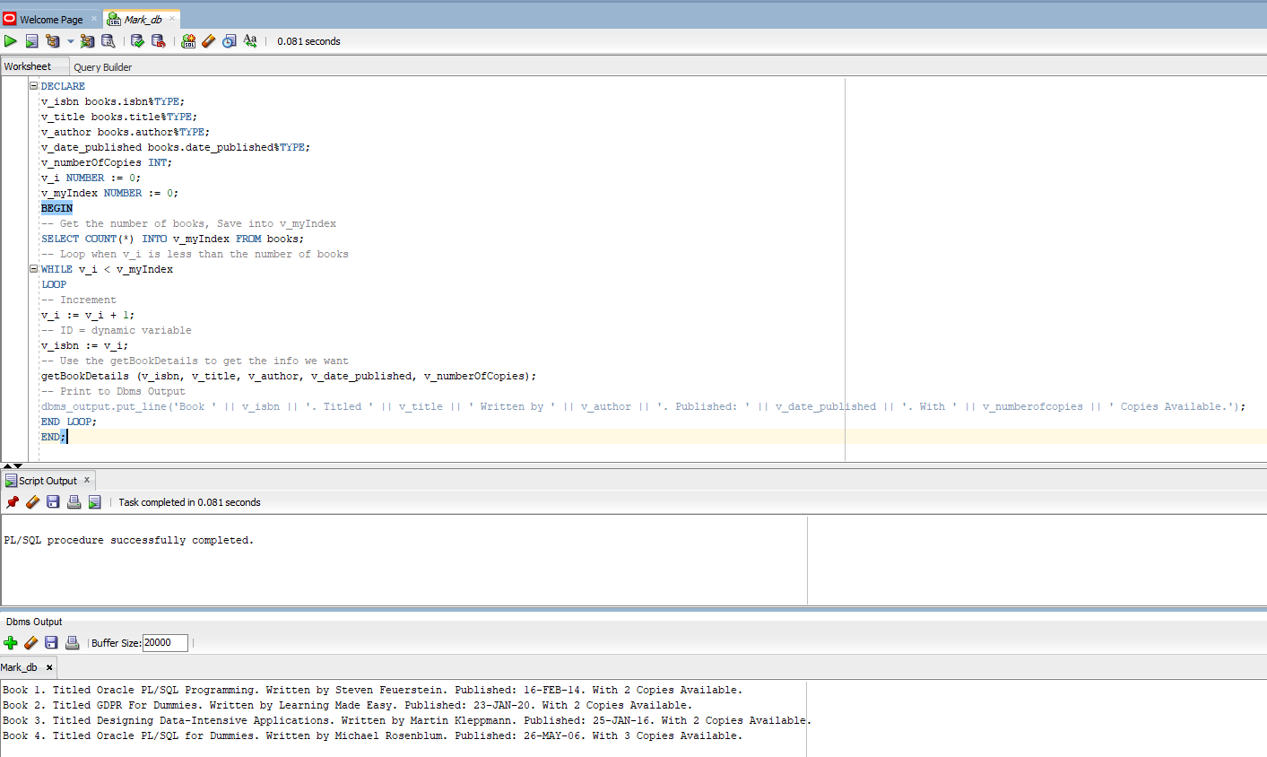

## 8.14 – Book Delete Procedure

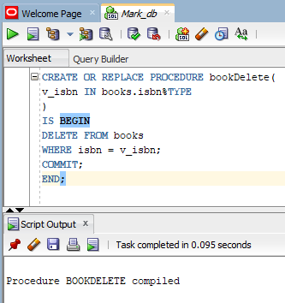

## 8.15 – Test Book Delete with 4

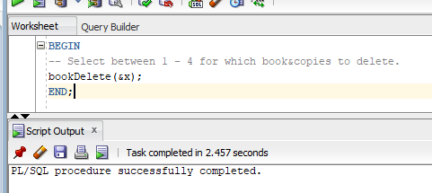

## 8.16 – Trigger For Delete/Insert/Update

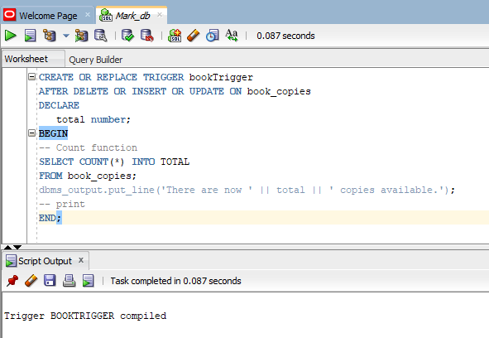

## 8.17 – Test Trigger with Delete

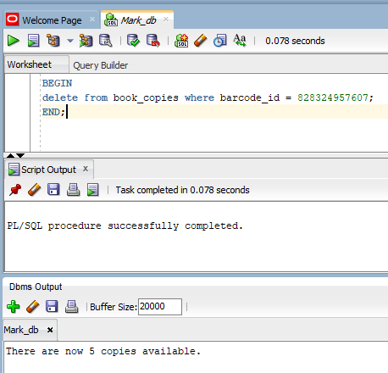

## 8.18 – Test Trigger with Insert

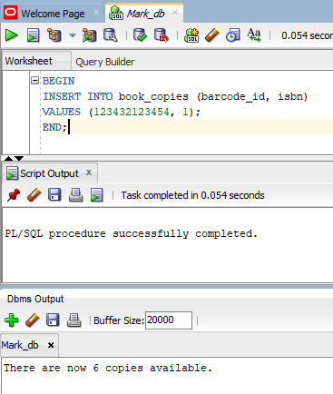

## 8.19 – Test Trigger with Update

