**Sample Format of a Project Proposal**

**Project Title:** should be brief and descriptive.

**Student:**

**Supervisor:**

**Introduction:**

This section is a generic preamble of the proposed work, which provides an overview and a clear statement of the proposed study. Introduction can further be divided into two sub sections.

**Background:** This section presents and summarizes the research problem that will be solvedand the approach to be used to solve that problem. The background should properly describe the conceptual and theoretical basis of the proposed study. Relevant references and previous work must be cited in order to support the research statement of the proposed study.

**Rationale and Justification:** In this part, the research problem must to be justified by stating and reasoning out why it is an interesting study and why it is important to do this study.

**Overall Objective:**

This is the focus of the study, so it should be a succinct statement that describes what is intended to be accomplished.

**Specific Objectives:**

Specific objectives should assist and should be relevant to the overall objective and should be achievable within the given timeframe. Specific objectives are measurable (outcome-based) activities to achieve the overall objective of the study.

**Software:**

List the software tools that will be used for the study (if any).

**Methodology:**

The experimental design is outlined here, with a sufficient description on proposed experiments or investigations and techniques. In addition, include the study area, study population, sample and sampling technique and the data collection methods (interviews, surveys, observations, measurements, etc).

Any other considerations such as ethical aspects of the study can also be mentioned. Whether ethical clearance that has already been obtained or whether informed consent has been obtained from the subjects and how to maintain the confidentiality of gathered data (especially in the case of sensitive data), etc can briefly discussed.

**Data analysis:**

The statistical techniques and other methods that will be used to analyze data and the way of presentation of the data (pie charts, bar charts, graphs, etc) can be briefly described here.

**Project Timeline/Work plan:**

Provide a rough time line for the completion of the proposed work to show that the project is achievable. A good way is to use a Gantt chart format as given in the following example to show the key activities along with their time durations.

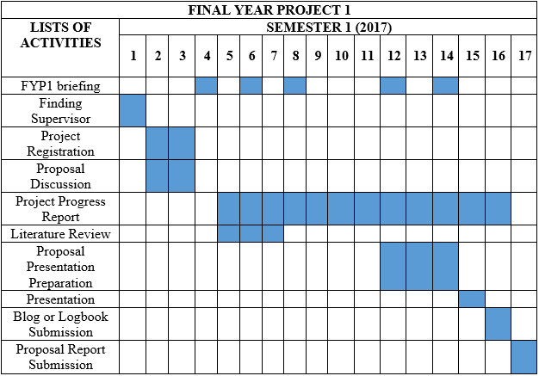

**Expected outcomes/anticipated results:**

It is advisable to say something about what the expected outcomes of the proposed project would be. This may for example, be a brief statement on how does the project make a contribution to knowledge, how does it advance theoretical understanding, what impact can it generate, etc.

**References:**

Provide a list of all sources, such as key research articles or texts, web pages, etc that have been referred to during the proposal development.