How to Restrict the Databases Shown in PgAdmin

The CES-WEB3 cluster has many databases – one for each student on the modules that use this DBMS, as well as research and teaching databases that may be accessible to various Group Roles

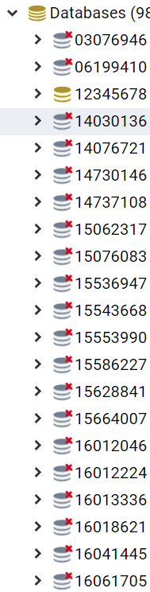

It is inconvenient to see all these databases, including many that you cannot link to yourself, e.g. as shown left. You will end up repeatedly scrolling up and down to find your database and perform actions upon it.

To solve this, restrict the server connection to show only databases of interest.

* Start pgAdmin
* Make sure you are first disconnected from the server

e.g.  rather than 

* Then right-click on the server node, and select Properties
* Switch to the Advanced tab
* In 'DB restriction' type in the name/s of the database(s) you want to see

e.g. this example asks only for database “12345678” and “usw_teaching”

note you should type in the database name/s without using any quotes

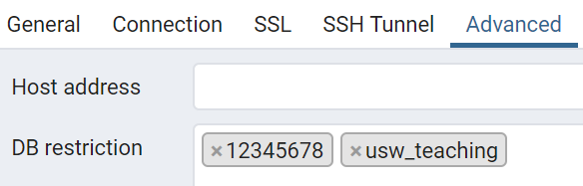

Click Save, and it’s Job Done!

Activate the server connections as usual, and supply your password

Now only the databases that you need/want to see are shown…

