**GIS and the Spatial Web**

Tutorial 21 – GeoServer 2

Please make every effort to complete this tutorial before next week’s lecture.

**Practical exercise**

1. Start the Postgres client, pgAdmin, which should be accessible from the start button.

*(if you wish to perform this work on your laptop/PC you will have to download and install Postgres/PostGIS from the EnterpriseDB website – it is up posted up on Bb)*

1. Create a connection to the PostGIS server (hostname **ces-gis** , or IP address 81.87.34.57). You should be able to login using the same *sXX* number as allocated on GeoServer, but your password is now initially set to be *eggs* (you can change it later if you wish).
2. Create a new schema in your database to receive any uploaded geospatial datasets.

You can access any data in your own database that you upload through QGIS (see below)

You can also access any data held in the **usw_teaching** database that is public readable

Create a WMS Layer using data held in a PostGIS table

Start by setting up a WMS layer/s using data in the **usw_teaching** database

1. Log into Geoserver using your *sXX* account and allocated password.
2. Create a new Store in your Workspace. This time specify that it will be a PostGIS Database store rather than a Shapefile store (see below).

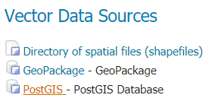

Now enter the PostGIS connection/account details as before to set it up correctly. The Name and Description can be whatever you like. The host is **ces-gis** (or localhost if you wish to connect up to a local PostGIS database), the database is **usw_teaching**, the schema is whatever you want to select ( **environ** for example), and the username and password are those needed to connect to the PostGIS server.

One of the many advantages of using PostGIS as the data source for GeoServer is that the Store “sees” all available spatial data tables in the selected schema, e.g.

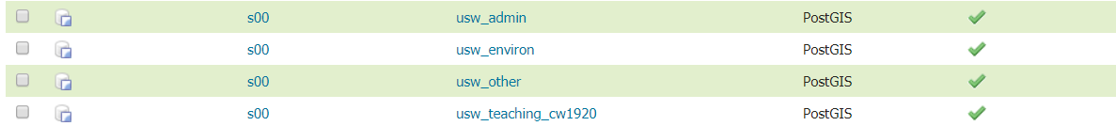

1. As before, you will need to go back to Workspace now and perform the edit URI bug

-fix that was previously described for Shapefiles. Then click the Layers link and proceed to create and publish a WMS Layer based on the recently added PostGIS Store. Just follow the same procedure and workflow as for a Shapefile source. Remember to click on **“Compute from data”** under Bounding Boxes, and **“Compute from native bounds”**.

1. Test the availability of the new Layer as you have done previously.

**Make sure you include a Leaflet/OpenLayers map that uses GeoServer to provide a WMS data feed, that is based on a PostGIS data Store, in your final website portfolio **

**Upload your own geospatial data to a PostGIS table**

Some additional data in shapefile, KML, and GeoJSON formats are provided on Blackboard…

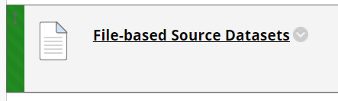

These will serve to run the practical - **but we also expect you to source and use your own geodatasets when creating your maps in your website portfolio**. You do not have access to the ces-gis filestore, but you can upload such datasets into your PostGIS database and then set up GeoServer WMS feeds as seen before…

1. Start QGIS and repeat the process of setting up a database connection to your PostGIS database account (the server details, usename and password are as before – see Bb slides for more details if needed).
2. Load the geojson, kml and shapefile examples into QGIS
3. Start DB Manager in QGIS (menu item Database | DB Manager) and use the PostGIS connection you defined to upload the map layers currently held in QGIS into spatial data tables in your PostGIS database. Further details are on BB slides and the process was demonstrated in the lecture slot.

When you load a dataset into QGIS first investigate its Coordinate Reference System. Go to the Layer’s Properties and look in the General Tab. We would probably prefer data held in the spatial database to only use OSBG National Grid coordinates (SRID code 27700). If your data are currently stored in a different projection / coordinate system (e.g. SRID: 4326 which is Lat./Long. WGS84) you can deal with this situation by using QGIS to upload and convert the coordinates at the same time. To do so, set up the Target SRID to be 27700.

1. Return to your Geoserver account. You can now create a new PostGIS Store in your Workspace, but this time connect it to your PostGIS database rather than **usw_teaching**.

The remainder of the process is a repeat of what you have seen before. Set up Layers using the new Store connected to your PostGIS database, and test the maps by developing scripts based on the Leaflet or OpenLayers APIs.