|  |
| --- |
| University of South Wales |
| IS PHYSICAL MEDIA DYING WITHIN THE MUSIC INDUSTRY |
| IS Management |

|  |
| --- |
| Baber M (FCES) |

Table of Contents

1 - Introduction 1

2 – Description of Organisations 1

2.1.1 - Spotify 1

2.2.2 - HMV 2

2.2.3 – Mission & Vision Statements 3

3 – Evaluation of Each Organisations Business Strategy 4

3.1 – Porters Five Forces 4

3.2 – VRIO 7

4 – Evaluation of e-Commerce Service 9

4.1 – Spotify 9

4.2 – HMV 10

5 – Analysis of Evaluations & Recommendations 11

5.1 – Spotify 11

5.1.1 - Recommendations 11

5.2 – HMV 11

5.2.1 – Recommendations 11

6 – References 12

7 – Appendix 14

7.1 – Figure 1 14

7.2 – Figure 2 14

7.3 – Figure 3 15

7.4 – Figure 4 15

7.5 – Figure 5 16

7.6 – Figure 6 16

7.7 – Figure 7 17

7.8 – Figure 8 17

# 1 - Introduction

This report evaluates the e-commerce strategies of two organisations in the business to consumer music industry. The music industry has several business models which include streaming, digital downloads and buying physical copies. Streaming services like Spotify which will be explored in this report are online only, whereas stores such as HMV which is also explored in this report have both digital downloads and physical copies through their stores.

(This report explores the music industry, as I have studied music for 3 years and was going to do music in university instead of computing. But due to how quickly the music industry is changing, it is harder and harder for artists to make a living from it.)

# 2 – Description of Organisations

## 2.1.1 - Spotify

With the growing size of streaming platforms vs physical, there is only one company that comes to mind, Spotify. Spotify is a music streaming platform who has been around since 2008 Spotify (2019) and is the most popular music streaming service. Figure 1 shows the increase in streaming subscriptions vs physical formats, which is why companies like HMV has suffered due to this shift from traditional sales to streaming services. With this shift from physical to digital, it would appear to the younger generation who are more tech savvy and want an on-demand streaming platform.

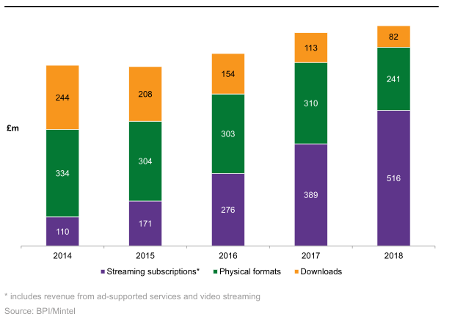

(Figure 1 – Sources of music, Mintel 2019)

Whilst there are alternatives to music streaming platforms such as, Amazon Prime Music, Apple Music, Google Play Music, Deezer Premium, Tidal and others, Spotify has been on the top of these lists as being the most used. Below in figure 2 it shows which of the streaming platforms was most used in the last 3 months.

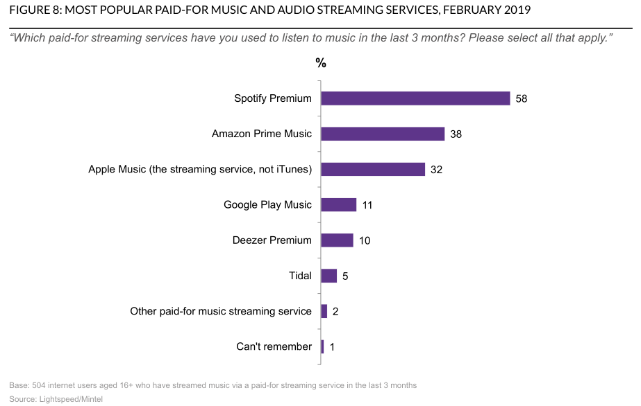

(Figure 2 – Most used paid streaming platform, Mintel 2019)

## 2.2.2 - HMV

HMV is a British retail company who specialises in selling music, film, games and technology products, with over 120 stores around the UK. Started in 1921 in London offering goods from sheet music, gramophones and all the way up to digital downloads. HMV had a rise in sales when the video format DVD was launched, boosting their growth and expanding to “200 UK stores in 2004” HMV (2019). Their main USP back in 1998 was the launch of their websites where they hoped to use their “Strong brand as a web USP” as stated by Lord (1997). Whilst being at the forefront of physical music sales they weren't without their faults, going into liquidation in 2013 and having a second case of liquidation the following year 2014 (Companies House 2019). Seeing as they’re still selling physical, it would appear more to an older generation of customers or people who aren't in a rush to move everything to digital.

## 2.2.3 – Mission & Vision Statements

|  |  |  |
| --- | --- | --- |
| Category | Spotify | HMV |
| Mission | *“To unlock the potential of human creativity by giving a million creative artists the opportunity to live off their art and billions of fans the opportunity to enjoy and be inspired by these creators”* | *“To share our top finds and tips with other entertainment fans like you”\** |
| Vision | “*We envision a cultural platform where professional creators can break free of their medium’s constraints and where everyone can enjoy an immersive artistic experience that enables us to empathize with each other and to feel part of a greater whole.”* | *“Discover new bands, artists, album and tracks, read about the latest films, stay up to date on your entertainment news and watch exclusive interviews with the people behind the music, film and games you love.”\** |
| Life Cycle Stage | Growth | Decline |

*Not clearly stated by HMV

From looking at both companies’ mission and vision statement, Spotify has a more defined mission and vision which outlines how they want people to use music to “Empathize with each other”, giving them an almost good for humanity sounding vision. Compared to HMV’s vision which outlines more of a community where we all discover and share music together.

# 3 – Evaluation of Each Organisations Business Strategy

## 3.1 – Porters Five Forces

Whilst there are different methods to analyse a company, such as PESTLE & SWOT. PESTLE focuses on looking at the Political, Economic, Social, Technological, Legal and Environmental. Whilst PESTLE is a good method, this report will focus on using the Porters Five Forces method. Porters Five Forces was first introduced in 1979 and is a model which focuses on analysing the industry (Riesewijk 2017), which will help give the company a competitive advantage over their rivals which was pointed out by Turban *el al* (2011). Whilst Porters give forces would be unique for each industry, the model has become universal (Turban 2011). The areas of industry Porters focuses on is as follows:

1. The Threat of new entrants
2. The Threat of substitute products
3. The Bargaining power of buyers
4. The Bargaining power of suppliers
5. The Rivalry among existing firms

1 - The threat of new entrants was also described by Masterson *et al.* (2017) as “barriers to entry”, which is how easy it is for people to get into the same business as you. With a stronger barrier of entry your company would be more secure in that area.

2 - Threat of substitute is where another competitor can come out with a similar and/or better product/service than the one you’re currently offering. Which was observed by Masterson *et al.* (2017) that the more alternatives there are, the harder it is to maintain the competitive advantage.

3 - The bargaining power of buyers is when the consumer is easily able to switch to a different retailer/service provider as pointed out by Riesewijk (2017). Which is important to companies due to the buyers/customers are “More important to the suppliers than the suppliers are to them” which was observed by Masterson *et al.*

4 – The bargaining power of suppliers is the relationship between a service provider and the suppliers. For both examples their relationships would rely with the artists, more so for Spotify as they want to get exclusive deals and get as much music on their platform as possible. The suppliers are more powerful when the cost of switching suppliers, is just too much which was also stated by Masterson *et al (2017).*

5 – The rivalry among existing firms can be one of the most difficult analysis for a company to do, as every company would want to have a competitive edge over their rivals giving them a unique selling point (USP), which was also pointed out by Masterson *et al (2017).*

(Porters Five Forces Table)

|  |  |  |
| --- | --- | --- |
| Force | Spotify | HMV |
| Threat of new entrants | There aren’t many barriers to entry here, but Spotify have built up a strong brand image, with access in 79 countries, have 232 million monthly active users Spotify (2019). | There are low barriers to entry for HMV, as anyone could start up a local music store. But with the rise of Spotify it would not be an ideal choice. As this report has already shown the decline in physical sales. |
| Threat of substitute | There are a few substitutes for Spotify, with big brands like Apple Music, Deezer and more. Spotify seems to have a wide selection of artists and claim to have paid their artists €13+ billion (£11.2 billion) in revenue (Spotify 2019). Which will enable them to make better deals with artists compared to Apple Music. | There are many substitutes for HMV from other stores such as local music shops, big brands like ASDA, Tesco, Sainsburys all having a music and film section. There are also the big streaming giants like Spotify who offer free and subscription services. While CD sales are dropping it’s interesting to note that vinyl sales have been increasing as stated by Butler (2018). |
| Bargaining power of buyers | The bargaining power of buyers with Spotify, is mainly their alternatives. The user could easily create an account with another ‘free’ alternative and continue to listen to their favourite music. There is also the exception of music lovers listening to internet radio and have illegal downloads which is always difficult to compete with. | There is high bargaining power of buyers for HMV. This is because anyone with a smart phone and an internet connection can stream countless hours of music for free. All just needing either a Facebook or Google account, which will allow them to use a single sign in and be set up in seconds. There are also other stores who compete with HMV as they could also sell products as a lower price. |
| Bargaining power of suppliers | For Spotify, the bargaining powers of the suppliers would be that of the artists, making sure they’re fairly being used. If we look at Apple, they were giving away Taylor Swifts album and she wrote them an open letter stating, “Three months is a long time to go unpaid, and it is unfair to ask anyone to work for nothing” - BBC News (2015). | With minimalism becoming more popular, people are more conscious about how much plastic is on their purchases. People won’t want to purchase old style plastic cases for CD’s and would look for alternatives, or even just have it digitally. |
| Rivalry among existing firms | With minimalism becoming more popular, people are more conscious about how much plastic is on their purchases. People won’t want to purchase old style plastic cases for CD’s and would look for alternatives, or even just have it digitally. | While HMV was a big firm for selling CD’s, they were also slow to adapt in the digital age and quickly. Therefore, their main rivalry is streaming platforms such as Spotify, Apple Music etc. Not only are the streaming services a rival for HMV, but any other shop which has a music or DVD section. For example, ASDA, TESCO, Small local shops would all have a music collection and could even have cheaper deals with how big some of these companies are. |

## 3.2 – VRIO

There are two resource analysis frameworks which look at the business internally, these are VRIN and VRIO. The VRIO model was introduced back in 1991 and was developed by a man called Jay Barney who stated VRIO is a mechanism that is made up of two existing theoretical frameworks to get a better understanding of internal analysis (Barney 2008). Barney also states that the core competencies for a business are:

Value – If the company has something which is an unique resource, could they use these resources themselves to get a better advantage over another company. A good example of this can be found in Barneys book (Strategic Management and Competitive Advantage). Sony who specialised in creating small electronic components and exported them to other companies, realised they could use their unique speciality to exploit an area themselves (Barney 2008).

Rarity – If the company has good value which should already be defined, how rare is their resources. This all depends on the number of competitors with the same resources or value vs the number of firms which require that resource or value (Barney 2008).

Imitability – If the company has good value and rarity they would have an advantage over other companies but having an advantage could make the company open to imitators. If someone noticed an exploit in the market and creates an alternative product which gives them a competitive advantage, the other competitors will be curious as to what has happened and how they can do the same. However, if the cost of developing this new product is too costly with R&D teams, that would mean they had a sustained competitive advantage.

Organisation – If the company has been built up with good organisational factors in mind, they’re able to exploit the value, rarity and imitability quickly and effectively. This can also be playing to your strengths (Free Management Books 2019), which will help the company grow and get a sustained competitive advantage.

This analysis will be used on both companies mentioned In this report, to see where they differ with this analysis.

|  |  |  |
| --- | --- | --- |
| VRIO | Spotify | HMV |
| Valuable | Has a vast selection of songs in their library and a great playlist feature, allowing users to create and share custom playlists and their own unique algorithm which collates a playlist each unique user ‘might’ like (Simon Lee 2019). | States their brand name is their value which so far hasn’t been that effective. But has started to open a ‘super store’ for their come back, which would specialise in a big catalogue of vinyl records and in house gigs (Marshall 2019). |
| Rare | Has a unique way of working, which is finding the balance between autonomy and alignment. Which allows the programming team to work on what they want, if they’re all working towards a common goal (Highfive 2019). | Nothing here, as the music industry is very populated and in demand. |
| Inimitable | Spotify have put a lot of time and money into their R&D team by adding an office in London specifically for R&D, and this shows that the project is prepared to learn and make changes. (Record of the day 2019). | No. This has been proven by many stores opening and being able to sell CD’s. |
| Organisation | By having an online streaming platform, Spotify can easily scale up or down depending on how many monthly listeners they have. This is a good advantage to have and be good organisational structure which has allowed the business to do what it does best. | Whilst HMV used to have a lot of stores around the UK this has declined and they were slow to adopt to the growing online market, which shows they weren’t very organised when setting up their business. |
| Advantage | With the VRIO analysis, Spotify has a Sustained Competitive Advantage over their competitors. | With the VRIO analysis for HMV, they don’t really have any advantage in the market.  Meaning they would only have a Competitive Disadvantage which was pointed out by Smith (2019) |

** Whilst attempting to answer the organisational part of VRIO, this has proven difficult as many companies don’t publicly display this type of information.

An analysis of Spotify’s website makes it very easy to identify their mission and vision, however this information is much more difficult to obtain from HMV’s corporate website and may suggest that HMV themselves, who have been struggling in the market may not full understanding themselves.

# 4 – Evaluation of e-Commerce Service

## 4.1 – Spotify

[Spotify](https://www.spotify.com/uk/)

|  |  |  |
| --- | --- | --- |
| Evaluation | Rank | Score |
| Landing Page – Very modern and clean, bright and bold with a big green button to get started with Spotify. | 5/5 – I personally like the modern design, it is responsive and clearly indicates what to click to get started. | 5/5 – More of a personal score, but like the overall landing page and the clean design. |
| Help – Website has a community forum where you can find answers to your questions which would have been filled in by the community. | 3/5 – Whilst being great to find answers to your questions from the community, sometimes you just want to get an answer from someone who works for the company. | 4/5 – With the community helping one another can sometimes put people off, with such a big audience and people from multiple countries, it should be easy to find answers to your questions. |
| Store (Premium) – To purchase a premium membership for the month it is made very easy, | 4/5 – Looks easy enough to go through the steps to get yourself a premium account for a month. | 4/5 – The store seems easy enough and you get unlimited music (Ad free) with the extra added functionality to download your music for offline use. |
| Web Player – Whilst some business computers won’t allow you to install their official app, you can also listen to music on their web player. | 5/5 – Looks the same as the official app, with big easy to find navigation options on the left and artists in the middle of the screen. | 4/5 – The web player is great and easy to use and could be easy to learn for all types of users. |

Spotify have clearly put a lot of R&D into their website, with community-based feedback and help to allow all types of users find help. Their premium offers are great for those who are on the go and want the ability to download their music and their web player just works. Which allows users to listen to music even if they’re not allowed to download and install their app. This factors into their mission and vision statement, whilst not exactly going to enable users to “Empathize with each other” it does enable a lot of people to take advantage of the free platform they’re offering, and to give everyone the opportunity to enjoy music.

Whilst researching Spotify and looking at their reviews, a lot of customers have rated Spotify as poor, with a total of 996 reviews, 42% of these reviews are bad with only 29% of the reviews being excellent (Trustpilot 2019).

## 4.2 – HMV

[HMV](https://www.hmv.com/)

|  |  |  |
| --- | --- | --- |
| Evaluation | Rank | Score |
| Landing Page – Has a more news like landing page, showing the recent news and features with a small button at the top for the shop. | 3/5 – The website for me is easy enough to understand as it’s always been very similar over the years. | 3/5 – The website seems fine enough to navigate and gives the user a lot of information if they want it. |
| Help - The help page (FAQ) is a big wall of text, which whilst is great that HMV have done it, doesn’t answer specific questions. | 2/5 – The help (FAQ) could be updated with a forum so HMV could hire admin staff to answer the questions or even the community. | 3/5 – Doesn’t really need to provide any major technical help, so having a simple help section seems fitting for the type of website HMV provides. |
| Store – The store looks like a typical e-commerce store providing the newest hits on the front of the store with sections for the user to go into or a search. | 4/5 – Store displays all the top hits first and most popular products, great for users who want to quickly see what/when something is out. Can go through the process of purchasing them with an account. | 4/5 – Store seems to provide an easy way for users to get their music delivered directly to them, without having to leave the house. Seems to do a good enough job of it. |

From what the website has provided, it would look like HMV have a decent e-commerce website proving the user with all the tools they would need to make a purchase. With a lot of news about products and live events, showing that they’re still trying to adapt to the ever-changing world of online shopping. Whilst having a website full of information, HMV are working towards their mission & vision statement which was to discovery and share their top finds of music, films and games that their customers would love.

Upon further investigation on reviews from HMV, they appear to have a mixed set of reviews. From 1-star ratings to 5-star ratings, but with an overall rating of 3.5 and having 62% of reviewers recommend HMV (Reviews.io 2019). HMV also have an average rating on another review website providing 407 reviews with 40% of the reviews being bad and 31% being excellent, giving them a better rating than Spotify.

# 5 – Analysis of Evaluations & Recommendations

## 5.1 – Spotify

With the rest of the report’s findings, digital streaming platforms such as Spotify could be the death of physical sales within the music industry. With how accessible Spotify is to any person with a smart phone, table or computer and a base entry costing nothing (£0) and a premium feature costing £9.99 a month, it would be hard to not at least try Spotify and explore the endless hours of music and their vast selection of music. Whilst having a lower rating than HMV, from personal experience I’ve found Spotify to offer great music for myself.

### 5.1.1 - Recommendations

For the average user, it would appear from their reviews that a lot of them might not be using the platform correctly or keep having issues. So, one recommendation would be to make the platform easier for an older generation. Whilst not having any issues for myself, I’ve only ever used the free edition of Spotify on a computer & mobile device.

As for their website, it comes across as sleek and clean which might put some people off. Especially when trying to find help, see the news about Spotify or find a contact page, they could try to make their website more user friendly by offering big buttons like HMV’s landing page.

## 5.2 – HMV

As for HMV they could benefit from sitting down and going over the VRIO analysis to help them see what areas in the market they can populate. As it stands they are within a very populated but dying industry, as other companies are selling other products alongside music and film such as super markets (ASDA, Tesco). Even with HMV selling records and having the in-shop gigs, this wouldn’t benefit their sales online.

(As a side note, I’ve always had a massive CD collection (200+) which I would sync digitally, but with trying to keep it up to date and backed up even I have just resorted to using Spotify and not owning as many physical CD’s.)

### 5.2.1 – Recommendations

Whilst their website has an easy to understand layout with big buttons which could be easier to the older generation, their shop button is very small at the top of their page. Which this being the case, it would be nice to see a big button for their different services at the top to make it much easier to see.

By having stores where people can visit, this has enabled HMV to have good reviews overall, as it is easier to explain what you need in person than it can be over email or on a forum. Which is one area that HMV benefits over Spotify, due to this they could advertise their in-shop gigs more across all stores, which would mean re-designing a lot of the store layouts to accommodate artists.

# 6 – References

Apple. (2019). *Apple Reports Third Quarter Results*. Available at: <https://www.apple.com/newsroom/2019/07/apple-reports-third-quarter-results/> (Accessed 26/10/19)

Barney, J, B., Hesterly, W, S. (2008) *Strategic Management and Competitive Advantage.* 2nd edn. New Jersey: Pearson.

BBC News (2015) *Apple Music changes policy after Taylor Swift stand.* Available at: <https://www.bbc.co.uk/news/entertainment-arts-33220189> (Date accessed 25/10/15)

BBC News (2018) *HMV: Did streaming cause retailer to fail?.* Available at: <https://www.bbc.co.uk/news/technology-46703208> (Date accessed 23/10/19)

Companies House (2019) *HMV GROUP PLC.* Available at: <https://beta.companieshouse.gov.uk/company/03412290/insolvency> (Accessed 06/11/19)

Davies, M, A. (2019) *Spotify VRIO/VRIN Analysis & Value Chain Analysis (Resource-Based View).* Available at: <https://www.rancord.org/spotify-vrin-vrio-analysis-value-chain-analysis-resource-based-view> (Accessed 06/11/19)

Free Management Books (2019) *VRIO Analysis.* Available at <http://www.free-management-ebooks.com/news/vrio-analysis/> (Accessed 07/11/19).

Highfive. (2019) *How Spotify built one of the best engineering cultures.* Available at <https://highfive.com/blog/how-spotify-built-one-of-the-best-engineering-cultures> (Accessed 14/11/19)

HMV (2019) *About Us.* Available at: <https://www.hmv.com/about> (Accessed 31/10/19)

Lee, S. (2019) *Why Spotify is the Outright Best Music Streaming App.* Available at <https://thisisglance.com/why-spotify-is-the-outright-best-music-streaming-app/> (Accessed 14/11/19)

Lord, R. (1997) *HMV to use strong brand as web USP.* Available at: <https://www.campaignlive.co.uk/article/hmv-use-strong-brand-web-usp/125159> (Accessed 06/11/19)

Marshall, B. *HMV opens up its Bury store to unsigned acts* Available at: <https://www.burytimes.co.uk/news/18051914.hmv-opens-bury-store-unsigned-acts/> (Accessed 28/11/19)

Masterson, R., Phillips, N., Pickton, D. (2017) *Marketing an introduction*. 4th edn. London Sage.

Mission Statement Academy (2019) *Spotify Mission and Vision Statement Analysis*. Available at: <http://mission-statement.com/spotify/> (Accessed 23/10/19)

Record of the Day (2019) *Spotify’s new London R&D Hub is open for business.* Available at <https://www.recordoftheday.com/news-and-press/spotifys-new-london-rd-hub-is-open-for-business> (Accessed 14/11/19)

Reviews.io (2019) *HMV Reviews*. Available at: <https://www.reviews.co.uk/company-reviews/store/HMV> (Accessed 13/11/19)

Riesewijk, M. (2017). ‘The Future of Spotify: Assessing Spotify’s Position by Analysing the Competition’. 27th Twente Student Conference on IT July 7th , 2017, Enschede, The Netherlands.

Smith, R. (2019) *Explaining The VRIO Framework (With A Real-Life Example.* Available at: <https://www.clearpointstrategy.com/vrio-framework/> (Accessed 06/11/19)

Spotify (2019) *Company Info*. Available at: <https://newsroom.spotify.com/company-info/> (Accessed 26/10/19).

Trustpilot (2019) *HMV (Uk Only).* Available at: <https://uk.trustpilot.com/review/www.hmv.com> (Accessed 13/11/19)

Trustpilot (2019) *Spotify.* Available at: <https://uk.trustpilot.com/review/www.spotify.com> (Accessed 13/11/19)

Turban, E., King, D., Lang, J. (2011) *Introduction to Electronic Commerce.* 3rd edn. New Jersey: Pearson.

# 7 – Appendix

## 7.1 – Figure 1

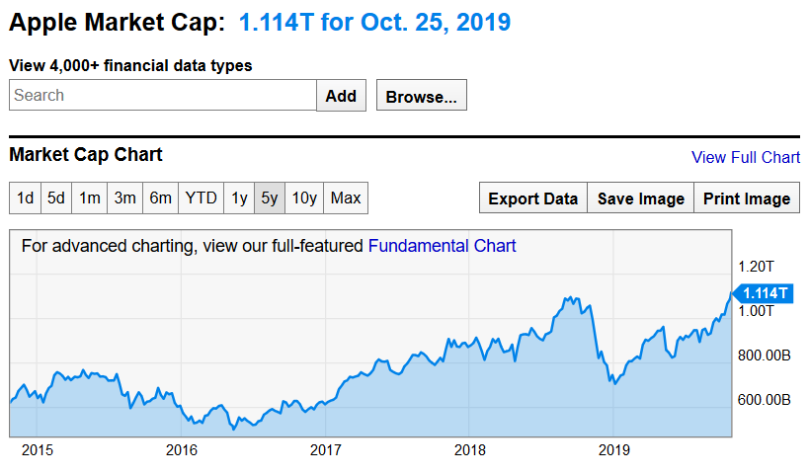

(Apple Stock Market - <https://ycharts.com/companies/AAPL/market_cap>)

## 7.2 – Figure 2

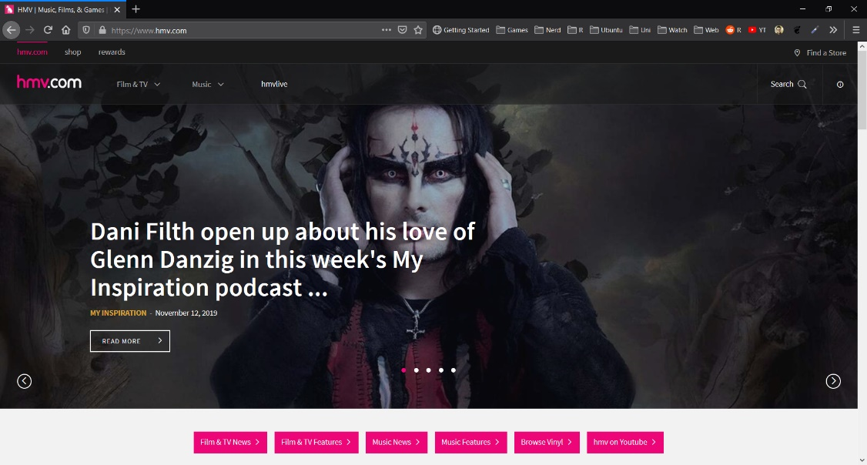

(HMV Landing Page – [https://www.hmv.com](https://www.hmv.com/))

## 7.3 – Figure 3

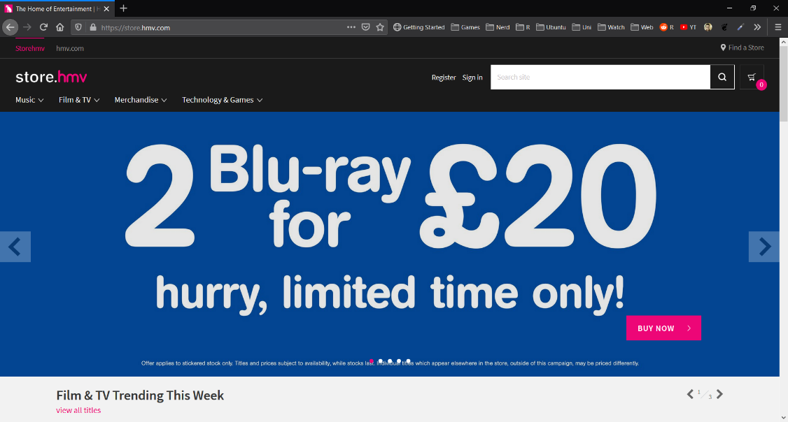

(HMV Store Page – <https://store.hmv.com/>)

## 7.4 – Figure 4

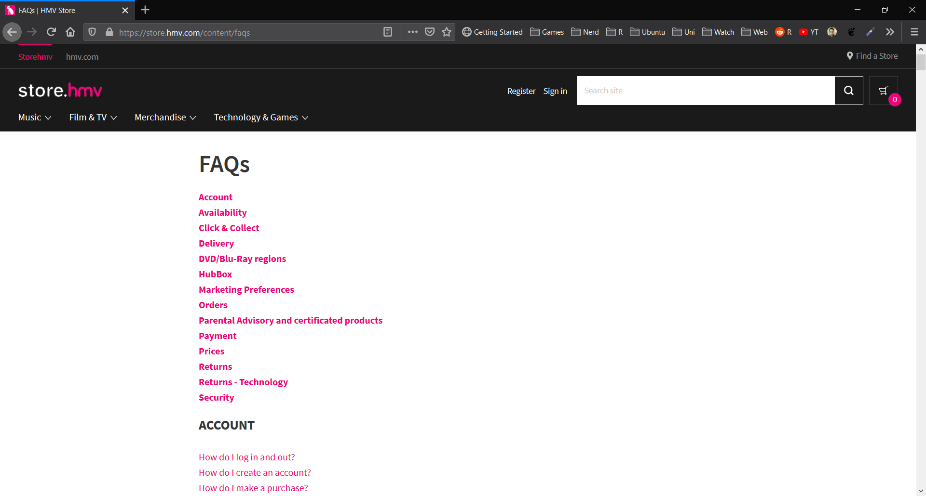

(HMV Help Page - <https://store.hmv.com/content/faqs>)

## 7.5 – Figure 5

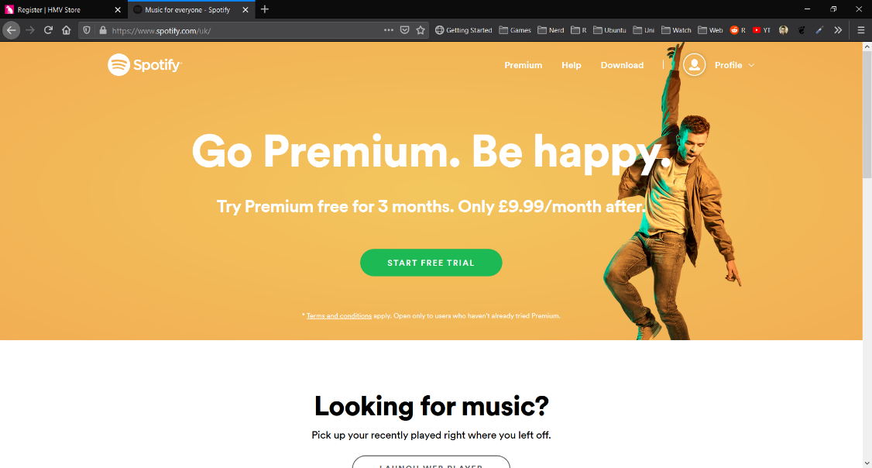

(Spotify Landing Page - <https://www.spotify.com/uk/>)

## 7.6 – Figure 6

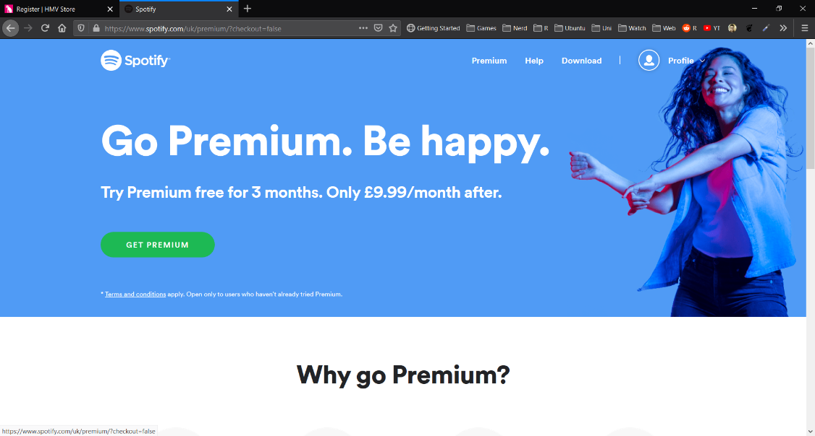

(Spotify Store Page - <https://www.spotify.com/uk/premium/?checkout=false>)

## 7.7 – Figure 7

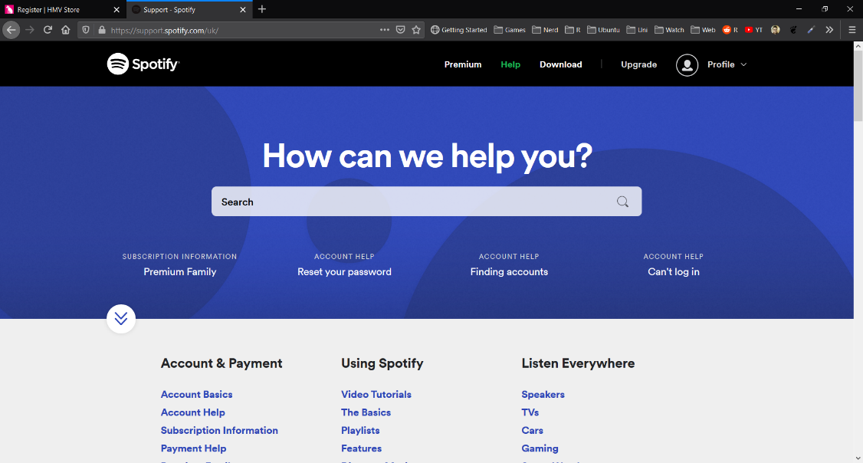

(Spotify Help Page - <https://support.spotify.com/uk/>)

## 7.8 – Figure 8

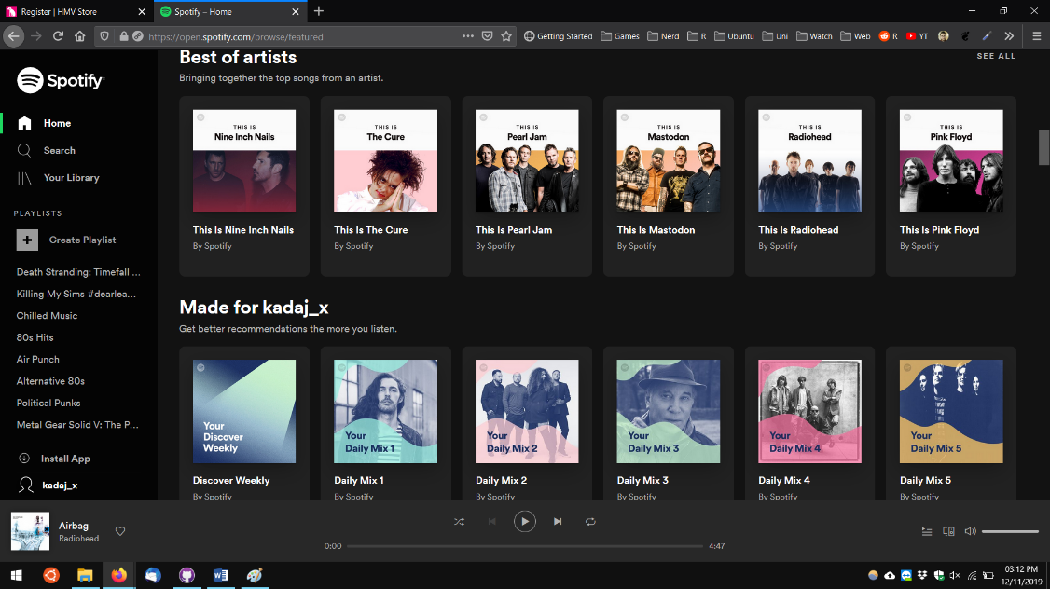

(Spotify Web Player - <https://open.spotify.com/browse/featured>)