Strategic IS Management

# 1 – Introduction – (100)

This report evaluates the company HMV and looks at how the organisation can make use of Lean Thinking to optimise their workflow. HMV is somehow still relevant in this fast-paced digital age with a high growth of streaming platforms, but report focuses on a core issue which could benefit their workflow.

HMV’s main complaint via Trustpilot shows that most of their problems are due to deliveries, with automated emails which aren’t very helpful and their products being out of stock when they state online they are in stock. With these reviews being publicly available, it could be damaging to their reputation and other potential customers would choose to shop somewhere else.

# 2 - Analysis of problem situation – (250)

## 2.1 - Introduction

**Purchasing a product online** - This will cover all steps involved for finding a product, checking the stock levels of product, getting the product ready for delivery, (organising the delivery slot?) and delivering the product.

The main problem which was found whilst researching HMV is their deliveries and their ambiguity around their stock, this can be seen with their reviews on publicly available review sites such as Trustpilot. With 593 reviews, 39% of the reviews are below average which mostly touch on the area of deliveries, loyalty scheme and stock.

Before tackling these problems, these problems should be analysed with the Five Laws of Lean.

## 2.2 - The Law of the Market – Law 0

Provide value from the customer perspective

Customer provides value, focus on the things that will make the customers happy. Can do a value stream to see which part provides value to the customer.

## 2.3 - The Law of Flexibility – Law 1

Being receptive to changes allows us to optimise performance

If the area which is being improved is flexible, it should be easier to optimise and improve the flow. Was the value achieved in the value stream? Muda types.

## 2.4 - The Law of Focus – Law 2

A few small changes can have a big overall impact

Flow how easily does the product move through each step. Make sure no part of the process is in batches, ‘Just In Case’ (Work in Progress), Errors (If a product is damaged, more work is put in to catch up and disrupts the flow) & Departments (By splitting up the teams, communication and disrupt the flow)

## 2.5 - The Law of Velocity – Law 3

Minimising work in progress (unfinished tasks) gets to the goal quicker

Little’s law?

## 2.6 - The Law of Complexity and Cost – Law 4

Work only on what we need to, producing the minimum viable solution

“The complexity of the service or product offering adds more non-value, costs, and WIP than either poor quality (low sigma) or slow speed (unlean) process problems.”

We should aim to develop the minimum viable solution.

Do what needs to be done, no more

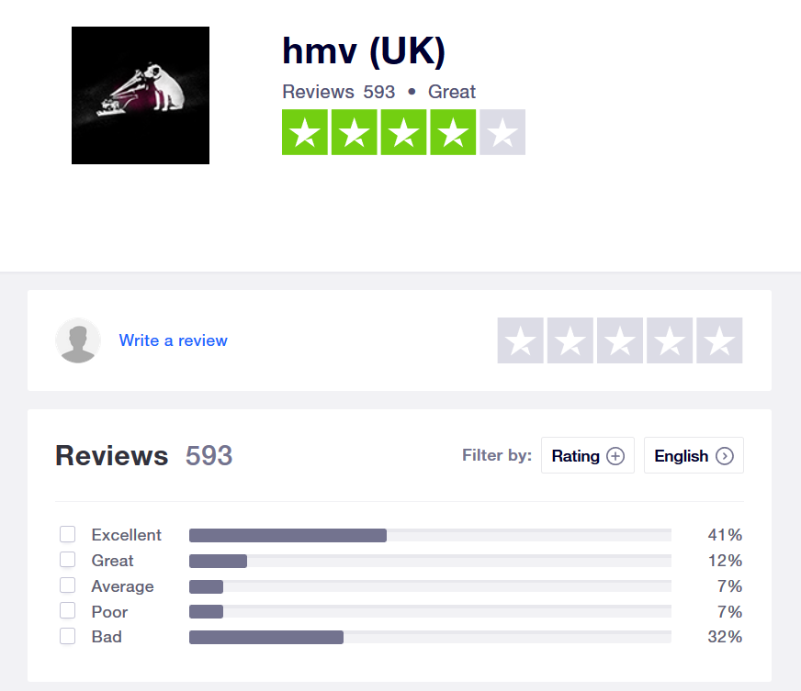

# 3 - Application of problem-solving technique – (250)

HMV’s problem can be broken down into a bunch of tasks known as a Value Stream, which outlines the description of each task with the type of Muda and value it offers.

|  |  |  |
| --- | --- | --- |
| Task | Description | Muda / Value? |
| 1 – Go to Shop | The customer would be required to go to the store and search for a product. | Type x Muda |
| 2 – Find Product | Now at the store, the customer can look for the required product or browse for other products. | Type x Muda |
| 3 – Seek Assistance | If the customer can’t find the product, they can ask for assistance from a member of staff. | Type x Muda |
| 4 – Check Stock | Staff can check for product in specified location, which was arranged by hand, if none is on the shelf the staff member can check stock. | Type x Muda |
| 5 – Track stock levels | When staff member grabs the product out from the warehouse, stock levels must be tracked on a paper stock book which should record the unique item number, stored location, seller price, stock number, cost, quantity and so on. | Type x Muda |
| 6 – Update Stock | Stock levels would need to be tracked and updated every time the stock is moved from warehouse to store front. This process should be done by a stock taker or a member of staff. | Type x Muda |
| 7 – Ring up order | Staff member can now ring up the customer and proceed with the check out. | Type x Muda |

|  |  |
| --- | --- |
| Task | Description |
| 1 – Go to Website | User goes to HMV’s website, must click an additional button to get to the shop. |
| 2 – Find Product | User can now look for a product on HMV’s online store, if product is |
| 3 – Purchase Product | Can select click and collect or give delivery details |
| 4 - | Details are collected and passed onto the delivery company. |
| 5 - | Delivery company can |
| 6 - |  |

# 4 - References

HMV (UK) (2020) *HMV (UK) Reviews.* Available at: <https://uk.trustpilot.com/review/www.hmv.com> - (Accessed: 07/02/2020)

The Guardian (2020) *HMV confirms three stores are closing with job losses expected.* <https://www.theguardian.com/business/2020/jan/04/hmv-confirms-three-stores-are-closing-with-job-losses-expected> - (Accessed: 10/02/2020)

BBC News (2018) HMV: Did streaming cause retailer to fail. Available at: <https://www.bbc.co.uk/news/technology-46703208> (Date accessed 10/02/20)

Companies House (2019) HMV GROUP PLC. Available at: <https://beta.companieshouse.gov.uk/company/03412290/insolvency> (Accessed 06/11/19)

Queensland Government (2020) *Keeping track of your stock.* Available at: <https://www.business.qld.gov.au/running-business/finances-cash-flow/stock-control/keeping-track> (Date accessed: 13/02/2020)

[https://www.theguardian.com/business/2016/sep/29/hmv-down-41m-as-decline-in-physical-media-continues - Date Accessed 28/01/20](https://www.theguardian.com/business/2016/sep/29/hmv-down-41m-as-decline-in-physical-media-continues%20-%20Date%20Accessed%2028/01/20)

<https://www.retailgazette.co.uk/blog/2018/12/hmv-officially-falls-administration-extremely-weak-christmas-trading/> - Date Accessed – 28/01/20

<https://completemusicupdate.com/article/hmv-owner-sunrise-buys-us-retail-chain-fye/> - Date

<https://thevinylfactory.com/news/hmv-new-store-birmingham-25000-records-hmvvault/>

<https://www.hmv.com/music/hmv-vinyl-week-2019-more-exclusives-revealed>

# 5 - Appendix