JavaScript Assignment

# 1 – Introduction

This report will look over creating a website which makes use of front-end and back-end functions using JavaScript, jQuery and PHP to manipulate the page layout. Starting with the design, the implementation and how the functions are navigating the DOM tree.

# 2 – Design

Before anyone can create a website, it would be ideal if they had an idea of what they want it to look like. This would have website layout and basic functions with a brief explanation of what functions they should carry out (e.g. print hello on click).

The design of the website was intended to be as simple as possible to not distract from the main operations of the JavaScript. The design was going to be a simple centered design which was sketched up.

This is the basic home screen which is slightly different to the main design simply by not having it centered

(Appendix x)

Which is the default page after loading up the website, from here we can see a drop-down menu which contains our 2 sources (XML + PHP). If the user clicks on one of these options, they would then be prompted with the 2 types of files of which to view.

All the design implemented here is making use Bootstrap 4

# Commentary on JavaScript functionality;

Being new to JavaScript & the use of jQuery, I wanted to make sure the jQuery was being loaded correctly, because of this I created a button which would display a message saying if it was or wasn’t loaded correctly. This was called function *testJQ(),* just prints a message if it is loaded or not loaded.

The next function I got started with was the dropdown effect, this was created with some CSS, JavaScript and some jQuery to give it a visual effect. Most of this is covered in my CSS file which I found on w3schools. I modified this code to be implemented with my bootstrap button to turn it into a drop-down.

# Commentary on PDO processing. An explanation of how your implementation caters for prohibiting the possibility of attempts at SQL Injection together with supporting evidence showing your implementation actually prohibiting such attempts;

# Commentary on XML processing;

# Evidence of testing using different browsers.

# All your code and details of database tables and XML files should be included as appendices

# References

Bootstrap - <https://getbootstrap.com/docs/4.4/getting-started/introduction/>

W3schools - <https://www.w3schools.com/howto/howto_js_dropdown.asp>

jQuery - <https://api.jquery.com/>

# Appendix

x.1 – Default Layout

x.1 – Default Layout

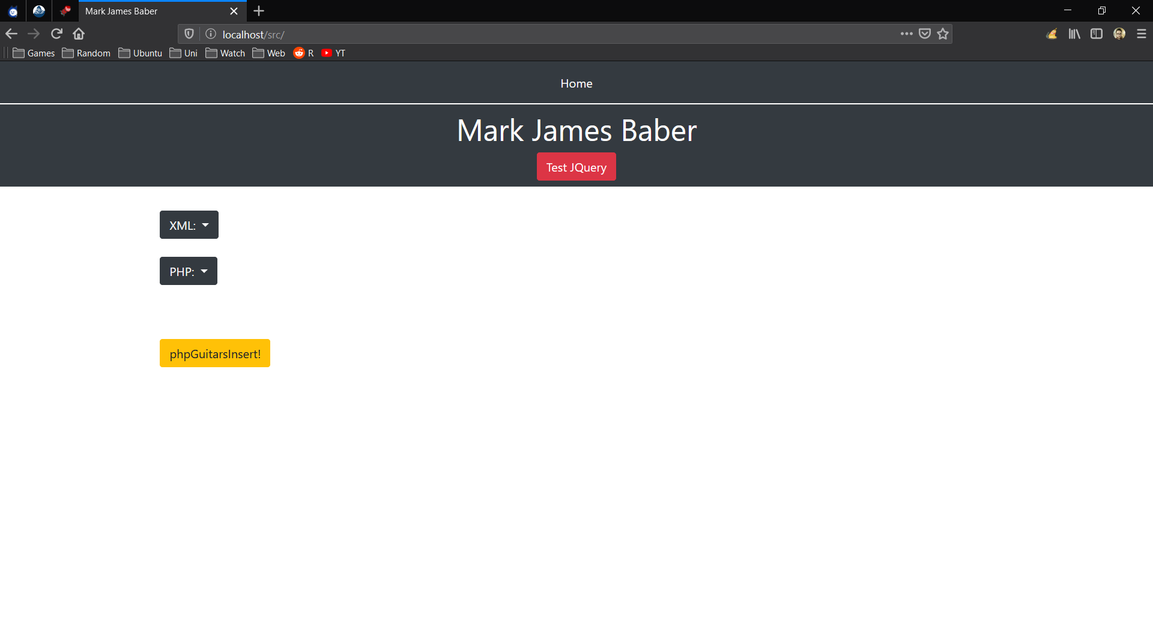

x.1 – XML-Drop Down Options

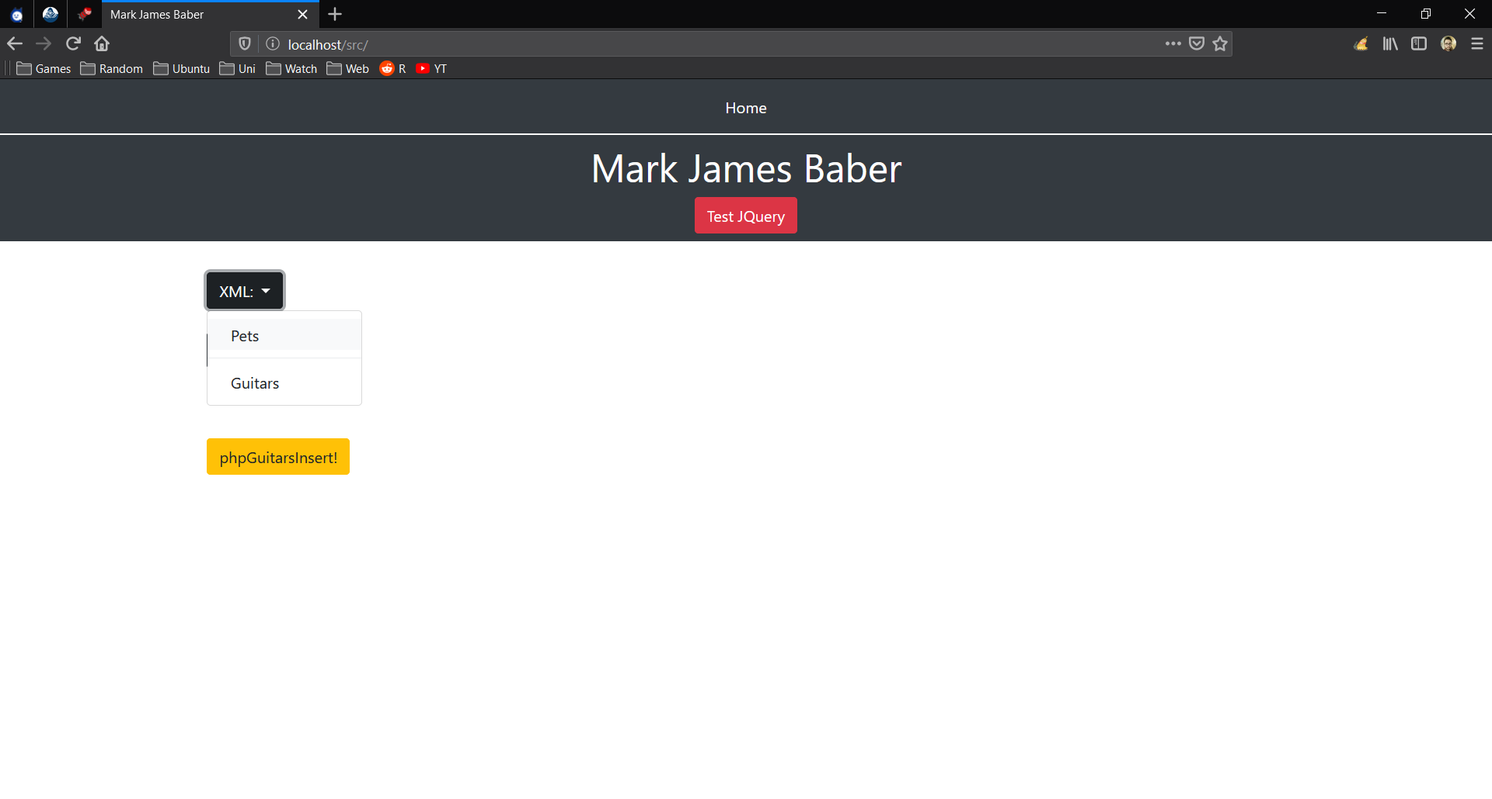

x.1 – PHP-Drop Down Options

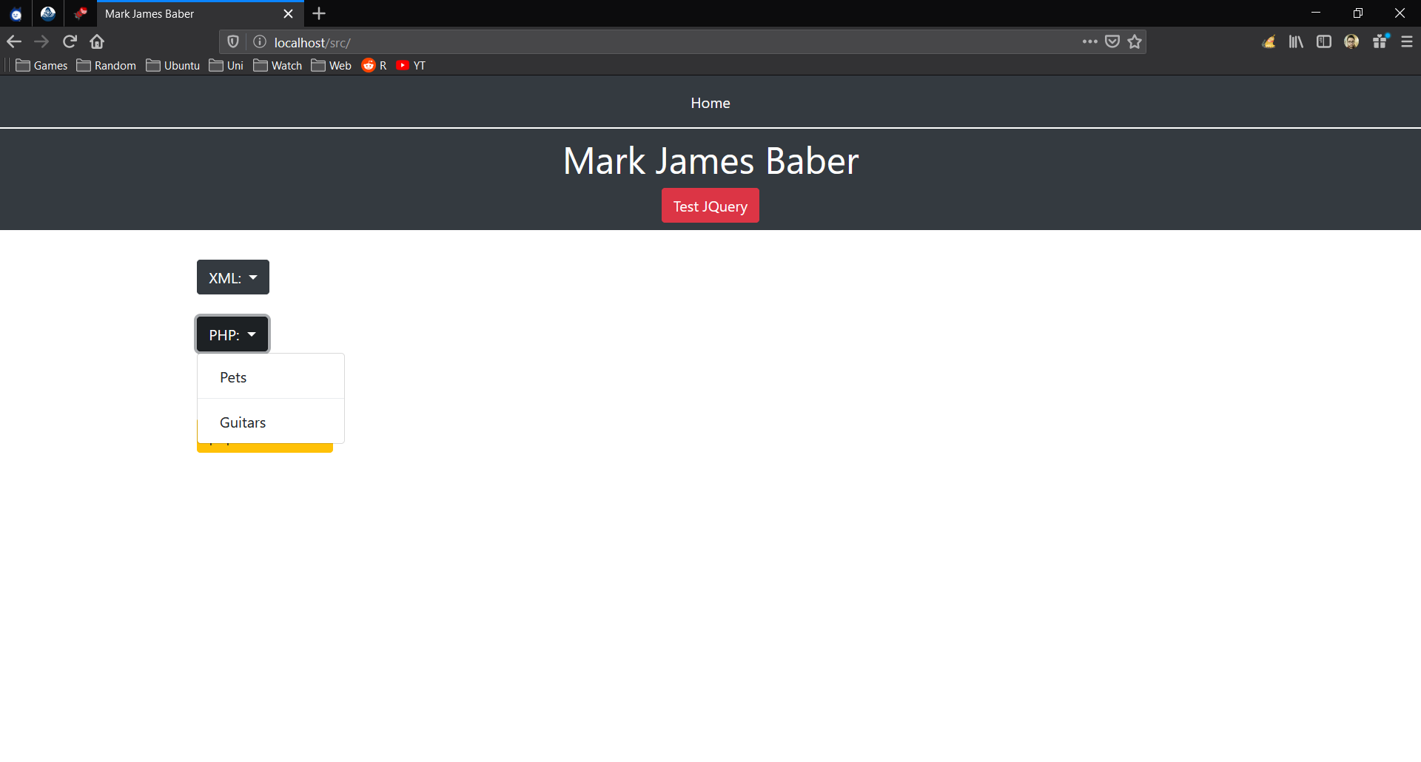

x.1 – XML Drop Down – Pets

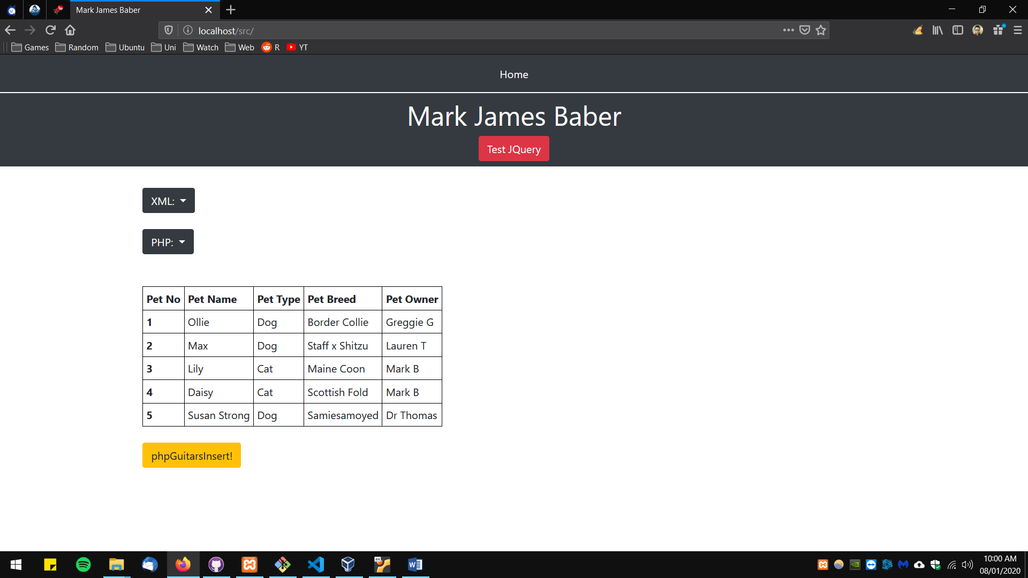

x.1 – XML Drop Down – Guitars

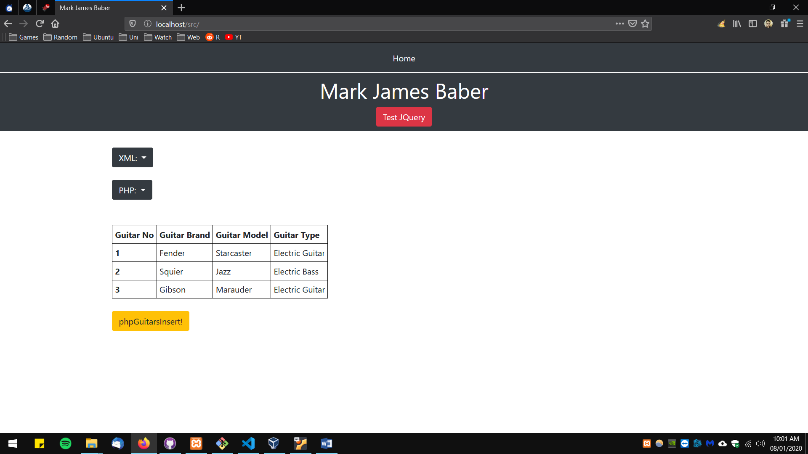

x.1 – PHP Drop Down – Pets

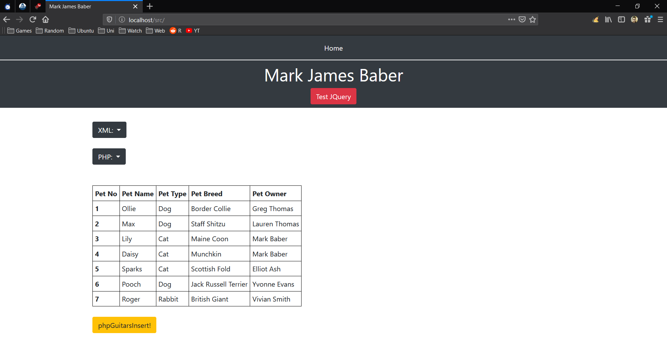

x.1 – PHP Drop Down – Guitars

