JavaScript Assignment

# Design documentation;

The design of the website was intended to be as simple as possible to not distract from the main operations of the JavaScript. The design was going to be a simple centered design which was sketched up (Appendix 1) with a second sketch as a backup (Appendix 2).

This is the basic home screen:

(Appendix x)

Which is the default page after loading up the website, from here we can see a drop down menu which contains our 2 sources (XML + PHP). If the user clicks on one of these options, they would then be prompted with the 2 types of files of which to view.

All the design implemented here is making use Bootstrap 4

# Commentary on JavaScript functionality;

# Commentary on PDO processing. An explanation of how your implementation caters for prohibiting the possibility of attempts at SQL Injection together with supporting evidence showing your implementation actually prohibiting such attempts;

# Commentary on XML processing;

# Evidence of testing using different browsers.

# All your code and details of database tables and XML files should be included as appendices

# References

Bootstrap - <https://getbootstrap.com>

# Appendix

x.1 – Default Layout

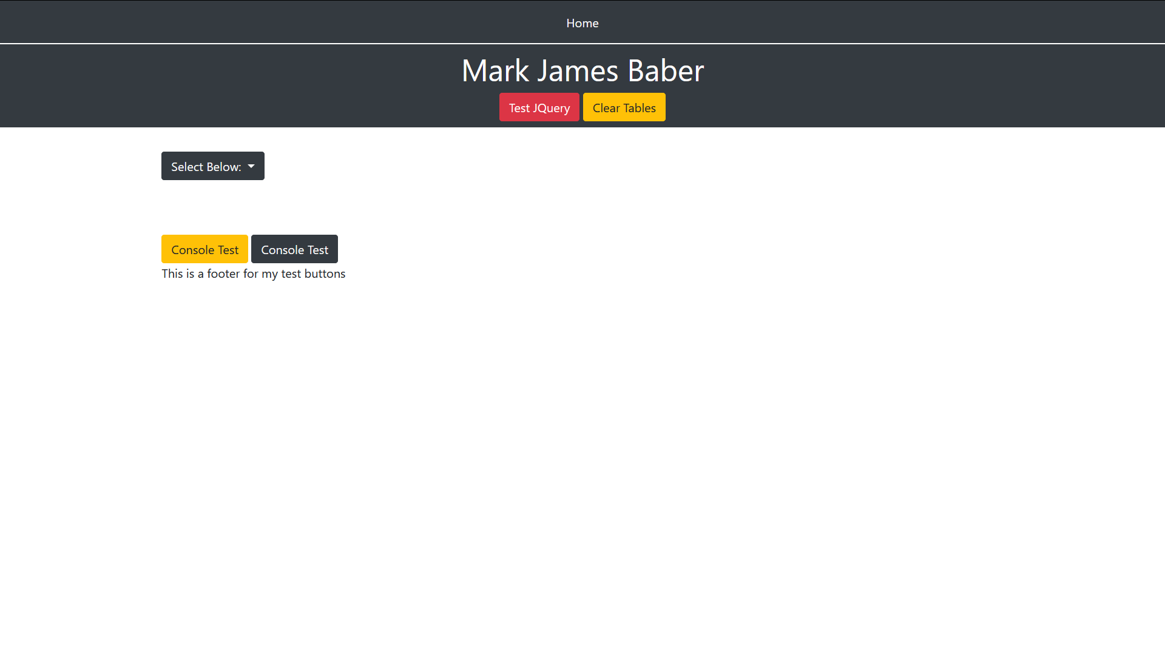

x.1 – Drop Down Options

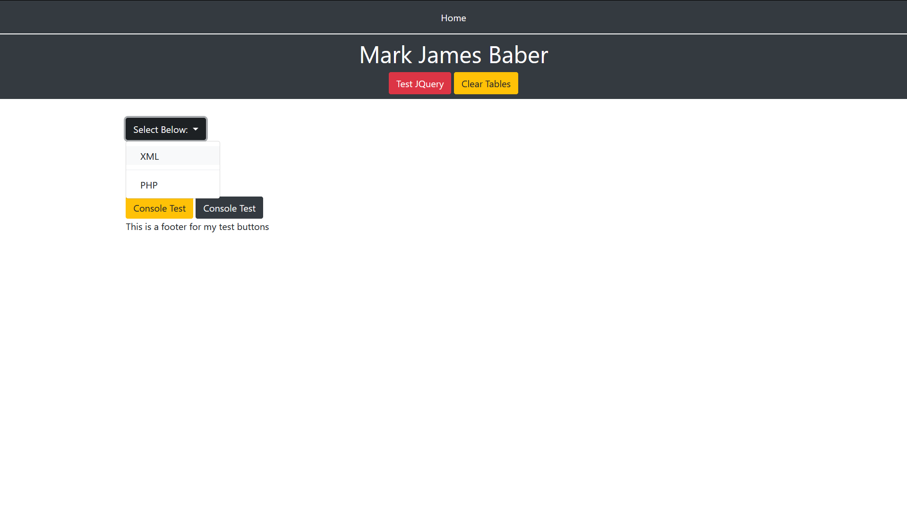

x.1 – Drop Down – XML - Pets

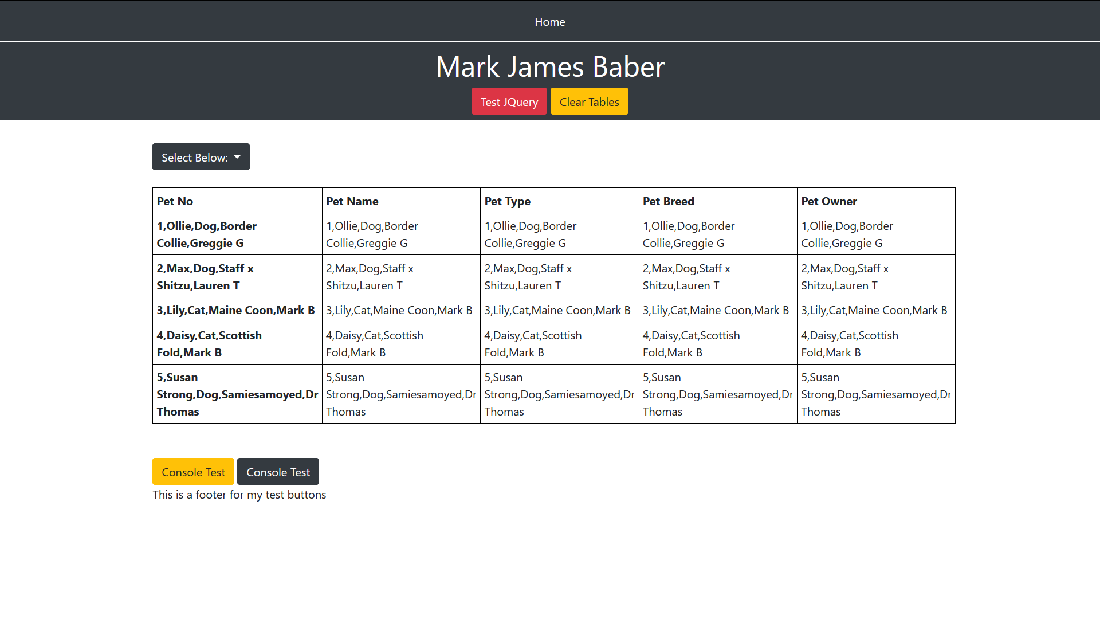

x.1 – Drop Down – PHP – Pets

