Matheus Jacob Duarte
Vitor da Luz

Aulas 12 e 13:
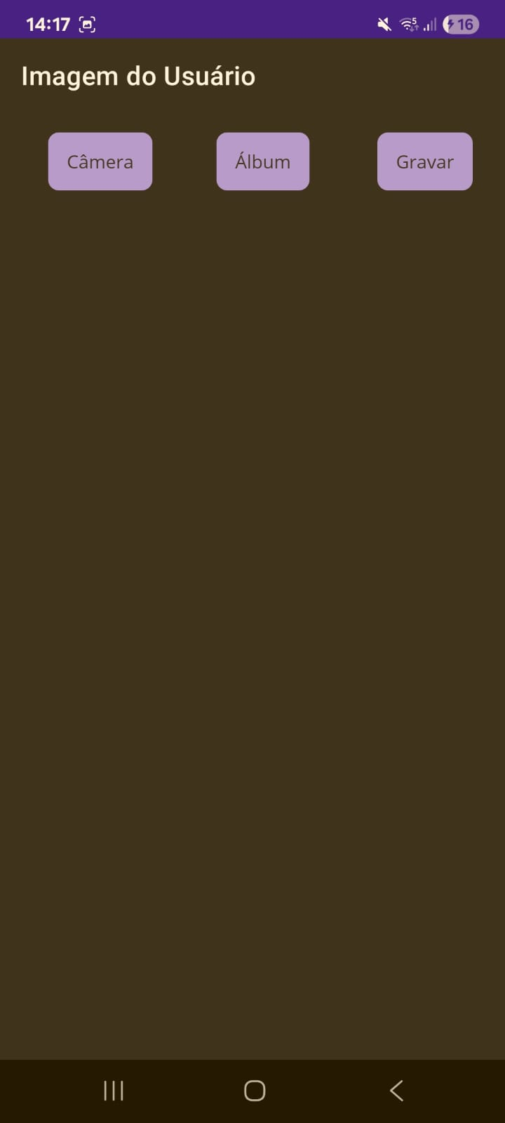
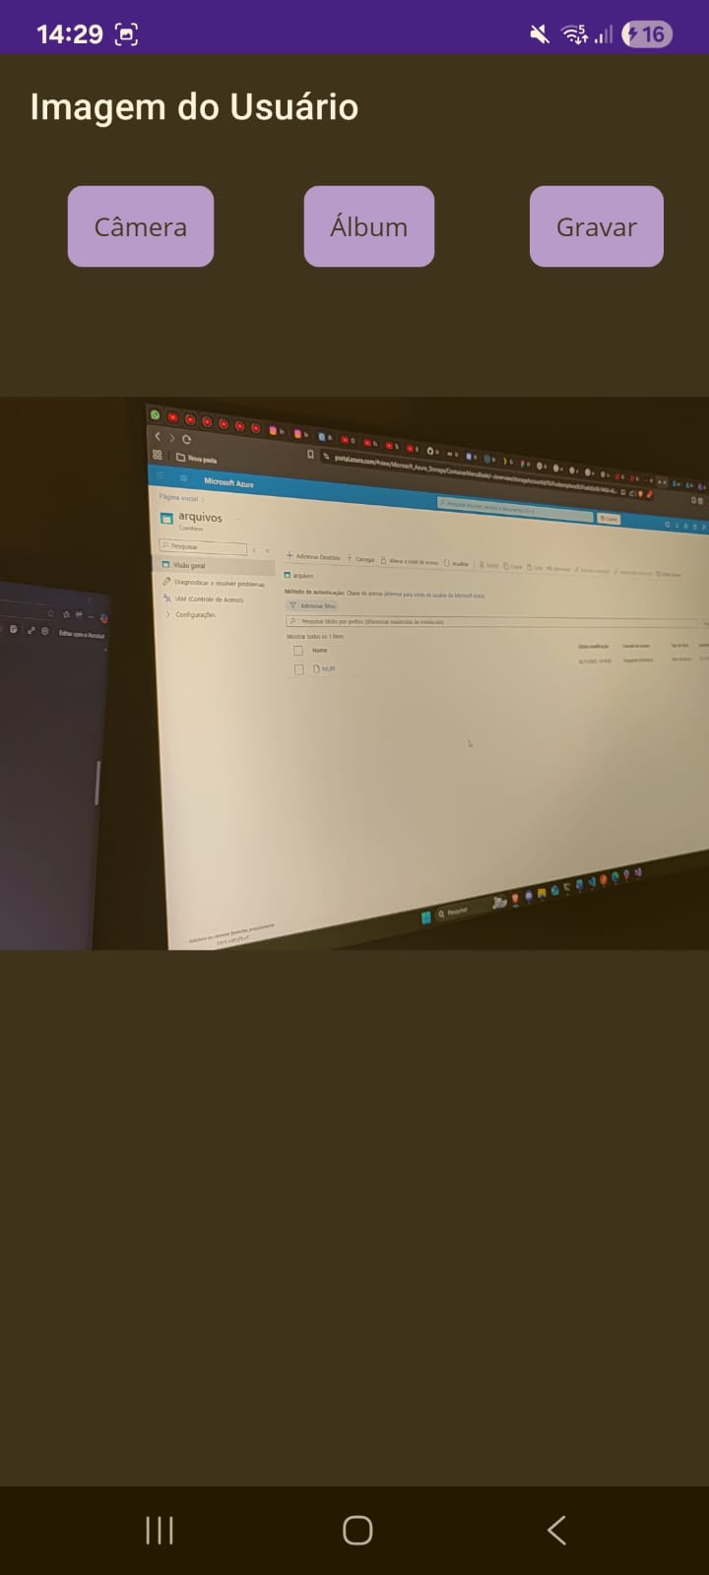
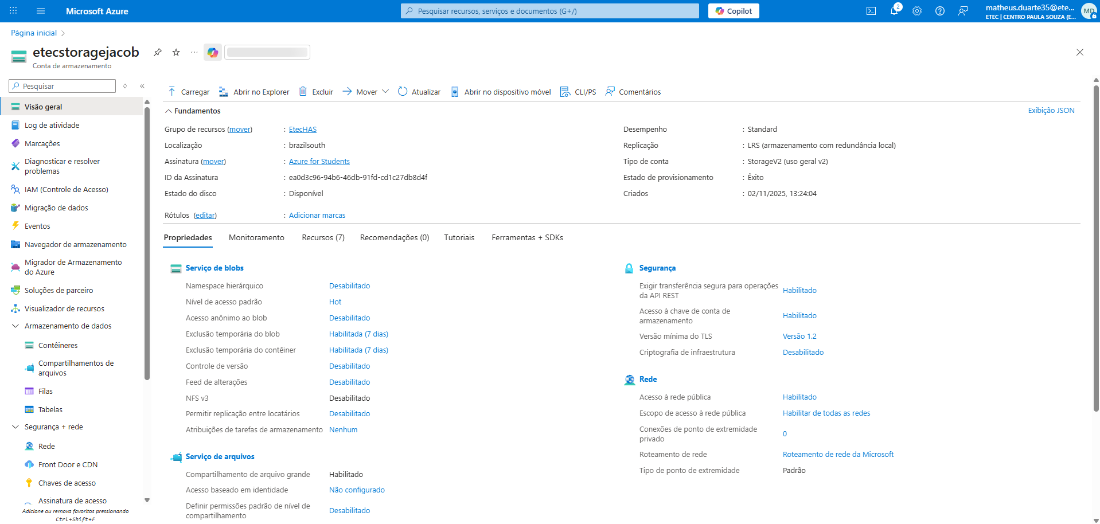

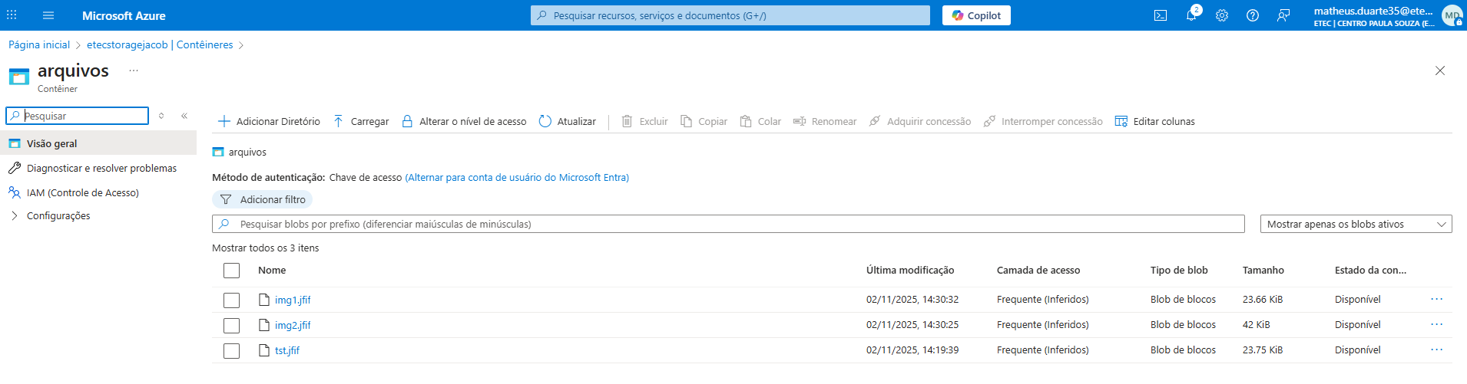

https://github.com/M4theusj/AppRpgEtec

