**Lab7-Report**

**57117136 孙伟杰**

**Task 1：Network Setup**

**Host U：设置IP地址为10.0.2.5**

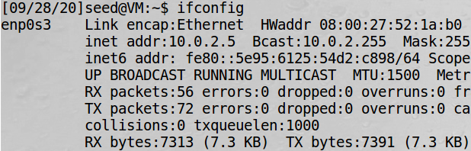

**VPN Server：使用192.168.60.1/24作为VPN网段**

**网卡对应IP分别为192.168.60.101和10.0.2.4**

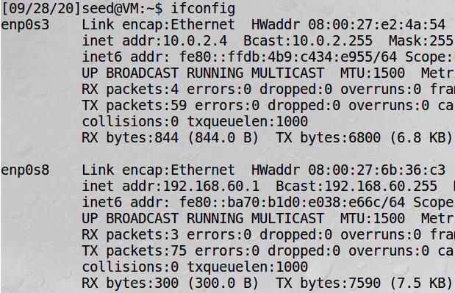

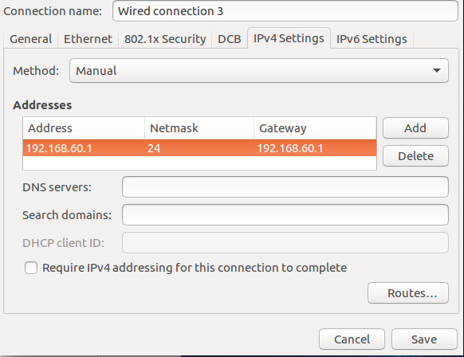

**Host V:设置IP地址为192.168.60.101，网关采用VPN服务器IP 192.168.60.1**

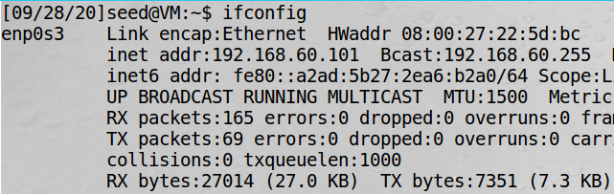

**Host U、V均可ping通VPN Server，反之VPN Server也可以ping通Host U、V**

**Task 2：Create and Configure TUN Interface**

**Task 2.a**

**在Host U上运行tun.py**

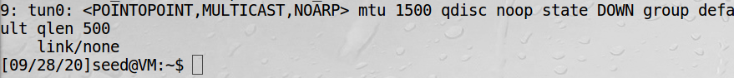

**Task 2.b**

**为接口tun0分配IP地址：**



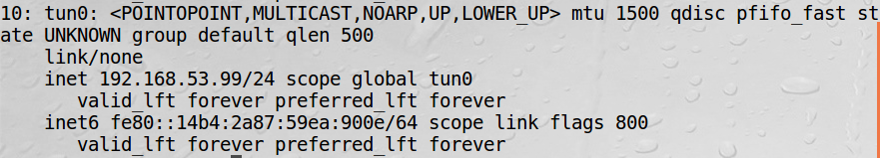

**Task 2.c**

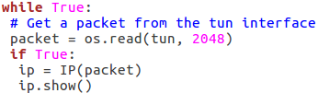

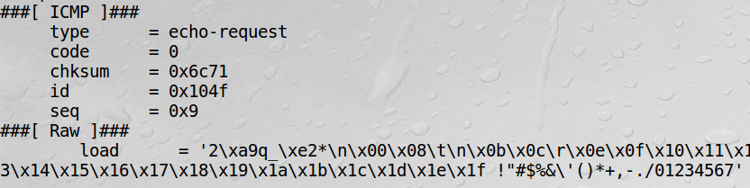

**tun.py输出了icmp报文，因为192.168.53.0/24在tuntap设备的网段中**

**1.On Host U, ping a host in the 192.168.53.0/24 network. What are printed out by the tun.py program? What has happened? Why?**

**2.On Host U, ping a host in the internal network 192.168.60.0/24, Does tun.py print out anything? Why?**

**无输出，因为192.168.60.0/24不在tuntap设备的网段中**

**Task 2.d**

**写入数据：**

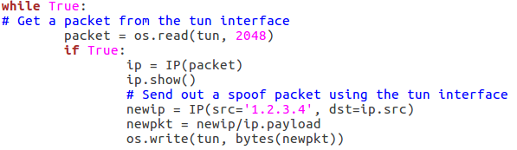

**1.After getting a packet from the TUN interface, send out a new packet to the TUN interface. Please use Wireshark to provide proofs that such packet is sent out successfully.**

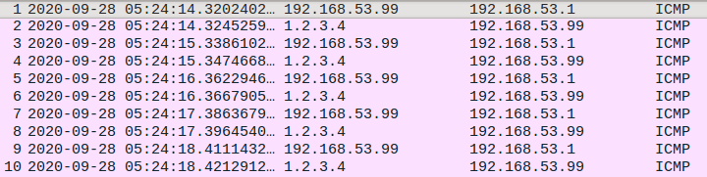

**2.Instead of writing an IP packet to the interface, write some arbitrary data to the interface, and report your observation.**

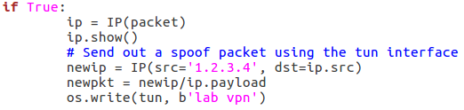

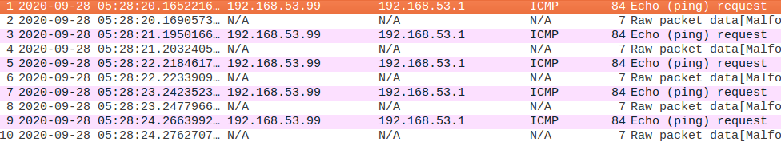

**Wireshark不能正常解析，包格式错误**

**Task 3**

**Tun_Client.py代码如下：**

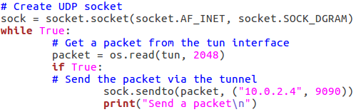

**Tun_Server.py代码如下：**

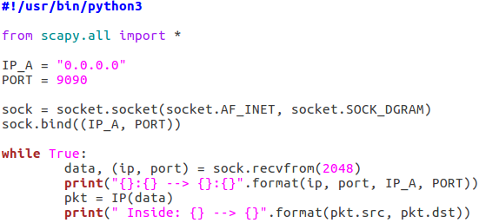

**在VPN Client添加路由记录**



**VPN Server成功收到了来自VPN Client的ping报文**

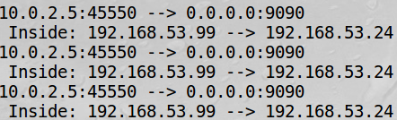

**Task 4**

**修改后tun_Server.py代码如下：**

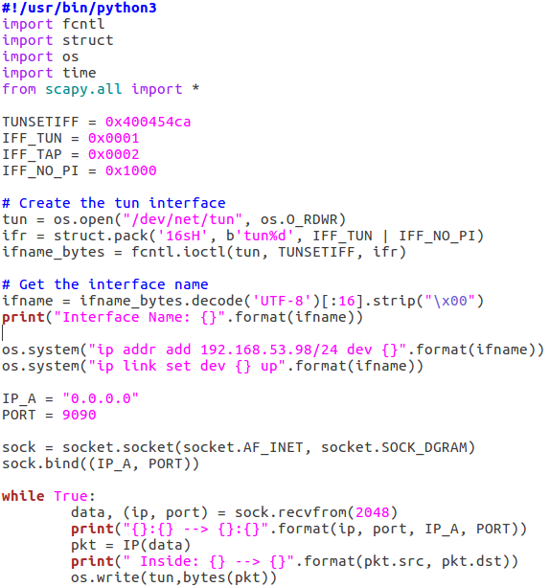



**Host V接收到报文如下：**

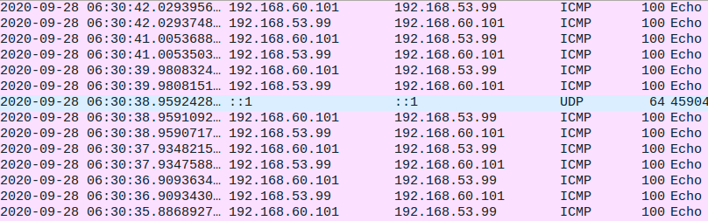

**Task 5**

**VPN Client代码如下：**

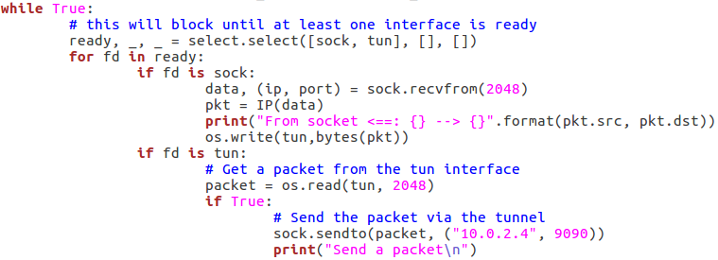

**VPN Server代码如下：**

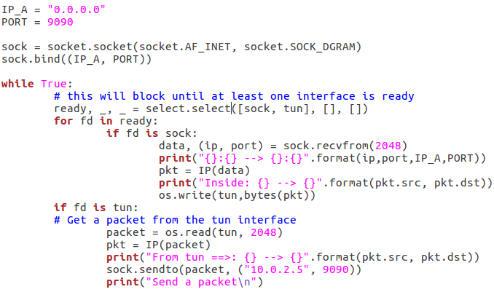

**Host U成功ping通Host V**

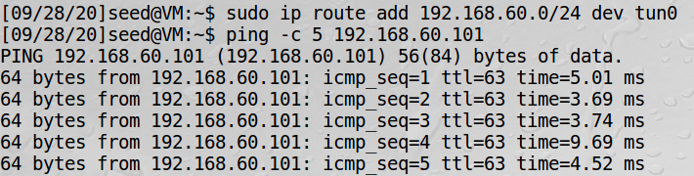

**Task 6**

**Once the tunnel is re‐established, what is going to happen to the telnet connection? Please describe and explain your observations.**

**打开隧道时进行telnet通信测试，可以正常通信；关闭隧道后进行telent通信，不会有报文传输；但若在短时间内打开隧道并重新连接，会恢复报文。说明隧道的短暂断开没有导致telnet连接也断开。**

**Task 7**

**删除默认路由后，Host U无法成功ping通Host V**

**添加路由表相关项后可以成功ping通**

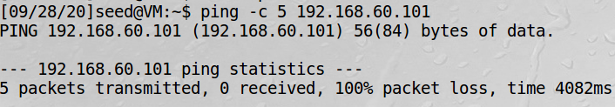

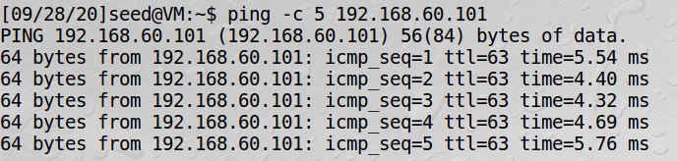

**Task 8**

**修改client程序的IP地址，使其与server端的TUN接口IP地址不在同一网段内**

**通过wireshark可以发现因为报文中的src、ip与tun不在同一网段，当报文从U抵达VPN Server后，VPN Server未能通过TUN将报文发送出去。**

**Task 9**

**修改代码然后进行测试**

**可以看到TAP口确实收到了一个ARP请求**

