**Q1:- Install a fresh drupal named as "Bootcamp2020"**

**Ans:-**

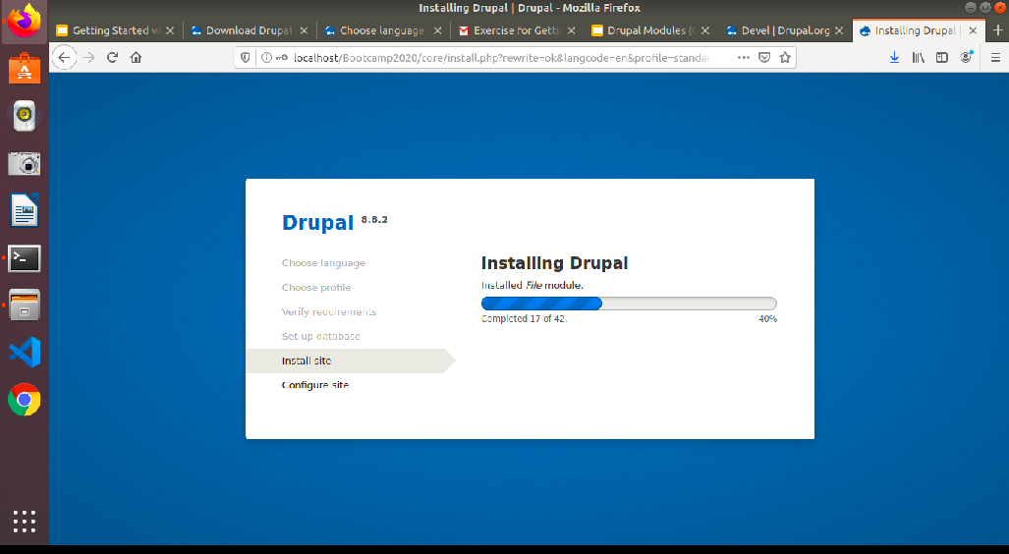

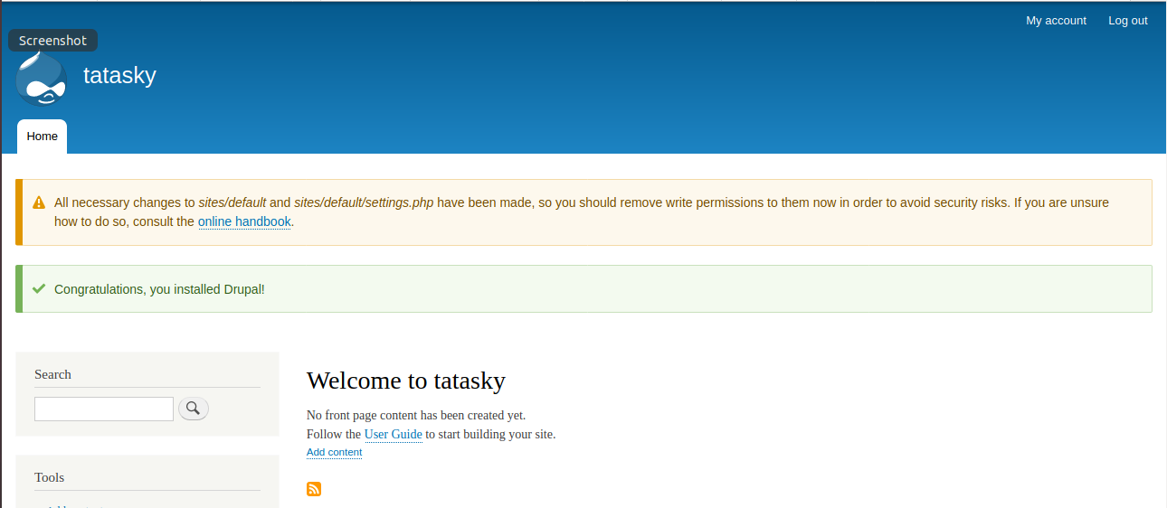

**Q2:- Write down the name of by default field-types available in Drupal 8.**

**Ans:- Select field type**

**General**

Boolean

Data

Element

Timestamp

Comment

Link

**Number**

List(float)

List(integer)

Number(decimal)

Number(floatl)

Number(integer)

**Reference**

Content

File

Taxonomy term

User

Other

**Text**

List(text)

List(formatted,long)

List(formatted,long,with summary)

List(plain)

List(plain,long)

**Q3:- Create a new Content Type named as "Book" with below fields -**

**Book Name (Text)**

**Description (Text - Formatted long)**

**Book Image (Image)**

**Book Price (Number - Integer)**

**Book Author (Text)**

**Ans :-**

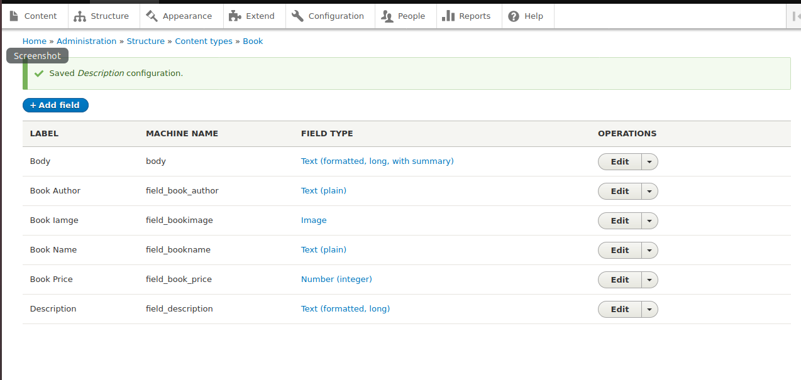

**Q4:- Arrange the fields in the same order as above using "Manage Form Display".**

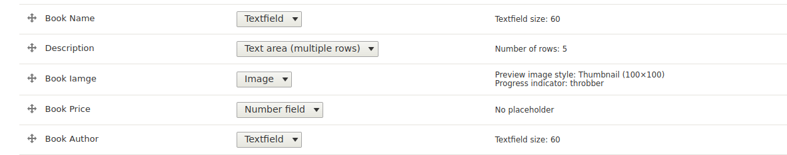

**Q5:- Create 1 node using the above content type. Node should contain all fields value without label in the same order as above.**

**Ans:-**

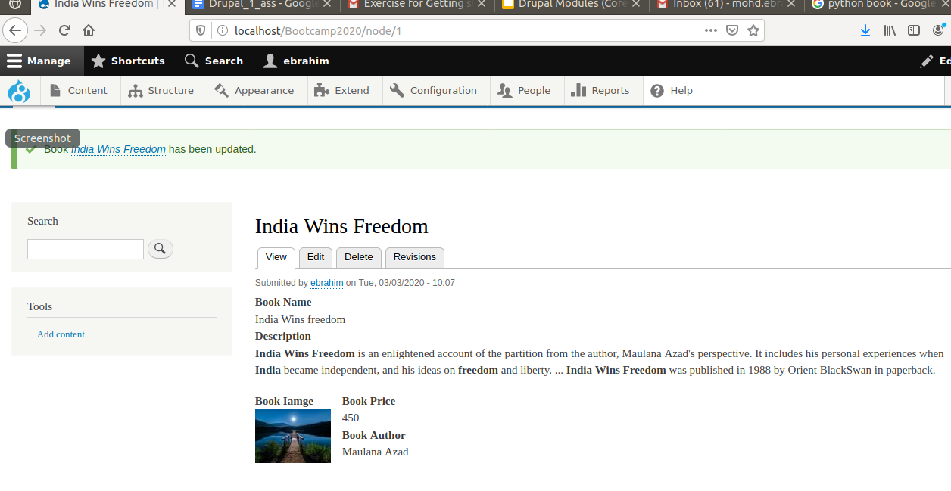

**Q6:- Download and Install Contrib Module "Admin Toolbar".**

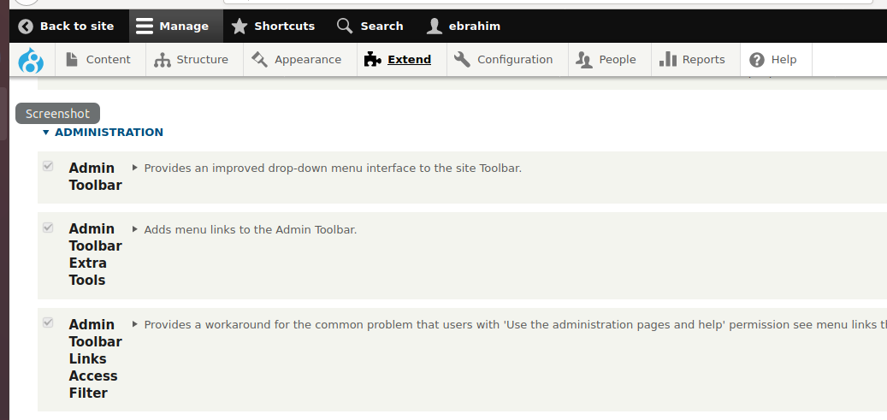

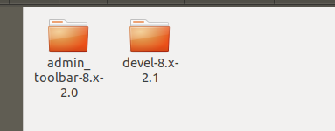

**Q7:- Download, Install and set as default Contrib Theme "Business".**

**Ans:-**

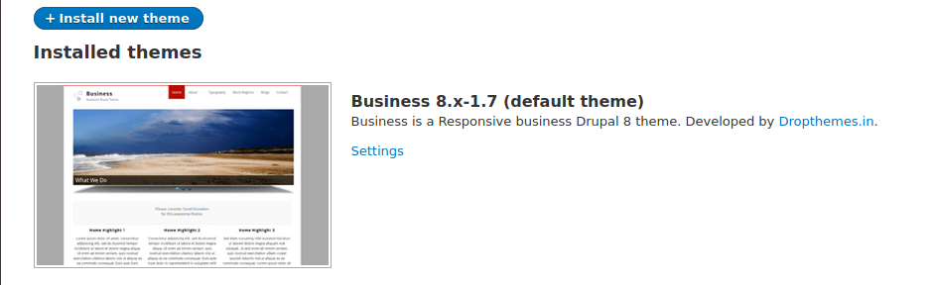

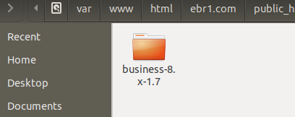

**Q8:- -Create a custom module with "/getnodes" path, Display all published nodes title**

**on this page.**

**Solution:- create a custom module let say Nodes**

step 1 :- create a Nodes.info.yml file and write following code

name: Nodes

description: contains details of all nodes

package: Custom

type: module

core: 8.x

Step 2:- create a folder named src and add a subfolder Controller

step 3:- Inside container add Nodes.Controller.php file and add following code :-

<?php

namespace Drupal\Nodes\Controller;

use Drupal\Core\Controller\ControllerBase;

class NodesController extends ControllerBase {

public function nodelist() {

$query = \Drupal::entityQuery('node')->condition('status', 1); //content type

$nids = $query->execute();

$url = '<table>';

$url .= "<tr><td><b>" . "Node ID" . '</td><td><b>' . "Node Name". '</td></tr>';

foreach ($nids as $nid) {

$node = \Drupal\node\Entity\Node::load($nid);

$body = $node->body->value;

$title = $node->title->value;

$type =$node->type->value;

$url .= "<tr><td>" . $nid . '</td><td>' . $node->title->value . '</td></tr>';

}

$url .= "</table>";

return [

'#markup' => $url,

];

}

}

Step 4 : come back to Nodes folder where Nodes.info.yml exists and create another file

named Nodes.routing.yml file and add following code:-

Nodes.getnodes:

path: '/getnodes'

defaults:

_controller: 'Drupal\Nodes\Controller\NodesController::nodelist'

_title: 'Nodes list'

requirements:

_permission: 'access content'

