**Q1. Install fresh drupal with virtual host "local.[YOUR-NAME]**[**recipes.com**](http://recipes.com/)**" (e.g** [**local.amanrecipes.com**](http://local.amanrecipes.com/)**).**

**Ans:-**

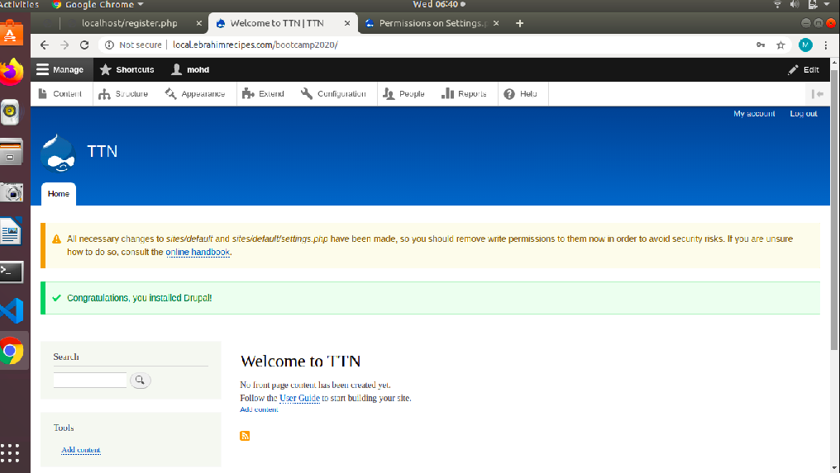

**Q2:- .Upload a new logo for the site and update site-name.**

**Ans:-**

**step1:- go to configuration and click basic site settings**

**step 2:- change the website name and click save**

**step 3:- go to appearance settings and upload the new logo in logo image section**

**step 4:- upload the logo and save the changes.**

**Step 5:- your websites name and logo have been uploaded**

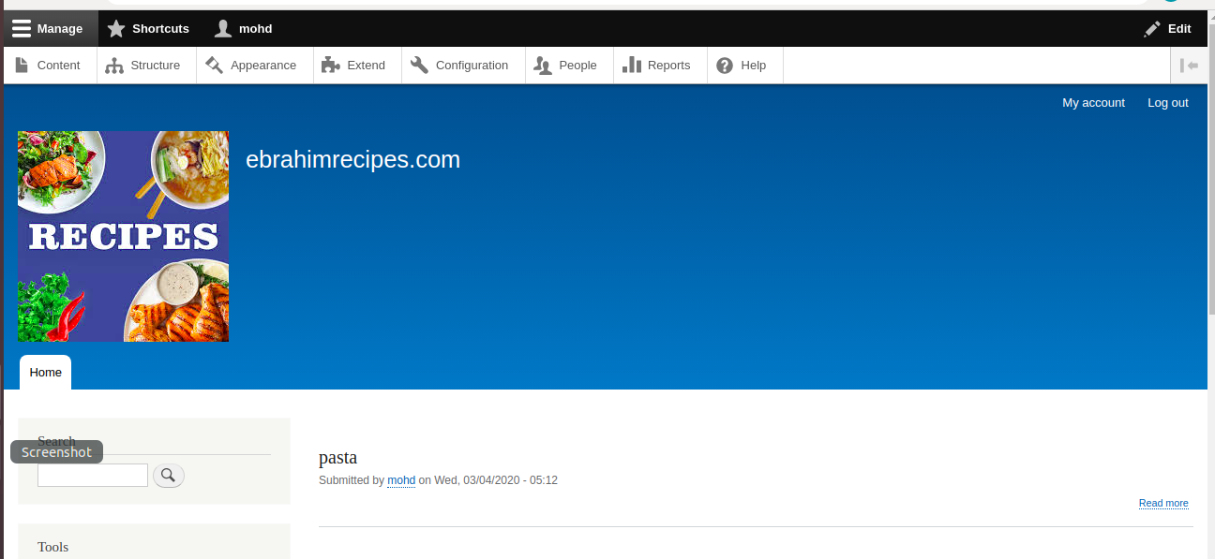

**Q3:- .Create two vocabularies :**

**a.Ingredient (pasta/noodles etc)**

**b.Cuisine (italian/chinese etc)**

**Ans:-**

**step1 :- Go to structure and choose Taxonomy**

**step2 :- click on add vocabularies and create vocabulary Cuisine**

**step 3 :- click on save button and now add the fields (pasta \ Noodles) etc**

**Step 4:- Now repeat the same steps from step 1 to 3 to create a new vocabulary ingredient Result :- both the vocabularies are created**

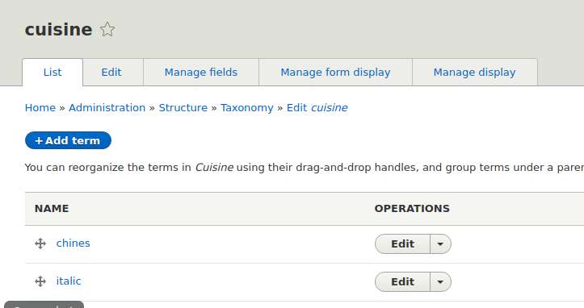

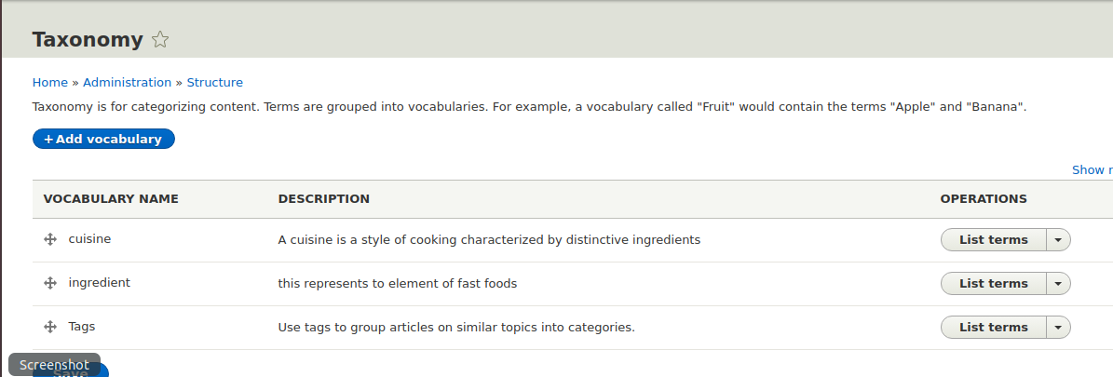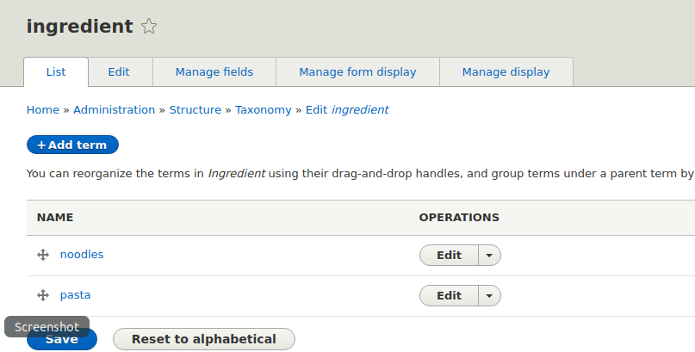

**Q4:- Add following fields in user account :**

**a.Full name**

**b.Phone no**

**Ans:-**

**step 1:- go to configuration>>People>>Account Settings >> Manage fields**

**step 2:- click on add field and add Name and phone number fields**

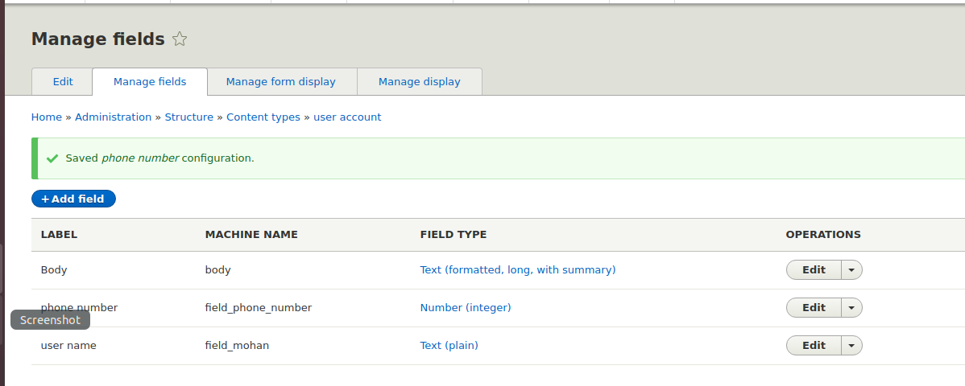

**Q5:- Create role "Publisher" and 2 users for this role.**

**Ans:-**

**Step 1:- go to people >> Roles**

**Step 2:- click on add roles**

**step 3:- create role Publisher**

**step 4:- go to users and click add user option**

**step 5:- enter the fields (name , email , passwords etc) and check role as Publisher**

**step 6:- follow step 5 and create 2 users for the role of publisher. Step 7:- At the end your user list will be shown as follow**

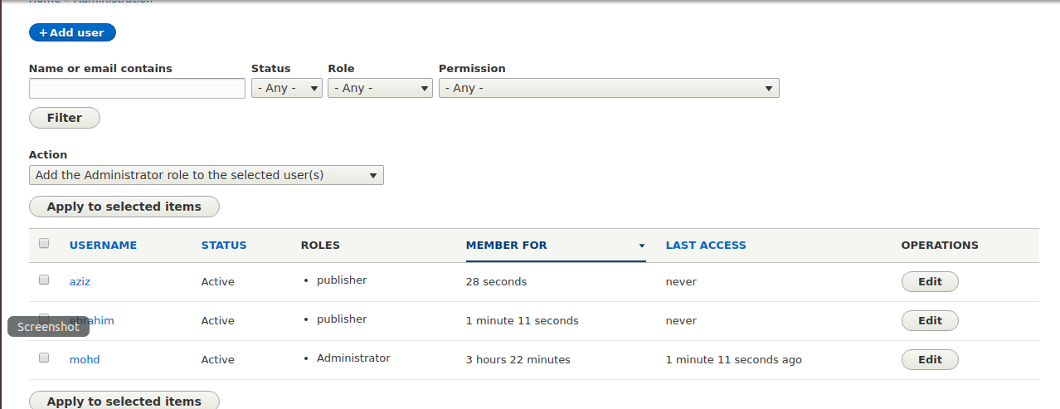

**Q6:- Create create content type named as "Recipe" with following fields**

**-Directions (body field)**

**-Cuisine Type (Use the Cuisine type vocab here)**

**-Ingredients (Use the Ingredient vocab here with unlimited values)**

**-Veg/Non-Veg? (Radio button field)**

**-Images (2 images allowed)**

**-Publisher (User reference field)**

**-Comments**

**Ans:-**

**step 1:- Go to Structure >> content type**

**Step 2: - click add content option**

**Step 3:- create the content named “Recipe”**

**Step 4: - choose Manage field options and add the fields as follow :- -Directions (body field) -Cuisine Type (Use the Cuisine type vocab here) -Ingredients (Use the Ingredient vocab here with unlimited values) -Veg/Non-Veg? (Radio button field) -Images (2 images allowed) -Publisher (User reference field) -Comments**

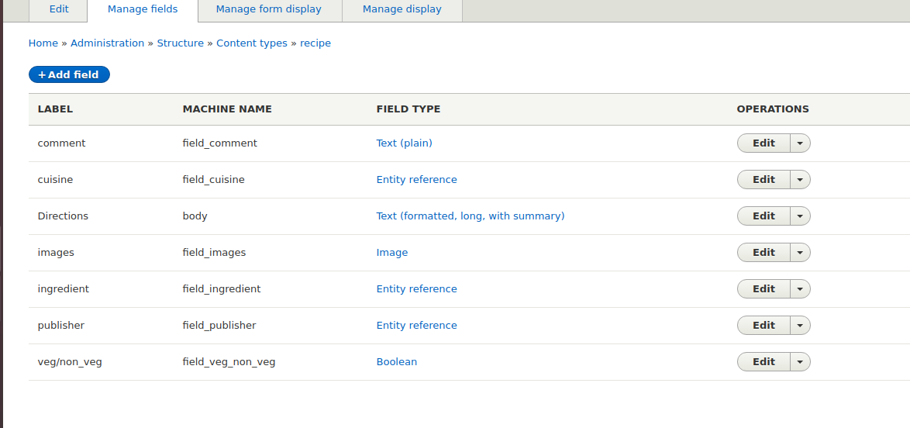

**Q7:- Create 4 recipes(nodes) using above content type with url alias**

**Solution:-**

**step1 :- Go to content and click add content**

**step2:- choose recipes in content type**

**step 3 :- now add the contents you want to add**

**Step 4:-add the nodes you want to add**

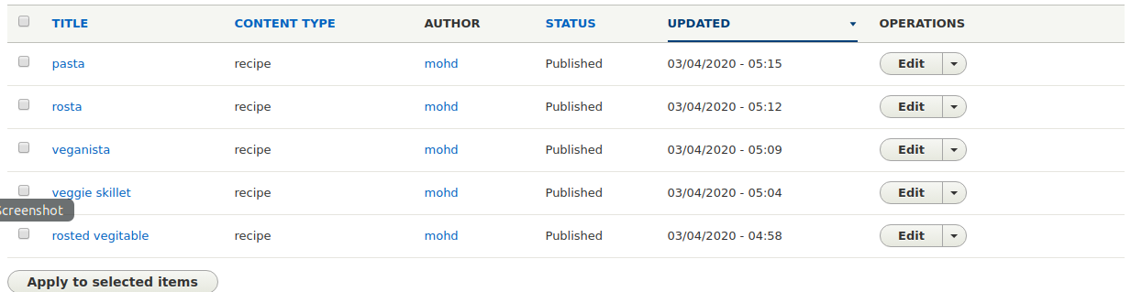

**Q8:-.Create a menu named “Recipe List” and add links to the recipes.**

**Solution:-**

**Step 1: - Go to structure >> Menus**

**Step 2:- Click add menu option**

**Step 3:- Add the title as Recipe List and save**

**Step 4:- go to add link**

**step 5 :- Add the Menu title , links and parent list name**

**Solution:-**

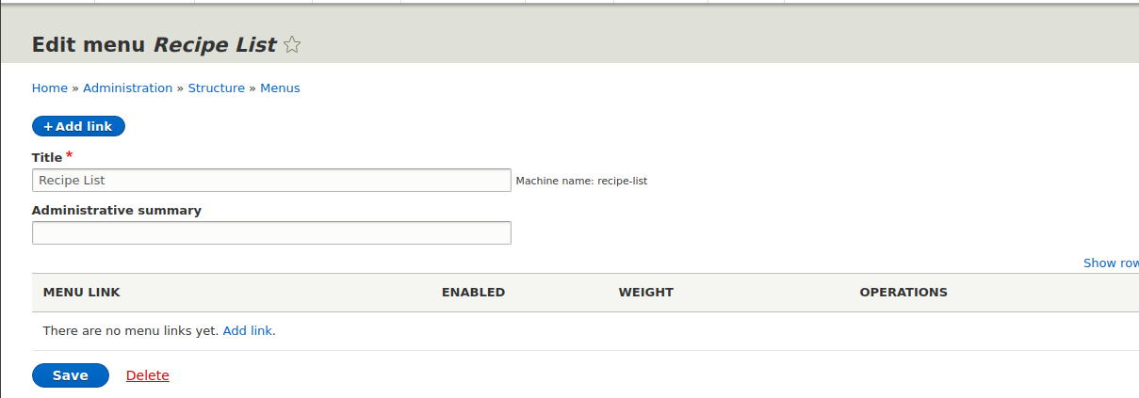

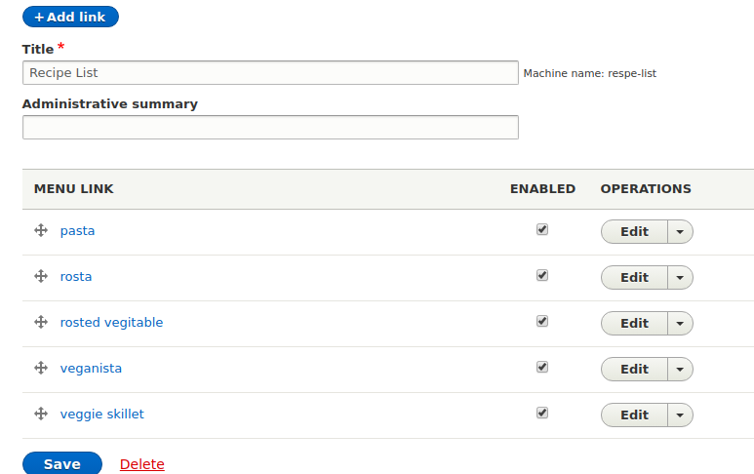

**Q9:- Place above created menu in Sidebar region.**

**Soln:- step1 :- Go to structure >> Blocks**

**Step2:- choose the sidebar block you want to add your menu**

**click on Place Block Option choose the menu you want to place**

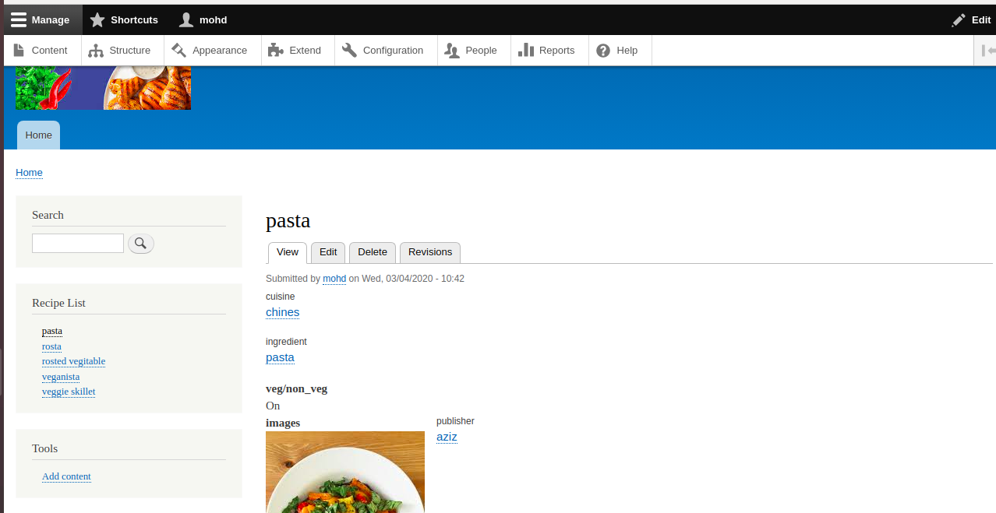

**Q10:- Create a custom block for copyright and place in the footer region.**

**Solution**

**step1:- go to structure>> Block**

**step 2:- create the custom block by clicking on add custom block**

**after filling block name , body description click on save block**

**Go to the structure >> Block layout**

**in Footer first add place your custom block and save Blocks**

**the footer has been added**

