**Q1:- create a form, do the validation with the help of jquery and regular expression.**

**i>Username should only start with letter A,P,Q,Z and end with Biya,We,Jzz**

**ii>User the last name should start with Bhfy, W124, Jv.! and end with A, P,Q,Z**

**iii> Contact no should start with 9,6,7,8 and end with 7,3646,976**

**iv> Email validation should be there with regular expression.**

***\*The above exercise will be on HTML and jquery with the proper functioning.***

***Ans:-*** *code is uploaded on git.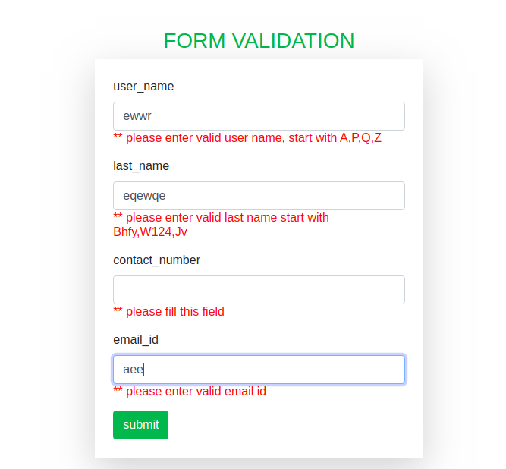*

**Q2:- Use XPath to determine/Select At least 10 elements on google chrome from the given HTML:-**

**https://docs.google.com/document/d/14O5UaTngsxnSIbYYVwR3y8THNnGBJXx0y_DtQdivAkU/edit**

**\**do not copy XPath from developer tool use only your understanding to determine Xpat***

**Ans :-** XPath is given below that selects 10 elements.

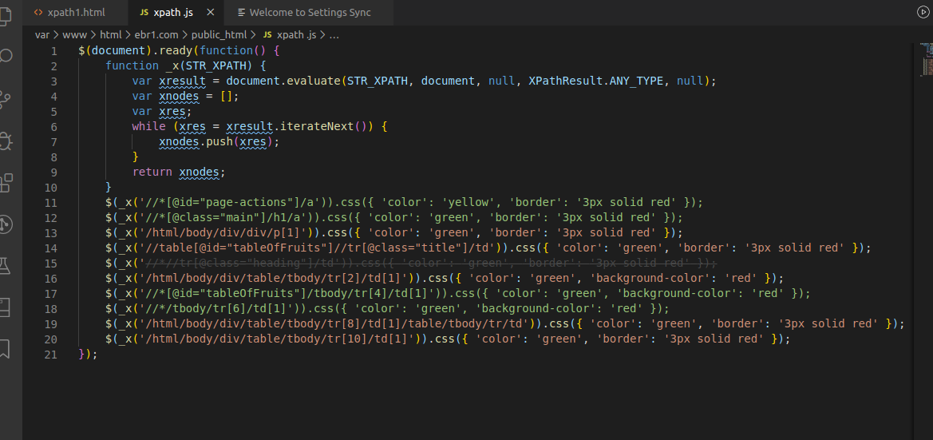

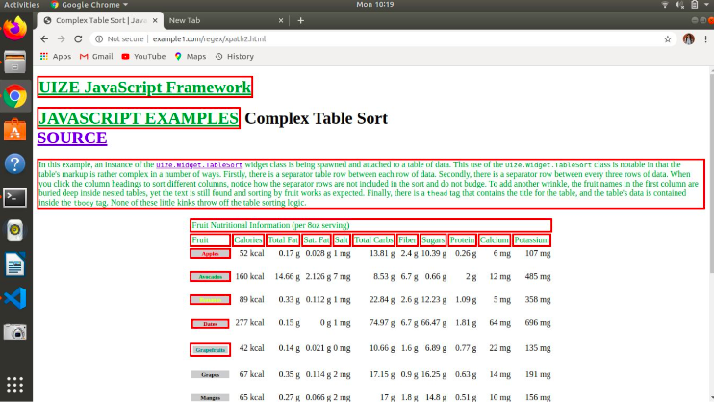

**Q3:- In the given HTML use text, contains the function of XPATH to determine the value of different 5 fruit names.**

**Ans:-**

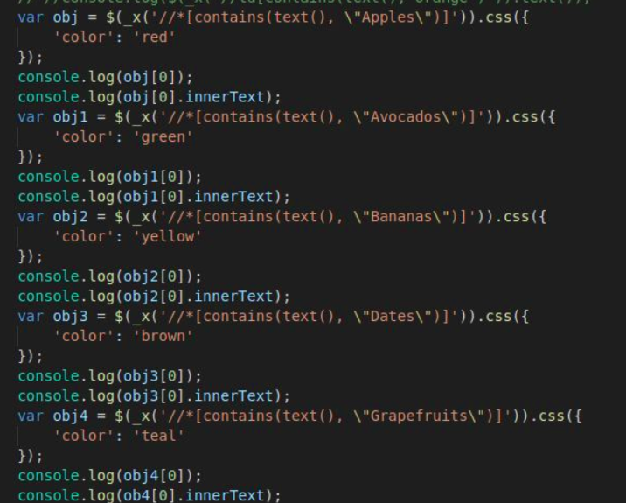

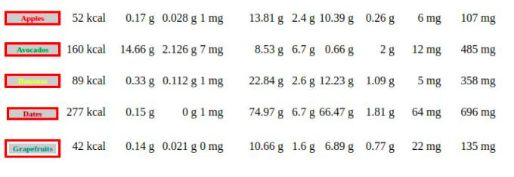

**Q4:- create a database according to your understanding with basic profile detail and write queries to fetch all data-name, contact, email, address on the basis of REGULAR EXPRESSION.**

**Ans:-** Querying using regex

