**Q1:-How are inline and block elements different from each other?**

**Ans**:-The <div> element is a block-level element.

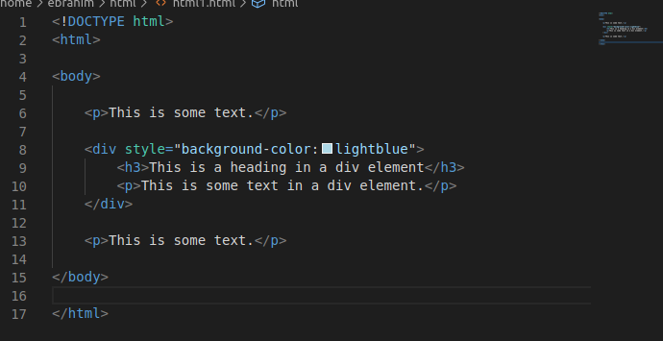

**Inline elements** can exist within **block**-level **elements**. A paragraph would normally be a **block**-level **element**.

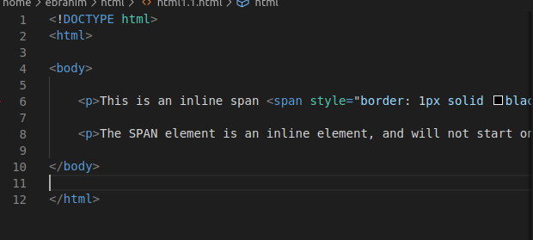

**Q2:-Explain the difference between visibility:hidden and display:none**

**Ans:- display:none** means that the tag in question will not appear on the page at all (although you can still interact with it through the dom). There will be no space allocated for it between the other tags.

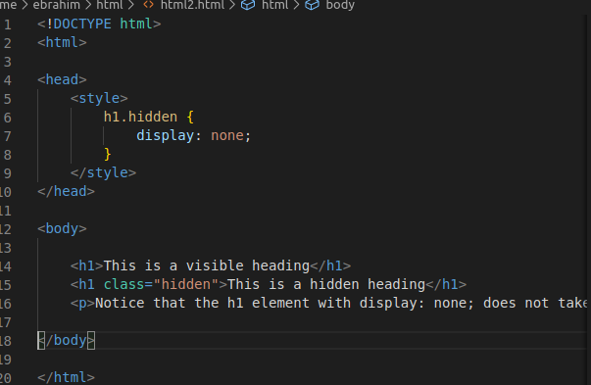

**visibility:hidden** means that unlike display:none, the tag is not visible, but space is allocated for it on the page. The tag is rendered, it just isn't seen on the page.

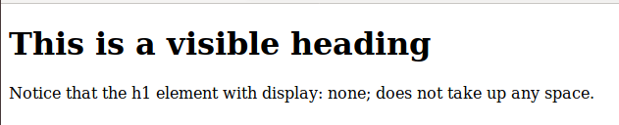

**Q3:-Explain the clear and float properties.**

**Ans:-**The CSS **float** property specifies how an element should float.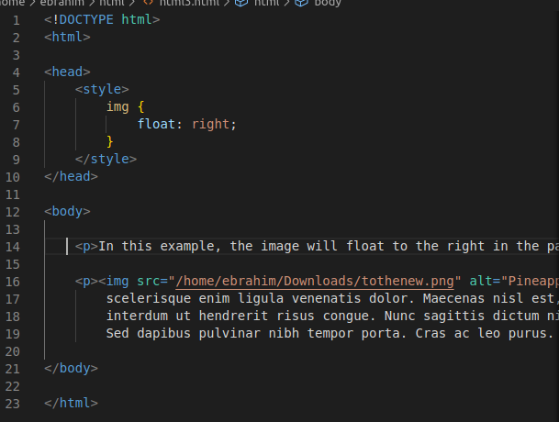

The CSS **clear** property specifies what elements can float beside the cleared element and on which side.

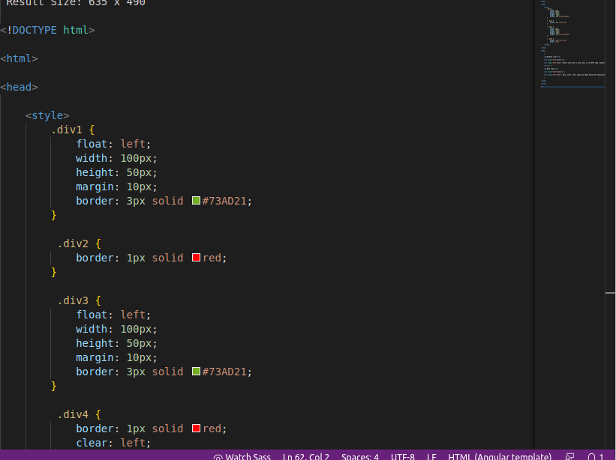

**Q4:-explain difference between absolute, relative,fixed and static.**

**Ans:-Static - this is the default value, all elements are in order as they appear in the document.**

**Relative - the element is positioned relative to its normal position.**

**Absolute - the element is positioned absolutely to its first positioned parent.**

**Fixed - the element is positioned related to the browser window.**

**Q5:-Write the HTML code to create a table in which there are 4 columns( ID , Employee Name, Designation, Department) and at least 6 rows. Also do some styling to it.**

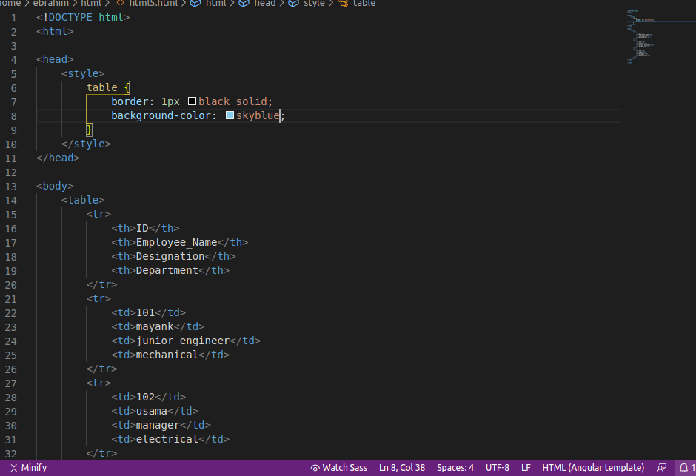

**Q6:-Why do we use meta tags?**

**Ans:-** The <meta> tag provides metadata about the HTML document. Metadata will not be displayed on the page, but will be machine parsable.

Meta elements are typically used to specify page description, keywords, author of the document, last modified, and other metadata.

The metadata can be used by browsers (how to display content or reload page), search engines (keywords), or other web services.

HTML5 introduced a method to let web designers take control over the viewport (the user's visible area of a web page), through the <meta> tag (See "Setting The Viewport" example below).

**Q7:-Explain box model.**

**Ans:-** All HTML elements can be considered as boxes. In CSS, the term "box model" is used when talking about design and layout. The CSS box model is essentially a box that wraps around every HTML element. It consists of: margins, borders, padding, and the actual content.

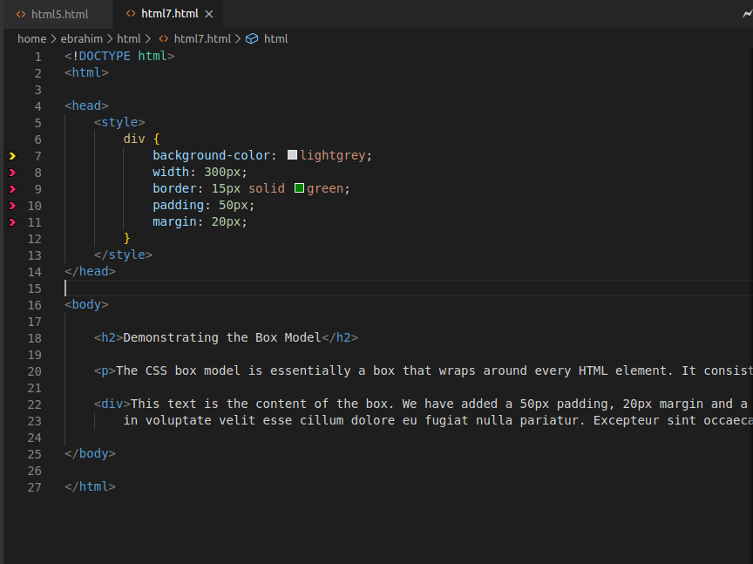

**Q8:-What are the different types of CSS Selectors?**

CSS selectors are used to "find" (or select) the HTML elements you want to style.

We can divide CSS selectors into five categories:

* Simple selectors (select elements based on name, id, class)
* [Combinator selectors](https://www.w3schools.com/css/css_combinators.asp) (select elements based on a specific relationship between them)
* [Pseudo-class selectors](https://www.w3schools.com/css/css_pseudo_classes.asp) (select elements based on a certain state)
* [Pseudo-elements selectors](https://www.w3schools.com/css/css_pseudo_elements.asp) (select and style a part of an element)
* [Attribute selectors](https://www.w3schools.com/css/css_attribute_selectors.asp) (select elements based on an attribute or attribute value)

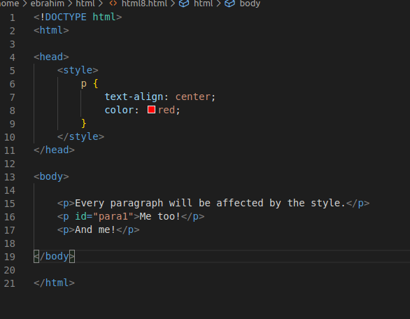

**Q9:-Define Doctype.**

**Ans:-** The <!DOCTYPE> declaration must be the very first thing in your HTML document, before the <html> tag.

The <!DOCTYPE> declaration is not an HTML tag; it is an instruction to the web browser about what version of HTML the page is written in.

In HTML 4.01, the <!DOCTYPE> declaration refers to a DTD, because HTML 4.01 was based on SGML. The DTD specifies the rules for the markup language, so that the browsers render the content correctly.

HTML5 is not based on SGML, and therefore does not require a reference to a DTD.

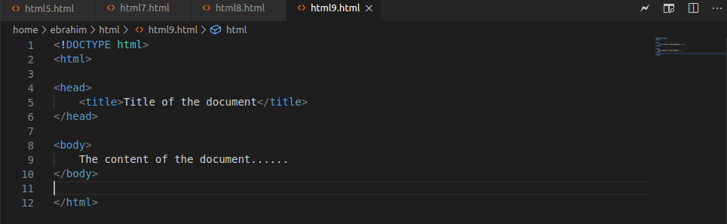

**Q10:-Explain 5 HTML5 semantic tags.**

**Ans:-** A semantic element clearly describes its meaning to both the browser and the developer.

The <**article**> element specifies independent, self-contained content.

The <**header**> element specifies a header for a document or section.

The <**footer**> element specifies a footer for a document or section.

The <**nav**> element defines a set of navigation links.

The <**aside**> element defines some content aside from the content it is placed in (like a sidebar).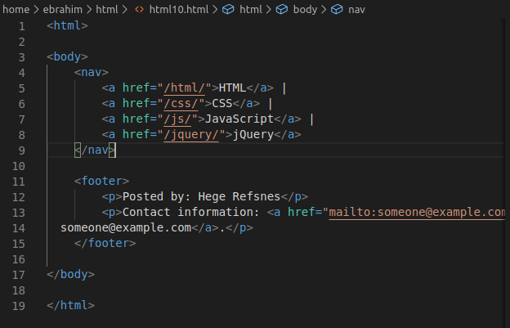

**Q11:-Create HTML for web-page.jpg (check resources, highest weightage for answers).**

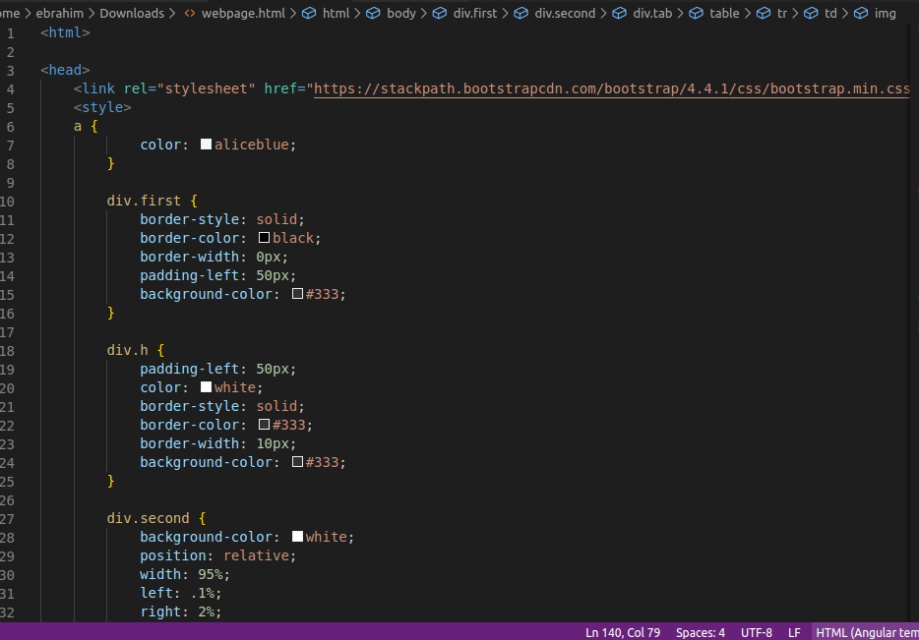

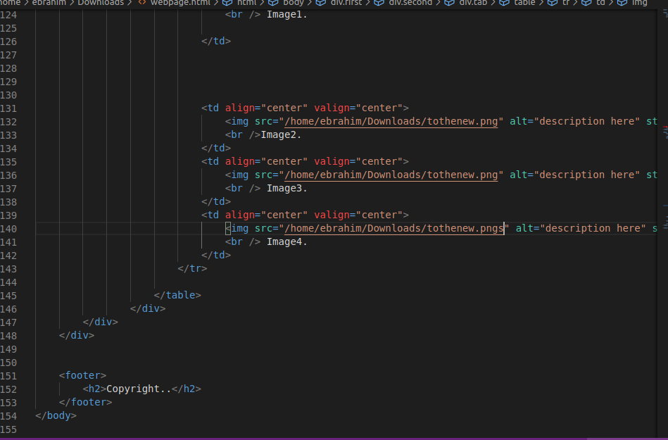

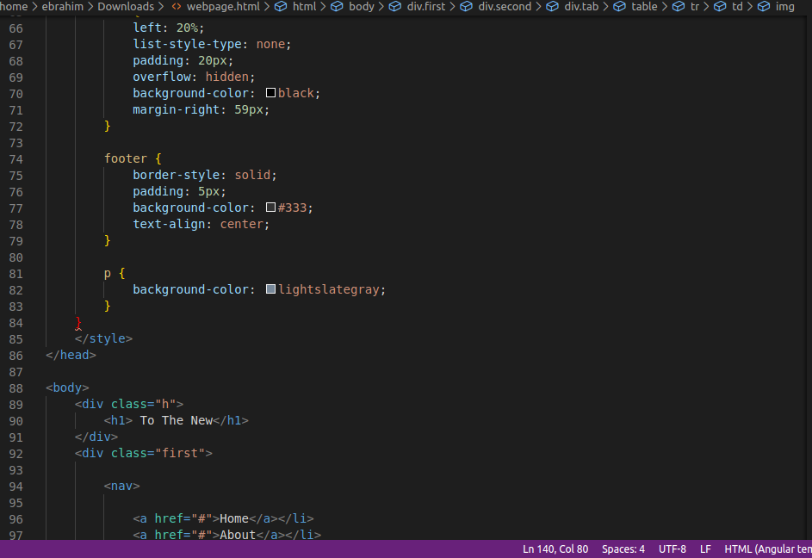

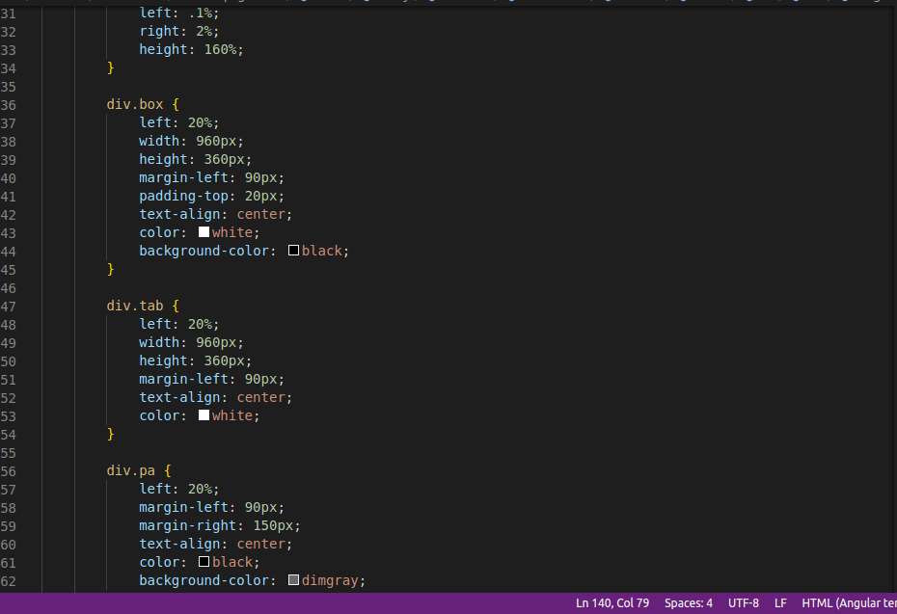

**Q12:-Create HTML for form.png (check resources, highest weightage for answers)**

**Note: 50% of marks are for last 2 exercises of creating html pages**

