**Q1:-Prompt for amount, interest rate and no. of years and calculate simple interest.**

**Ans:-**

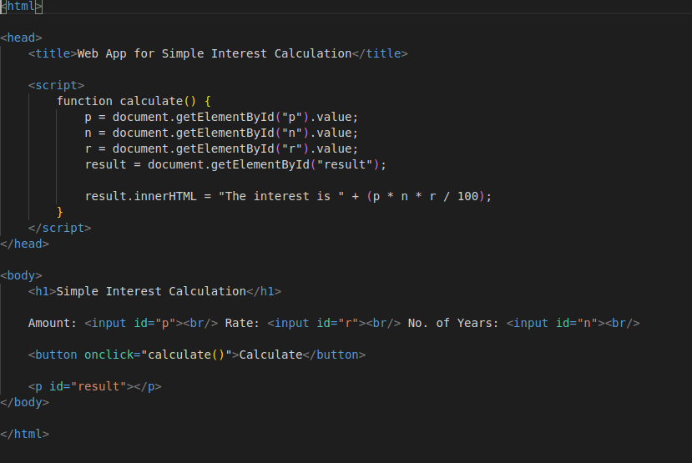

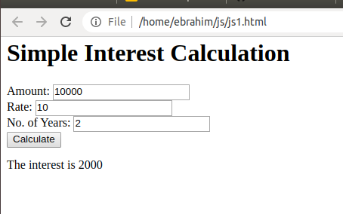

**Q2:- is palindrome string**

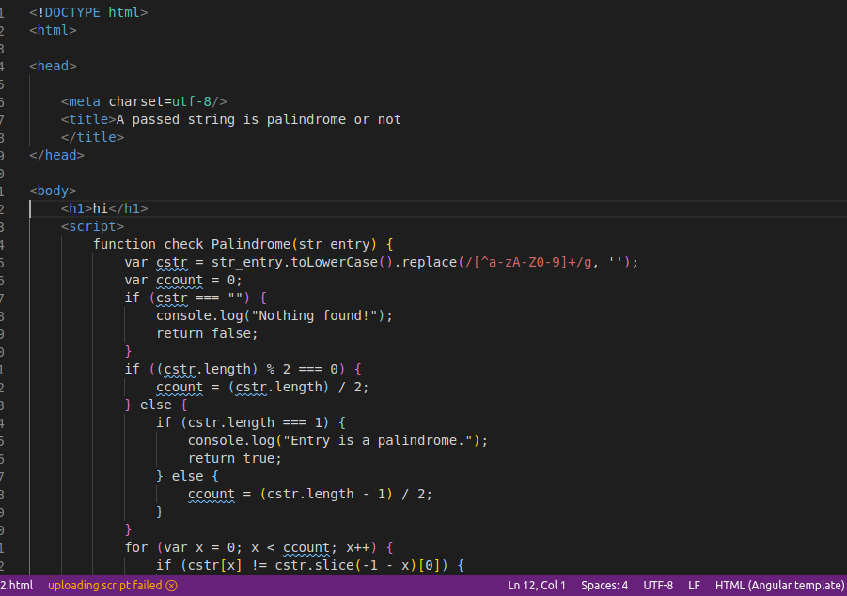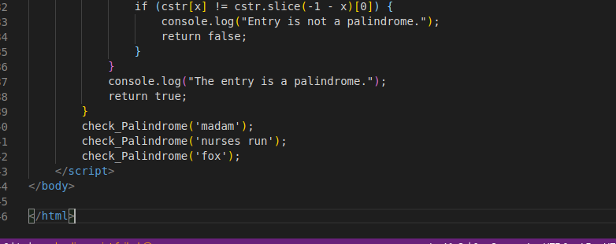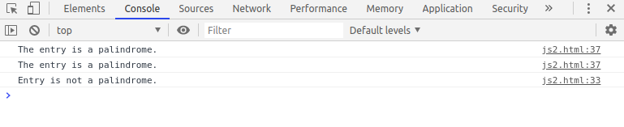

**Q3:- Area of circle.**

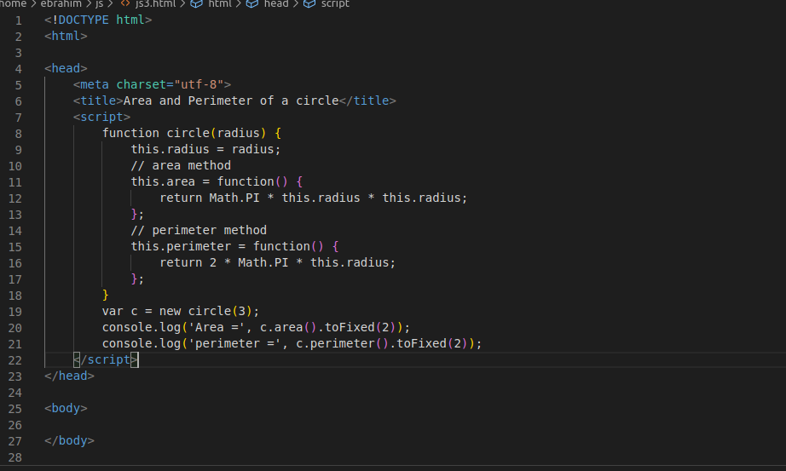

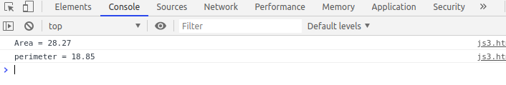

**Q4:- Copy information of one object to another and log it to console.**

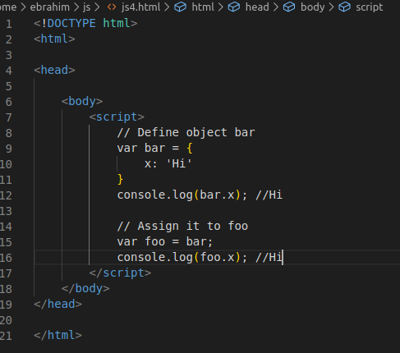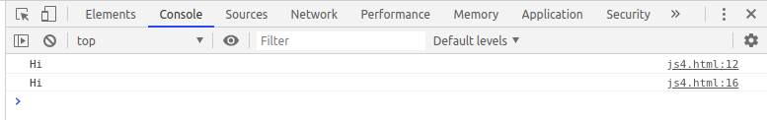

Q5:create a list of objects of Employee with info as follow :

* Name, age, salary ,DOB
* filter all employees with salary greater than 5000
* group employee on the basis of their age
* fetch employees with salary less than 1000 and age greater than 20. Then give them an increment 5 times their salary.

Ans:- filter all employees with salary greater than 5000

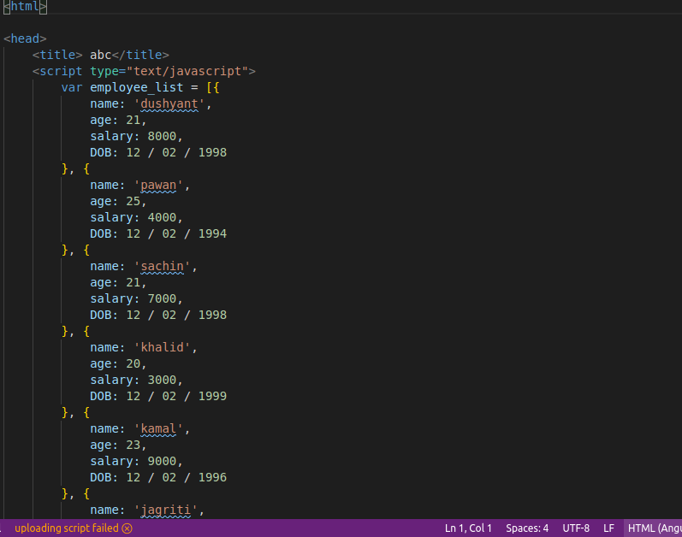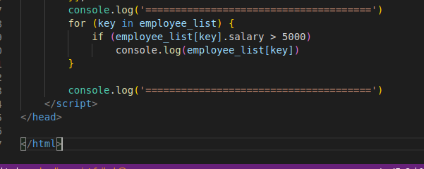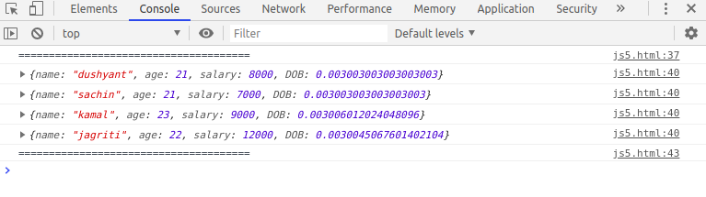

* fetch employees with salary less than 1000 and age greater than 20. Then give them an increment 5 times their salary.

