Q1:-Steps(with command and screenshots) for installing apache.

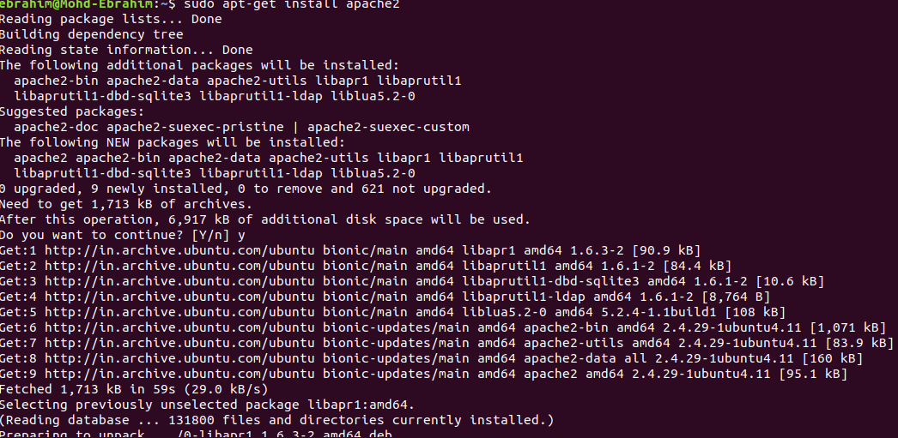

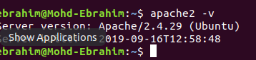

Q2:-Installation steps(with command and screenshots) PHP and print current version

Ans:- step to install php.

### **Update Package Index**

Command :- sudo apt-get update

### **Install phpMyAdmin Package**

Command:- sudo apt-get install -y phpmyadmin

### **Configure phpMyAdmin Package**

After installing phpMyAdmin, you will be presented with the package configuration screen.

Press the SPACE bar to place an **“*”** beside “apache2.”

**Q3:- installation steps(with command and screenshots) MySQL and print the current version.**

Press TAB to highlight “OK,” then hit ENTER.

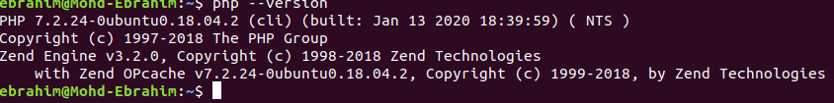

**Q4:- what is HHTP?**

**Ans:-** **HTTP** stands for **H**yper **T**ext **T**ransfer **P**rotocol

**WWW** is about communication between web **clients** and **servers**

Communication between client computers and web servers is done by sending **HTTP Requests** and receiving **HTTP Responses**

**Q5:- What domain name will have the following address – 127.0.0.1**

**Ans:-** 127.0. 0.1 is the loopback Internet protocol (IP) address also referred to as the localhost. The address is used to establish an IP connection to the same machine or computer being used by the end-user.

**Q6:- What language should you use for writing queries for the database?**

**SQL** is the most mainstream language that is used to access databases because it can work with any database. The databases, with which you interface, are programs that enable clients to store and manage information in a logical manner.

**Q7:- Which command is used for restart apache.**

**Ans:-** sudo service apache2 start.

**Q8:- Print fibonacci series .**

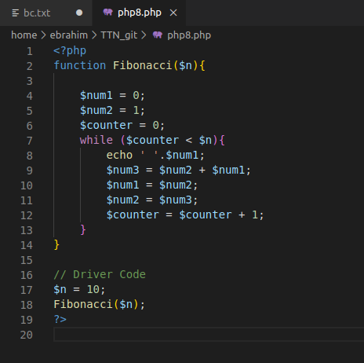



**Print 1 & 6 using foreach in array( 1, 2, 3, 4, 5, 6, 7 ).**

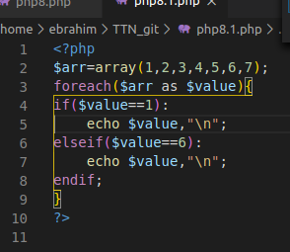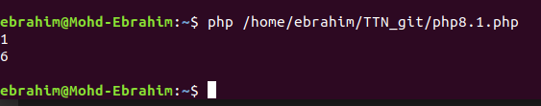

**Print 1 2 3 4 using break and foreach in array( 1, 2, 3, 4, 5, 6,**

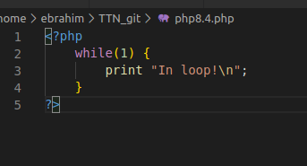

**Create and print an infinite loop**

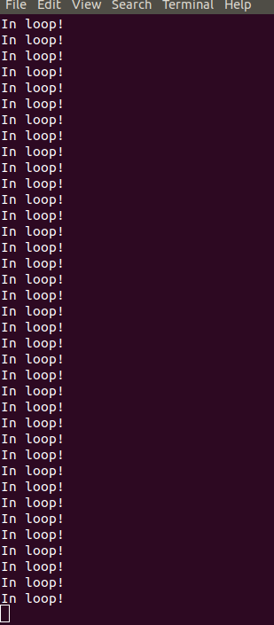

**Print 1,2,3,6,7 from array( 1, 2, 3, 4, 5, 6, 7 ).**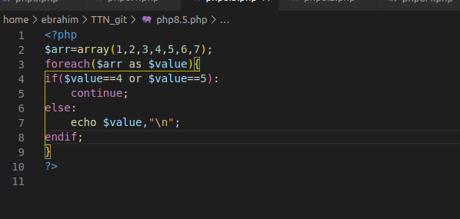

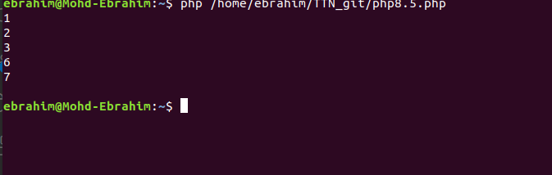

**Create a function to calculate factorial value of a number. Use this function to get factorial of 5.**

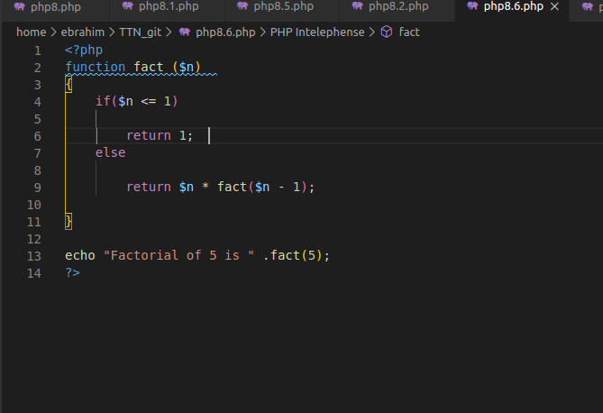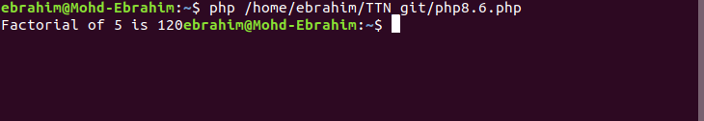

**Using loop find the sum of numbers from 1 to 15.**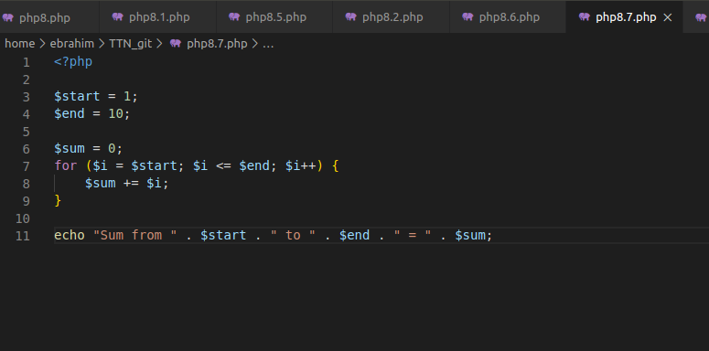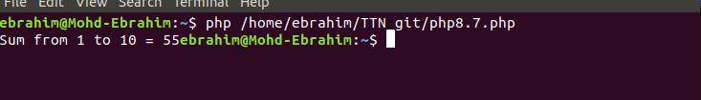

**Give examples of Print, printf, sprintf.**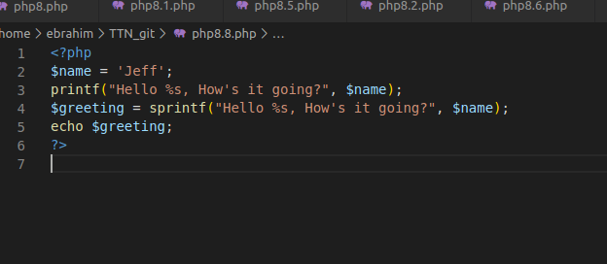

**Using Alternative syntax print values of array( 1, 2, 3, 4, 5, 6, 7 )**

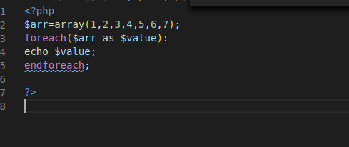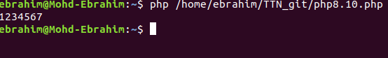

**Create a script that displays 1-2-3-4-5-6-7-8-9-10 on one line. There will be no hyphen(-) at the starting and ending position.**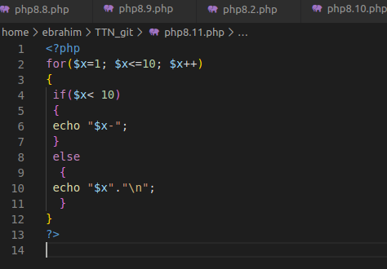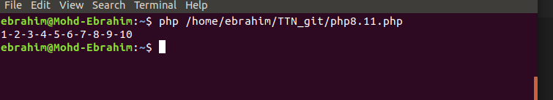

**Include a PHP file (abc.php) in another file (xyz.php) and use variables from abc.php in xyz.php.**

