**Q1:- How to get array first element without knowing the key of Array using PHP built-in function only?**

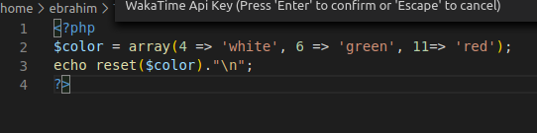

**Q2:-How can we get the second of the current time using date built-in functions?**

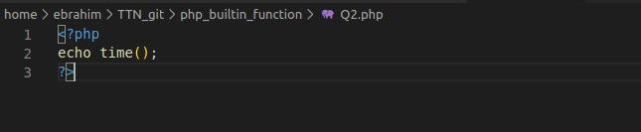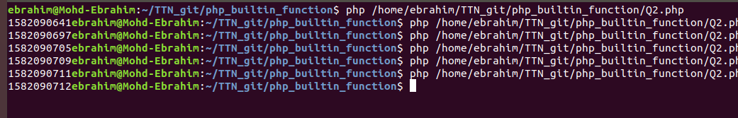

**Q3:-What is the difference between the functions unlink and unset?**

**Ans:-** Both the functions are used to do some undo operations but used in different situations cause both acts differently. The [unlink() function](https://www.geeksforgeeks.org/php-unlink-function/) is used when you want to delete the files completely. The [unset() Function](https://www.geeksforgeeks.org/php-unset-function/) is used when you want to make that file empty.

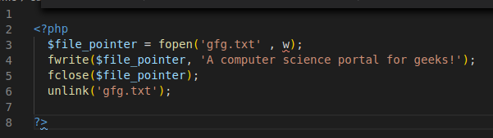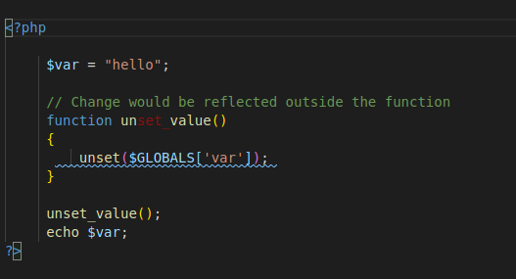

**Q4:- How to append data into a file named 'abc.txt'?**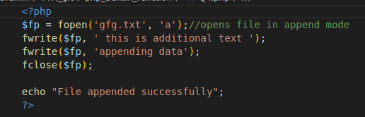



**Q5:-How can we get the properties (size, type, width, height) of an image using PHP built-in functions?**

**Q6:-Write a program to check if a string is a PALINDROME or not using built-in functions?**

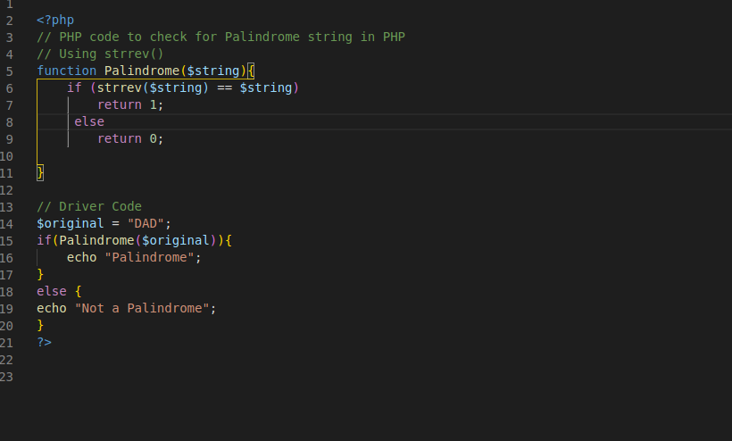

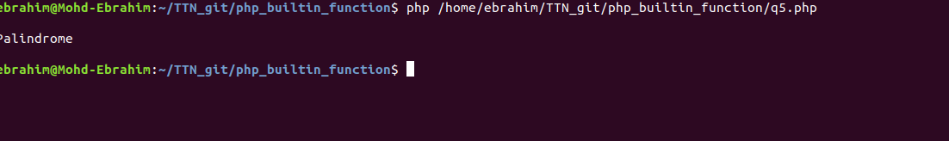

**Q7:- How to pass variables by value and reference in PHP? Explain with code snippets.**

**Pass by value:**- PHP variables are passed by value as the function arguments in PHP. When variables in PHP is passed by value, the scope of the variable defined at function level bound within the scope of function. Changing either of the variables doesn’t have any effect on either of the variables.

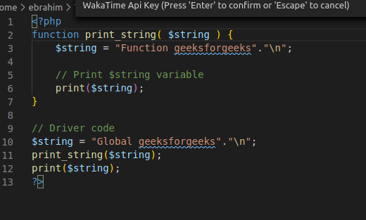

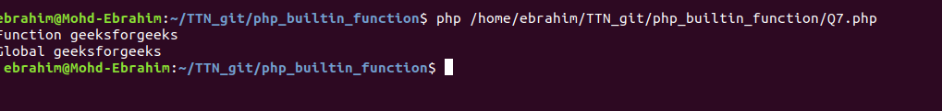

**Pass by reference:** When variables are passed by reference, use & (ampersand) symbol need to be added before variable argument. For example: function( &$x ). Scope of both global and function variables becomes global as both variables are defined by the same reference. Therefore, whenever the global variable is changed, the variable inside function also gets changed and vice-versa is applicable.

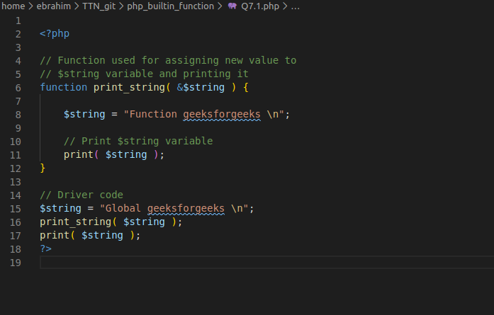



**Q8:- What’s the difference between the include() and require() functions? Show with an example.**

**include():-**This function is used to copy all the contents of a file called within the function, text wise into a file from which it is called. This happens before the server executes the code.

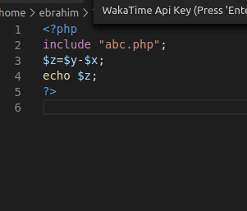

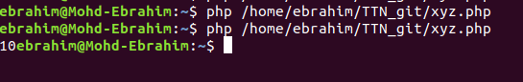

The require() function performs the same as the include() function. It also takes the file that is required and copies the whole code into the file from where the require() function is called. There is a single difference between the include() and require() function.

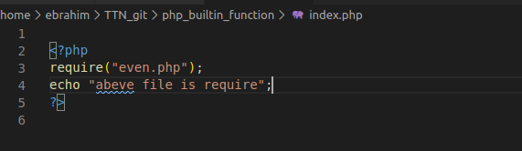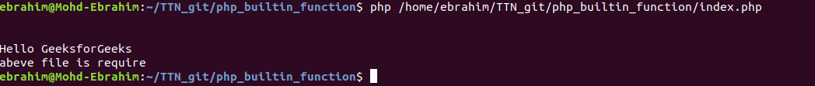

**Q9:-Explain different sorting function in PHP? Show with Examples.**

1. **sort()**
2. **rsort()**
3. **asort()**
4. **ksort()**
5. **arsort()**
6. **krsort()**

**sort() –** sorts arrays in ascending order

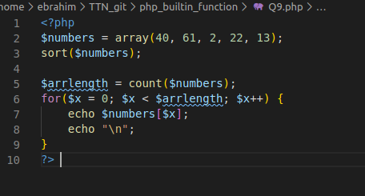

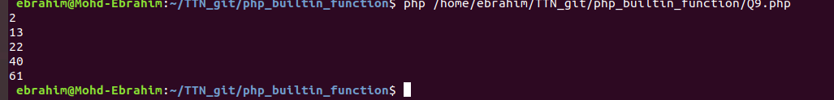

**rsort() –** sorts arrays in descending order

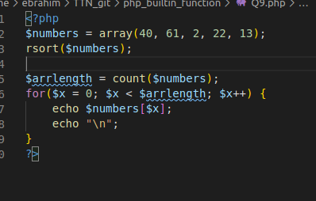

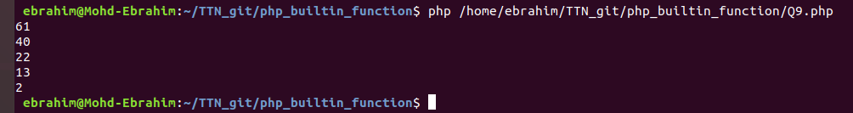

**asort() –** sorts associative arrays in ascending order, according to the value

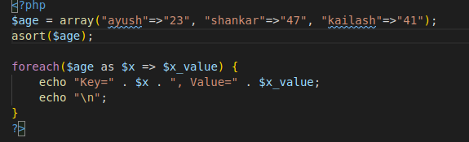



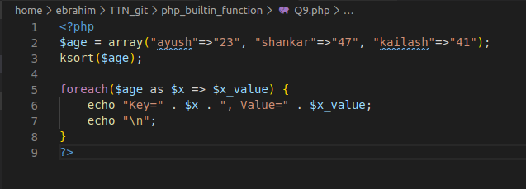



**arsort() –** sorts associative arrays in descending order, according to the value

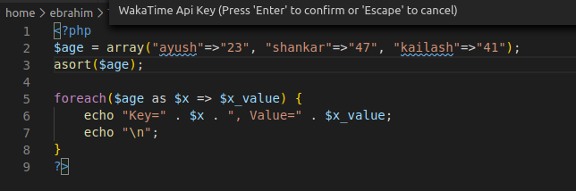



**Q10:-Differences between printf, print, echo, sprintf,vprintf, vfprintf, vsprintf in PHP?**

**Ans:-**

***print* :**

* Output a string onto the screen – Also “print” is not a real function so you are welcome to remove the parentheses.
* Because this is a language construct and not a function, it cannot be called using [variable functions](http://php.net/manual/en/functions.variable-functions.php)
* Always returns a 1

***echo :***

* Output one or more strings
* Also not a real function but a language construct
* Does not returns anything so its cannot behave as a function.

***printf :***

* Output a formatted string
* Returns the length of the outputted string

***sprintf:***

* Returns a formatted string
* Returns a string produced according to the formatting string *format*

***vprintf:***

* Returns a formatted string
* Operates as printf() but accepts an array of arguments, rather than a variable number of arguments.
* Display array values as a formatted string according to *format*

***vsprintf:***

* Display array values as a formatted string according to *format*
* Operates as sprintf() but accepts an array of arguments, rather than a variable number of argument

***vfprintf :***

* Write a formatted string to a stream
* Write a string produced according to *format* to the stream resource specified by handle
* Returns the length of the outputted string

**Q11:-Find Time Difference between two dates**

**'2012-11-04 05:04:00' => Timezone = GMT**

**'2012-11-05 10:44:00' => Timezone = IST**

**And Return Date Time in GMT format.**

**Q12:- Return contents of your working directory in descending order by name in PHP**

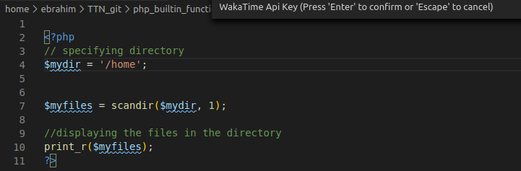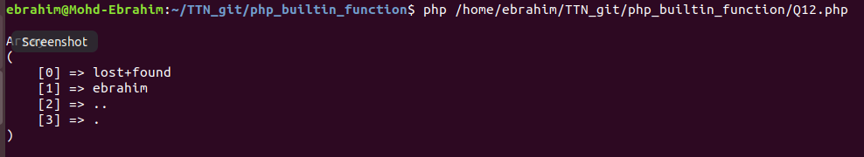

**Q13:- Write a Code using your knowledge of builtin functions to convert Sample string to Resultant String.**

**Sample string: '082307'**

**Resultant String: ‘08:23:07’**

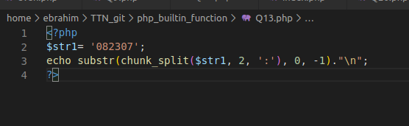

**Q14:- Write code to extract the file name from the following string.**

**Sample String: '**[**www.example.com/public_html/index.php?q=123**](http://www.example.com/public_html/index.php?q=123)**'**

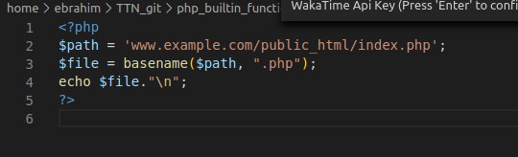

**Q15:- Write a PHP script to extract the user name from the following email ID.**

**Sample String: 'rayy@example.com'**

**Using Built-In Functions only!**

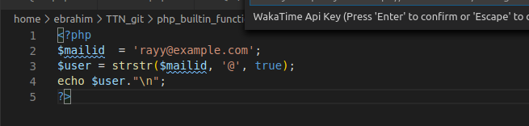

**Q17:- Write a Code to insert a string at the specified position in a given string.**

**String: 'The brown fox'**

**Insert 'quick' between 'The' and 'brown'.**

**Using Built-In Functions Only**

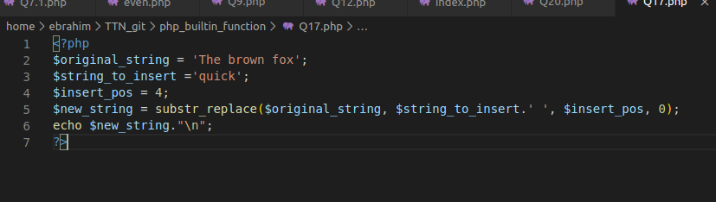



**Q18:- Write a program in PHP which performs the same function as built-in function array_count_values**

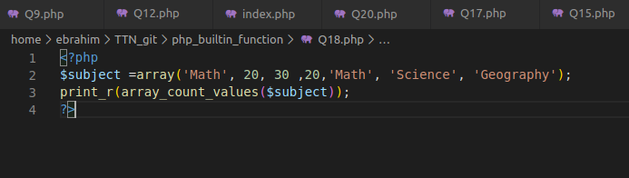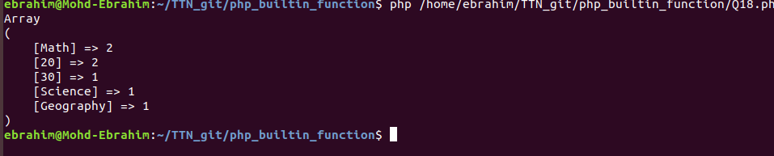

**Q19:-What is the use of sessions and cookies in PHP? How to set a session and a cookie with a code snippet.**

**Ans:- PHP Sessions.** A session is a way to store information (in variables) to be used across multiple pages. Unlike a cookie, the information is not stored on the users computer.

**PHP Cookie.** A cookie is often used to identify a user. A cookie is a small file that the server embeds on the user's computer. Each time the same computer requests a page with a browser, it will send the cookie too. With PHP, you can both create and retrieve cookie values.

A cookie is created with the setcookie() function.

**Q20:-What is the output of this question ?**

**<?php**

**$a = array_fill(5, 6, 'banana');**

**$b = array_fill(-2, 4, 'pear');**

**print_r($a);**

**print_r($b);**

**?>**

