**Birzeit University**

**Faculty of Engineering and Technology Department of Electrical and Computer Engineering**

**First Semester – 2023/2024**

**ENCS2340 - Digital Systems**

**Homework # 2**

Student name : Mohammad Sheikh

Student ID : 1221541

Q1 )

Q3)

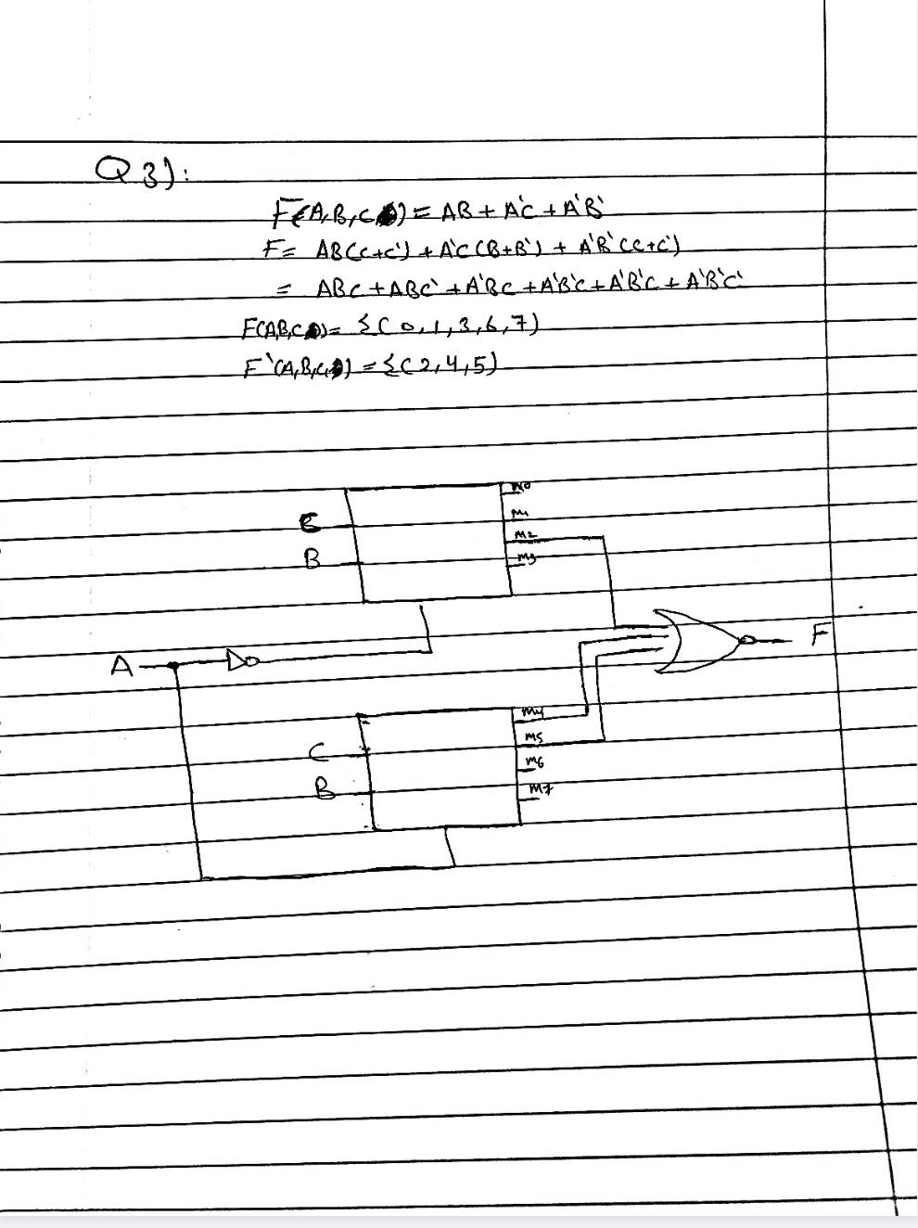

Q4 )

B –

Q4 )

C-

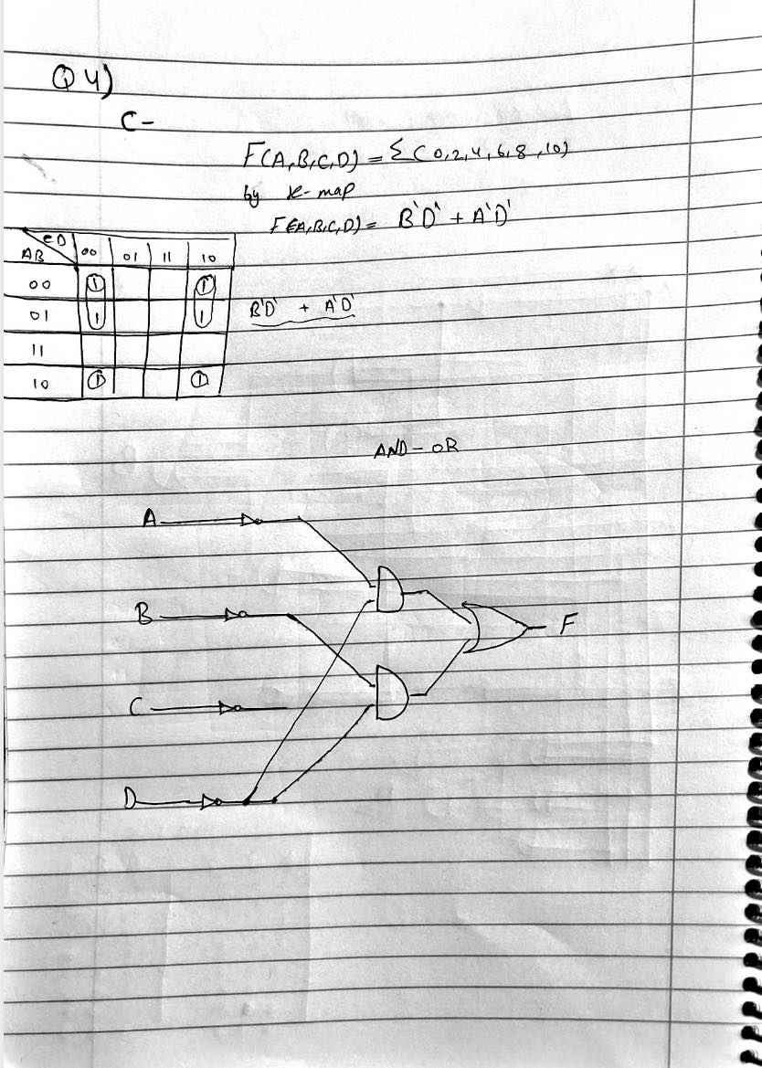

Q 4 )

D -

Q5 )

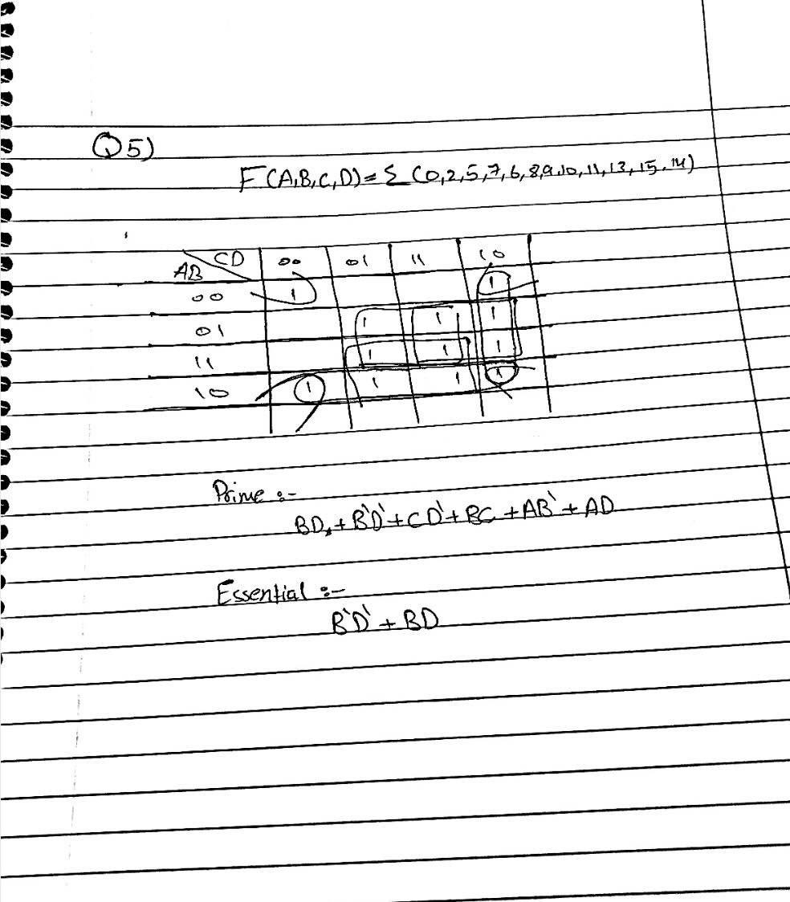

Q 6)

An Odd Parity Generator is a digital circuit that adds a parity bit to a data stream. This parity bit ensures that the total number of 1’s in the data stream is odd, which helps in detecting single bit errors during data transmission. If the input data word has an odd number of 1’s, a ‘0’ is added as the parity bit, and if it has an even number of 1’s, a ‘1’ is added.

Here’s how it works:

1. If the input data word has an odd number of 1’s , the parity generator adds a ‘0’ as the parity bit.
2. If the input data word has an even number of 1’s , the parity generator adds a ‘1’ as the parity bit.