LAB LINUX - Comp311

Name : Mohammad Sheikh ID : 1221541 Sec : 3

Q #1:

Q #2:

Q #3:

Q #4:

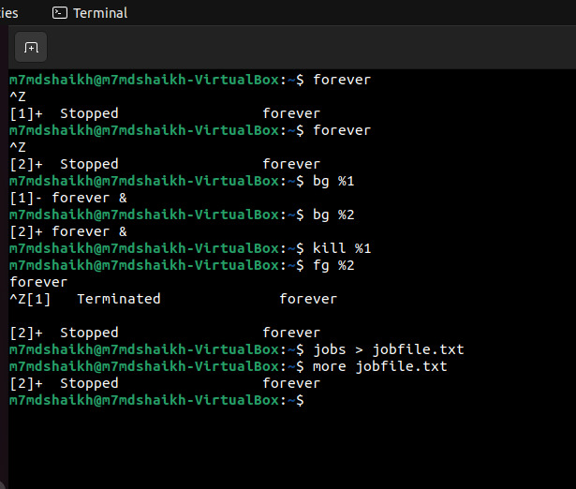

Q #5:

Q #6:

Q #7:

Q #8:

Q #9:

Q #10:

