LAB LINUX - Comp311

QUESTION 2:

Name : Mohammad Sheikh ID : 1221541 Sec : 3

Q1:

Q2 :

Q3 :

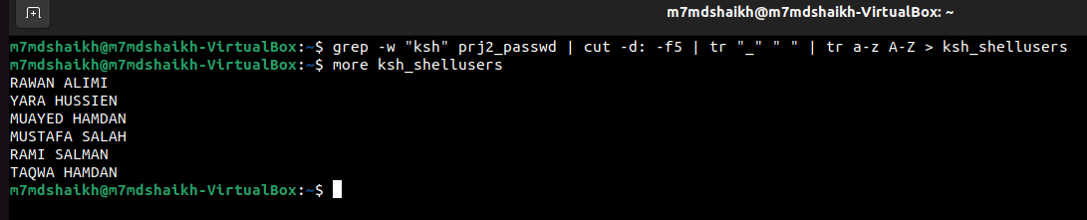

Q4 :

Q5 :

Q6 :

Q7 :

But in file no student have a number id started with u118

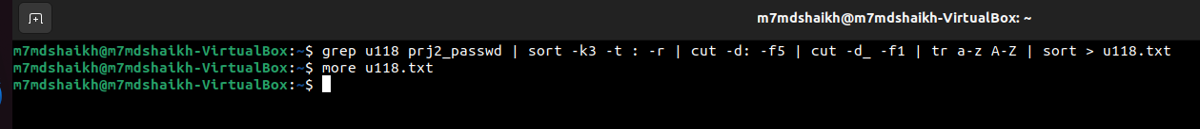

here I put 116 instated of 118 and this is the result :

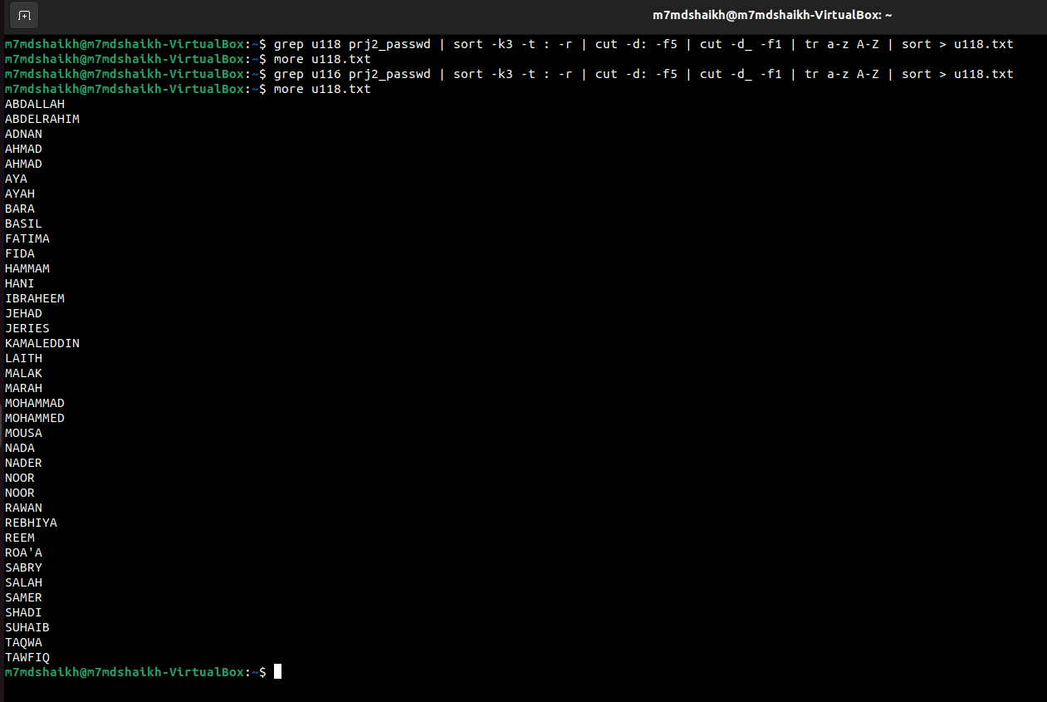

Q8 :

Q9 :

Q10 :

