ERD

Proj_1
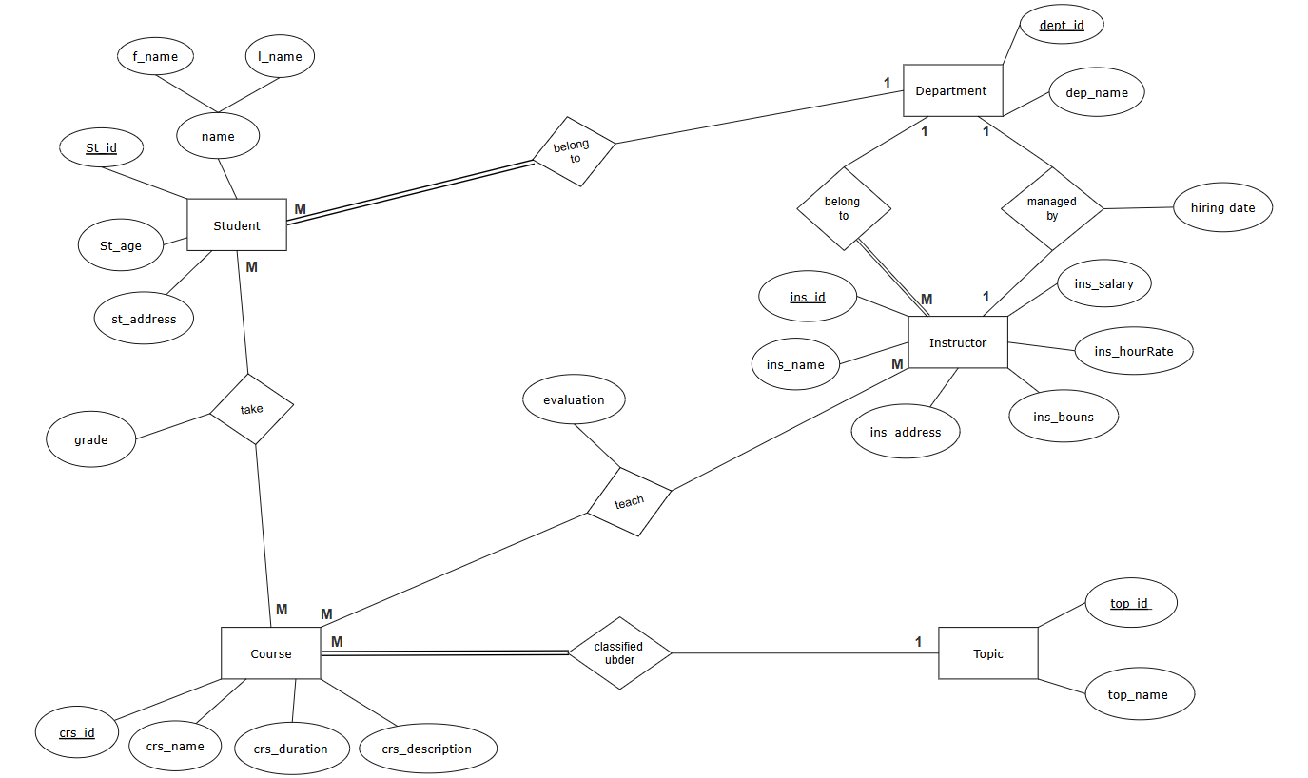

Proj_2
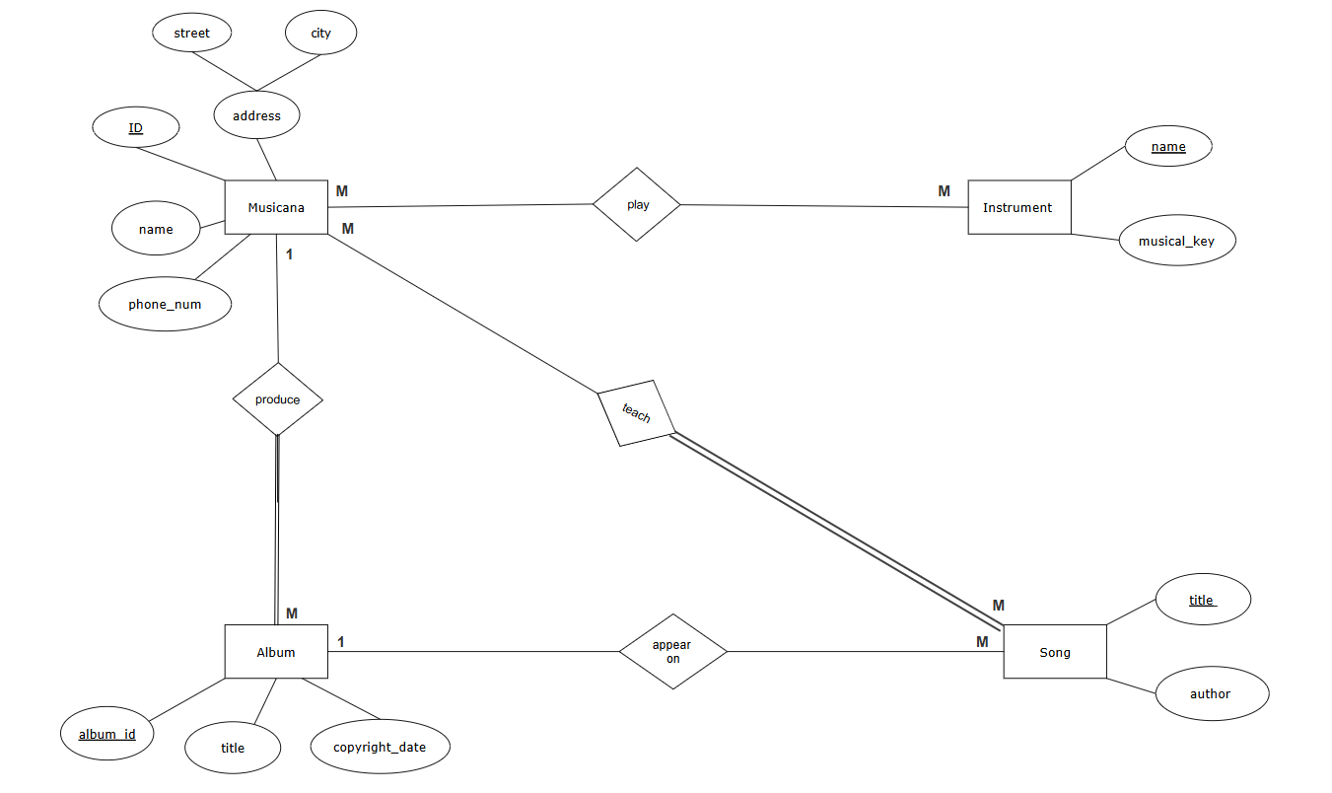

Proj_3
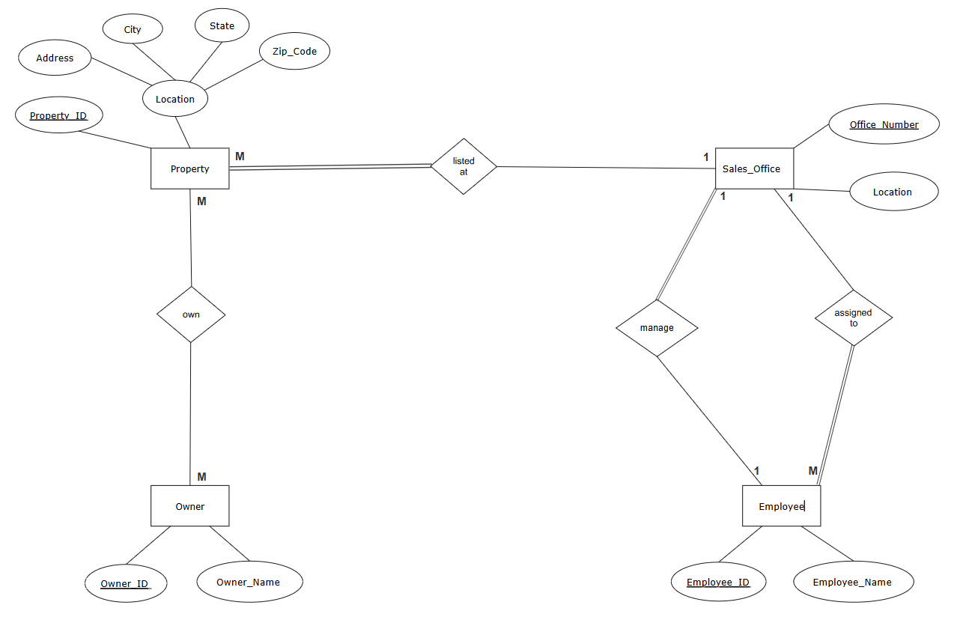

Proj_4
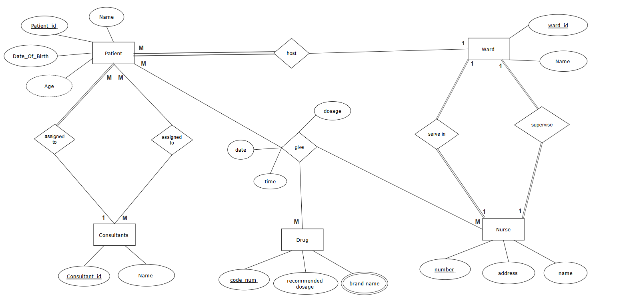

Proj_5
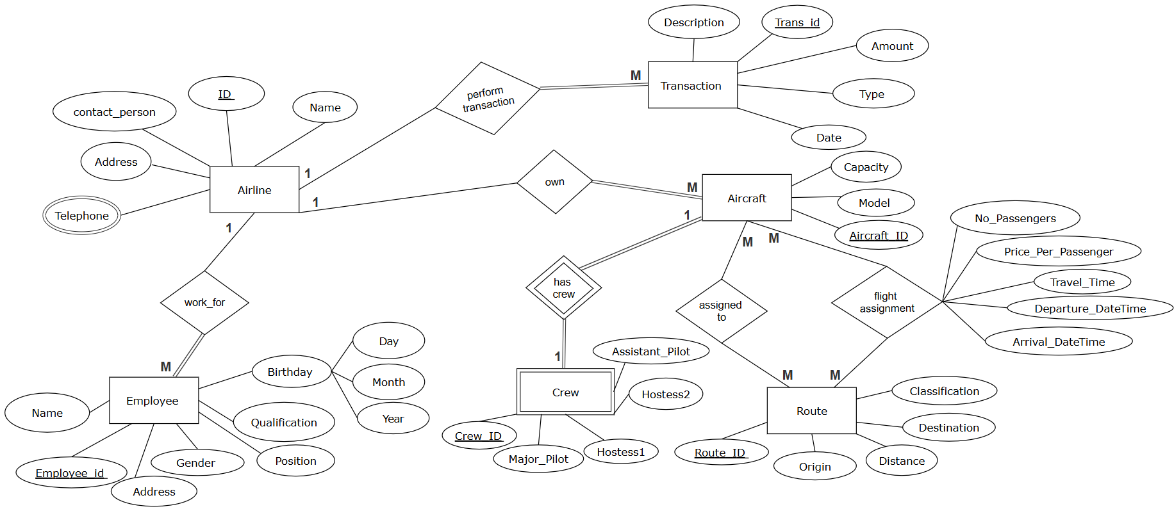

Self
- Relationship between ERD & UML:
1. ERD and UML are both modeling tools
- Both are used during the system design phase.
- They help visualize and plan the system before implementation.
- But each focus on a different aspect:
  - ERD focuses on data structure
  - UML focuses on system structure and behavior
2. ERD can be represented inside UML
- Class Diagrams in UML can represent the same information as ERDs.
  - Entities → Classes
  - Attributes → Class attributes
  - Relationships → Associations between classes
So, an ERD can be considered a simplified form of a UML Class Diagram, focused only on data.
- Where is the equation written?
The derived entity equation is usually documented in the design documents such as the ERD (Entity-Relationship Diagram), Data Dictionary, or Business Logic Specifications. It may also be written directly in the backend code (e.g., SQL queries or business logic functions).
How does the developer receive it?
The developer receives the derived equation either from:
- The System Analyst or Database Designer through proper documentation.
- A shared business logic document that outlines how each derived attribute is calculated.
- Or by direct communication with the analyst or client if documentation is missing.
How is it implemented?
The equation is usually implemented as:
- A computed column in a SQL query or view.
- A function or formula in backend code (Python, Java, etc.).

- Relationship Between Strong Entity and Weak Entity (as Classes):
A Strong Entity is like an independent class (Parent/Base Class). It has its own primary key and can exist on its own.
A Weak Entity is like a dependent class (Child or Composed Class). It cannot exist without the strong entity and depends on it for identification.
The relationship between them is similar to Composition in Object-Oriented Programming:
- The weak entity is owned by the strong entity.
- If the strong entity is deleted, the weak one usually cannot exist.

- Enhanced ERD, Inheritance, and SOLID:
Enhanced ERD (EERD) extends the basic ERD by introducing advanced concepts like:
- Generalization
- Specialization
- Inheritance
- Aggregation
These features directly support object-oriented programming (OOP) by allowing entities to be modeled using class inheritance, where:
- Superclasses (general entities) define shared attributes.
- Subclasses (specialized entities) inherit and extend those attributes.
It helps in building structured class hierarchies and supports SOLID principles by:
- Promoting responsibility separation (SRP)
- Enabling extension without modification (OCP)
- Supporting substitutability (LSP)
- Encouraging cleaner, focused models (ISP)
- Allowing abstraction and dependency inversion (DIP

- The selection of a primary key depends:
1. Nature of the Data
- Is there a naturally unique attribute already in the table?
→ If yes, it may be used as a natural key (e.g., National ID, ISBN).
→ If no, then use a surrogate key (e.g., auto-incremented ID).
2. Stability of the Attribute
- Will the value remain constant over time?
→ Choose attributes that don’t change (e.g., employee ID, not name/email).
3. Data Integrity
- Is the attribute always available and non-null?
→ Must choose an attribute that always exists for every row.
4. Performance
- Is the attribute suitable for fast indexing and searching?
→ Numeric keys (like integers) are better for performance than long strings.
5. Simplicity and Clarity
- Is the key simple and easy to use in queries and joins?
→ A single-column key is better than a multi-column (composite) key unless necessary.
6. Uniqueness Across the System
- Will the key remain unique even in the future?
→ Make sure it won’t cause duplication later when data grows or integrates with other systems.

- Why Do We Define a Primary Key When Modeling the System as Classes
Reason | Explanation
Unique Object Identity | Helps distinguish each object (like a row in a table)
ORM and Database Mapping | Required for mapping classes to database tables
Object Updates and Tracking | Makes it easy to update/delete specific instances
Relationships Between Classes | Enables linking classes just like foreign keys
System Consistency | Keeps object models aligned with database structure

