Class diagram
A Class Diagram shows the structure of a system by displaying classes, their attributes, methods, and the relationships between them.
It helps in designing and understanding object-oriented systems.
Relationships can be:
- Association → general connection between classes
- Inheritance → one class inherits features from another
- Aggregation/Composition → a class is made of other classes
- Dependency → one class depends on another
Example:
- Book class: title, author → borrow(), return()
- Member class: name, ID → register(), payFees
- A Member borrows a Book → Association

Cluster Index
Cluster Indexing is a database indexing technique used to speed up data retrieval
- In a Clustered Index, the table’s rows are physically stored on disk in the same order as the index
- There’s only one clustered index per table because the data rows can only be sorted one way
- It makes searching for ranges of values faster
- Primary keys are often implemented as clustered indexes
- Clustered indexes are useful when:
- You often search for ranges of values (e.g. dates, IDs).
- You run queries that sort or order data by a specific column.
Ex:
If you create a clustered index on a column like EmployeeID, the table’s rows are stored sorted by EmployeeID. So, searching for employees between ID 100 and 200 is fast
select *
from Employees
where Employee_ID between 100 and 200
-> is very fast because the database can directly read the matching block of rows
-> Without a clustered index, the database might have to scan the entire table to find those rows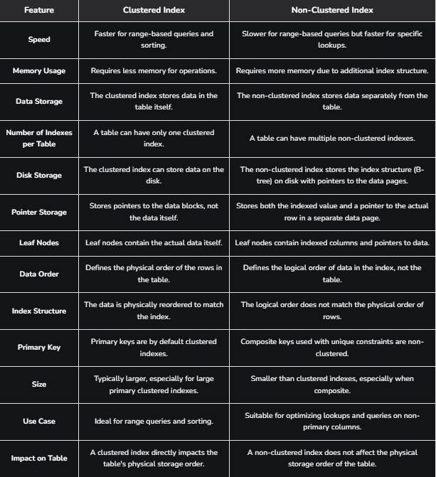
Built in stored procedures
Built-in Stored Procedures are predefined procedures provided by a database system (like SQL Server, MySQL) to help perform common tasks.
- They are already created for you by the database engine.
- You can run them to manage the database, get information, or perform administrative tasks.
- They usually start with special characters, like sp_ in SQL Server or start with mysql. in MySQL.
Ex in SQL Server:
- sp_help → shows info about tables, views, procedures.
- sp_who → shows current users and sessions.
- sp_rename → renames a table, column, or other object
exec sp_help 'Employees'

SQL Injection
SQL injection (SQLi) :
is a web security vulnerability that allows an attacker to interfere with the queries that an application makes to its database.
This can allow an attacker to view data that they are not normally able to retrieve.
This might include data that belongs to other users, or any other data that the application can access.
In many cases, an attacker can modify or delete this data, causing persistent changes to the application's content or behavior.
How to detect SQL injection vulnerabilities:
You can detect SQL injection manually using a systematic set of tests against every entry point in the application. submit:
- The single quote character ' and look for errors or other anomalies.
- Some SQL-specific syntax that evaluates to the base (original) value of the entry point, and to a different value, and look for systematic differences in the application responses.
- Boolean conditions such as OR 1=1 and OR 1=2, and look for differences in the application's responses.
- Payloads designed to trigger time delays when executed within a SQL query, and look for differences in the time taken to respond.
- OAST payloads designed to trigger an out-of-band network interaction when executed within a SQL query, and monitor any resulting interactions.
Some common SQL injection examples include:
- Retrieving hidden data, where you can modify a SQL query to return additional results.
- Subverting application logic, where you can change a query to interfere with the application's logic.
- UNION attacks, where you can retrieve data from different database tables.
- Blind SQL injection, where the results of a query you control are not returned in the application's responses.

