CS 1632 - DELIVERABLE 2: Unit Testing and Code Coverage

https://github.com/M94/cs1632-d2

Austin Choi

The test that I had an issue writing was the getPath() method for my Place class. This method takes an index and returns a path from the array of paths in a Place object. However, since the array is private, the only way to add paths is to use the addPath() method. Testing if getPath() would return a stored path would require me to test addPath() at the same time as well, which goes against the rule that each test should only test one thing. I could not just use method stubbing for addPath() because I needed it to actually add a new path to the place object’s array so getPath() could fetch it. In the end, I decided to only test what the method would return if the array were empty. Since the method itself only contains one line of code, I did not feel the need to do additional testing on it.

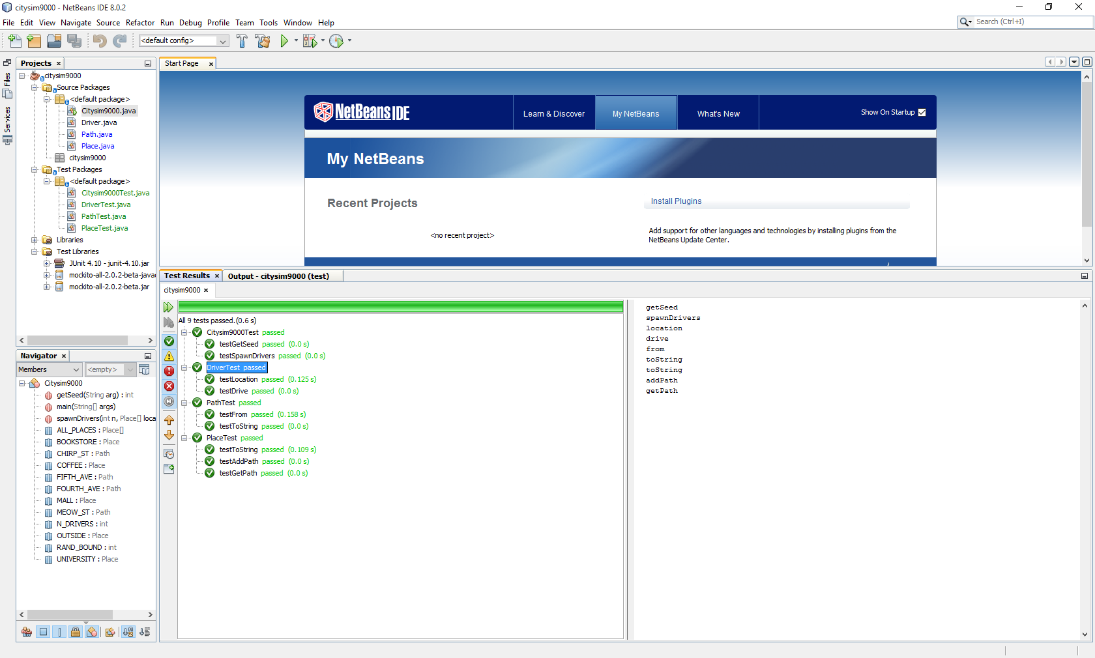Unit Tests: all public methods covered

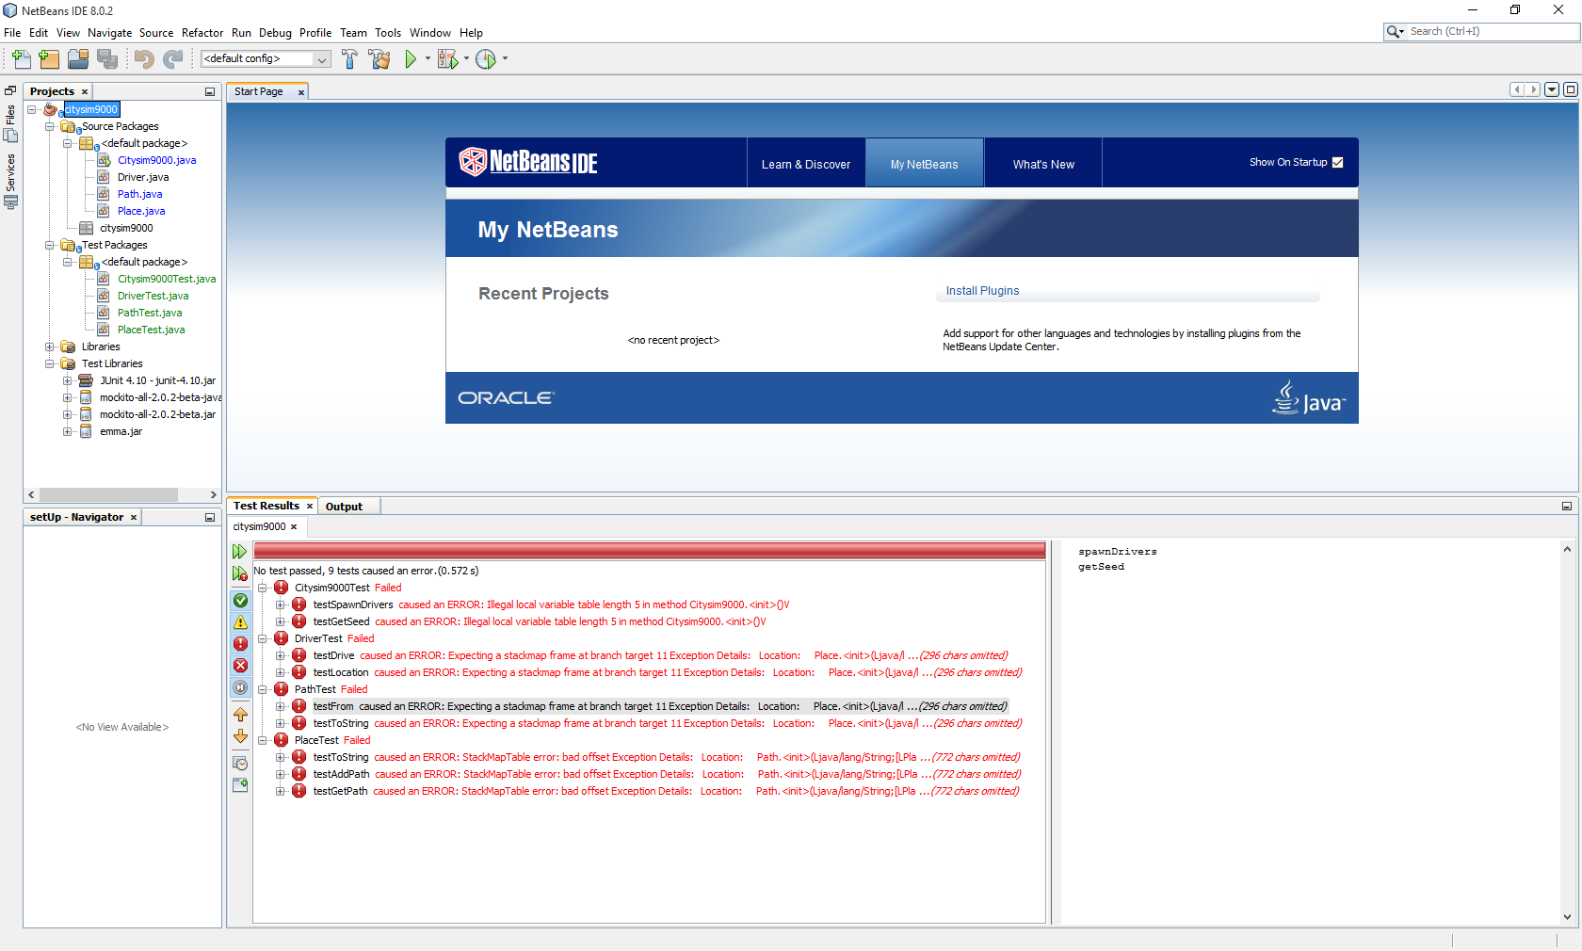The code coverage tool in NetBeans was acting up. It threw errors on every test. I could not determine why it was not working. I will probably use Eclipse on the next project..