# CPCS 403 – Assignment 1

## Storyboard:

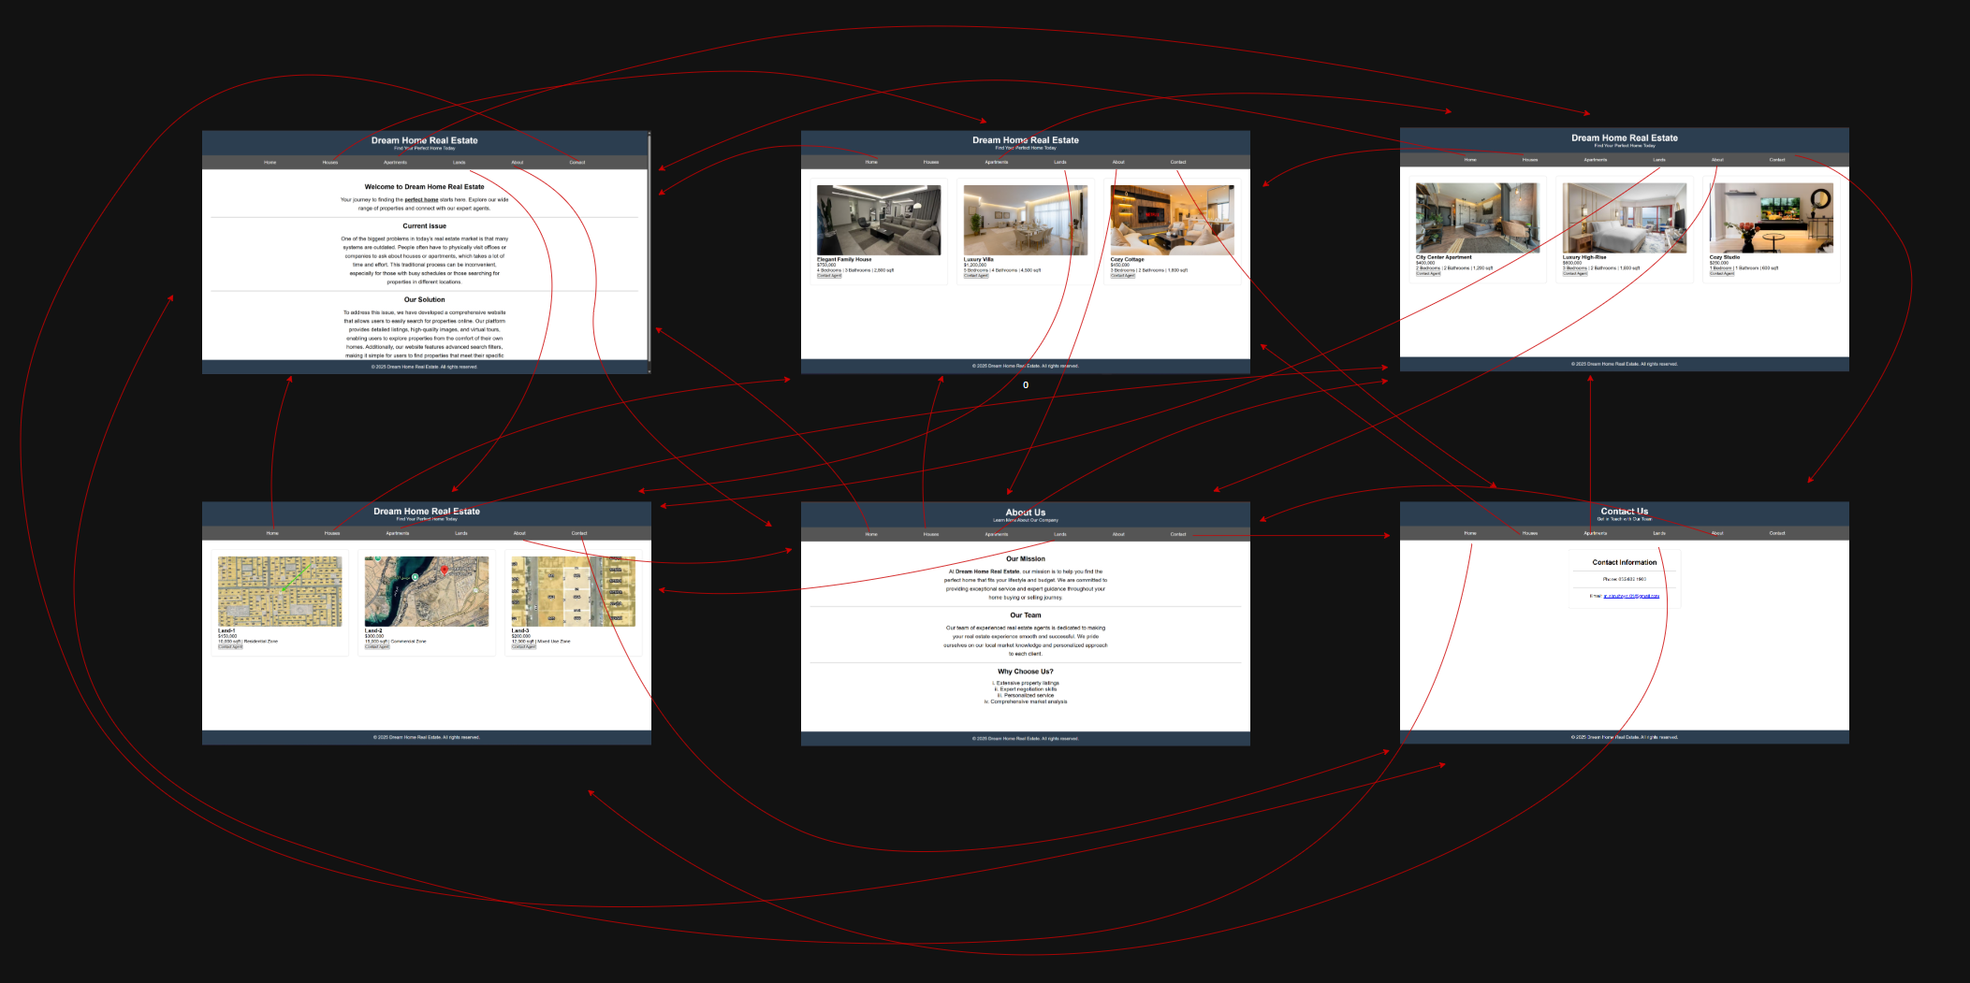

Site map:

Problem definition:

Finding a new home should be exciting, not exhausting. Too often, it means sacrificing your valuable time visiting offices and viewing properties that aren't the right fit, making the search a frustrating and inconvenient chore.

Recommended solution:

We put the power of the property market in your hands. Our platform lets you tour homes virtually, browse beautiful photo galleries, and filter your search down to the perfect detail—all from the comfort of your couch. We make finding your next home simple, efficient, and enjoyable.

Benefits:

* Reduced Search Time
* Fewer Wasted Visits
* 24/7 Accessibility
* Search From Anywhere
* Lower Travel Expenses
* And much more…