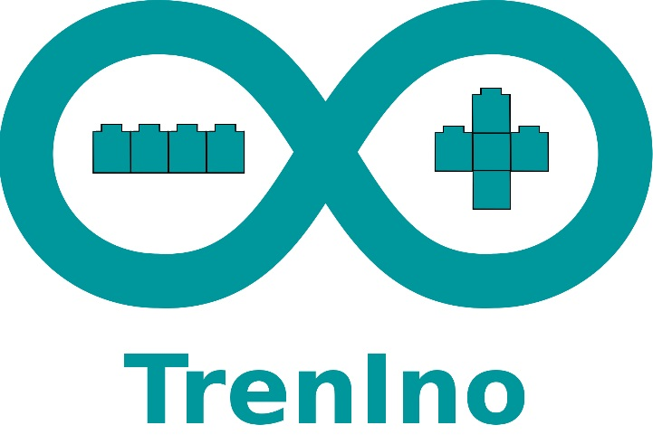 **"TrenIno" is a project that combines the passion for Lego® bricks and Arduino®.**  
This railway diorama, called “**DepotIno**”, simulates a small railway yard where the 3 locomotives (red, yellow and green) go from the shed to the tunnel.  
The departure of the locomotives occurs randomly and once the locomotive arrives in the tunnel it will "hide" for a few seconds (in order to simulate the exit from the yard) and then return to the starting track.  
The entry and exit of the locomotives is managed by activating the **switches** hidden between the bricks while on each train a **sensor** has been mounted that reads the colors of the bricks positioned on the tracks, each color was then assigned a specific task: stop, reverse direction or turn off on train. If the batteries of a locomotive are close to exhaustion, one of the switches is activated automatically and directs the train to the charging station located near the tunnel and then turns it off and disconnected from the system waiting for the batteries to be changed. Near the roadhouse there is a **traffic light** that signals the departure of the locomotives.

The path that goes from the shed to the tunnel crosses a forest, where you can hear the sound of birds and the water flowing in the stream and on the bridge a fourth locomotive makes an random passage. In addition, the shed has been equipped with lighting to facilitate work even in the evening hours.

Designed by **MezzanineLab**, the diorama measures 230×88 cm (or 288×112 stud) and is made up of more than **10,000** bricks, **4** locomotives and about **50** characters. It also includes a train station with roads, cars, and level crossings.

****Fantasy, technique, bricks and lines of code: a mix between 2 different worlds that together I can create limitless adventures.  
Follow us on our Facebook page: **facebook.com/m9lab**