Support the Bubble Bobble project on LEGO Ideas!
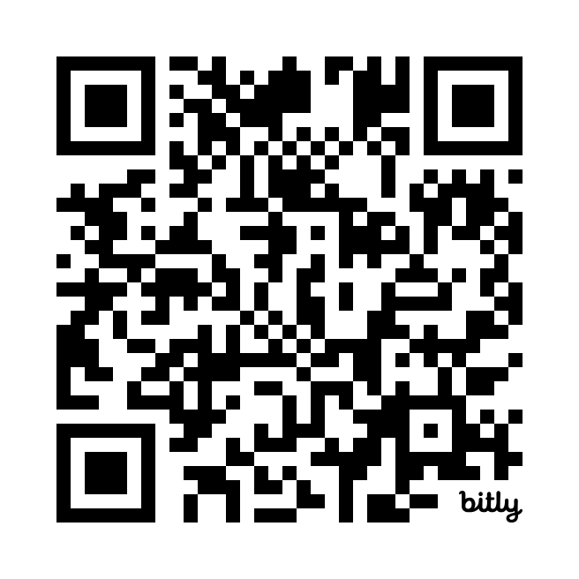
It only takes a few seconds of your time to help me: scan the qrcode on the side (or go to bit.ly/3LEccE4) and vote for this project by clicking on the yellow “support” button at the top right, it’s free, you just need your e-mail and a few seconds of your time.
If it gets 10,000 votes it could be considered to become a real Lego set.
Thank you so much, I’m counting on your support to bring Bub and Bob as a Lego set to shelves all over the world!!!
