
“Find the Characters” Game
There are 5 special characters hidden in the diorama, if you manage to find them all you will receive a candy!
What are the special characters to find?
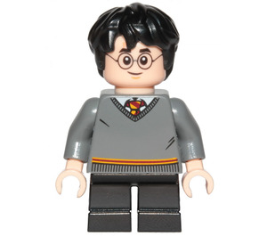 | 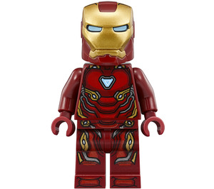 | 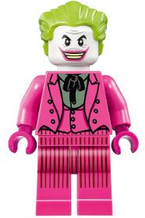 | 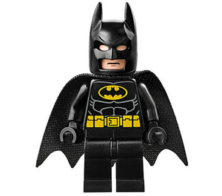 | 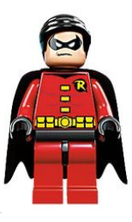
Harry Potter | Iron Man | Joker | Batman | Robin

Once you've found them, DO NOT POINT THEM but raise your hand and we will be with you as soon as possible!
Good hunting!

