General Flowchart

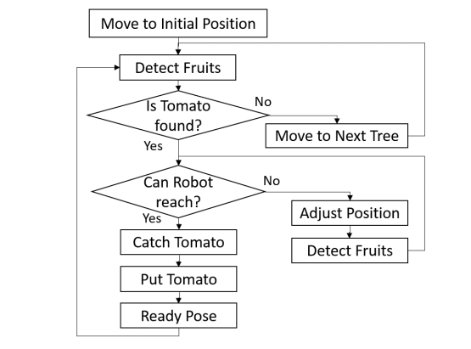

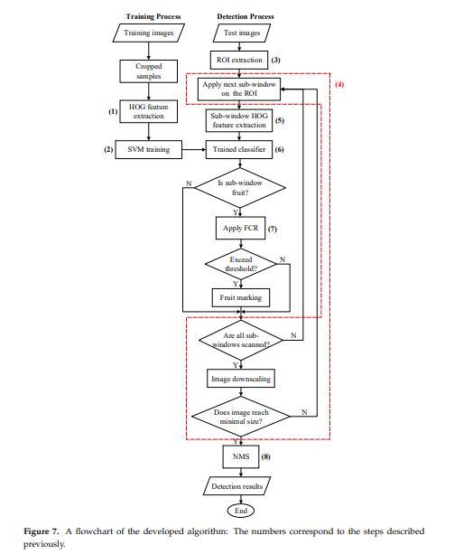

Motor

**Simple line following algorithm**

1. Start

2. Read SLL SL. SR and SRR sensor's value.

3. If SLL and SRR on black surface

4. If SL and SR on black surface

5. Move forward (rotate both motor on full speed)

6. Go to step 2

7. If SR on white line

8. Move Right (reduce Right motor speed to half)

9. Go to step 2

10. If SL on white line

11. Move Left (reduce Left motor speed to half)

12. Go to step 2

13. If SLL and/or SRR is/are on white surface

14. Not a simple line

15. Follow 90-degree tum algorithm

90-degree tum algorithm

1. Start

2. Read SLL, SL, SR and SRR sensor's value.

3. If SLL and SRR on black surface

4. Follow simple line following algorithm

5. If SLL and SL on white line

6. // 90° left tum

7. While SLL and SRR are not back on black surface

8. Rotate left motor in reverse direction and right motor in forward direction

9. Read SLL SL, SR and SRR sensor's value.

10. If SRR and SR on white line

11. //90° right tum

12. While SLL and SRR are not back on black surface

13. Rotate right motor in reverse direction and left motor in forward direction

14. Read SLL, SL, SR and SRR sensor's value.

15. Go to step 2

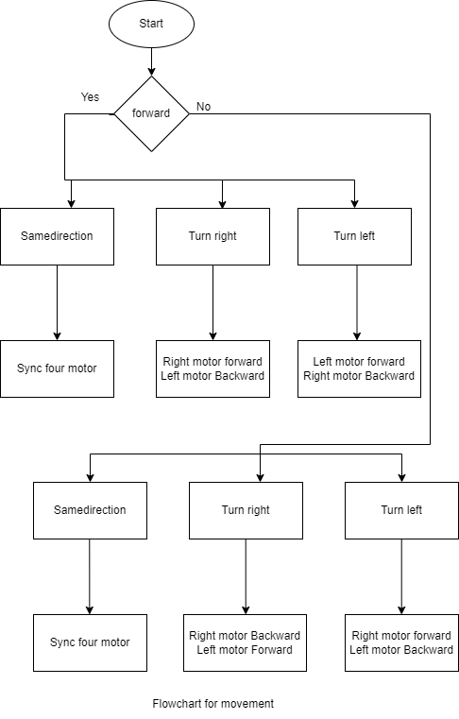

Arm

