1: 下载安装包

官网 <http://nginx.org/en/download.html>

依赖包：gcc / pcre-devel / openssl / openssl-devel

安装依赖包：yum -y install gcc pcre-devel openssl openssl-devel

下载：wget  <http://nginx.org/download/nginx-1.9.11.tar.gz>

解压：tar zxvf nginx-1.9.11.tar.gz

编译：(1) mkdir /usr/local/nginx

(2) cd nginx-1.9.11

(3) mv \* /usr/local/nginx

(4) cd /usr/local/nginx

(5) ./configure --prefix=/usr/local/nginx

(6) make

(7) make install

默认安装路径：/usr/local/nginx

安装成功：(1) cd /usr/local/nginx/sbin/

(2) ./nginx –t (没有log文件夹要自己创建)

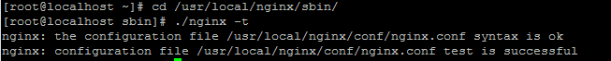

启动：(1) cd /usr/local/nginx/sbin/

(2) ./nginx

端口修改：vi /usr/local/nginx/conf/nginx.conf

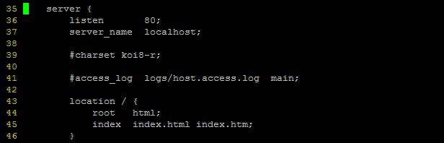

查看端口状态：netstat -ntlp

访问Nginx：

1：curl <http://27.54.237.80>

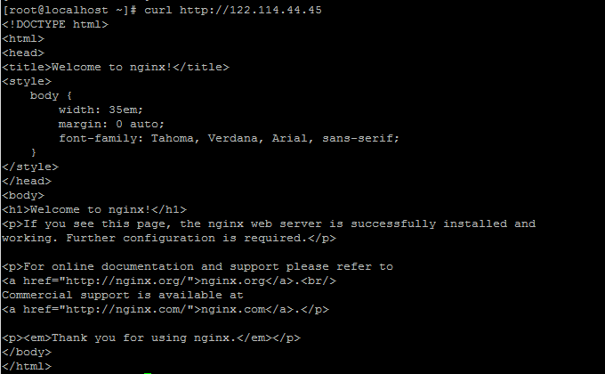

2：浏览器访问：http://122.114.44.45

