CST4067 Cloud and Big Data Technologies
Design and Implementation Document
Secure Cloud File Vault with Custom ABAC Policy Engine
and BigQuery Access Analytics
Moazzam Ali Sani
M01104554

Module Code: CST4067
Word Count: approximately 2,300 words

Contents
1. Introduction 3
2. Aims and Objectives 3
3. Concept 3
4. Security Concepts and Cloud Technology Used 4
AES-256-GCM Encryption 4
TLS in Transit 4
Firebase Authentication and JWT Verification 4
Custom ABAC Policy Engine 4
Google Cloud Platform Services 4
5. Requirements Specification 5
Program Behaviour Requirements 5
Security Requirements 5
6. Analysis and Design 5
System Architecture 5
ABAC Policy Evaluation Flow 6
Policy Document Structure 7
BigQuery Audit Schema 7
7. Implementation 7
Project Structure 7
Encryption Module 7
ABAC Engine 8
BigQuery Logger 8
Firebase Authentication 8
Deployment and Services 9
8. Evaluation and Conclusion 9
References 11

1. Introduction
Many organisations are using cloud computing for file storage and sharing. With the growth of data in the cloud, the demand for the right security controls is growing as well. Many of the existing systems still make use of simple username and password for data security. However, these methods are not sufficient to manage access control based on other requirements like assignment of roles to users, departments to users or even job specific attributes to users, particularly in large organizations.
In this project, a secure vault is being developed for storing files on a Cloud. Unlike status-neutral encryption, the components give users the ability to upload and securely store files. Even if files are accessed without authorization, they are encrypted prior to storage using the Advanced Encryption Standard in Galois/Counter Mode with a 256-bit key. A custom Attribute-Based Access Control policy engine is used to control access to files. Even before approving or denying access, user attributes such as department and clearance level are compared against a policy that is bound to each file. All access events are logged into Google BigQuery, and using analytic queries, it is possible to monitor for unusual events like repeated access denials from the same user.
This system demonstrates a real-life implementation of cloud security, fine-grained access control and big data audit logging.

2. Aims and Objectives
The goal of this project is to develop a secure cloud file vault for storing files on Google Cloud Platform with attribute-based access control and real-time audit logging.
This project has the following goals.
- To encrypt all files uploaded prior to being stored in Google Cloud Storage with AES-256-GCM.
- To implement a custom ABAC policy engine that takes user attributes and considers file policies prior to granting or denying access.
- To use Firebase Authentication and validate every incoming request with a JSON Web Token for managing user identity.
- To capture every access event to Google BigQuery and run analytics queries to look for unusual access patterns.
- To create an admin panel for creating policies, editing user attributes, and setting policies on files.
- To show how the system operates in test scenarios for both allowed and denied access, as well as how live policy changes take effect without restarting the application.

3. Concept
SecureVault is a web-based file vault built with Python and Flask. Each user can log in and upload a file. The server encrypts the file with AES-256-GCM, and to keep the file private while it is in Google Cloud Storage, three parameters are stored in Firestore: the encryption key, a random nonce, and the metadata of the file.
A key difference from typical cloud file storage is the custom ABAC policy engine. The engine evaluates a set of attribute conditions present in a policy document as opposed to simple role-based rules where a user is granted a role and that role confers access. Multiple conditions can be combined with different operators. A requirement might be that a user must be in the Finance department with a clearance level of three or more, for instance. When the user does not meet all the conditions, the engine returns a denial decision and a reason indicating which condition was not satisfied.
Using streaming inserts, all access events, both allowed and denied, go into a BigQuery audit table. This builds an active log. Three pre-written analytics queries are run against this table and display denial counts per user, access volume per department, and users having an unusual denial count in the last 24 hours. These results are shown on the analytics page.

4. Security Concepts and Cloud Technology Used

AES-256-GCM Encryption
During file creation, a new key and a randomly generated 96-bit nonce are generated and the key and nonce are saved with the file metadata to Firestore. When using the Advanced Encryption Standard (AES) encryption method, files are encrypted as follows: AES-256, which is a 256-bit key symmetric encryption standard published by the National Institute of Standards and Technology (NIST), is used to encrypt files in Galois/Counter Mode (GCM) where authenticated encryption is used and will detect if the encrypted file is altered during decryption [3].

TLS in Transit
All communication between the browser and the Flask backend is encrypted using Transport Layer Security, as is all communication between the backend and the Google Cloud services, thus no data is sent over an unencrypted connection [6].

Firebase Authentication and JWT Verification
Flask handles users’ identities with the help of Firebase. When a user logs in, Flask makes a request to the Firebase REST API, which returns a signed JSON Web Token. The request is then passed to the Firebase Admin SDK which validates it on each protected call, if the user’s token is valid and has not expired [7].

Custom ABAC Policy Engine
Attribute-Based Access Control (ABAC) is more detailed than Role-Based Access Control (RBAC) which, in turn, assigns roles to users and the user’s actions are based on the role. In ABAC, the access decisions are based on conditions and the user’s attributes. The conditions in this system can check department, clearance level or any other attribute from the user profile. Supported operators include equals, not_equals, gte, lte and in_list. All conditions in a policy must be met, otherwise the access is denied.

Google Cloud Platform Services
The encrypted file blobs are stored in Google Cloud Storage. Firestore holds file metadata, user profiles, and policy documents. Each access event is streamed to BigQuery, and the results of analytics SQL queries are returned from BigQuery. Firebase Authentication manages user accounts [7, 8, 9].

5. Requirements Specification

Program Behaviour Requirements
- A registered user must be able to log in with an email address and password.
- Before uploading the file to Cloud Storage, the system must encrypt it using AES-256-GCM.
- The encryption key, nonce, owner UID, upload date, and policy ID must be stored in Firestore as file metadata.
- The dashboard must show all the files in the vault and indicate if the currently logged-in user can access each file or not.
- A user can download a file only if the ABAC engine returns an allow decision for that user and that file.
- The owner of a file can remove their own file at any time regardless of the policy.
- A user with the Admin role must be able to create new policies, edit user attributes, and assign policies to files from the admin panel.
- All access events must be reported to BigQuery and all results must be displayed on the analytics page.

Security Requirements
- All files must be encrypted at rest using AES-256-GCM before uploading.
- All communications between the client and server must use TLS.
- All API requests must carry a valid Firebase JWT. The token must be verified by the backend before processing.
- A file access decision must only be made after the ABAC engine has evaluated all policy conditions against the user’s current attributes.
- All deny decisions must be logged to BigQuery with a reason string.
- The analytics page must only be accessible to users whose department attribute is set to Admin.

6. Analysis and Design

System Architecture
There are four layers in the system. The presentation layer comprises the set of HTML pages rendered by Flask using Jinja2 templates. The application layer is the Flask backend where authentication, encryption, routing, and ABAC decisions are made. Google Cloud Storage stores encrypted file blobs and Firestore provides structured data such as user profiles, file metadata, and policy documents. The analytics layer is BigQuery, where streaming inserts are done and SQL queries are run. Communication between all four layers is via HTTPS.
Figure 1 shows the admin dashboard. It shows three files uploaded with three different policies (public, finance_read, finance_full). All files are listed as Allowed for the admin user since the clearance for the admin user is five and the department is Admin.
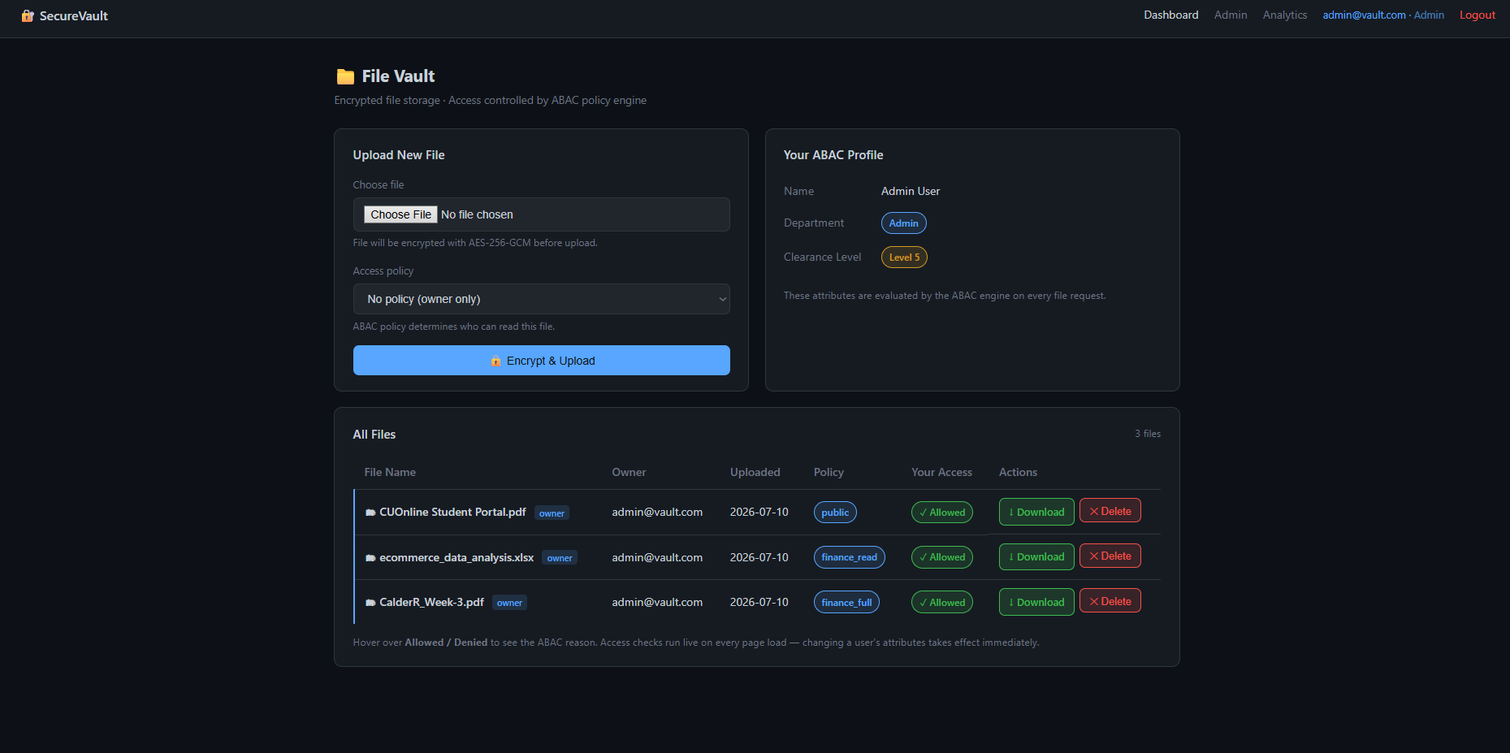
Figure 1: Admin dashboard showing three files with different ABAC policies assigned

ABAC Policy Evaluation Flow
When a user makes a read, write, or delete request, the ABACEngine class performs the following steps. It fetches the user attribute document from the Firestore users collection using the UID from the user session. Second, it gets the file metadata document from the Firestore files collection. Third, it checks if the file has a policy attached. When there is no policy, the file is only accessible by the owner. The engine then looks for a matching policy and checks if the requested action is contained in the permitted actions list. Then it evaluates each condition using the internal evaluation method. This checks if the attribute value of the user matches the required value specified in the condition using the defined operator. If certain conditions are not met, the engine responds with a deny result and a reason string.
Figure 2 displays the dashboard view of Bob in the HR department who has clearance level two. The public file is displayed as Allowed since there are no conditions set for that policy. The finance files are denied because the department attribute of Bob does not match the Finance condition required by those policies. Denied files do not show a download button.
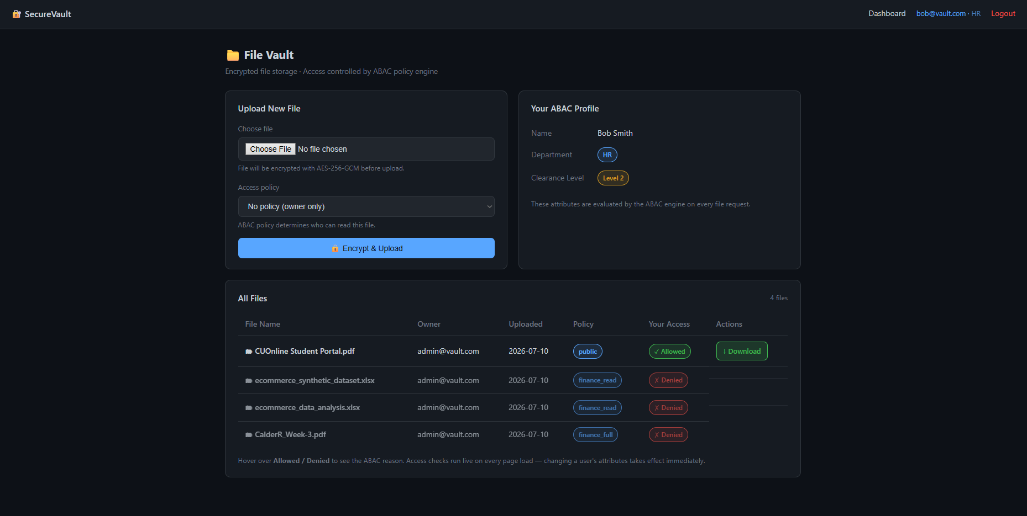
Figure 2: Bob’s dashboard (HR, Clearance 2) showing ABAC deny decisions for finance-policy files

Policy Document Structure
There are three fields in each policy document in Firestore. The conditions field is an array of condition objects containing the name of an attribute, an operator, and a value to test against. The permitted_actions field is an array of allowed actions like read, write, and delete. The policy_name field is a human-readable label that is displayed in the admin panel.

BigQuery Audit Schema
The access_events table has the following fields: event_id, timestamp, user_uid, user_department, file_id, action, decision (ALLOW or DENY), deny_reason, and policy_id. Three analytics queries are performed on this table: the total number of access denials per user, access counts per department with allow rates, and users with three or more access denials in a 24-hour period.

7. Implementation

Project Structure
The system was built using Python 3.12 and Flask 3.0. The code is organized into four modules: encryption.py contains a collection of methods to perform AES-256-GCM operations; abac_engine.py contains the methods to evaluate ABAC; bigquery_logger.py contains methods used for audit logging; app.py contains all the Flask routes and service connections. Templates are stored in the templates directory and served to the application using Jinja2.

Encryption Module
The encryption module is based on the cryptography Python library. The generate_key function creates a new 256-bit key. The encrypt_file function generates a random 96-bit nonce, encrypts the file, and stores both the encrypted bytes and the nonce in Firestore as a base64 string. The decrypt_file function reverses this using the stored key and nonce. GCM mode ensures that if the encrypted file is modified in any way, decryption will fail, providing both confidentiality and integrity protection.

ABAC Engine
The ABACEngine class requires a Firestore Client passed to the constructor. The primary method is evaluate, which receives a user UID, a file ID, and a requested action. It retrieves documents from Firestore and executes the evaluation of conditions. The internal evaluation method supports five operators: equals, not_equals, gte, lte, and in_list. The result from the evaluation is returned as a tuple containing a boolean decision and a reason string, thus keeping the engine completely separate from the Flask routes and allowing for separate testing or replacing.
Because user attributes are read from Firestore on every request, updates made in the admin panel are reflected immediately. Figure 3 shows Alice’s dashboard. Alice works in the Finance department and has clearance level three. All four files are displayed as Allowed, including the finance_full file which requires clearance level three.
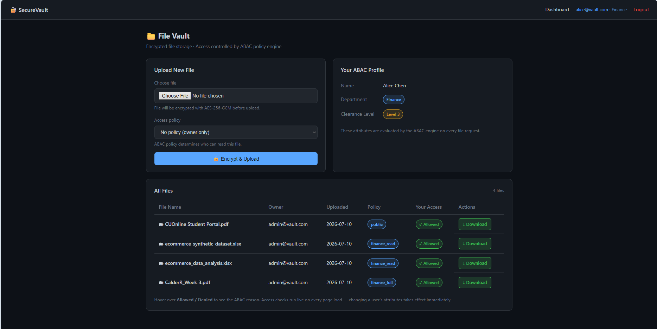
Figure 3: Alice’s dashboard (Finance, Clearance 3) showing all four files as Allowed

BigQuery Logger
The BigQueryLogger class uses the google-cloud-bigquery Python client library to push streaming inserts to the access_events table. The log_event method constructs a row dictionary and calls the insert_rows_json method. All logging errors are caught and printed without crashing the application. The get_analytics method runs three SQL queries and returns the results as lists of dictionaries, which are then rendered as tables by the analytics template.

Firebase Authentication
To manage user logins, a call is made to the Firebase Authentication REST signInWithPassword endpoint with the user-entered email and password. The ID token is then sent to Flask where it is extracted. It is then passed to the Firebase Admin SDK verify_id_token method where it is verified for signature and expiry. The user UID and attributes are then stored in the Flask session for the duration of the signed-in session.

Deployment and Services
The application runs on a local Flask development server. All four GCP services were provisioned using Google Cloud Console. The Firestore database runs in Native mode. All events are written to the access_events table, which has a nine-field schema, in the BigQuery dataset file_vault_audit. A Google Cloud Storage bucket was created in the region us-central1 with Standard storage class.

8. Evaluation and Conclusion
The system has been implemented to meet all the goals of the project. Files are encrypted on upload using AES-256-GCM and decrypted on download. Compound attribute conditions are properly evaluated by the ABAC engine in real time, providing allow or deny decisions. Firebase Authentication verifies each request and BigQuery receives streaming inserts in real time, with the analytics page displaying updated query results.
The system was tested with four groups of users with varied attributes. Bob belongs to HR and was denied access to files protected by finance policies due to a mismatch between his department attribute and the required value. Carol, a member of Finance, was denied access to files requiring a higher clearance level but was granted access to files with a lower clearance requirement. Alice, who has the correct department and clearance, was granted access to all finance files. No restart or re-login was required when the admin changed a user’s clearance level from the admin panel, and the change took effect on the next request.
The BigQuery analytics page following the test session is shown in Figure 4. The access events by department table indicates that the Admin department had six access events with a 100 percent allow rate. As other test users attempt access, their departments and denial counts will appear in the table. The anomalous user detection query returned no results at the time of capture, which was expected given the small number of test events at that stage.
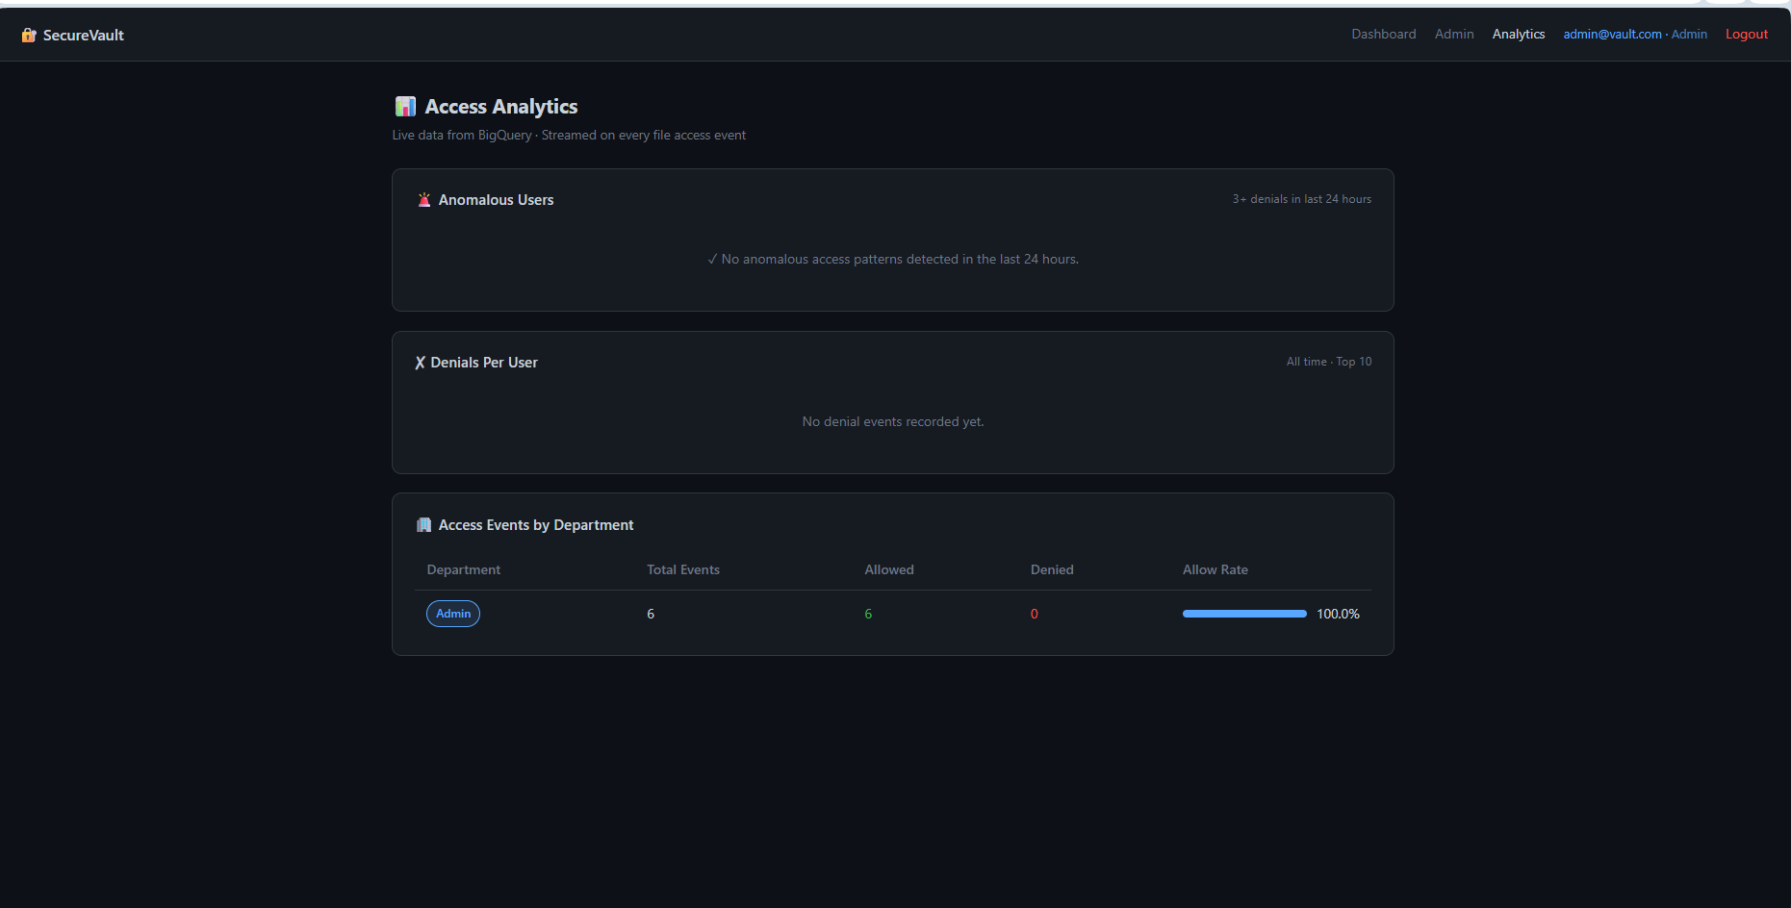
Figure 4: BigQuery analytics page showing access events by department with allow rates
Improvements can be made to a production version of this system. The encryption keys are currently stored in Firestore alongside the file metadata. A better solution is to use Google Cloud Key Management Service to store the keys separately from the data they encrypt. The Flask development server is not suitable for production deployment and should be replaced with a production WSGI server. The admin panel currently supports only department and clearance level conditions when creating policies. A more flexible interface would allow the admin to specify any attribute condition without needing developer involvement.
The project demonstrates that cloud security, attribute-based access control, and big data audit logging can be applied together in a single working application. The custom ABAC policy engine provides more flexible and fine-grained access control than a standard role-based system. The BigQuery analytics layer provides real-time visibility of access patterns, which is helpful in identifying unusual behaviour and auditing file access across departments.

References
[1] National Institute of Standards and Technology (2014). Guide to Attribute Based Access Control (ABAC) Definition and Considerations. NIST Special Publication 800-162. Available at: https://nvlpubs.nist.gov/nistpubs/specialpublications/NIST.SP.800-162.pdf [Accessed July 2026].
[2] National Institute of Standards and Technology (2023). Attribute Considerations for Access Control Systems. NIST Special Publication 800-205. Available at: https://nvlpubs.nist.gov/nistpubs/SpecialPublications/NIST.SP.800-205.pdf [Accessed July 2026].
[3] Dworkin, M. (2007). Recommendation for Block Cipher Modes of Operation: Galois/Counter Mode (GCM) and GMAC. NIST Special Publication 800-38D. National Institute of Standards and Technology. doi: 10.6028/NIST.SP.800-38D.
[4] Singh, D., Sinha, S. and Thada, V. (2021). Review of Attribute Based Access Control (ABAC) Models for Cloud Computing. In: Proceedings of the 2021 International Conference on Computational Performance Evaluation (ComPE). IEEE, pp. 710-715. doi: 10.1109/ComPE53109.2021.9752139.
[5] Hong, D., Wei, S.L., Hong, P. and Yu, N. (2022). Efficient and Secure Attribute-Based Access Control With Identical Sub-Policies Frequently Used in Cloud Storage. IEEE Transactions on Dependable and Secure Computing, 19(1), pp. 635-646. doi: 10.1109/TDSC.2020.2987903.
[6] Rescorla, E. (2018). The Transport Layer Security (TLS) Protocol Version 1.3. RFC 8446. Internet Engineering Task Force. Available at: https://tools.ietf.org/html/rfc8446 [Accessed July 2026].
[7] Google LLC (2024). Firebase Authentication Documentation. Available at: https://firebase.google.com/docs/auth [Accessed July 2026].
[8] Google LLC (2024). Google Cloud BigQuery Documentation. Available at: https://cloud.google.com/bigquery/docs [Accessed July 2026].
[9] Google LLC (2024). Google Cloud Storage Documentation. Available at: https://cloud.google.com/storage/docs [Accessed July 2026].

