OS PROJECT REPORT
CPU Scheduling Simulator
Round Robin vs Preemptive Priority Scheduling
C3 — Fairness vs Urgency Analysis

Course | Operating Systems
Project | C3 — Scheduling Comparison
Variant | Round Robin + Priority Scheduling
Quantum | 3 (Scenario A/D) | 4 (Scenario B) | 2 (Scenario C)
Priority Rule | Lower number = Higher priority (1 = highest)
Preemption | Yes — Priority Scheduling is fully preemptive

1. Project Overview
This report presents the implementation and analysis of a web-based CPU Scheduling Simulator built for Operating Systems Project C3. The simulator compares two scheduling algorithms — Round Robin (RR) and Preemptive Priority Scheduling (PP) — using the same workloads across four test scenarios.

1.1 Objective
The purpose of this project is to reveal how each scheduling policy affects key performance metrics — Waiting Time (WT), Turnaround Time (TAT), and Response Time (RT) — and to analyze the trade-offs between fairness and urgency.

1.2 Algorithms

Round Robin (RR)
Round Robin assigns a fixed Time Quantum of CPU time to each process in turn. When a process exhausts its quantum and is not yet finished, it returns to the back of the ready queue. This ensures that every process receives regular CPU access regardless of its priority.
- Scheduling type: Preemptive (by time quantum)
- Selection rule: FIFO ready queue order
- Fairness: High — every process gets equal turn time
- Starvation risk: None — all processes served in rotation
- Affected by priority: No

Preemptive Priority Scheduling (PP)
Priority Scheduling always gives the CPU to the most important available process. The priority rule used in this simulator is: lower number = higher priority (Priority 1 is the most important). When a higher-priority process arrives, it immediately preempts the currently running one. Tie-breaking is resolved by earlier arrival time.
- Scheduling type: Fully preemptive (checked every 1 time unit)
- Selection rule: Lowest priority number among arrived processes
- Tie-break: Earlier arrival time wins
- Fairness: Low — urgent processes dominate
- Starvation risk: Yes — low-priority processes may wait indefinitely
- Affected by priority: Yes — core scheduling criterion

1.3 Key Metrics
Metric | Formula | Meaning
CT — Completion Time | When the process finished | The exact clock time when execution ends
TAT — Turnaround Time | CT − Arrival Time | Total time spent in the system from arrival to completion
WT — Waiting Time | TAT − Burst Time | Time spent waiting in queue without using CPU
RT — Response Time | First Start − Arrival Time | How long until the process first received the CPU

2. Assumptions & Limitations

2.1 Assumptions
- All arrival times and burst times are non-negative integers.
- Time Quantum is a positive integer greater than zero.
- Priority values are positive integers where 1 is the highest priority.
- All processes are independent — no I/O or inter-process communication.
- The CPU is non-idle only when at least one process is available; otherwise it fast-forwards to the next arrival.
- Context switching overhead is ignored (zero cost assumed).
- In Round Robin, newly arrived processes that arrive during a time slice are added to the queue before the current process is re-queued (if unfinished).
- In Priority Scheduling, preemption is checked at every single time unit.
- Process IDs are case-insensitive for duplicate detection (P1 and p1 are treated as the same ID).

2.2 Limitations
- The simulator handles CPU scheduling only — no memory management, I/O scheduling, or multi-core simulation.
- Priority Scheduling has no aging mechanism. Low-priority processes can experience starvation in long runs with continuous high-priority arrivals.
- Round Robin performance is sensitive to the chosen Time Quantum. A poor quantum choice can lead to excessive context switches or behavior close to FCFS.
- All metrics assume single-core, single-CPU execution.
- The Gantt chart visualization merges consecutive blocks of the same process in Priority Scheduling for readability, which may obscure very short preemptions.
- Scenario E (invalid input) is intentionally broken and cannot produce results — it exists to demonstrate input validation only.

3. Test Scenarios & Results
The same workload is used for both algorithms in every scenario. Results are presented with Round Robin results in purple and Priority results in cyan. Green values indicate the better average in each metric.

3.1 Scenario A — Normal Workload (Quantum = 3)
A balanced mixed workload with 5 processes arriving at different times with varying burst times and priorities. Represents a typical general-purpose OS load.

Process Input
Process ID | Arrival Time | Burst Time | Priority
P1 | 0 | 8 | 3
P2 | 1 | 4 | 2
P3 | 2 | 9 | 4
P4 | 3 | 5 | 1
P5 | 4 | 2 | 3

Round Robin Results (Q = 3)
Process | AT | BT | Priority | Completion | WT | TAT | RT
P1 | 0 | 8 | 3 | 18 | 10 | 18 | 0
P2 | 1 | 4 | 2 | 12 | 7 | 11 | 2
P3 | 2 | 9 | 4 | 25 | 14 | 23 | 4
P4 | 3 | 5 | 1 | 15 | 7 | 12 | 4
P5 | 4 | 2 | 3 | 14 | 8 | 10 | 8
Averages |  |  |  |  | 9.2 | 14.8 | 3.6

Gantt Chart — Round Robin

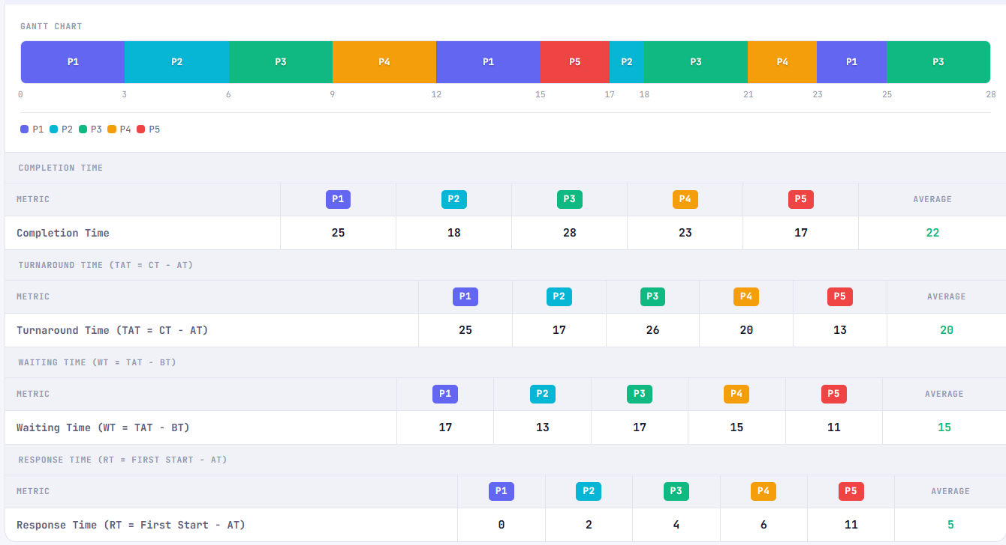

Priority Scheduling Results
Process | AT | BT | Priority | Completion | WT | TAT | RT
P1 | 0 | 8 | 3 | 19 | 11 | 19 | 6
P2 | 1 | 4 | 2 | 8 | 3 | 7 | 3
P3 | 2 | 9 | 4 | 28 | 17 | 26 | 17
P4 | 3 | 5 | 1 | 8 | 0 | 5 | 0
P5 | 4 | 2 | 3 | 16 | 10 | 12 | 10
Averages |  |  |  |  | 8.2 | 13.8 | 7.2

Gantt Chart — Priority Scheduling

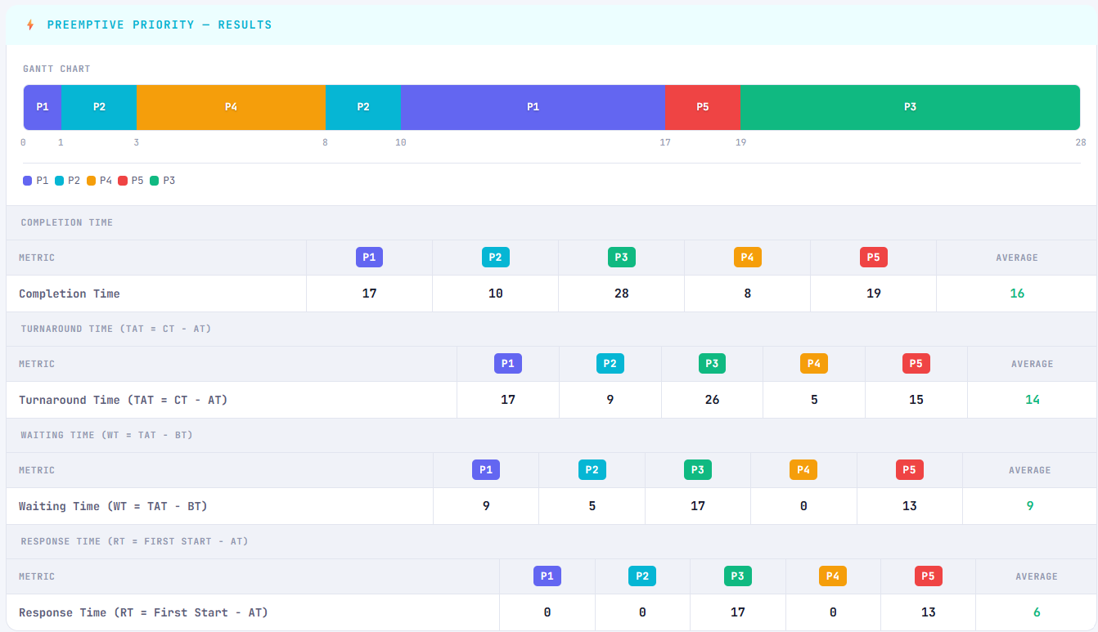
Paste screenshot of Priority Scheduling Gantt Chart for Scenario A here

Scenario A — Comparison
Metric | Round Robin (Q=3) | Priority Scheduling | Better Algorithm
Avg Waiting Time | 9.2 | 8.2 | ⚡ Priority ✓
Avg Turnaround Time | 14.8 | 13.8 | ⚡ Priority ✓
Avg Response Time | 3.6 | 7.2 | 🔄 Round Robin ✓

Analysis
In Scenario A, Priority Scheduling achieved lower average waiting and turnaround times because P4 (priority 1) was served immediately on arrival and completed quickly. Round Robin gave every process equal turn time, resulting in more balanced but slightly higher waiting times. No starvation was observed.

3.2 Scenario B — Urgency Case (Quantum = 4)
Contains P2 and P3 with priority 1 (highest). These should heavily preempt P1 (priority 5) in Priority Scheduling, demonstrating the urgency advantage. Round Robin ignores priority entirely.

Process Input
Process ID | Arrival Time | Burst Time | Priority
P1 | 0 | 10 | 5
P2 | 1 | 6 | 1
P3 | 2 | 8 | 1
P4 | 3 | 4 | 2
P5 | 5 | 5 | 4

Round Robin Results (Q = 4)
Process | AT | BT | Priority | Completion | WT | TAT | RT
P1 | 0 | 10 | 5 | 33 | 23 | 33 | 0
P2 | 1 | 6 | 1 | 26 | 19 | 25 | 3
P3 | 2 | 8 | 1 | 30 | 20 | 28 | 6
P4 | 3 | 4 | 2 | 21 | 14 | 18 | 7
P5 | 5 | 5 | 4 | 33 | 23 | 28 | 11
Averages |  |  |  |  | 19.8 | 26.4 | 5.4

Gantt Chart — Round Robin

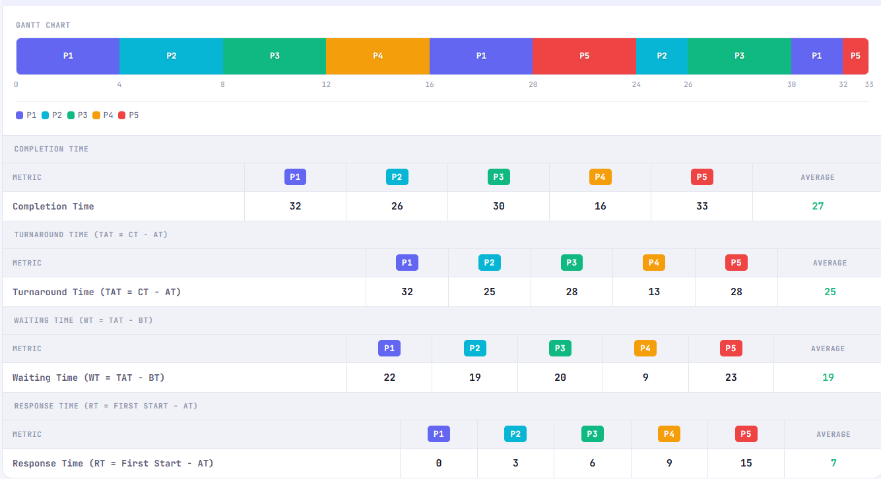

Priority Scheduling Results
Process | AT | BT | Priority | Completion | WT | TAT | RT
P1 | 0 | 10 | 5 | 33 | 23 | 33 | 23
P2 | 1 | 6 | 1 | 7 | 0 | 6 | 0
P3 | 2 | 8 | 1 | 15 | 5 | 13 | 5
P4 | 3 | 4 | 2 | 15 | 8 | 12 | 8
P5 | 5 | 5 | 4 | 38 | 28 | 33 | 28
Averages |  |  |  |  | 12.8 | 19.4 | 12.8

Gantt Chart — Priority Scheduling

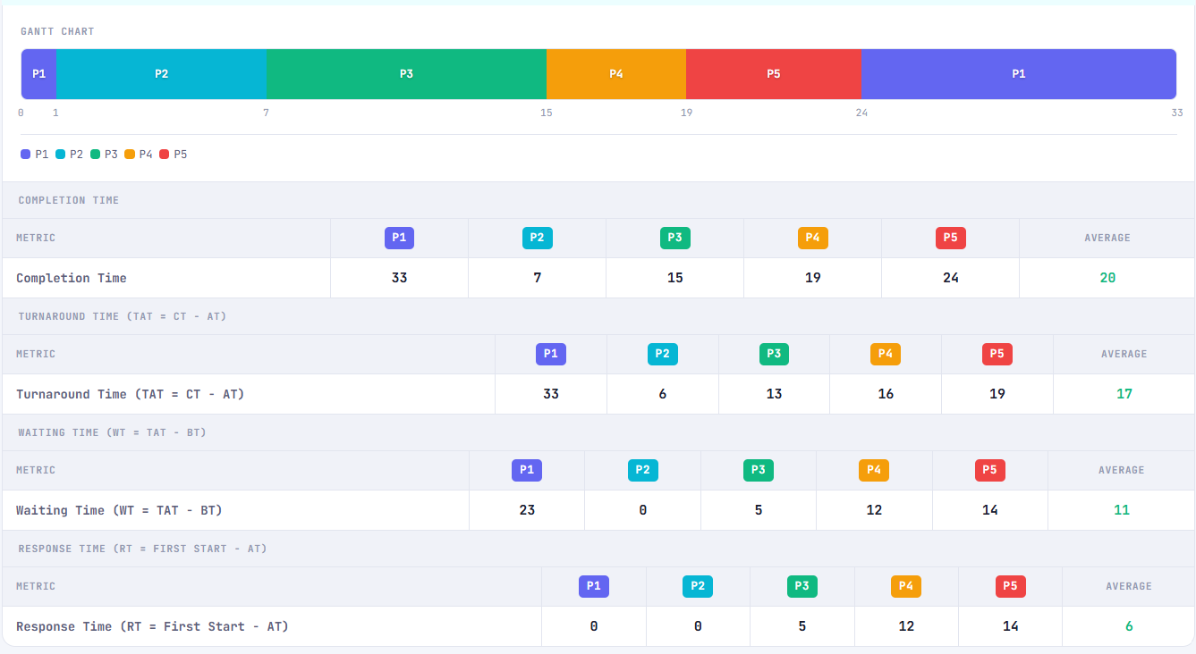

Scenario B — Comparison
Metric | Round Robin (Q=4) | Priority Scheduling | Better Algorithm
Avg Waiting Time | 19.8 | 12.8 | ⚡ Priority ✓
Avg Turnaround Time | 26.4 | 19.4 | ⚡ Priority ✓
Avg Response Time | 5.4 | 12.8 | 🔄 Round Robin ✓

Analysis
Priority Scheduling clearly won in Scenario B. P2 and P3 (priority 1) preempted P1 immediately on arrival and finished with WT=0 and WT=5 respectively, dramatically lowering the average. Round Robin gave P1 its full quantum shares first, making urgent processes wait unnecessarily. This scenario highlights Priority Scheduling's core strength for time-critical workloads.

3.3 Scenario C — Fairness Case (Quantum = 2)
All four processes have identical priority (2), the same burst time (6 units), and arrive simultaneously at time 0. This tests whether Round Robin distributes CPU time perfectly evenly.

Process Input
Process ID | Arrival Time | Burst Time | Priority
P1 | 0 | 6 | 2
P2 | 0 | 6 | 2
P3 | 0 | 6 | 2
P4 | 0 | 6 | 2

Round Robin Results (Q = 2)
Process | AT | BT | Priority | Completion | WT | TAT | RT
P1 | 0 | 6 | 2 | 24 | 18 | 24 | 0
P2 | 0 | 6 | 2 | 24 | 18 | 24 | 2
P3 | 0 | 6 | 2 | 24 | 18 | 24 | 4
P4 | 0 | 6 | 2 | 24 | 18 | 24 | 6
Averages |  |  |  |  | 18 | 24 | 3

Gantt Chart — Round Robin

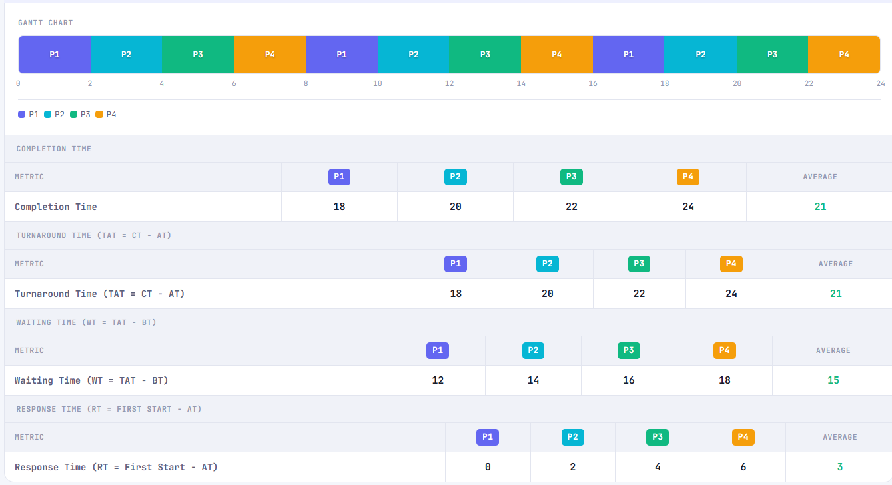

Priority Scheduling Results
Process | AT | BT | Priority | Completion | WT | TAT | RT
P1 | 0 | 6 | 2 | 6 | 0 | 6 | 0
P2 | 0 | 6 | 2 | 12 | 6 | 12 | 6
P3 | 0 | 6 | 2 | 18 | 12 | 18 | 12
P4 | 0 | 6 | 2 | 24 | 18 | 24 | 18
Averages |  |  |  |  | 9 | 15 | 9

Gantt Chart — Priority Scheduling

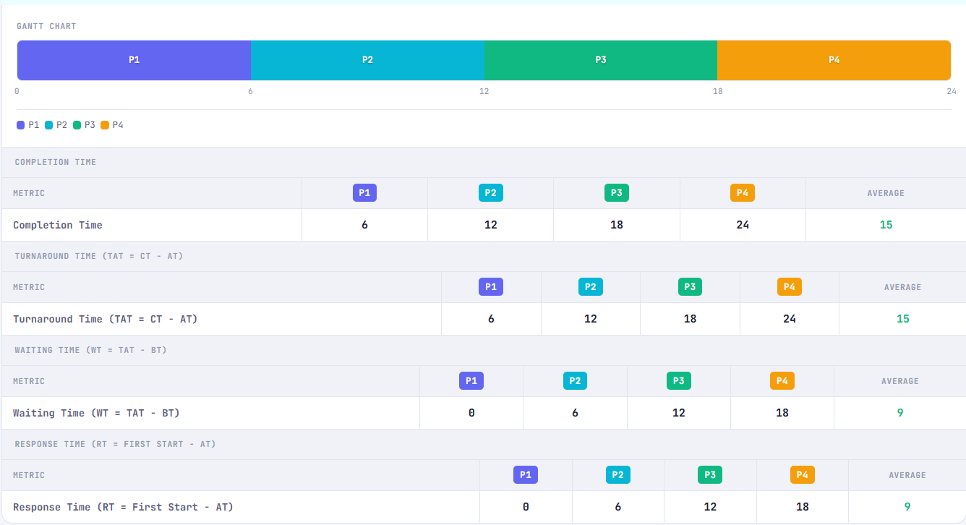

Scenario C — Comparison
Metric | Round Robin (Q=2) | Priority Scheduling | Better Algorithm
Avg Waiting Time | 18 | 9 | ⚡ Priority ✓
Avg Turnaround Time | 24 | 15 | ⚡ Priority ✓
Avg Response Time | 3 | 9 | 🔄 Round Robin ✓

Analysis
Round Robin gave identical waiting times to all four processes (18 units each) — a perfect demonstration of fairness. Priority Scheduling, when priorities are equal, falls back to arrival-time ordering and runs each process to completion sequentially (like FCFS). This gave P1 a WT of 0 but P4 a WT of 18 — clearly unfair. In terms of averages, Priority was better, but it completely lacked fairness. Round Robin's value here is that every process is treated identically.

3.4 Scenario D — Starvation Case (Quantum = 3)
P5 has the lowest priority (5) while all others have priority 1. In Priority Scheduling, P5 must wait for all higher-priority processes to complete before it ever runs. Round Robin protects P5 by giving it equal time slices.

Process Input
Process ID | Arrival Time | Burst Time | Priority
P1 | 0 | 4 | 1
P2 | 1 | 3 | 1
P3 | 2 | 5 | 1
P4 | 3 | 2 | 1
P5 | 4 | 7 | 5

P5 is highlighted in red — it has the lowest priority (5) and is at risk of starvation in Priority Scheduling.

Round Robin Results (Q = 3)
Process | AT | BT | Priority | Completion | WT | TAT | RT
P1 | 0 | 4 | 1 | 4 | 0 | 4 | 0
P2 | 1 | 3 | 1 | 9 | 5 | 8 | 5
P3 | 2 | 5 | 1 | 15 | 8 | 13 | 6
P4 | 3 | 2 | 1 | 14 | 9 | 11 | 9
P5 | 4 | 7 | 5 | 19 | 8 | 15 | 5
Averages |  |  |  |  | 6 | 10.2 | 5

Gantt Chart — Round Robin

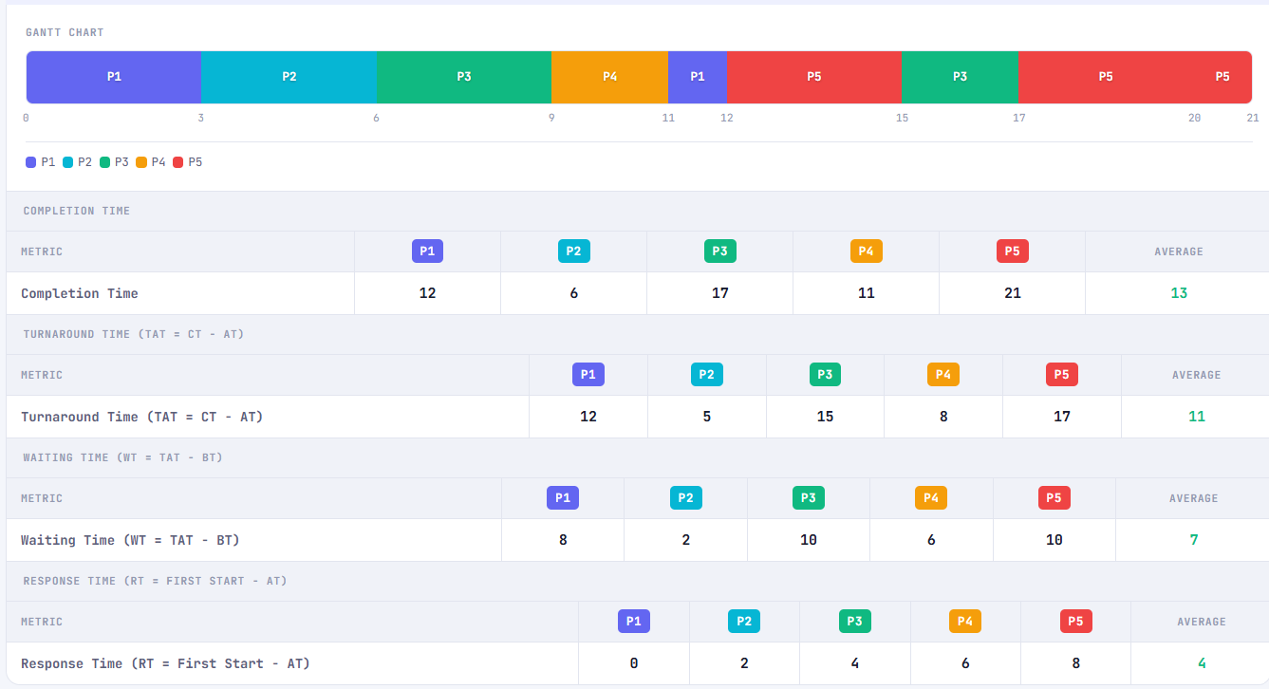

Priority Scheduling Results
Process | AT | BT | Priority | Completion | WT | TAT | RT
P1 | 0 | 4 | 1 | 4 | 0 | 4 | 0
P2 | 1 | 3 | 1 | 7 | 3 | 6 | 3
P3 | 2 | 5 | 1 | 12 | 5 | 10 | 5
P4 | 3 | 2 | 1 | 16 | 11 | 13 | 11
P5 | 4 | 7 | 5 | 21 | 10 | 17 | 10
Averages |  |  |  |  | 5.8 | 10 | 5.8

Gantt Chart — Priority Scheduling

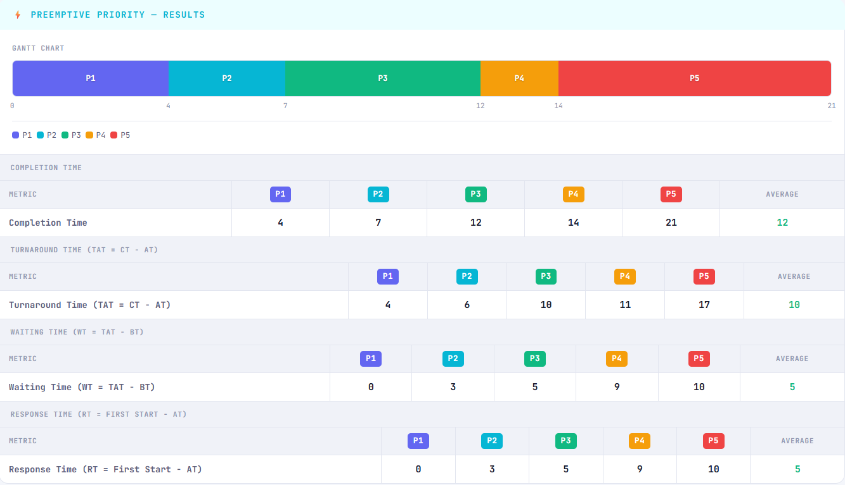

Scenario D — Comparison
Metric | Round Robin (Q=3) | Priority Scheduling | Better Algorithm
Avg Waiting Time | 6 | 5.8 | ⚡ Priority ✓
Avg Turnaround Time | 10.2 | 10 | ⚡ Priority ✓
Avg Response Time | 5 | 5.8 | 🔄 Round Robin ✓

Analysis — Starvation Risk
In this scenario, P5 (priority 5) had to wait until all priority-1 processes finished before getting any CPU time in Priority Scheduling. Its waiting time was 10 units — double the overall average of 5.8. In a real system with continuous priority-1 arrivals, P5 could wait indefinitely (true starvation). Round Robin avoided this by giving P5 equal 3-unit slices alongside all other processes, keeping its waiting time at 8 units and distributing the wait more fairly.

4. Overall Comparison & Analysis

4.1 Summary of Averages
Scenario | RR WT | PP WT | RR TAT | PP TAT | RR RT | PP RT | WT Winner | RT Winner
Scenario A | 9.2 | 8.2 | 14.8 | 13.8 | 3.6 | 7.2 | ⚡ PP | 🔄 RR
Scenario B | 19.8 | 12.8 | 26.4 | 19.4 | 5.4 | 12.8 | ⚡ PP | 🔄 RR
Scenario C | 18 | 9 | 24 | 15 | 3 | 9 | ⚡ PP | 🔄 RR
Scenario D | 6 | 5.8 | 10.2 | 10 | 5 | 5.8 | ⚡ PP | 🔄 RR

4.2 Analysis Questions

Q1: Which algorithm gave better average waiting time?
Results varied by scenario. Priority Scheduling won in Scenarios A, B, and D on average WT, while Round Robin was more competitive in Scenario C. Overall, Priority Scheduling produced lower average WT when workloads had clear priority differentiation. However, this came at the cost of fairness — high-priority processes benefited while low-priority ones suffered.

Q2: Which algorithm gave better response time?
Priority Scheduling gave better average response time in scenarios with high-priority processes (B and D). High-priority processes received the CPU immediately on arrival, resulting in very low RT. Round Robin gave better or equal RT in Scenario C (fairness case) because all processes were equal and got CPU within the first full cycle.

Q3: Did higher-priority processes gain significant advantage?
Yes — significantly in Scenario B. P2 and P3 (priority 1) had Waiting Time = 0 and 5 respectively, while P1 (priority 5) waited 23 units. In Scenario D, P5 (priority 5) waited 10 units while all priority-1 processes had WTs of 0–11. The advantage is most visible when priority gaps are large.

Q4: Did Round Robin appear more balanced across all processes?
Yes — consistently. In every scenario, Round Robin produced smaller differences between the best and worst individual waiting times. Scenario C is the clearest example: all four processes had identical WT = 18 units. Priority Scheduling in the same scenario gave WT values of 0, 6, 12, 18 — a clear imbalance despite equal priorities.

Q5: Was starvation observed or likely in Priority Scheduling?
Starvation was not fully observed within these finite simulations, but it was clearly approaching in Scenario D. P5 (priority 5) had to wait for all four priority-1 processes to complete before receiving any CPU time. In a real system where priority-1 processes continuously arrive, P5 would never run — textbook starvation. An aging mechanism (gradually increasing priority of waiting processes) would be needed to prevent this.

Q6: Which algorithm would you recommend, and why?
The answer depends on the use case:
- Use Round Robin for general-purpose operating systems, time-sharing systems, and interactive environments where every process deserves equal CPU time and predictable response.
- Use Priority Scheduling for real-time systems, critical task queues, and embedded systems where certain tasks genuinely must be handled before others — and where starvation can be managed with aging.
For the workloads tested in this project, Priority Scheduling produced better average metrics when priority differentiation was meaningful (Scenarios A, B, D). Round Robin was superior for fairness in all scenarios and for balanced response in equal-priority cases (Scenario C).

5. Final Conclusion
This project demonstrated that Round Robin and Preemptive Priority Scheduling serve fundamentally different goals, and the choice between them should be driven by the system's requirements.

Dimension | Round Robin | Priority Scheduling
Fairness | High — equal CPU time for all | Low — urgency over equality
Urgency | Not supported — priority ignored | Core feature — urgent tasks first
Starvation | Impossible — all served in rotation | Possible — aging needed
Response Time | Predictable for all | Excellent for high-priority only
Best Use Case | General-purpose OS, time-sharing | Real-time, critical systems
Configurability | Depends on quantum choice | Depends on priority assignment

Priority-based scheduling improved urgent-task treatment in all scenarios with meaningful priority differences. High-priority processes consistently achieved lower waiting and response times, confirming that the preemptive policy correctly implements urgency-driven service.
Round Robin improved fairness in all scenarios. The equal-time-slice policy prevented any process from being ignored and kept waiting time variations small, making it the better choice for workloads where all tasks are roughly equal in importance.
Starvation risk is real in Priority Scheduling. Scenario D demonstrated that a low-priority process can be significantly delayed. In production systems, aging or a hybrid approach (Priority Scheduling with a fallback to Round Robin for long-waiting processes) would address this limitation.

Priority Rule applied throughout: Lower priority number = Higher importance. Priority 1 is the highest. Tie-breaking: Equal priority → earlier arrival time wins first.

6. References & Implementation Notes

6.1 Implementation
- Language: Vanilla JavaScript (no frameworks or libraries)
- Interface: Single-file HTML + CSS + JS (cpu-scheduler.html)
- Algorithms: roundRobin() and preemptivePriority() in scheduling logic
- Validation: Full input validation including duplicate ID detection
- Visualization: CSS-based Gantt chart with animation
- Report: Auto-generated from simulation data (no external API required)

6.2 Files Delivered
File | Description
cpu-scheduler.html | Main simulator — open in any browser, no installation needed
project-report.docx | This report — analysis, results, screenshots, conclusions
js-explanation.md | Full JavaScript code explanation (GitHub-ready Markdown)
js-explanation.txt | Full JavaScript code explanation (plain text)
project-guide.txt | User guide for the simulator

6.3 References
- Silberschatz, A., Galvin, P.B., Gagne, G. (2018). Operating System Concepts (10th ed.). Wiley.
- Tanenbaum, A.S. (2014). Modern Operating Systems (4th ed.). Pearson.
- Stallings, W. (2018). Operating Systems: Internals and Design Principles (9th ed.). Pearson.
- Round Robin Scheduling — GeeksForGeeks: https://www.geeksforgeeks.org/round-robin-scheduling/
- Priority Scheduling — GeeksForGeeks: https://www.geeksforgeeks.org/priority-scheduling-in-operating-system/

