LAB Logbook

Lab 1
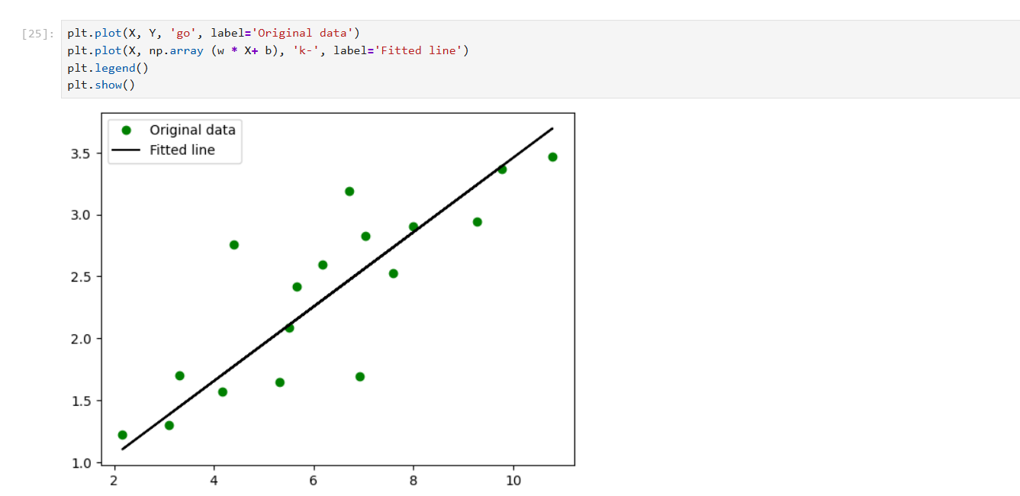

Lab 2
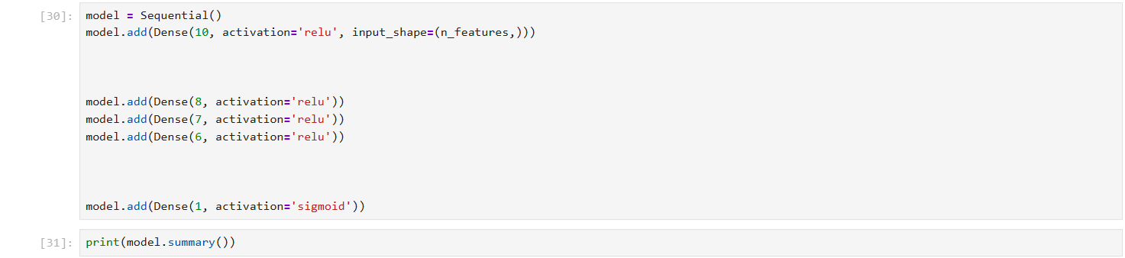

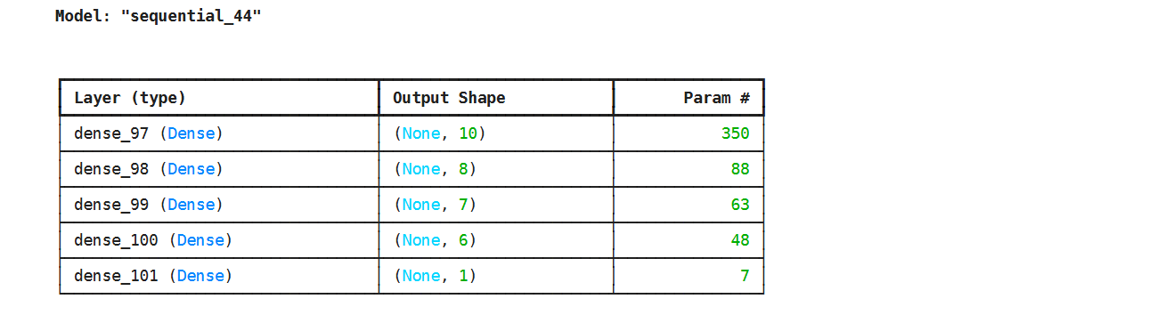

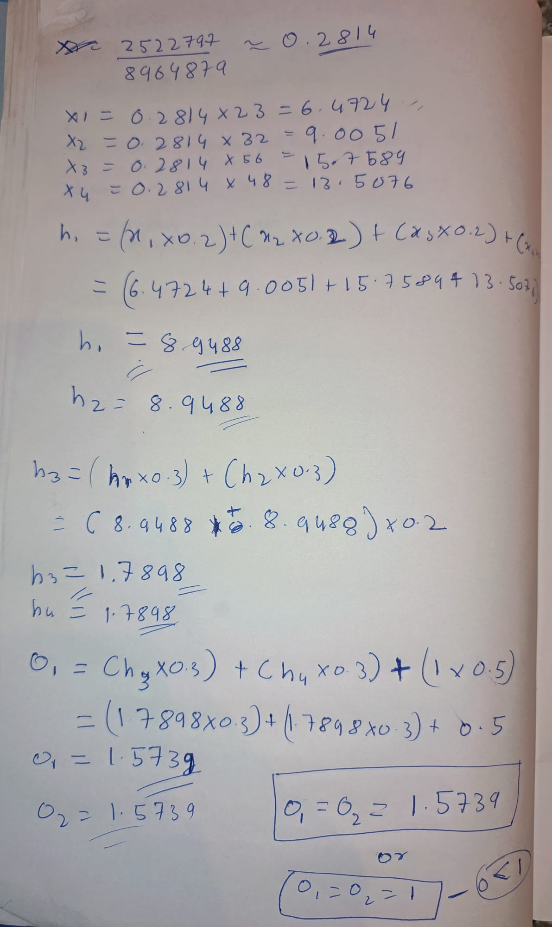
O_1 = 1.5739
O_2 = 1.5739

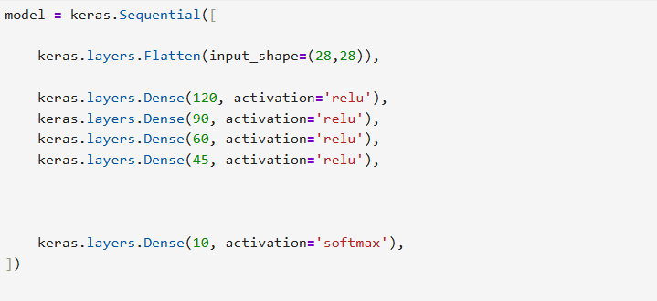
Lab 3

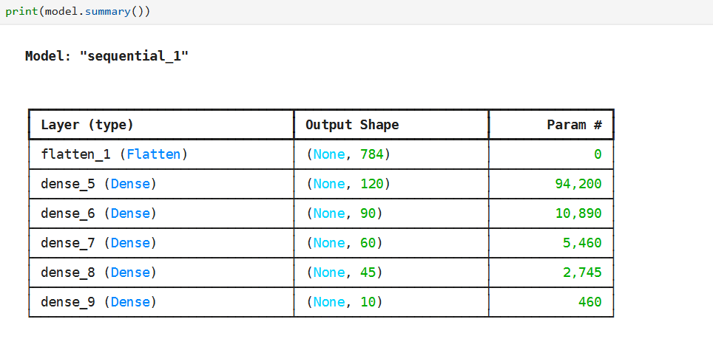

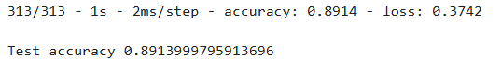

Lab 4

Lab 5

Lab 6

Lab 7

Lab 8

Lab 9

Lab 10

Lab 11

Lab 12

