Explain the below linux commands with an example. Share the screenshot of each command with the output:

**Pwd** : which tells where you are – in which directory, starting from the root (/)

Example : 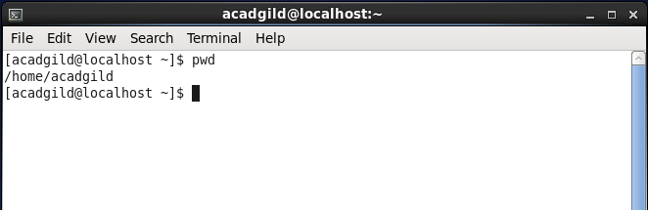

**Vi** : vi is an interactive text editor which is display-oriented: the screen of your [terminal](https://www.computerhope.com/jargon/t/terminal.htm) acts as a window into the file you are editing. Changes you make to the file are reflected in what you see.

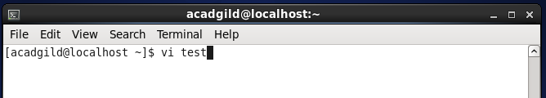

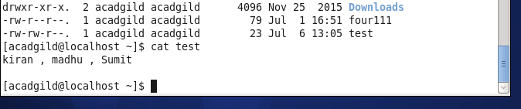

**Touch** : it will just create empty file

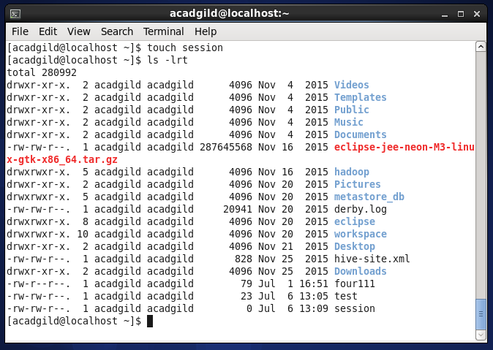

**Mkdir** : Short for "make directory", mkdir is used to create [directories](https://www.computerhope.com/jargon/d/director.htm) on a [file system](https://www.computerhope.com/jargon/f/filesyst.htm).

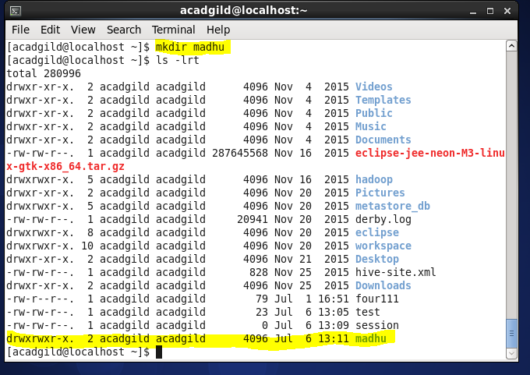

**Rm** : remove files or directories

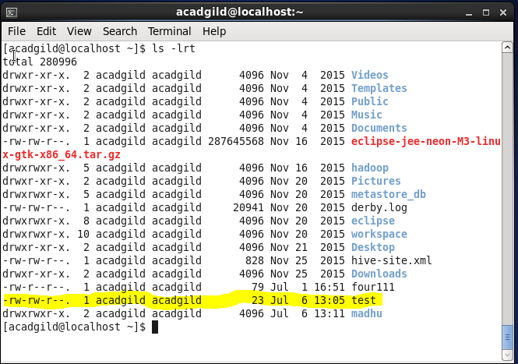

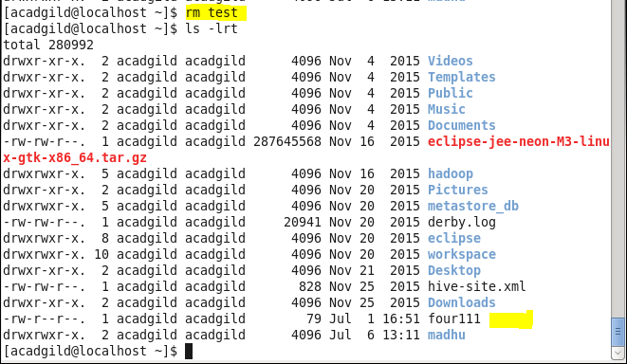

**Ls** : ls list the directory contents

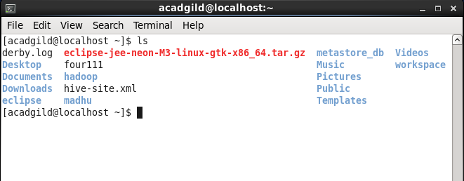

**Echo** : displays a line of text

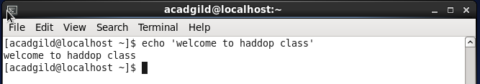

**Cat** : cat command allows us to create single or multiple files, view contain of file, concatenate files and redirect output in terminal or files.

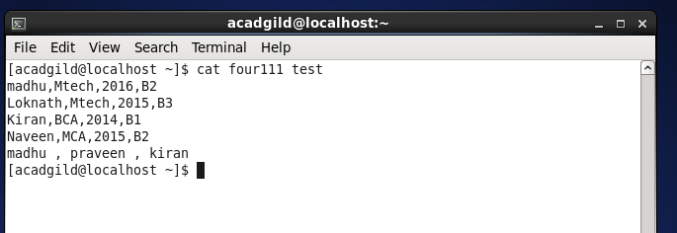

**Who** : Display who is on the system.

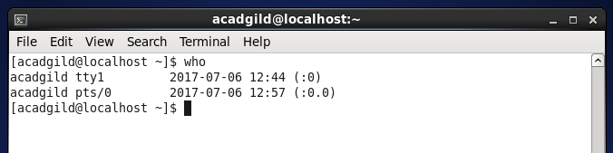

**Cd** : used to change directory

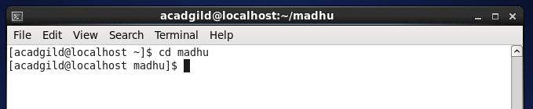

**Date** : displays date with timestamp

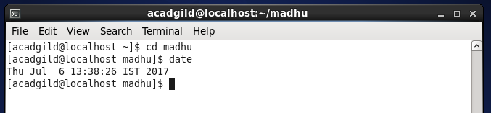

**Cal** : used to display calendar

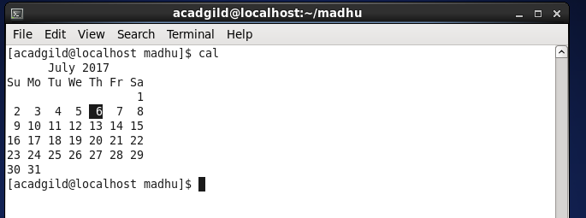

**Mv** : mv renames file SOURCE to DEST, or moves the SOURCE file (or files) to DIRECTORY.

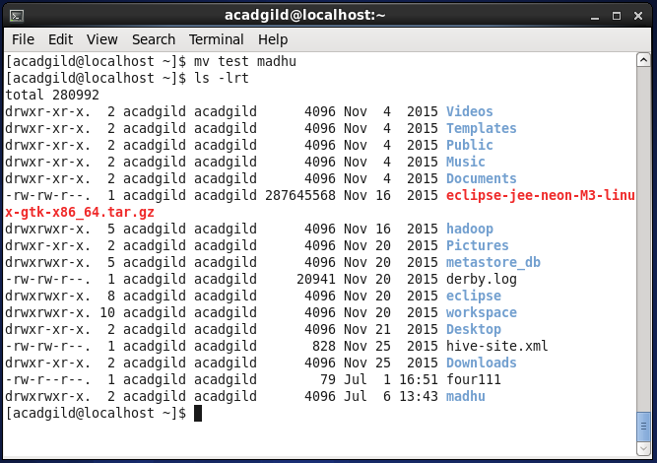

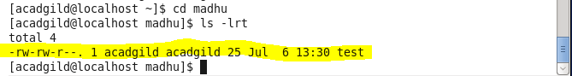

**Cp** : used to copy files

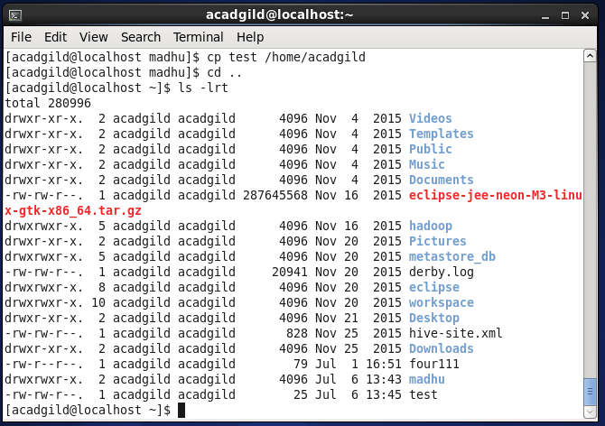

**Which** : which command is used to find the location of a program.

