Step 1 :Create database ‘Custom’

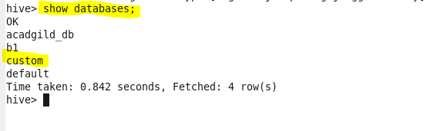

Step 2: create table temprrature_data

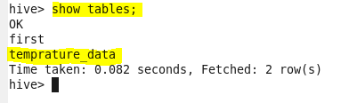

Step 3 : data has been loaded to table

