Problem statements

Fetch date and temperature from temperature_data where zip code is greater than

300000 and less than 399999.

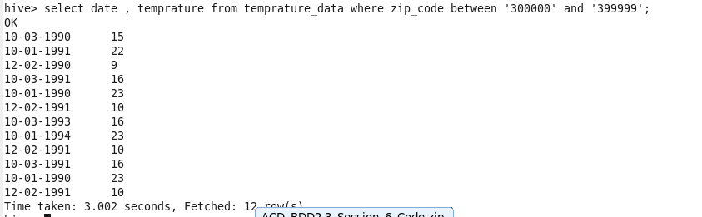

Calculate maximum temperature corresponding to every year from temperature_data

table.



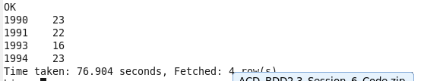

Create a view on the top of last query, name it temperature_data_vw.



• Export contents from temperature_data_vw to a file in local file system, such that each

file is '|' delimited.

