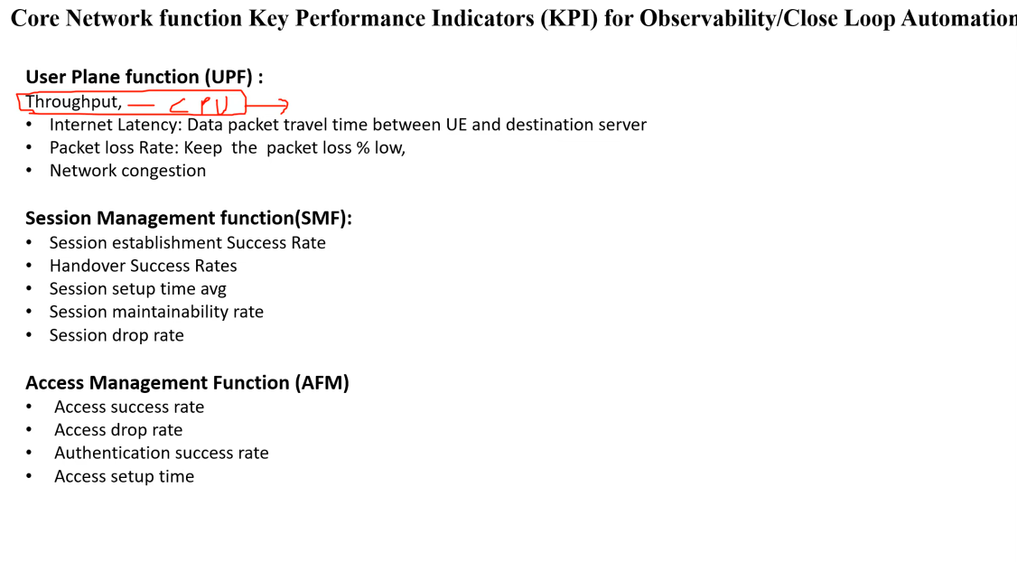
Distributed agent collecting → centralized system aggregating
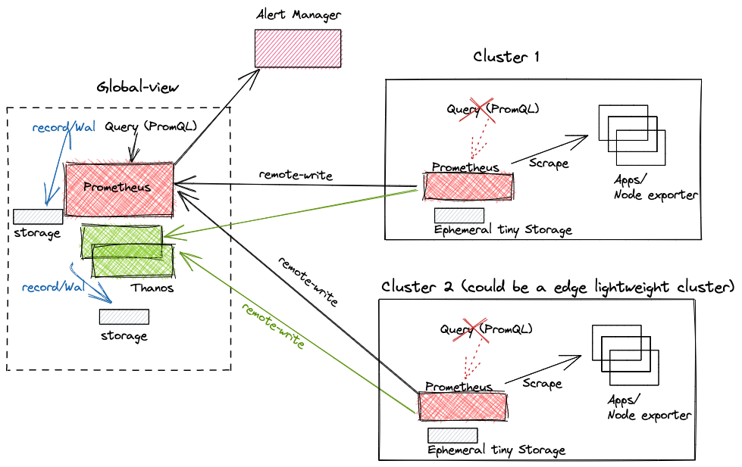
Remote write with lightweight Prometheus in Workload clusters and a standard Prometheus instance in Management cluster.

