

Department of Computing

CS-250: Data Structure and Algorithms

LAB 1: Introduction to Version Control (Git) and Simple Test Cases

Date Due: 11th September 2026

Fall Semester, 2026

Class: BSCS 15D

Name: Maryam Amir

CMS ID: 550843

Task 1

Create an array named numbers containing 2, 4, 6, 8 and 10. Change the third element to 7. Use a for loop to display all five values, separated by spaces. Predict the output before running your program
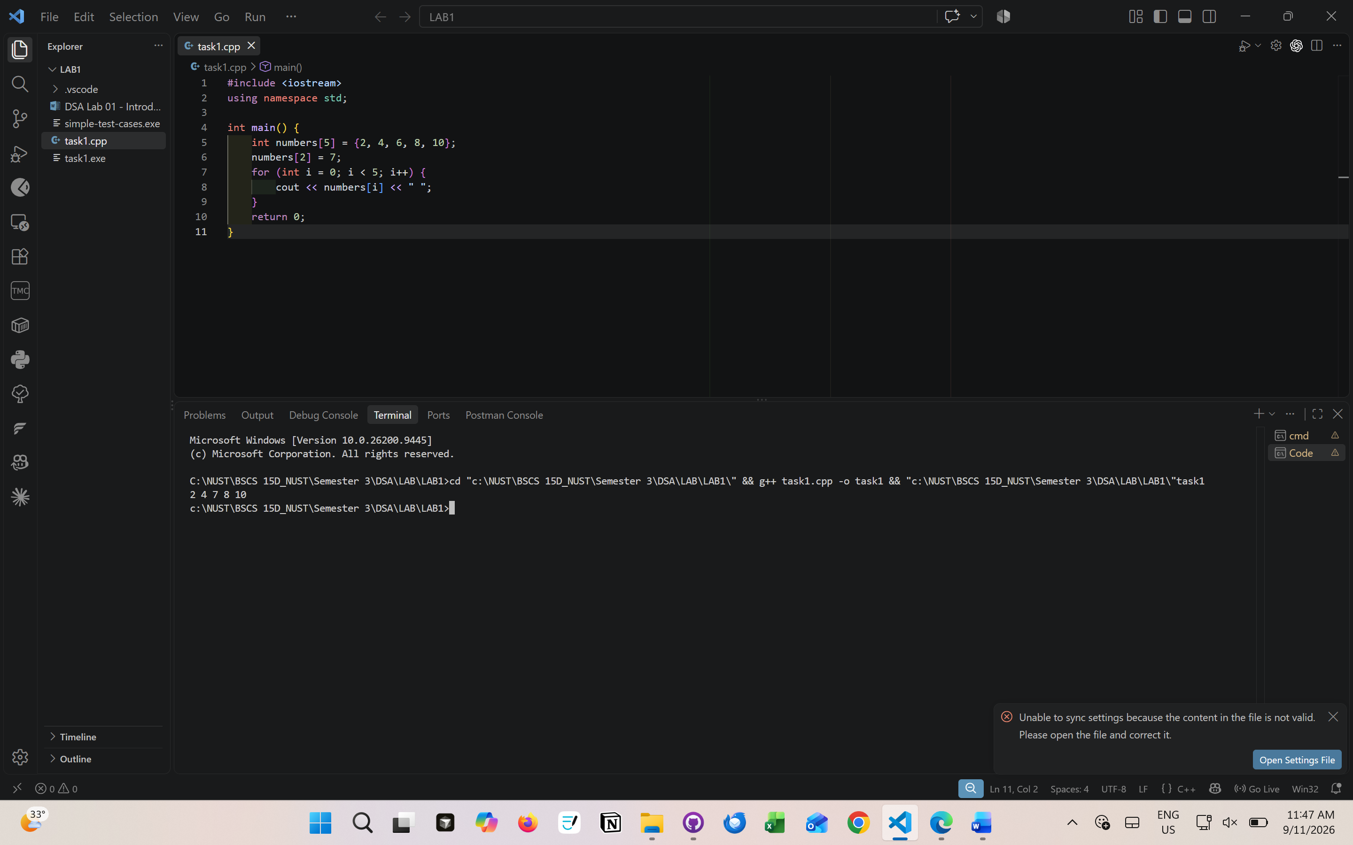

Task 2

Declare int numbers[5]; and initialise int total = 0;. Use one loop to read five integers into the array and a second loop to add them to total. Display the total. Assume the user enters exactly five valid integers whose sum fits in int.
Test input | Expected total | Actual total
1 2 3 4 5 | 15 | 15
0 0 0 0 0 | 0 | 0
-2 4 -1 0 3 | 4 | 4
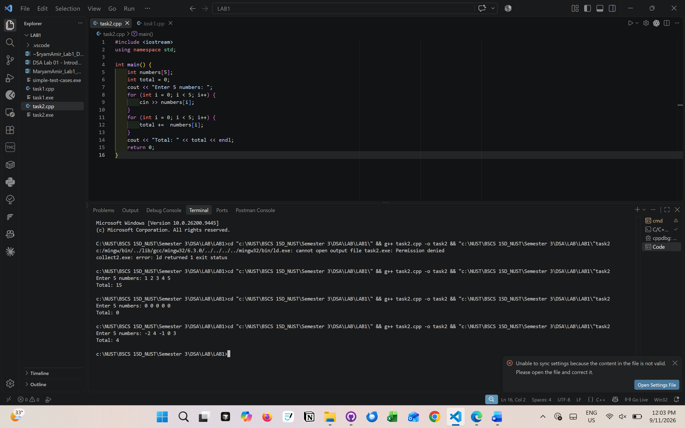

Task 3

Define a class named Student with two public integer data members, rollNumber and marks. Add a public member function void display() that prints both values with labels on separate lines. Define the class above main().
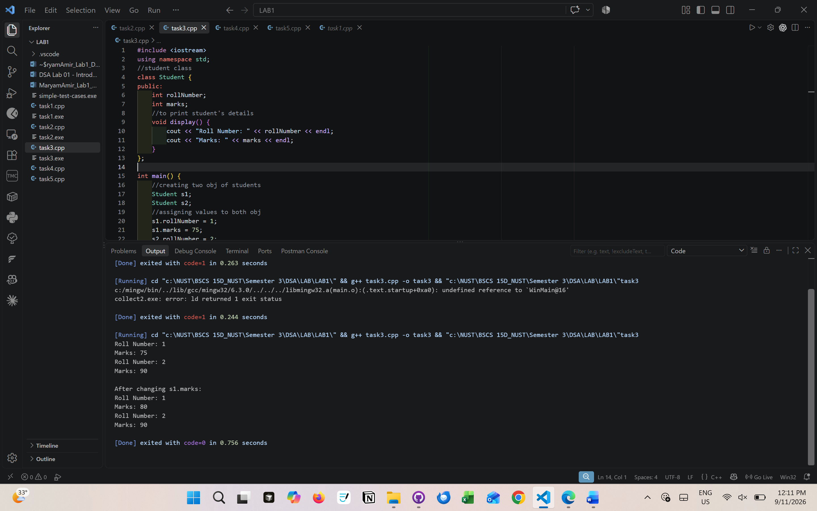
Expected:
Roll Number: 1
Marks: 75
Roll Number: 2
Marks: 90

After changing s1.marks:
Roll Number: 1
Marks: 80
Roll Number: 2
Marks: 90
Justification: when s1 marks are changed it will not affect s2 because both are separate objects

Task 4

Read 8 integers into an array. Find and display the largest and smallest values and their indices. If a value occurs more than once, report its first occurrence.

Task 5

Read 6 integers into an array. Reverse the elements without using another array, then display the updated array.

Task 6

Read 10 integers into an array. Move the first occurrence of each distinct value into the beginning of the same array, preserving the original order. Display these unique values and their count. Do not use another array.

Task 7

Create a folder named dsa-lab01 and place your tasks inside it. Open a terminal in that folder

