

Department of Computing

CS-250: Data Structure and Algorithms

LAB 2: Static and Dynamic Arrays
Pointers and Dynamic Memory Allocation

Date Due: 18th September 2026

Fall Semester, 2026

Class: BSCS 15D

Name: Maryam Amir

CMS ID: 550843

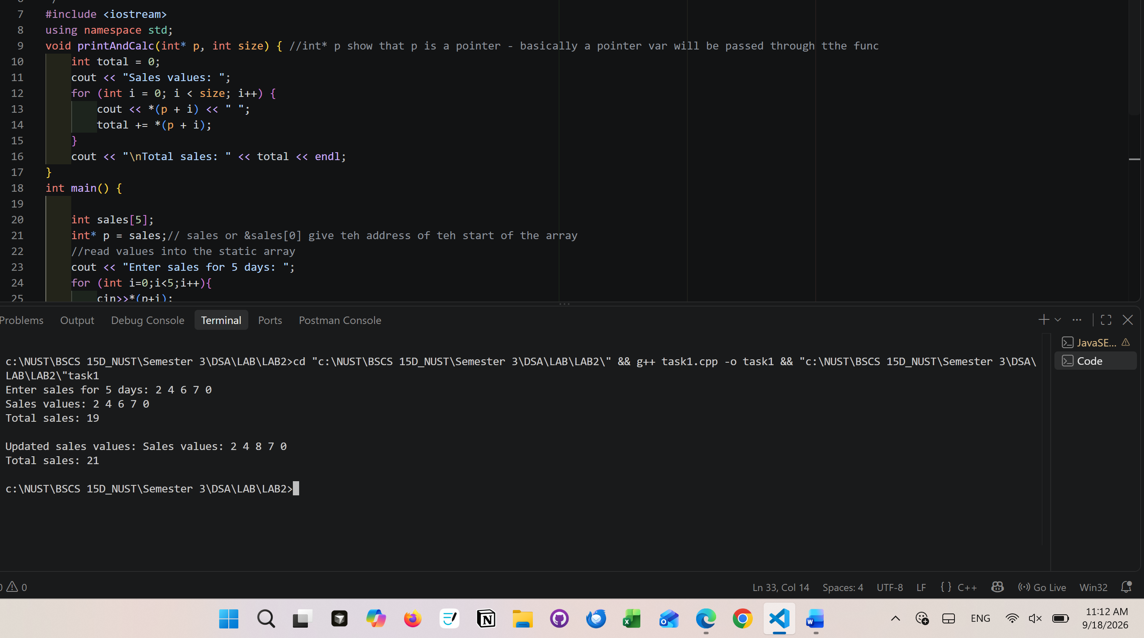
Task 1

Explanation – Task1.3
p address stored in p
&p address of the pointer var itself
*p value stored at the address p
*(p+2) value stored at address p+2 – basically the third element of the array
*(p + 5) the size of the array is 5 and since the first element is stored at address p the last element is on address p+4. p+5 is index out of bounds -> there is no sixth element
Index | p | p+1 | p+2 | p+3 | p+4
Value | 2 | 4 | 6 | 7 | 0

Task 2
Test input | Expected result | Actual result | Pass or Fail
n = 4; marks = 40 50 70 81 | Total 241; average 60.25; pass count 3 | Marks: 40 50 70 81  Total: 241  Average: 60  Pass count: 3 | pass
n = 1; mark = 0 | Total 0; average 0; pass count 0 | Marks: 0  Total: 0  Average: 0  Pass count: 0 | pass
n = 0 | Error; no allocation or mark input | Error | pass

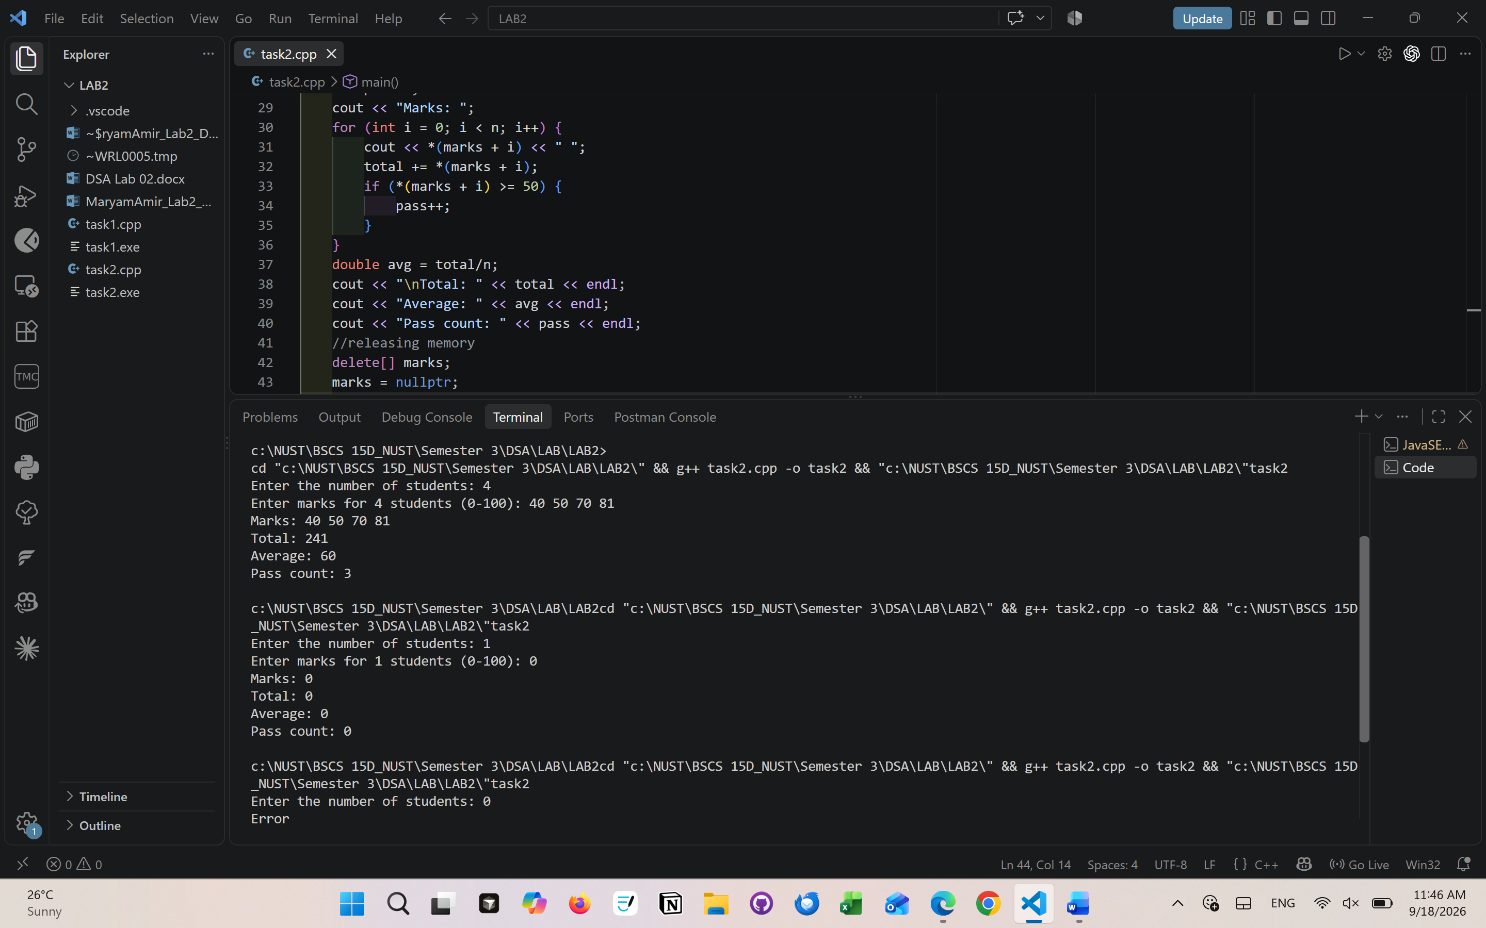
Why are marks and the allocated elements different objects?
Marks is a pointer which stores the address of the array’s first element. The array itself is present in heap since it’s a dynamic array. The marks pointer var (on stack) and the array (on heap) itself are present in two different sections of the memory which is why they have to be deleted separately.
Explain why entering n at runtime works with new int[n], while int marks[n]; is not a standard C++ fixed-size array declaration when n is a runtime variable.
“new ” is used because it dynamicalay allocated the required amount of memory (from heap) at runtime. The standard int marks[n] is not a runtime var an dwill give a static array in stack rather than a dynamic array on heap.

Task 3
Input by row | Expected totals | Actual | Pass or fail
Branch 1: 2 4 6  Branch 2: 1 3 5 | Branch totals: 12 and 9  Day totals: 3, 7 and 11 | Sales Table:  2 4 6  1 3 5  Branch totals:  Branch 1: 12  Branch 2: 9  Day totals:  Day 1: 3  Day 2: 7  Day 3: 11 | pass
Both rows: 0 0 0 | Every total is 0 | Sales Table:  0 0 0  0 0 0  Branch totals:  Branch 1: 0  Branch 2: 0  Day totals:  Day 1: 0  Day 2: 0  Day 3: 0 | pass

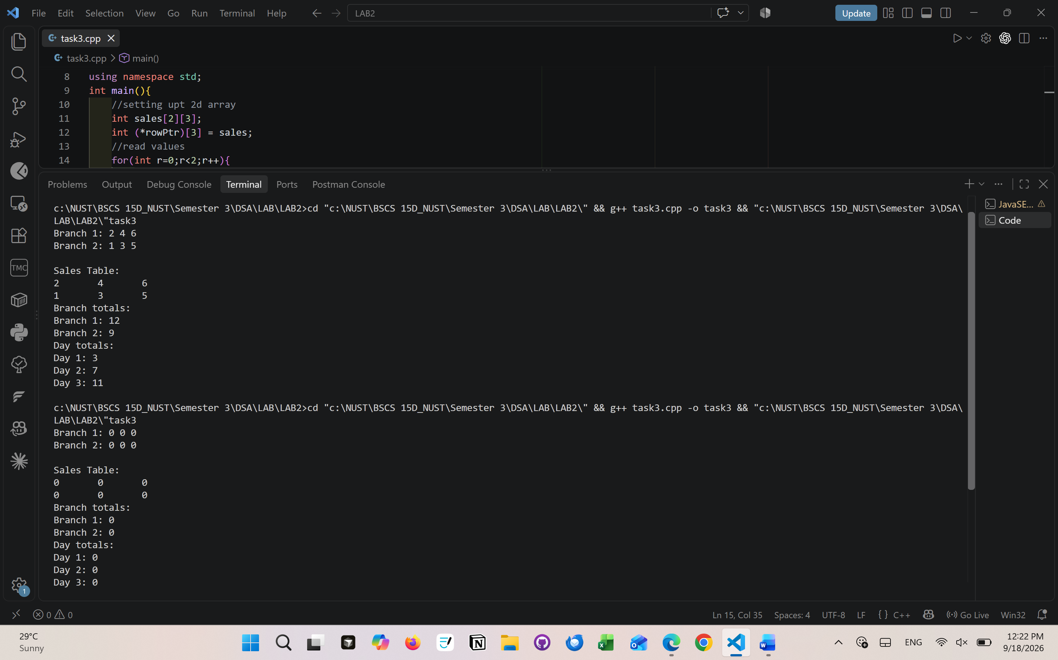
Explain what rowPtr + 1 points to and why its step differs from the step of an int* pointing to one integer. Why should int** p = sales; not be used?
The rowPtr+1 points to the entire row of 2d arrays.
Pointer arithmetic depends on the type. An int* steps by the size of one integer while rowPtr steps by the size of full row.
An int** does not point to a block of numbers. It points to a list of memory addresses (pointers). When int** p = sales, it will look at the sales data as a list of memory addresses. So if the sales data is [100,150, 200,.. etc] then it will read the data as Address 100 which will cause the program to crash.

Task 4
Input by row | Expected result | Actual result | Pass or fail
2 × 3: 50 60 70 / 80 40 90 | Totals: 180, 210; top student: 2 | Students total:  Student 1: 180  Student 2: 210  Top student: 2  Highest total: 210 | pass
2 × 2: 40 60 / 50 50 | Totals: 100, 100; top student: 1 | Students total:  Student 1: 100  Student 2: 100  Top student: 1  Highest total: 100 | pass
1 × 1: 75 | Total: 75; top student: 1 | Students total:  Student 1: 75  Top student: 1  Highest total: 75 | pass
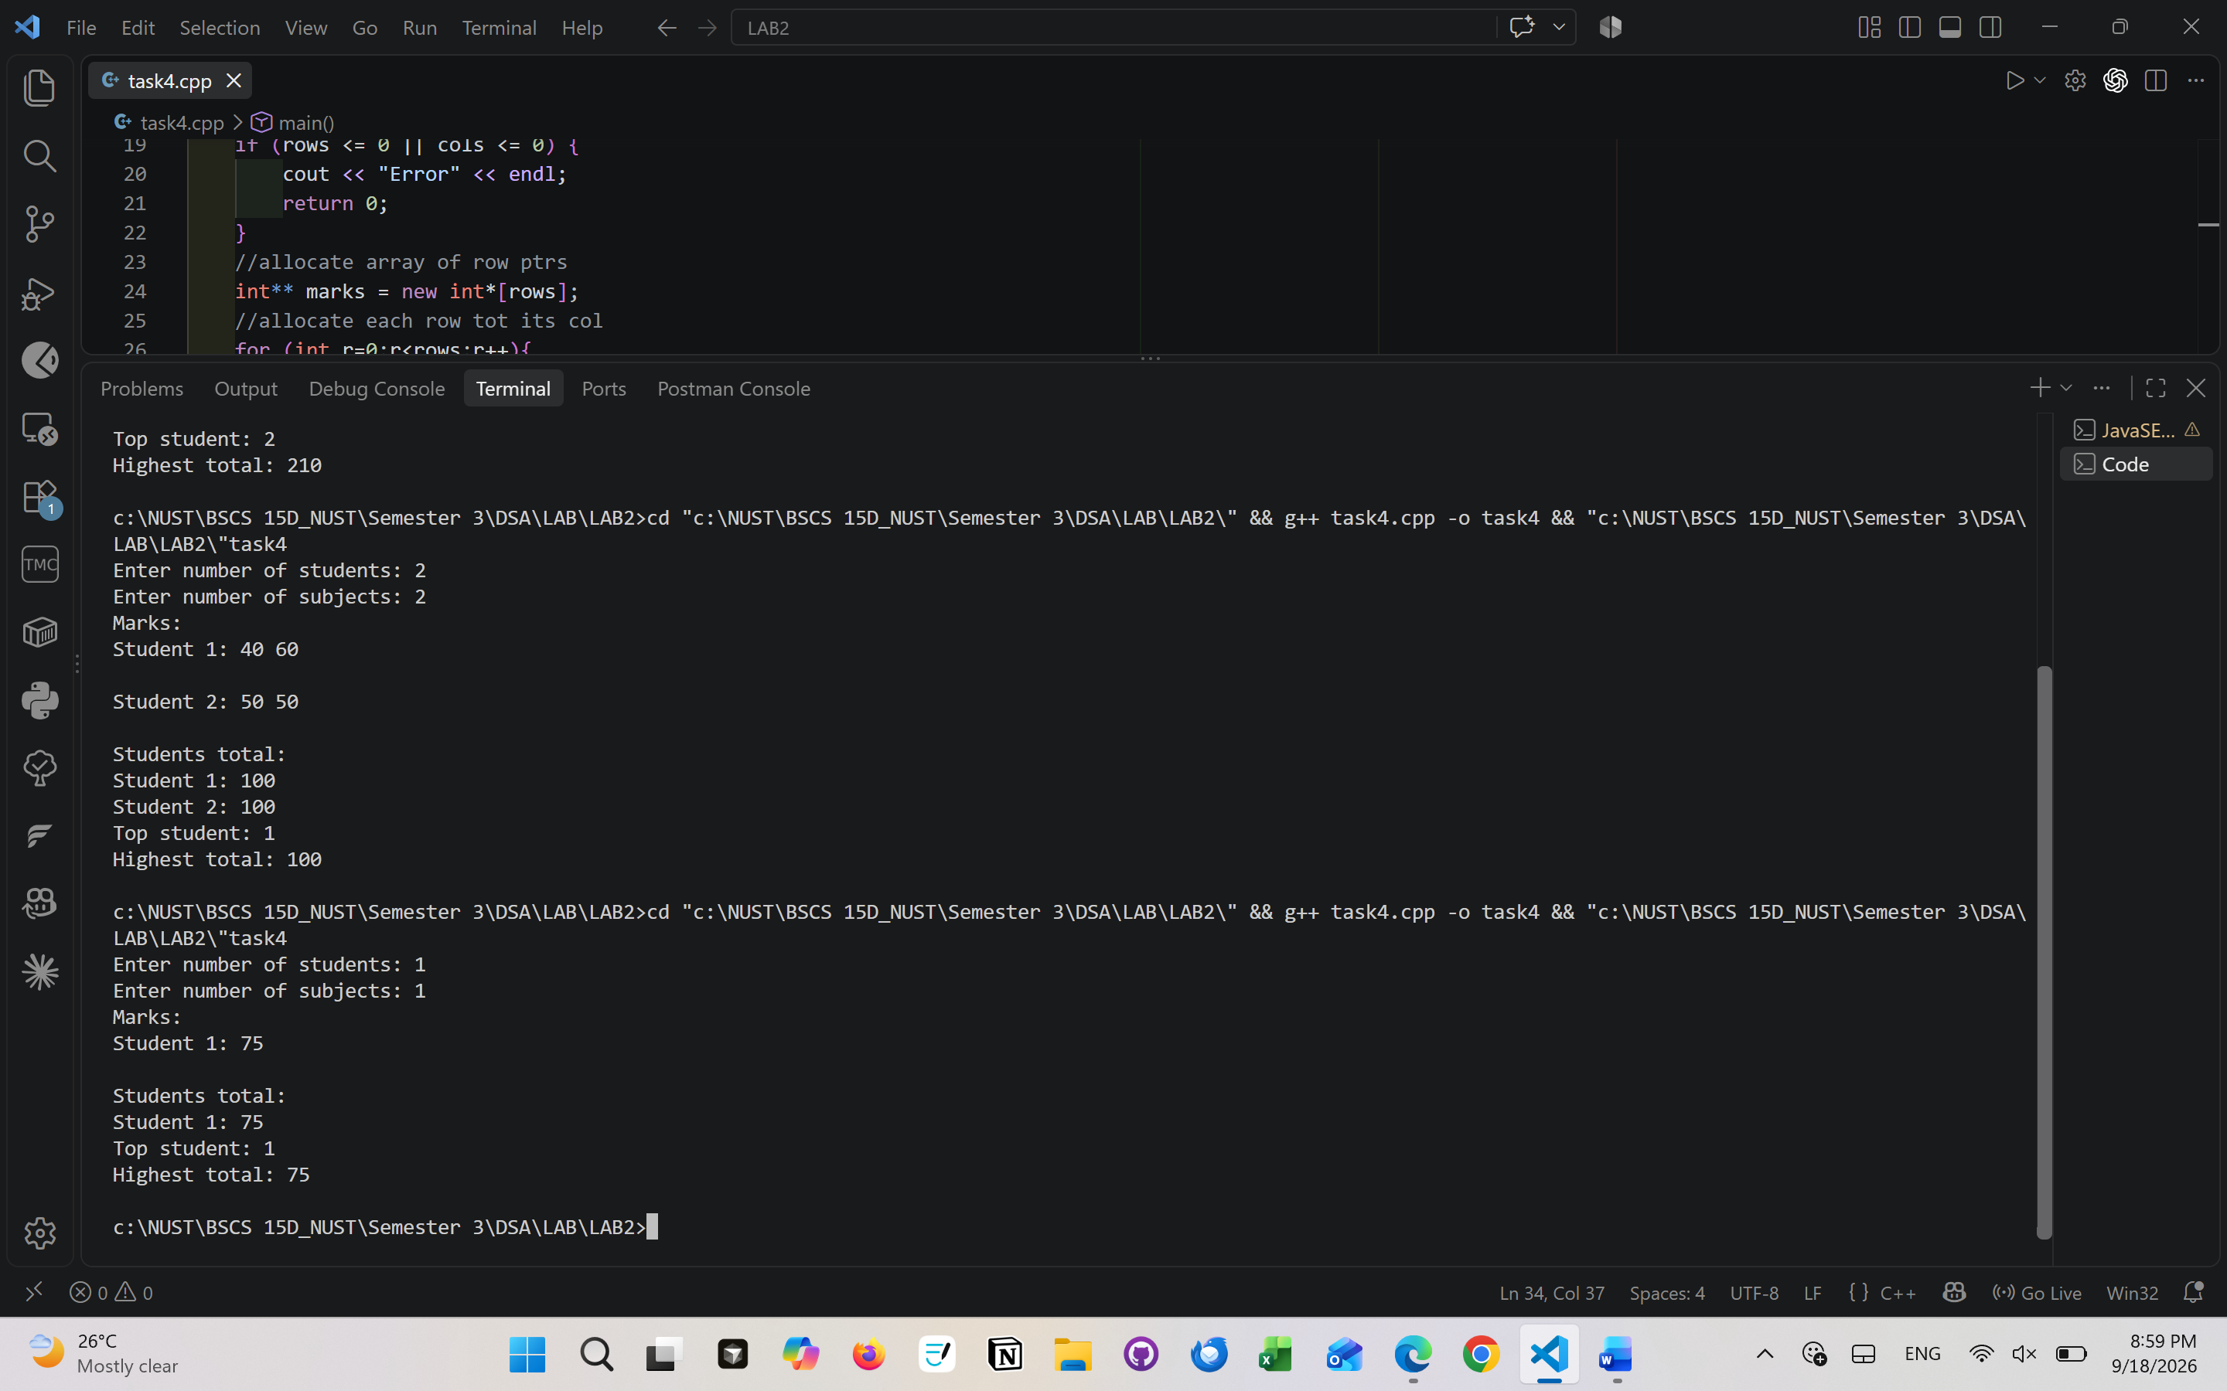
Explain what would remain allocated if only delete[] marks; were executed.
When only marks array is deleted, the row pointer array is released but the individual rows remain allocated. This is a memory leak. So both the row pointer array and individual rows should be deleted separately.

For two students and three subjects, sketch the pointer variable, the array of two row pointers and the two separately allocated rows. Label marks, marks[0] and marks[0][0].
- Base pointer – on the stack (stores the address of pointer array)
Var name | Data type | Hold address of
marks | Int** | The row pointer array (marks[0])

- Array of row pointer – on the heap (stores address of separate rows)
Index | Pointer var | Holds address of
0 | marks[0] | Start of row 0 – student1
1 | marks[1] | Start of row 1 – student2

- Separate allocated rows – on the heap (stores the actual marks values for the 3 subjects)
Row 0 – student1
Subj1 – Index0 | Subj2 – Index1 | Subj3 – Index2
marks[0][0] | marks[0][1] | marks[0][2]
Row 1 – student2
Subj1 – Index0 | Subj2 – Index1 | Subj3 – Index2
marks[1][0] | marks[1][1] | marks[1][2]
Marks master pointer pointing to array of row ptrs
Marks[0] specific row ptr pointing to Studnet1’s subjects
Marks[0][0] is the actual int value/marks inside the first slot of first row

Task 5
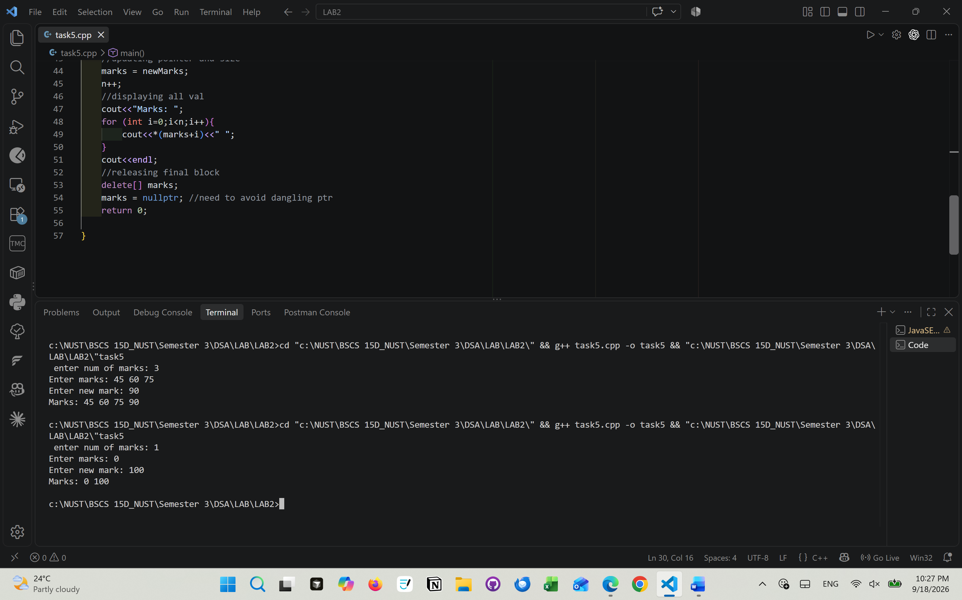
Explain why changing n alone does not increase the old block’s capacity.
Changing n alone wont increase the capacity as it’s a var on stack with no permanent link to the heap. Also, the heap allocations are fixed on time of creation – they cant stretch as adj memory are usually occupied by other data.

Task 6
error | problem | consequence
i<=n | Array index out of bound | Values[3] doesn’t exist the index value for size 3 array is from 0 to 2. Correct: i<n
Delete values | Incorrect syntax | Since an array was allocated (new int[n]) then it should be deleted that was as well. Correct: delete[] values;
cout << values[0]; | Using values after deletion | The allocated array no longer exists after delete[] values = values is trying to access the released memory address. Correct: value s= nullptr;
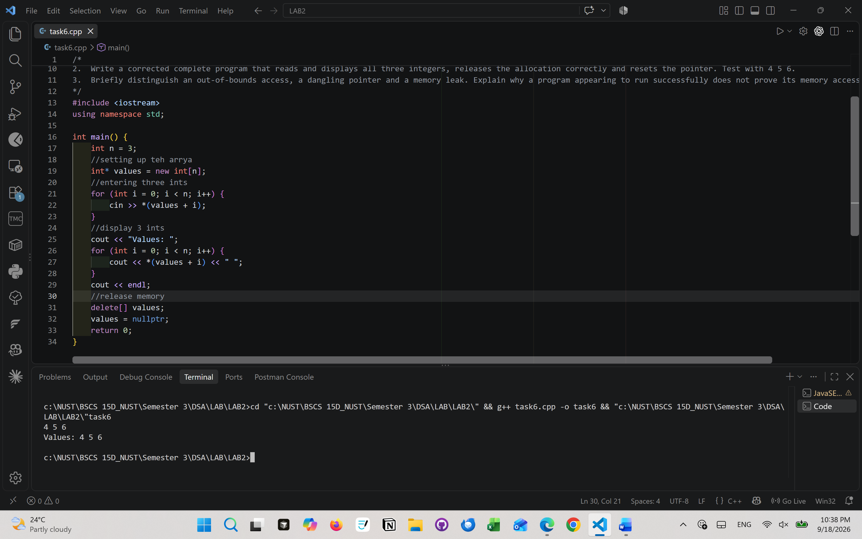
Concept | Meaning | Eg | Problem | Solution
Out-of-bounds access | Trying to access an array position that does not exist | int a[3]; then a[3] | You access memory outside the array -undefined behavior | Keep indices within 0 to n-1
Dangling pointer | A pointer still points to memory that has already been released | int* p = new int[3]; delete[] p; | p contains an old address, but that memory no longer belongs to your array | Set p = nullptr after delete[]
Memory leak | Allocated memory is never released | int* p = new int[3]; p = nullptr; | The array is still occupying memory, but you have lost its address, so you can't delete[] it | Always delete[] dynamically allocated arrays before losing the pointer

